**Project Proposal on**

**Courier Management System**



**Submitted By: Submitted To:**

**Uma Manandhar Sudeep Bajimaya**

**Batch: 22A Module Leader**

**NCC ID: 00175043**

Contents

***Chapter 1*** 3

***Introduction*** 4

**Justification of the Project** 4

• **System Background** 4

• **Problem Statement** 4

**Description of the project** 5

**Features of the project** 5

**Overview of the Project** 5

**Chapter 2** 6

**Scope of the Project** 6

**Scope** 6

**Limitation** 6

**Aims** 6

**Objectives** 6

**Overview of Scope** 6

**Chapter 3** 7

**Development Methodology** 7

**Design Pattern** 8

**Architecture** 9

**Chapter 4** 10

**Project Planning** 10

**Mile Stone** 12

**Gantt Chart** 14

**Scheduling** 14

**Gantt chart:** 15

**Chapter 5** 16

**Risk Management** 16

**Chapter 6** 17

**Configuration Management** 17

**Chapter 7** 18

**Conclusion** 18

**Chapter 8** 19

**References and Bibliography** 19

***Table of Figure***

**Fig: System Development Lifecycle 7**

**Fig: Model View Controller 8**

**Fig: Three-tier Architecture 9**

**Fig: Work Breakdown System. 11**

**Fig: Milestone Time Chart 13**

**Fig: Scheduling 14**

**Fig: Gantt chart 15**

**Fig: Configuration Management 17**

***Chapter 1***

## ***Introduction***

Courier Management System which supports the high accessibility of courier services to all the corporate and to the customer. Courier which means all the goods, messages, mail, package as well as other item which can transfer from one country to another country. The system is being used for day to day activities such as booking a courier, maintain hub details, and maintain company details, process data of businesses and many other things. This Courier Management System project will have different operative system. The login system will have login facility for admin and users as well. After login user can provide all the details for placing orders.

This system will help all the employee of the company and make work systematically and flexibility. Database record will help to recognize the existing customer which will help in future reference.

## **Justification of the Project**

### **System Background**

Courier Management system is application which handle all the process of courier. System will be used day to day for all the courier activities. Courier services became increasingly popular with the arrival of Internet shopping. Being able to order large and multiple items from online sellers required specialist delivery services that would enable customers to not only receive their items but also enable online sellers to offer things such as next day delivery. Something that is only possible with a courier service.

### **Problem Statement**

This company has the system for only CRUD operation but it’s not enough for this company. People when transfer their products using any courier service wants to know whether their product has been shifted to their right person or not,if not than by what time it will be shifted and where it is now. Taking all this information manualy is very difficul and time taking process. To handle all these activities include various processes. There can be online payment

## **Description of the project**

### **Features of the project**

* Collect information of the customer details and place to transfer goods
* It deals with monitoring the information and transactions of track id.
* The system can perform CRUD operation as well as many more features.
* Online tracking courier Service.
* Pickup and Dispatch schedule.
* Customer Web portal.
* Courier management software with online payment will be system enabled.

### **Overview of the Project**

Courier Management System is a web-based which supports the high accessibility of courier services to the corporate and to the customer. All the features mention above are the essential features which will be implementing on the project. Before making a project features should be identify so that it could be easy to complete project

# **Chapter 2**

## **Scope of the Project**

### **Scope**

* The system for better services and faster processing.
* Different branch sectors where we can use this system.

### 

### **Limitation**

* This system can only bring essential features.
* Once the delivery process is processed it cannot be undone.
* Delivery might be delay if there is any technical problem or natural disturbance.

### **Aims**

* Computerized the maintenance of courier management.
* Providing a better service to the customer
* Make the system perform the entire task for the courier.
* Make online registration.
* Build the desktop-based application.

### **Objectives**

* To provide best services to employee to do work fast and easier.
* To provide information about the new system of courier to customer.
* To attempt and training to employee to use this technology.

### **Overview of Scope**

Overall scope Limitation, Amis and objectives are listed which will be implementing in the project. Scope which will know about the project how long and up to where it will be use. There are some of limitation in the project which is listed in above list. Aims and Objects which is the main process to be identify in the project.

# **Chapter 3**

## **Development Methodology**

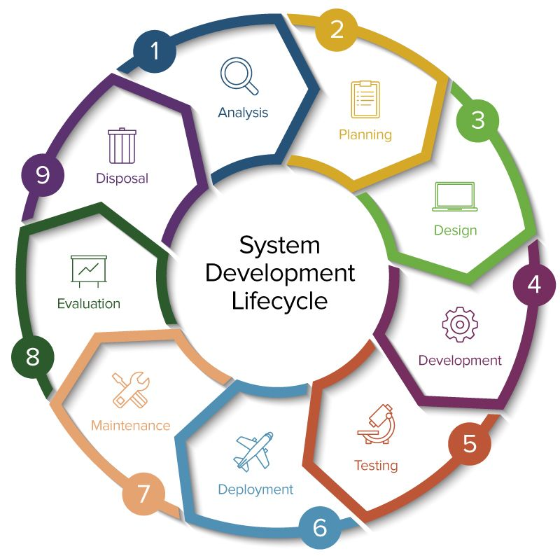

**Fig: System Development Lifecycle**

I choose Object-oriented methodology because it’s good for my project. Object-oriented methodologies do not focus solely on the processes or data of a system but view an information system as a collection of interacting objects that work together to accomplish tasks.

OOA is divided into stages and each stage consists of many tasks which are further broken-down into sub-tasks. The analyst interacts with the users to identify their requirements and examines the system to identify its functions. The analyst then constructs a model of what the system is required to do rather than how it will be done.

OOA is easy to understand. It is reusability of analysis, objects, design and programming. It improves communication among users, analysts, designers and programmers. System often be developed at a lower cost and can be developed more rapidly.

## **Design Pattern**

The Model-View-Controller (**MVC**) is an architectural pattern that separates an application into three main logical components: the model, the view, and the controller. It is commonly used for developing user interfaces.

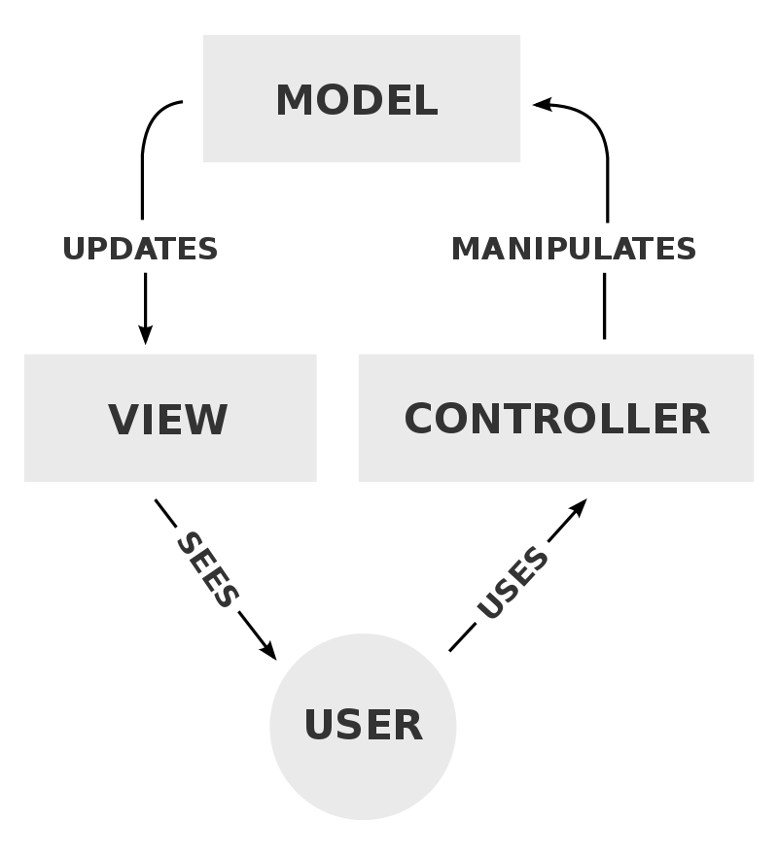

**Fig: Model View Controller**

**Model:** Model which is known as central component of the pattern which is the application dynamic data structure, independent of the user interface. It manages the data, logic and rules of the application.

**View:** Information from chart, diagram or tabular view can help us to identify or manage the system interfaces. It means presentation of the model in a particular format.

**Controller:** Controller main work is to respond to user and performs interactions on the data model objects. Controller receives input and passes the input to the model.

MVC supports rapid and parallel development. It creates multiple views for a model. It will support for asynchronous technique. While modification it does not affect the entire model so, MVC design pattern is selected for the entire project.

**Architecture**

The art and the product of planning, designing and constructing buildings or any other structures. The practice of architecture is employed to fulfill both particular and expressive requirements.

Three-tier architecture is a client-server architecture in which the functional process logic, computer data storage and user interface are developed and maintained on separate platforms. The three tiers in three-tier architecture are:

1. Presentation Tier
2. Application Tier
3. Data Tier

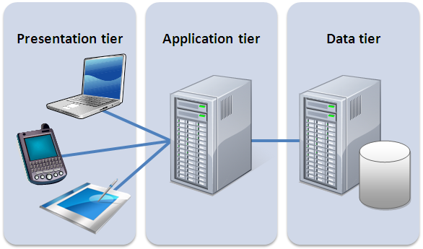

**Fig: Three-tier Architecture**

In the project application and data tier will be used where,

Application Tier

It is also called the middle tier, logic tier, business logic this tier is pulled from the presentation tier. It controls application functionality by performing detailed processing.

Data Tier

Database servers are where all the information is stored and retrieved. Data is tier which is kept independent of application servers or business logic.

The two tiers has been selected for architecture because application tier performs business logic which drives an application core capability, and the data tier comprises of the database/data storage system and data access layer. That’s why the middle and last tier has been selected.

# **Chapter 4**

## **Project Planning**

* Work Breakdown System (WBS)

|  |  |  |
| --- | --- | --- |
| WBS | **Task name** | **Days** |
| **0.** | Courier Management System | **Total** |
| **1**  **1.1**  **1.2**  **1.3** | Project management  Feasibility study  Planning  Monitoring and controlling | **16**  **6**  **5**  **5** |
| **2**  **2.1**  **2.2**  **2.3** | Analysis  Requirements  Use cases  Architecture | **29**  **10**  **9**  **10** |
| **3**  **3.1**  **3.2**  **3.3** | Design  Structural model  Behavioral model  UI design | **26**  **11**  **10**  **5** |
| **4**  **4.1**  **4.2** | Coding  Client-side coding  Server-side coding | **21**  **9**  **12** |
| **5**  **5.1**  **5.2**  **5.3** | Testing  Integration Testing  Black Box Testing  White Box Testing | **7**  **3**  **2**  **2** |
| **6**  **6.1**  **6.2**  **6.4** | Reporting  User manual  Final report  Presentation materials | **11**  **3**  **4**  **4** |

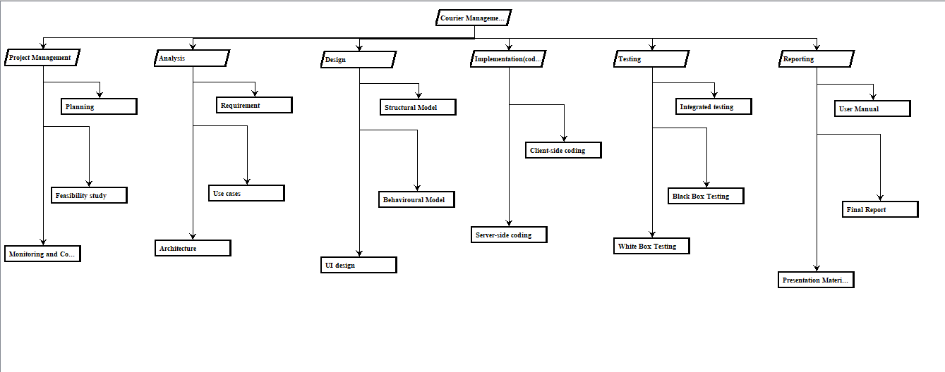

**Fig: Work Breakdown System.**

The Work Breakdown System WBS which is required to our service to complete project. This structure represents a hierarchical subdivision in areas. It provides development to project with planning, cost, scheduling time. The development of WBS occurs at the starting of project and precede different task. It is a framework for natural development for planning and dividing work into technical, schedule, cost, and time.

## **Mile Stone**

**Time Estimation of Project:**

|  |  |  |  |
| --- | --- | --- | --- |
| Milestone | Days | Start Date | End Date |
| **Proposal** | **15days** | 26th March 2019 | 9th April, 2019 |
| Feasibility study | 6 days |  |  |
| Planning | 5 days |  |  |
| Monitoring and Controlling | 5 days |  |  |
| **Analysis** | **29 days** | 10th April 2019 | 8th May, 2019 |
| Requirements | 10 days |  |  |
| Use cases | 9 days |  |  |
| Architecture | 10 days |  |  |
| **Design** | **26 days** | 9th May 2019 | 3rd June, 2019 |
| Structural Model | 11 days |  |  |
| Behavioral Model | 10 days |  |  |
| UI design | 5days |  |  |
| **Implementation(coding)** | **21days** | 4th June 2019 | 24th June, 2019 |
| Client-side coding | 9 days |  |  |
| Server-side coding | 12 days |  |  |
| **Testing** | **7 days** | 25th June 2019 | 1st July, 2019 |
| Integration Testing | 3 days |  |  |
| Black Box Testing | 2 days |  |  |
| White Box Testing | 2 days |  |  |
| **Final Documentation** |  | 2th July 2019 | 12th July, 2019 |

Proposal was started on 26th march 2019 and will end on 9th April 2019. In this duration I studied feasibility, planning of the project and Monitoring for 15 days. After Proposal Analysis which is most important task in every project (started from 10th April and will complete up to 8th May), I will analyze requirement, Use case diagram and Architecture. Design will be start after completion of analysis (9th May to 3rd June 2019) I will complete Structural, Behavioral and UI design. Implementation or Coding which is the main process of project which I will start after completion of design on 4th June 2019 to 24th June 2019 where I will complete to study about client-side coding and server-side coding. After coding testing which will be started from 5th June till 1st July 2019 during which I will test Black Box and white box testing process. To the end final documentation will be seen including User Manual and Presentation Material from 2nd July to 12th July 2019.

Finally I will be submitting my overall project in 109 days including all the task mentioned above.

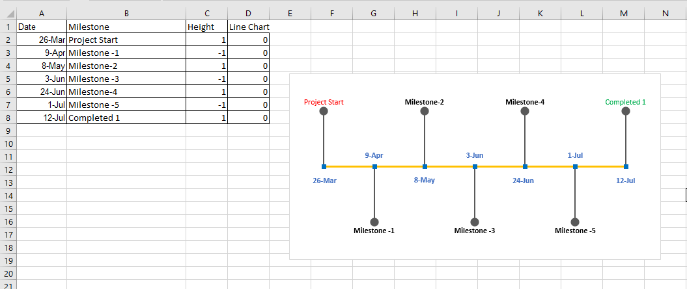

**Fig: Milestone Time Chart**

## **Gantt chart**

A Gantt chart is one of the most popular and useful projects which will show activities or task of project in time. It is a horizontal bar chart which visually represents a project plan over time.

### **Scheduling**

The scheduling for the project development has been set in Project Libre application which is shown below: -

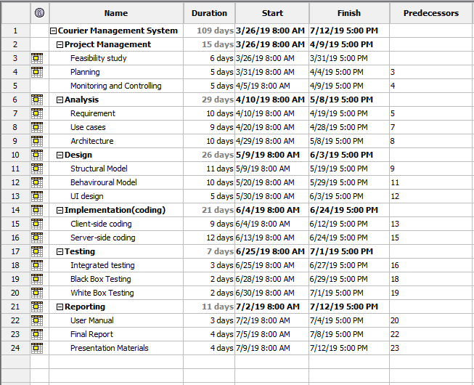

**Fig: Scheduling**

### **Gantt chart:**

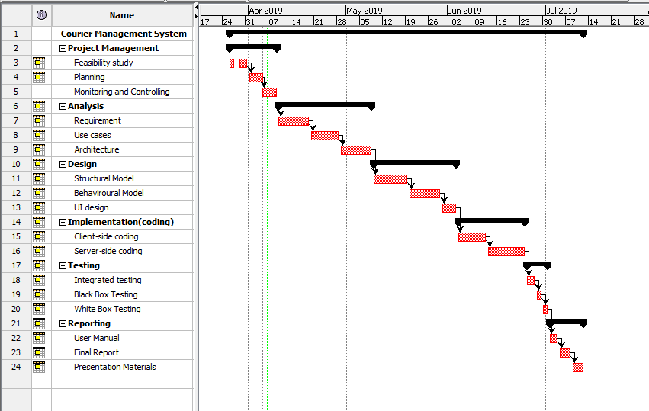

**Fig: Gantt chart**

Project schedule is being used to perform task in timeframe so that it could be deliver project on time. The above table shows the project scheduling from planning to Final project. It is a time schedule divided into different task in accurate duration.

# **Chapter 5**

## **Risk Management**

Risk Management is the process of managing risk which may occur in the project while making. Risks can come from various sources including financial marks, threats, phase in design, development, production, credit risk, accident, natural causes and disasters and many more. The threats likelihood, risk, impact and their consequences are identified and evaluated.

The risk management is the way to recognize is the system feasible or not for the company which can help to analyze risk.

Risk, Likelihood, Consequences and Impact are listed below and shown in table.

* Virus
* Natural Disaster
* Risk in Resources
* Risk in Financial
* Disk Problem

|  |  |
| --- | --- |
| Consequence | Value |
| Very low | 1 |
| Low | 2 |
| Medium | 3 |
| High | 4 |
| Very high | 5 |

|  |  |
| --- | --- |
| Likelihood | Value |
| Low | 1 |
| Medium | 2 |
| High | 3 |

|  |  |  |  |  |
| --- | --- | --- | --- | --- |
| **Risk** | **Likelihood** | **Consequences** | **Impact** | **Action** |
| **Virus** | **2** | **1** | **2** | **Installation of Antivirus** |
| **Natural Disaster** | **1** | **5** | **5** | **Preventing from disaster as much as we can** |
| **Risk in Resources** | **2** | **3** | **9** | **Properly using available resources** |
| **Risk in Financial** | **2** | **6** | **10** | **Preplanning and conducting budget wise system** |
| **Disk Problem** | **1** | **3** | **8** | **Daily Backup of the project.** |

# **Chapter 6**

## **Configuration Management**

Configuration management is process of establishing, maintaining, product performance, functionality, design and operational information throughout its life. This management system is mostly used by military organization to change lifecycle of complex system. Similarly, project has also been shown configuration management in cmd which is shown below.

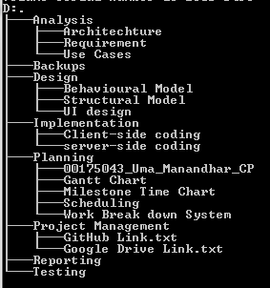

**Fig: Configuration Management**

# **Chapter 7**

## **Conclusion**

Finally, project proposal has been completed with essential features its aims, limitation, objectives along with identifying problem of the project. This will help to run courier management system can run smoothly and earn profit as well.

Project has been estimated timely up to 109 days to complete project. I have chosen PHP language for development of the system. With the help of Project Libre Gant Chart, scheduling WBS has been developed for time estimating and for Milestone chart excel has been used. So, with all above features my project has been started.

# **Chapter 8**

## **References and Bibliography**

[**https://bia.ca/risk-management-the-what-why-and-how/**](https://bia.ca/risk-management-the-what-why-and-how/)

[**http://www.gantt.com/**](http://www.gantt.com/)

[**https://www.teamgantt.com/what-is-a-gantt-chart**](https://www.teamgantt.com/what-is-a-gantt-chart)

[**https://en.wikipedia.org/wiki/Work_breakdown_structure**](https://en.wikipedia.org/wiki/Work_breakdown_structure)

[**https://en.wikipedia.org/wiki/Configuration_management**](https://en.wikipedia.org/wiki/Configuration_management)

**<https://www.wrike.com/project-management-guide/faq/what-is-a-milestone-in-project-management/>**

[**https://www.google.com/search?q=3+tier+architecture&source=lnms&tbm=isch&sa=X&ved=0ahUKEwjh5oDvhcDhAhWYfisKHb1dDRYQ_AUIDigB&biw=673&bih=590**](https://www.google.com/search?q=3+tier+architecture&source=lnms&tbm=isch&sa=X&ved=0ahUKEwjh5oDvhcDhAhWYfisKHb1dDRYQ_AUIDigB&biw=673&bih=590)

[**https://en.wikipedia.org/wiki/Model%E2%80%93view%E2%80%93controller**](https://en.wikipedia.org/wiki/Model%E2%80%93view%E2%80%93controller)