**Design**

A design is a construction or activity or plan which is done before any project where prototype activity sequence diagram is done.

1. **Structural Diagram**
   1. **Final Class Diagram**

Class diagram is the view of an application which visualize, describes the system and construct the executable code for developing software application.

**Justification of Final Class Diagram**

* It analyzes and design the view of application
* It describes the function which will be performed in the system
* Forward and reverse engineering
  1. **Data Flow Diagram**

Data Flow diagram is a process or a system which provides information about the outputs and inputs of each entity and process. It is use to illustrate the data into the system within the system and out of the system.

**Justification of Data Flow Diagram**

* Simple to create and easy to understand.
* Use to illustrate the system.
* Complex system can be illustrated to different levels of details.

**Notation**

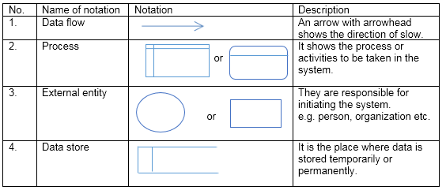

**Table1: Notation for DFD**

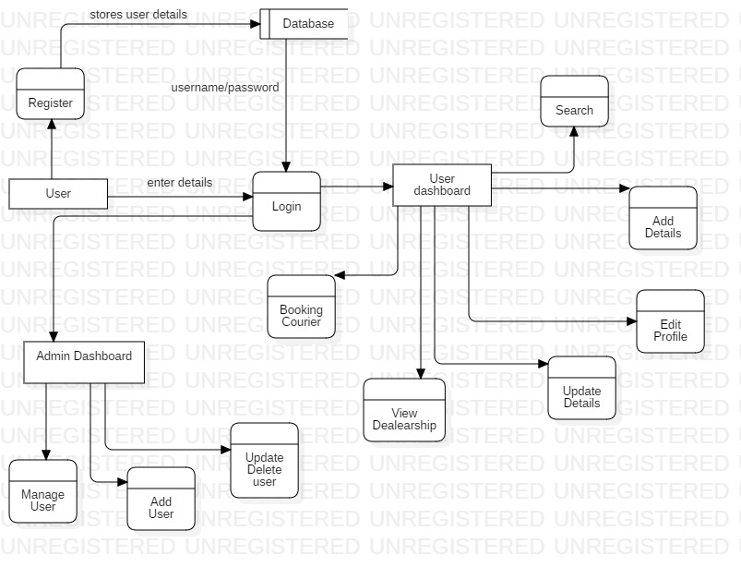

Fig1Data Flow diagram

**Description**

The above diagram shows data flow of the system. After Register and login user can book courier, view dealership, update details, edit profile, add and search. Likewise, admin can manage user, add user, update and delete user, payment details.

1. **Behavioral Model**
   1. **Activity Diagram**

Activity diagram is a graphical representation which describes parallel and conditional activities of the project. In the below diagram activity diagram is shown of my project.

I am using this design because it helps to understand how function of system will be working. I will be implementing using these designs.

**Justification of Activity diagram**

* Simple to use and understand
* It has high level understanding of the system

**Notation**

The following notation are used while making activity diagram:

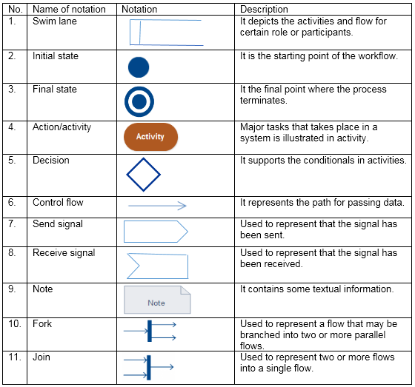

Table2: Notation for activity diagram

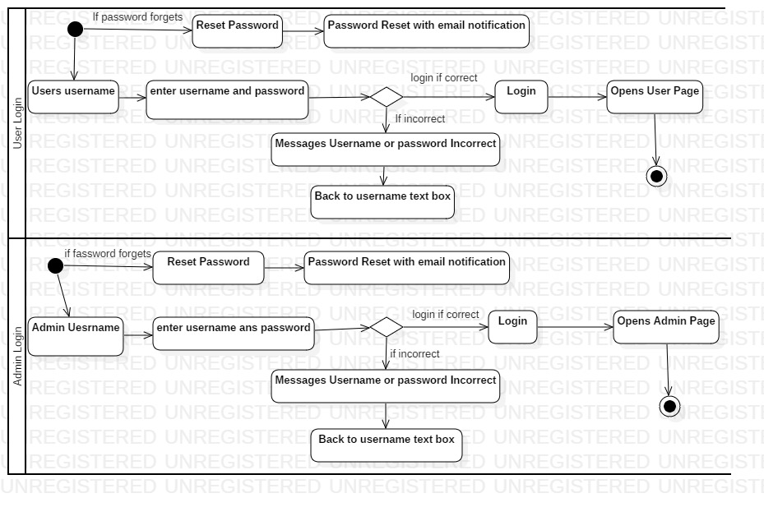

Fig2: User Login Activity diagram

**Description**

The above diagram shows the login activity of user and admin of system. The user or admin after visits the site they login with their username and password. If the provide username and password is correct then user or admin page will open if not then it returns with message ‘Username or Password is incorrect’ and goes back to text box.

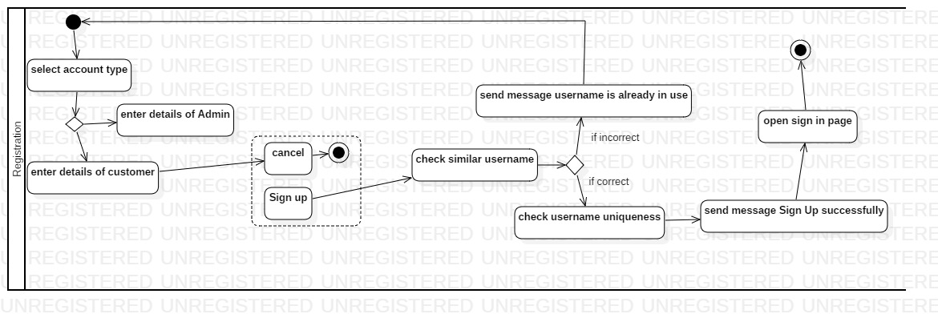

Fig3: Registration Activity Diagram

**Description**

The above diagram shows the registration activity of system. If user doesn’t have their account then they can create their account by providing their details and login in the page.

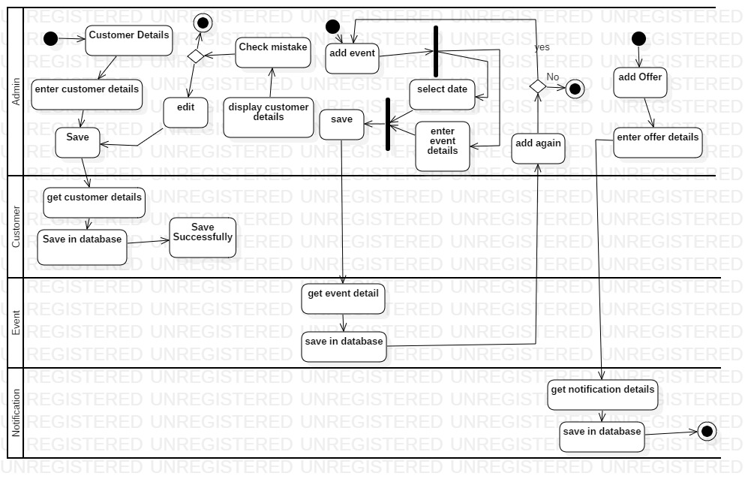

Fig4: Admin action activity diagram

**Description**

The above diagram shows the action which is done by admin in the system. Admin can add and edit the details of customer. They can add event and other offers. In the diagram it shows the process how the system does the work.

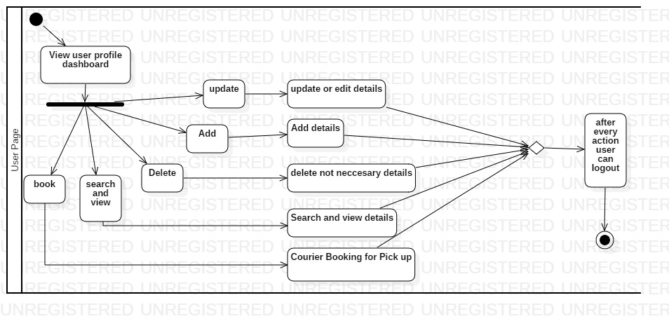

Fig5: User Page activity diagram

**Description**

The above diagram shows the user page activity where they can do the above shown activity in their profile page. User can book the courier for pick up and delivery, search and view the details, delete the not needed details, add new details and update all the details.

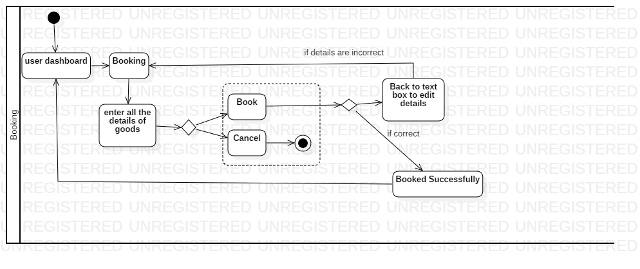

Fig6: Booking activity diagram

**Description**

The above diagram shows the booking activity where user add booking of their courier. It shows the activity from user dashboard and enters all the details of goods and book if the provided details are correct than system will provide a message of booked successfully if not then it returns back to booking form.

* 1. **Sequence Diagram**

A sequence diagram is a behavioral design which shows how operations are carried out between the object which are managed in a time sequence

**Justification of Sequence diagram**

* It represents all the details of use case diagram
* It shows the inside part of a system functionality
* A team can make different functionality viewing all these sequence diagrams.

**Notation**

The all the notation that has been used while making activity diagram are listed below:

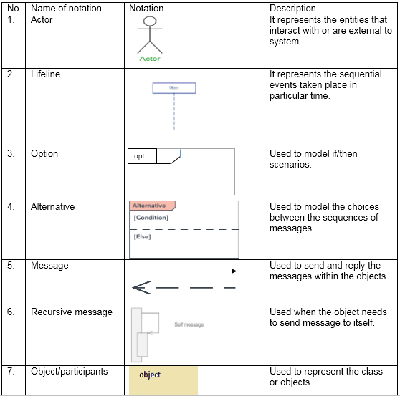

Table3: Notation of sequence diagram

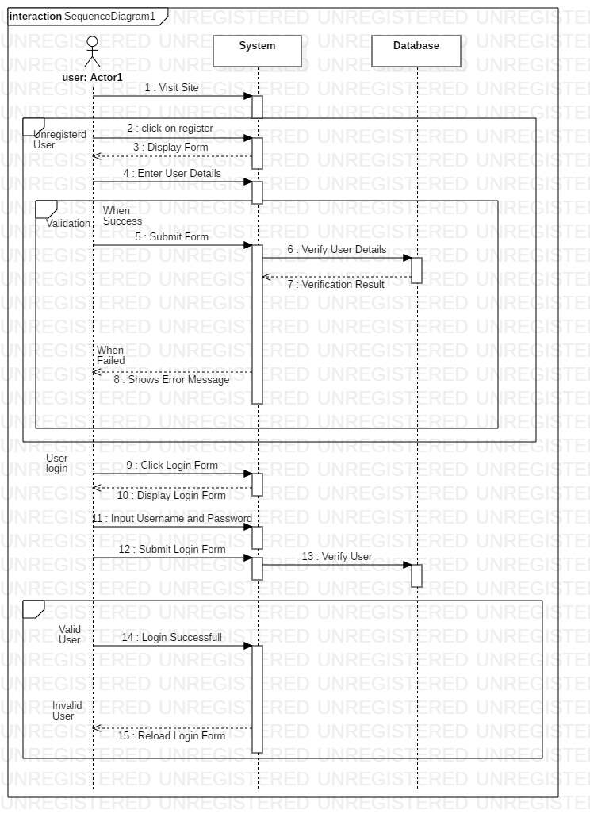

Fig7: User Register Sequence diagram

**Description**

The above diagram shows the user register in sequence diagram. When user visit site they can register by providing all the details in form. If the provided information are correct then account will be created if not then it will go direct back to register form.

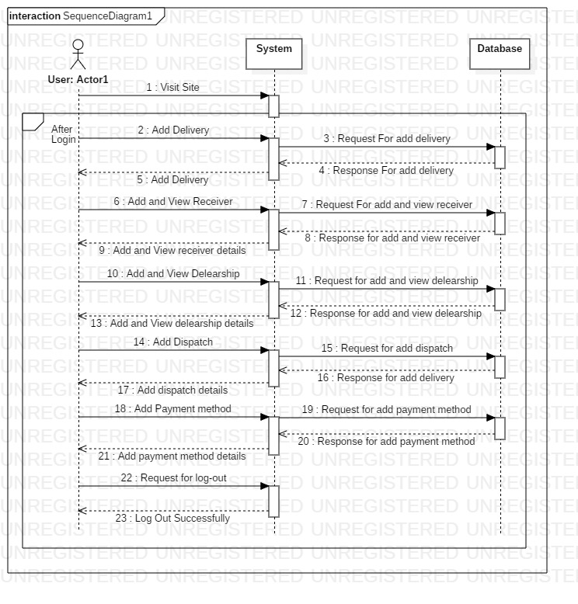

Fig8: User after login sequence diagram

**Description**

In the above diagram it shown the user profile after login where in the page they can book, add, manage, update the information after they process system will send message to database and requests every task in the user profile.

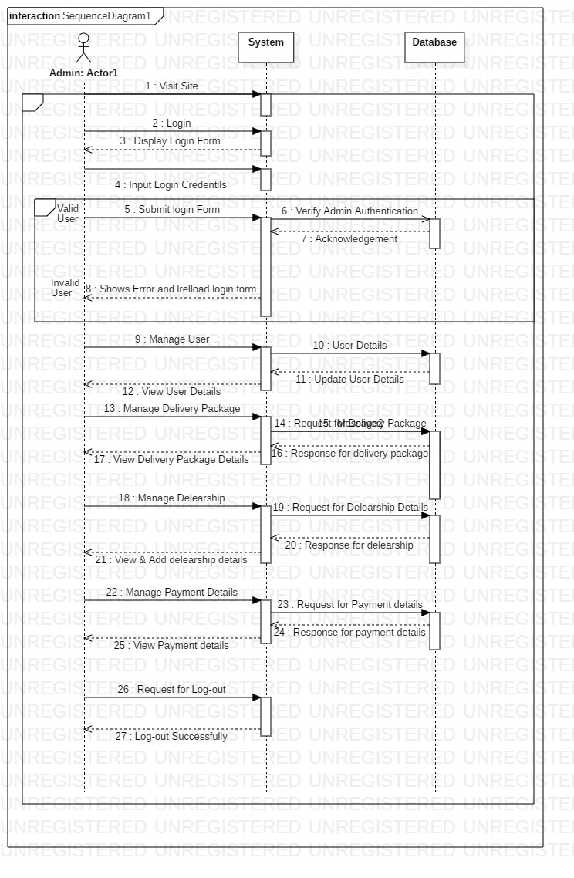

Fig9: Admin sequence diagram

**Description**

The above diagram shows the admin sequence diagram where it has shown the action which will be done by admin when the task will perform. In the system if admin do any process then system directly direct to database and response the details to admin page.

1. **Database Model**
   1. **Data Dictionary**

Data dictionary is the metadata about the tables. Data dictionary can be useful in any developing program.

The following are the data dictionary of the system:

* Data Dictionary for User

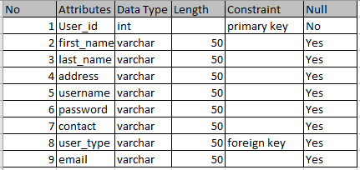

* Data Dictionary for Courier

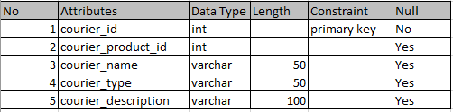

* Data Dictionary for Delivery

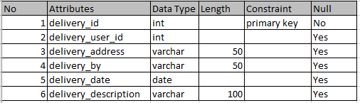

* Data Dictionary for Shipment

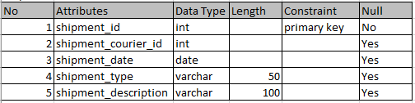

* Data Dictionary for User type

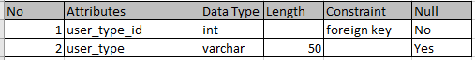

* 1. **ER Diagram**

Entity Relationship diagram is a database design tool which have different entities and their relationship with each other. It is a data modelling technique for defining the business process.

**Justification of ER Diagram**

* Easy to implement the database and tables
* It can be used for organizing the relational database
* It can be useful for troubleshooting the problems

**Notation**

The following are the notation used in ER diagram:

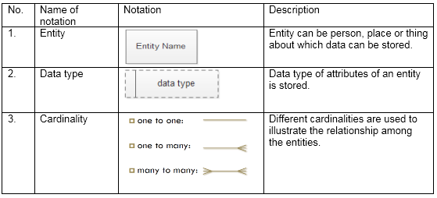

Table4: Notation of ER diagram

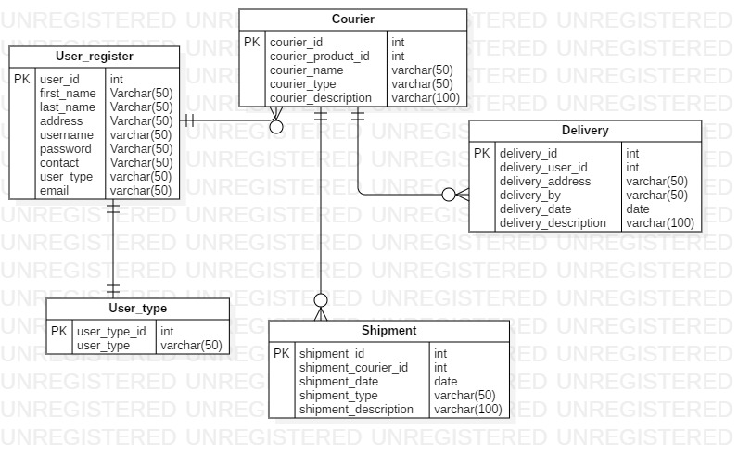

Fig10: ER Diagram

**Description**

The relationship between the entities with different attributes has been shown in the above diagram. User register is one to one relation with user type. Whereas user register has one to many relations with courier. Courier have one to many relations with shipment and delivery.

1. **Architecture Model**

Architecture is process of planning designing and constructing any structures. The architecture for courier management system is base on the three-tier architecture. The three tiers are:

1. Presentation tier

Presentation tier is the front-end layer of project which consists user interface. HTML, css, JavaScript are applied in this layer.

1. Application tier

This tier consists of the functional business logic. It is core PHP, C#, java etc.

1. Data tier

This tier consists of data storage. For example: Oracle, SQL, MySQL

**Justification of Architecture Model**

* Flexible in managing the data.
* Change in business logic doesn’t impact the whole system.
* It is more secured architecture.

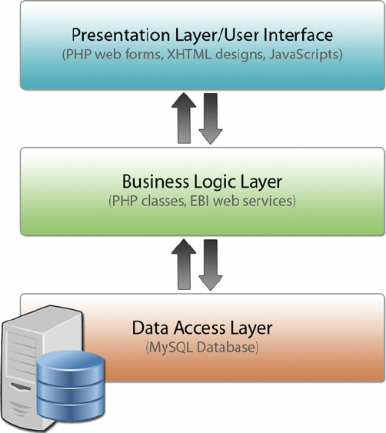

Fig11: Three-tier Architecture

The above is shown the three-tier architecture of my project where the data stored in data layer is presented in presentation layer on which the users interacts through the medium of application layer.

1. **UI Modeling**

User Interface modelling is one of the most important part of design development which include the visual model and notation which will be using in main application. It is the first phase design before main application. It is the fun process as a software development.

* 1. **Prototyping**

Prototyping is early model of the final application which is built to test a concept before final. It can be considered as the blueprint of the system.

I have designed the UI interface in balsamiq which are shown below:

**Justification of Prototyping**

* Detection of error before implementing
* Usability testing
* Better understanding of the software
* Improve efficiency

**Login**

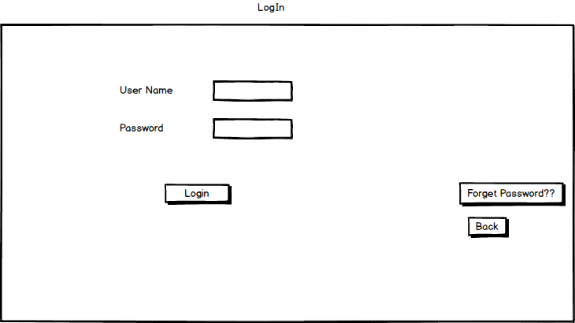

**Register**

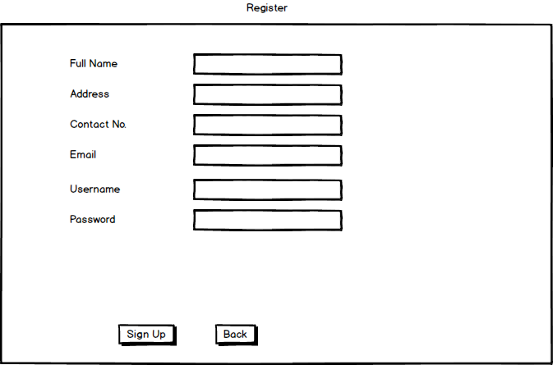

**Home page**

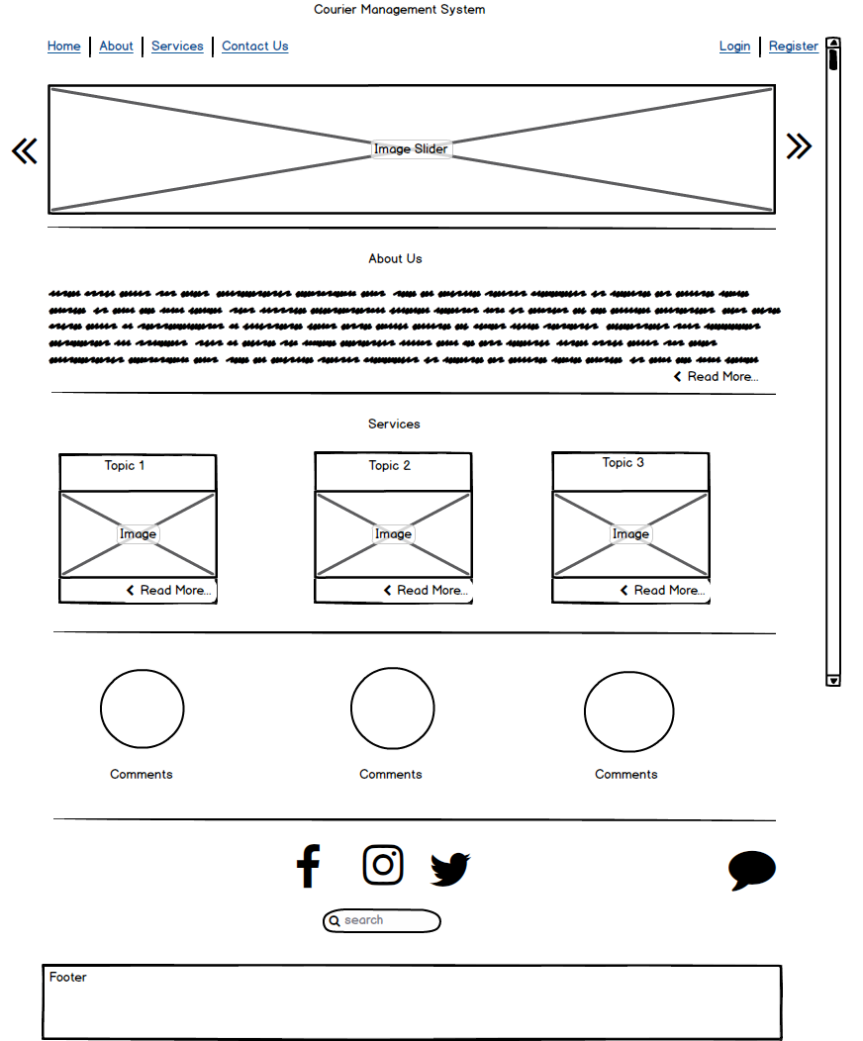

**About**

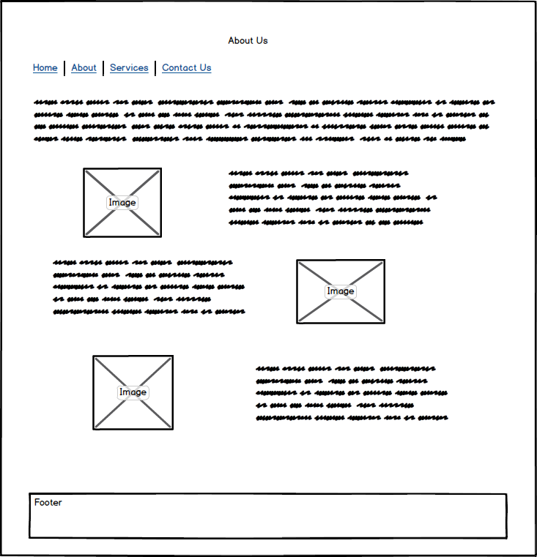

**Services**

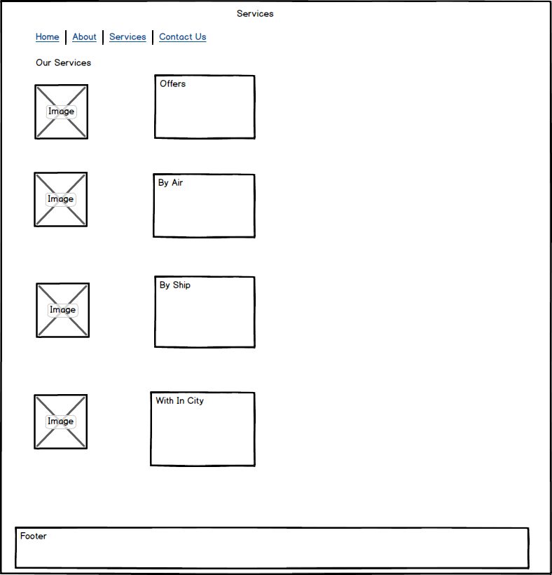

**Contact Us**

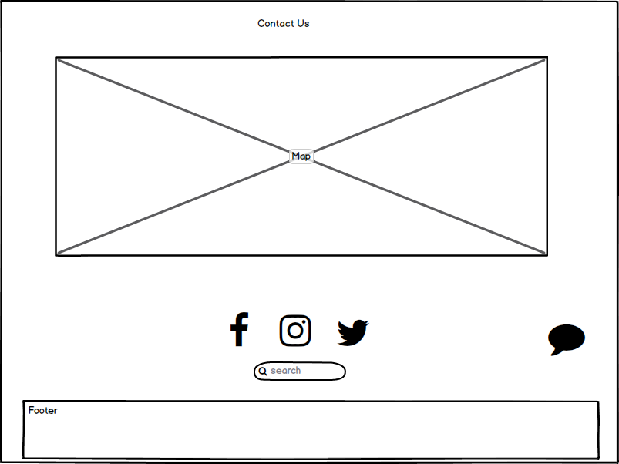

**User Profile after login**

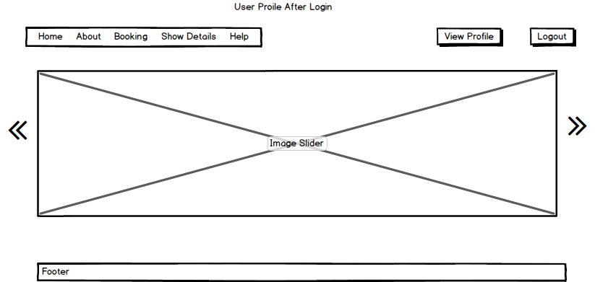

**Booking**

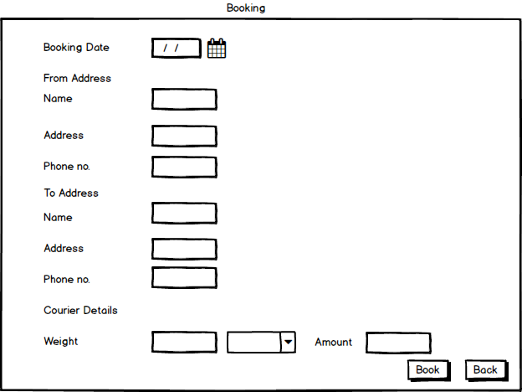

**Admin Dashboard**

