Week 1 – Design Patterns and Principles
Exercise 1: Singleton Pattern
Question
Implement the Singleton Pattern to ensure that only one instance of a Logger class is created throughout the application lifecycle.
Explanation
Singleton Pattern is a design pattern that allows only one object of a class to be created. The constructor is made private, and a static method is used to access the single object.
Code
Logger.java
public class Logger {

private static Logger instance;

private Logger() {
System.out.println("Logger Created");
}

public static Logger getInstance() {
if (instance == null) {
instance = new Logger();
}
return instance;
}
}
Main.java
public class Main {

public static void main(String[] args) {

Logger logger1 = Logger.getInstance();
Logger logger2 = Logger.getInstance();

System.out.println(logger1);
System.out.println(logger2);

if (logger1 == logger2) {
System.out.println("Only one instance created");
}
}
}
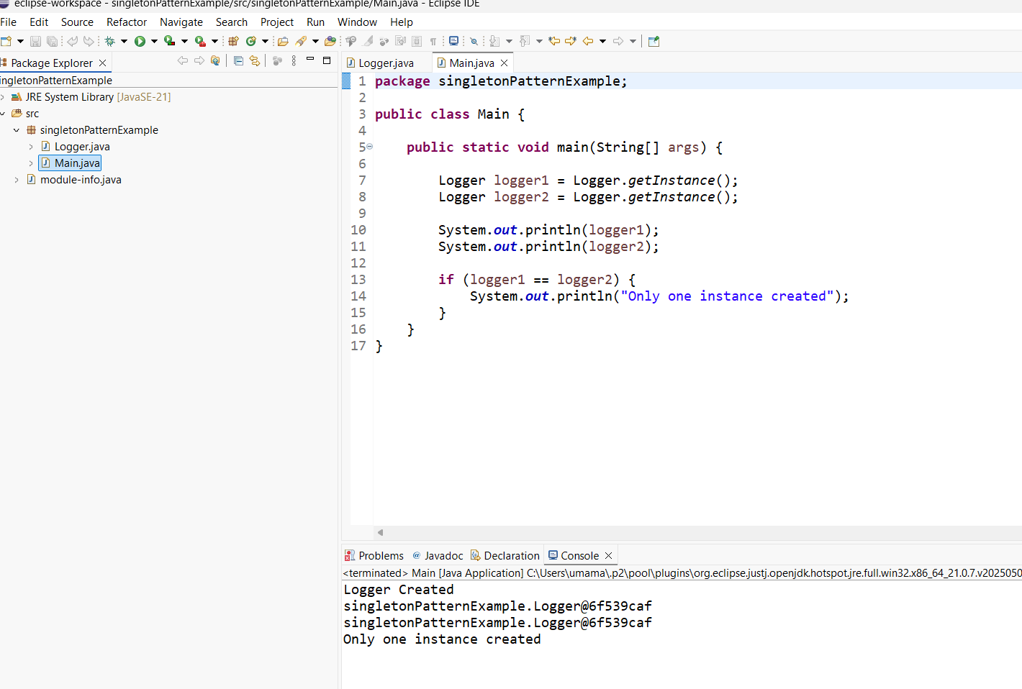

Exercise 2: Factory Method Pattern
Question
Implement the Factory Method Pattern to create different types of documents such as Word, PDF, and Excel.
Explanation
Factory Method Pattern is a Creational Design Pattern used to create objects without exposing the object creation logic to the client. An abstract factory defines a method for creating objects, and concrete factory classes create specific document types.
Code
Document.java
public interface Document {
void open();
}
PdfDocument.java
public class PdfDocument implements Document {

@Override
public void open() {
System.out.println("PDF Document Opened");
}
}
WordDocument.java
public class WordDocument implements Document {

@Override
public void open() {
System.out.println("Word Document Opened");
}
}
ExcelDocument.java
public class ExcelDocument implements Document {

@Override
public void open() {
System.out.println("Excel Document Opened");
}
}
DocumentFactory.java
public abstract class DocumentFactory {

public abstract Document createDocument();
}
PdfFactory.java
public class PdfFactory extends DocumentFactory {

@Override
public Document createDocument() {
return new PdfDocument();
}
}
WordFactory.java
public class WordFactory extends DocumentFactory {

@Override
public Document createDocument() {
return new WordDocument();
}
}
ExcelFactory.java
public class ExcelFactory extends DocumentFactory {

@Override
public Document createDocument() {
return new ExcelDocument();
}
}
Main.java
public class Main {

public static void main(String[] args) {

DocumentFactory pdfFactory = new PdfFactory();
Document pdf = pdfFactory.createDocument();
pdf.open();

DocumentFactory wordFactory = new WordFactory();
Document word = wordFactory.createDocument();
word.open();

DocumentFactory excelFactory = new ExcelFactory();
Document excel = excelFactory.createDocument();
excel.open();
}
}

