Schema Creation
CREATE TABLE Customers (
CustomerID NUMBER PRIMARY KEY,
Name VARCHAR2(100),
DOB DATE,
Balance NUMBER,
LastModified DATE
);

CREATE TABLE Accounts (
AccountID NUMBER PRIMARY KEY,
CustomerID NUMBER,
AccountType VARCHAR2(20),
Balance NUMBER,
LastModified DATE,
FOREIGN KEY (CustomerID) REFERENCES Customers(CustomerID)
);

CREATE TABLE Transactions (
TransactionID NUMBER PRIMARY KEY,
AccountID NUMBER,
TransactionDate DATE,
Amount NUMBER,
TransactionType VARCHAR2(10),
FOREIGN KEY (AccountID) REFERENCES Accounts(AccountID)
);

CREATE TABLE Loans (
LoanID NUMBER PRIMARY KEY,
CustomerID NUMBER,
LoanAmount NUMBER,
InterestRate NUMBER,
StartDate DATE,
EndDate DATE,
FOREIGN KEY (CustomerID) REFERENCES Customers(CustomerID)
);

CREATE TABLE Employees (
EmployeeID NUMBER PRIMARY KEY,
Name VARCHAR2(100),
Position VARCHAR2(50),
Salary NUMBER,
Department VARCHAR2(50),
HireDate DATE
);
Sample Data Insertion
INSERT INTO Customers
VALUES (
1,
'John Doe',
TO_DATE('1950-05-15','YYYY-MM-DD'),
15000,
SYSDATE
);

INSERT INTO Customers
VALUES (
2,
'Jane Smith',
TO_DATE('1990-07-20','YYYY-MM-DD'),
1500,
SYSDATE
);

INSERT INTO Accounts
VALUES (
1,
1,
'Savings',
1000,
SYSDATE
);

INSERT INTO Accounts
VALUES (
2,
2,
'Checking',
1500,
SYSDATE
);

INSERT INTO Loans
VALUES (
1,
1,
5000,
5,
SYSDATE,
SYSDATE + 20
);

INSERT INTO Loans
VALUES (
2,
2,
7000,
6,
SYSDATE,
SYSDATE + 60
);

INSERT INTO Employees
VALUES (
1,
'Alice Johnson',
'Manager',
70000,
'HR',
TO_DATE('2015-06-15','YYYY-MM-DD')
);

INSERT INTO Employees
VALUES (
2,
'Bob Brown',
'Developer',
60000,
'IT',
TO_DATE('2017-03-20','YYYY-MM-DD')
);

COMMIT;

Exercise 1: Control Structures
Scenario 1: Senior Citizen Loan Discount
Question
Write a PL/SQL block that loops through all customers, checks their age, and if they are above 60, apply a 1% discount to their current loan interest rates.
Code
SET SERVEROUTPUT ON;

DECLARE
v_age NUMBER;
BEGIN

FOR cust IN (
SELECT c.CustomerID,
c.Name,
c.DOB,
l.LoanID,
l.InterestRate
FROM Customers c
JOIN Loans l
ON c.CustomerID = l.CustomerID
)
LOOP

v_age := TRUNC(MONTHS_BETWEEN(SYSDATE, cust.DOB)/12);

IF v_age > 60 THEN

UPDATE Loans
SET InterestRate = InterestRate - 1
WHERE LoanID = cust.LoanID;

DBMS_OUTPUT.PUT_LINE(
'Discount Applied to Customer: '
|| cust.Name
|| ' | New Interest Rate: '
|| (cust.InterestRate - 1)
);

ELSE

DBMS_OUTPUT.PUT_LINE(
'No Discount for Customer: '
|| cust.Name
);

END IF;

END LOOP;

COMMIT;

END;
/
Output
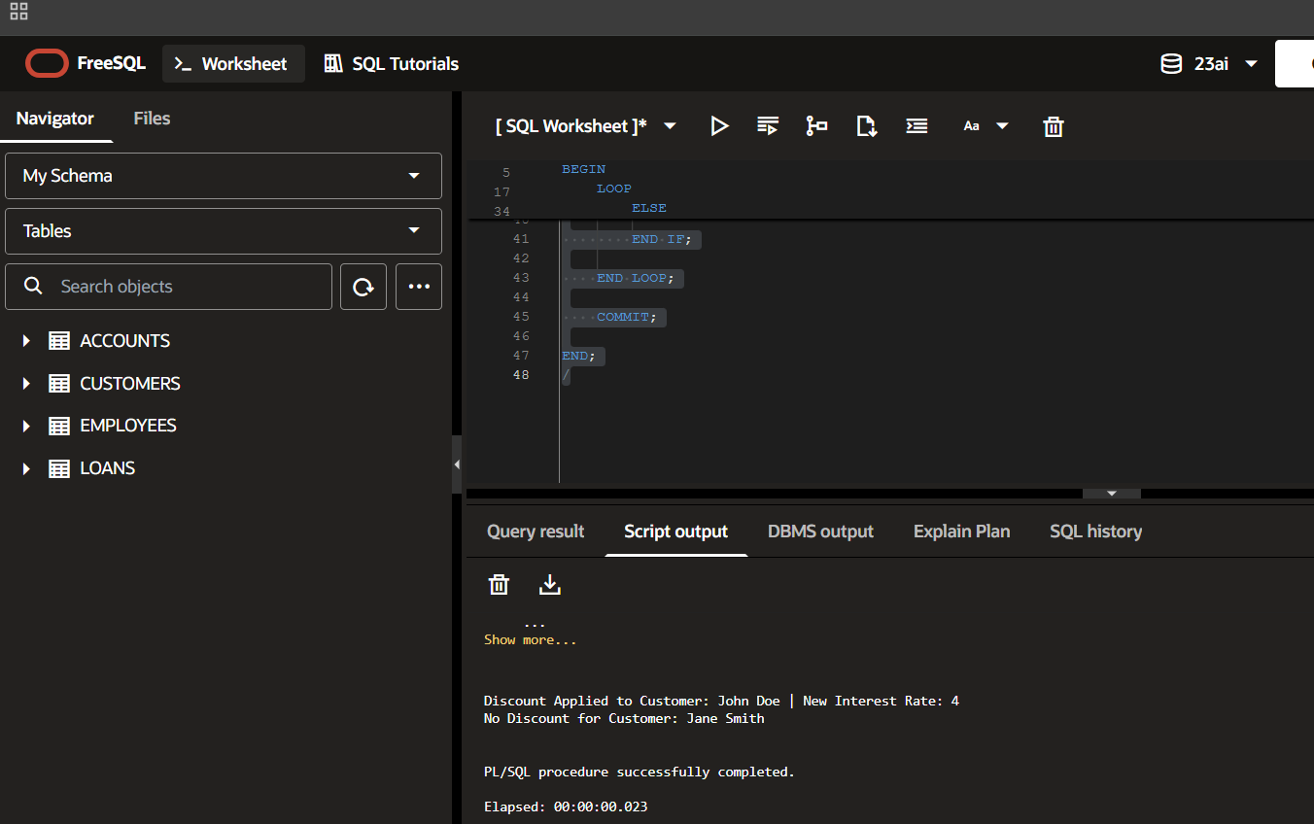

Scenario 2: VIP Customer Promotion
Question
Write a PL/SQL block that iterates through all customers and sets a flag IsVIP to TRUE for those with a balance over $10,000.
Code
ALTER TABLE Customers
ADD IsVIP VARCHAR2(5);

SET SERVEROUTPUT ON;

BEGIN

FOR cust IN (
SELECT CustomerID,
Name,
Balance
FROM Customers
)
LOOP

IF cust.Balance > 10000 THEN

UPDATE Customers
SET IsVIP = 'TRUE'
WHERE CustomerID = cust.CustomerID;

DBMS_OUTPUT.PUT_LINE(
'VIP Status Granted to: '
|| cust.Name
);

ELSE

DBMS_OUTPUT.PUT_LINE(
'Not Eligible for VIP: '
|| cust.Name
);

END IF;

END LOOP;

COMMIT;

END;
/
Output
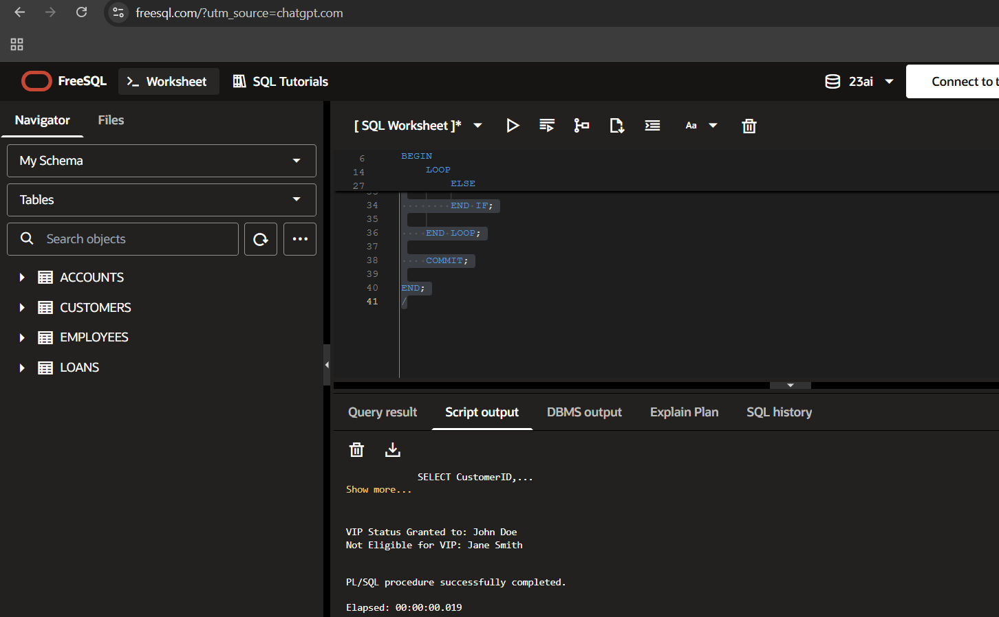

Scenario 3: Loan Due Reminder
Question
Write a PL/SQL block that fetches all loans due in the next 30 days and prints a reminder message for each customer.
Code
SET SERVEROUTPUT ON;

BEGIN

FOR loan_rec IN (
SELECT LoanID,
CustomerID,
EndDate
FROM Loans
WHERE EndDate BETWEEN SYSDATE
AND SYSDATE + 30
)
LOOP

DBMS_OUTPUT.PUT_LINE(
'Reminder: Loan '
|| loan_rec.LoanID
|| ' for Customer '
|| loan_rec.CustomerID
|| ' is due within 30 days.'
);

END LOOP;

END;
/
Output
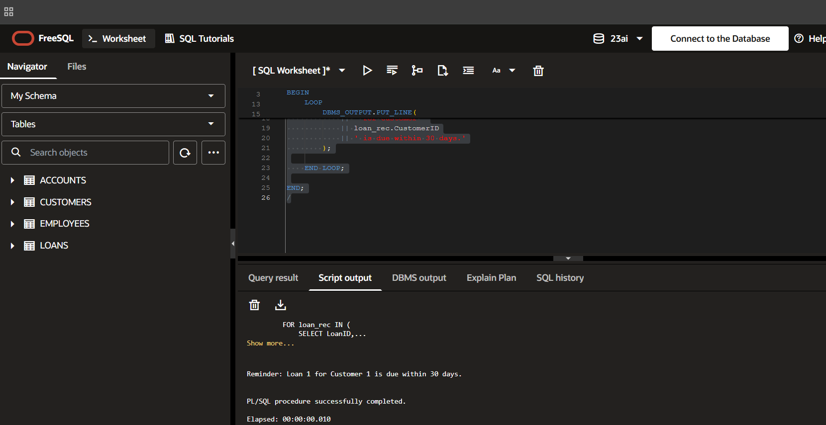

Exercise 3: Stored Procedures
Scenario 1: Process Monthly Interest
Question
Write a stored procedure ProcessMonthlyInterest that calculates and updates the balance of all savings accounts by applying an interest rate of 1% to the current balance.
Code
CREATE OR REPLACE PROCEDURE ProcessMonthlyInterest
IS
BEGIN

UPDATE Accounts
SET Balance = Balance + (Balance * 0.01)
WHERE AccountType = 'Savings';

COMMIT;

DBMS_OUTPUT.PUT_LINE(
'Monthly interest applied successfully.'
);

END;
/
Execute
SET SERVEROUTPUT ON;

BEGIN
ProcessMonthlyInterest;
END;
/
Check Output
SELECT * FROM Accounts;
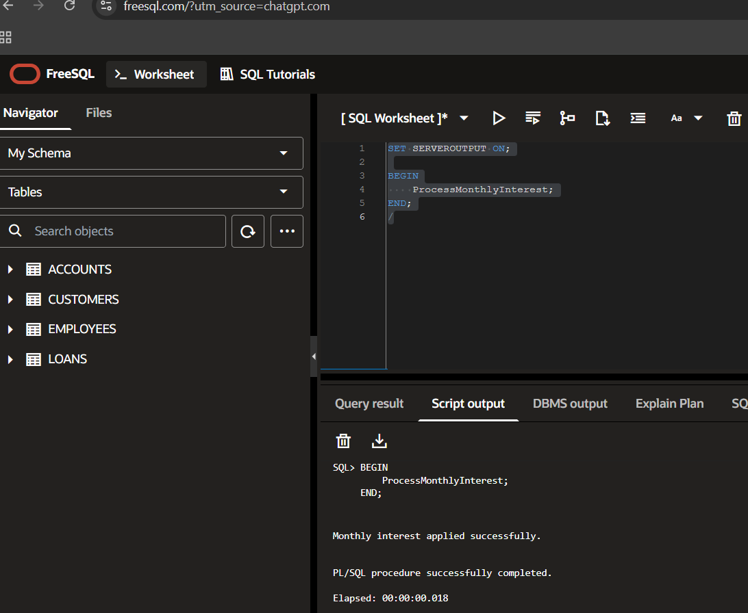
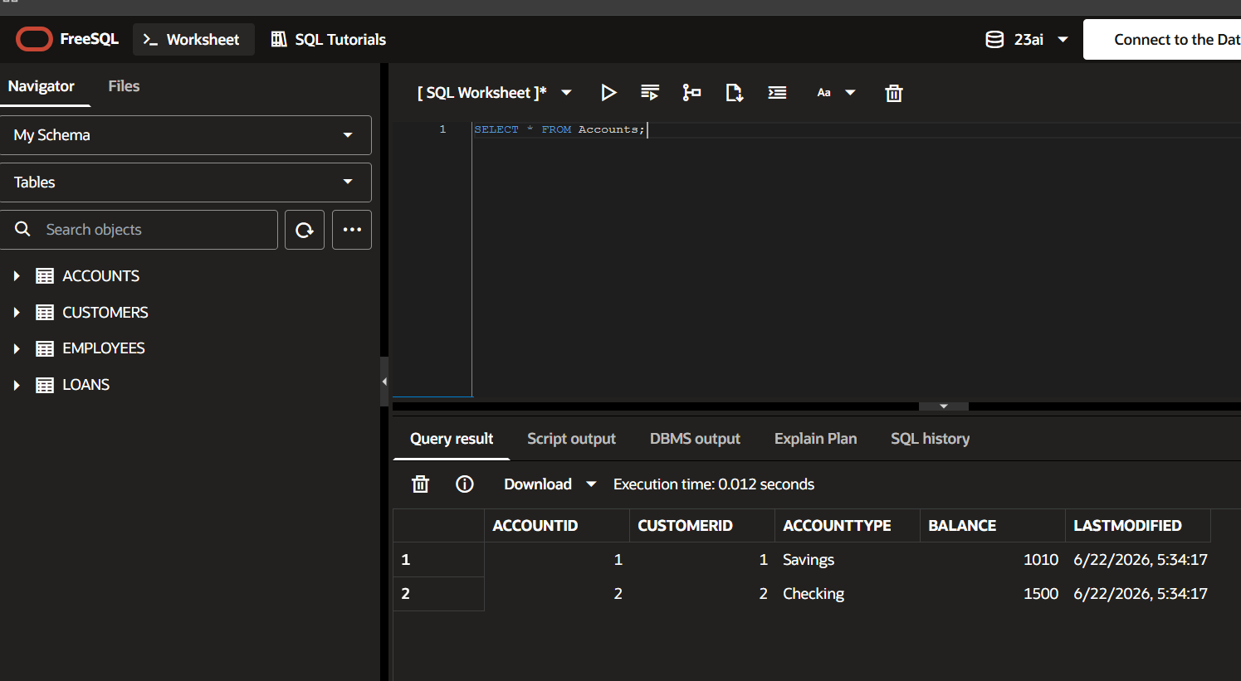

Scenario 2: Update Employee Bonus
Question
Write a stored procedure UpdateEmployeeBonus that updates the salary of employees in a given department by adding a bonus percentage passed as a parameter.
Code
CREATE OR REPLACE PROCEDURE UpdateEmployeeBonus(
p_department IN VARCHAR2,
p_bonus_percent IN NUMBER
)
IS
BEGIN

UPDATE Employees
SET Salary = Salary +
(Salary * p_bonus_percent / 100)
WHERE Department = p_department;

COMMIT;

DBMS_OUTPUT.PUT_LINE(
'Bonus updated successfully.'
);

END;
/
Execute
SET SERVEROUTPUT ON;

BEGIN
UpdateEmployeeBonus('HR',10);
END;
/
Check Output
SELECT * FROM Employees;
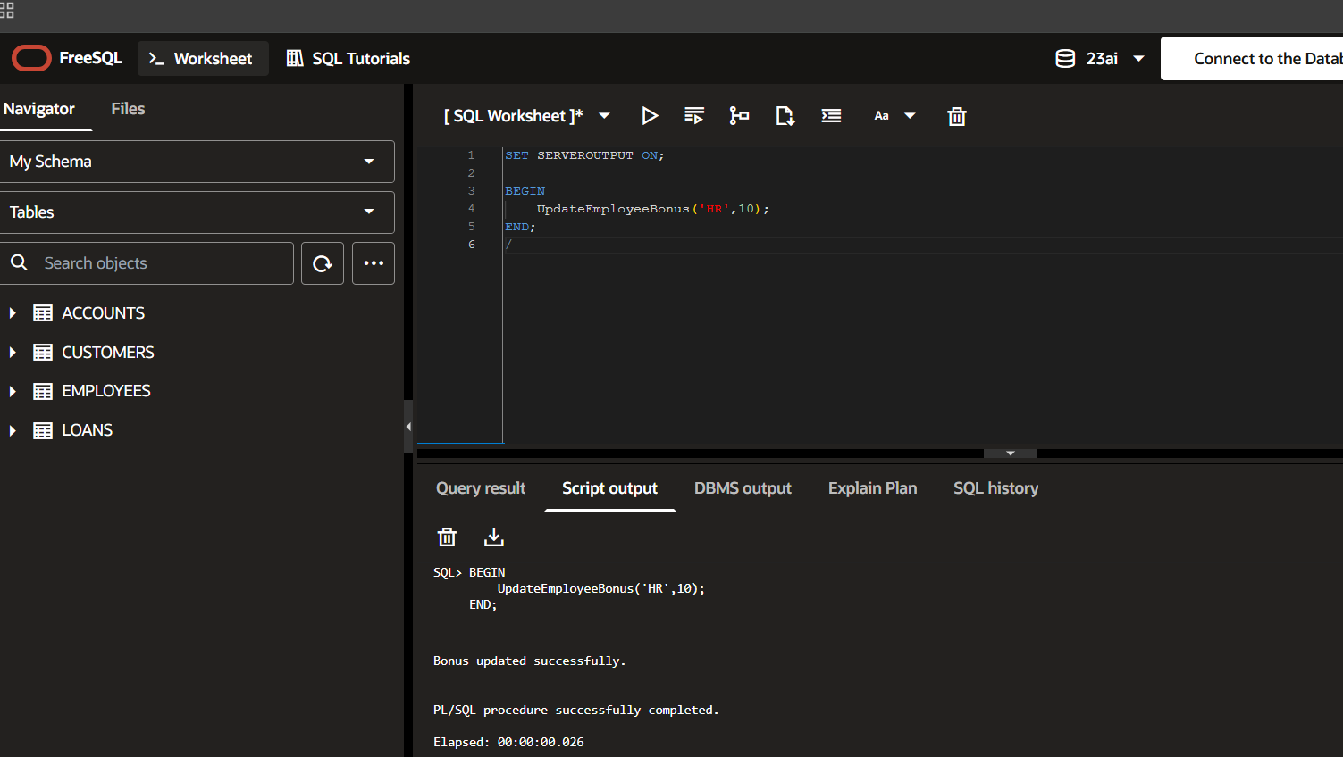
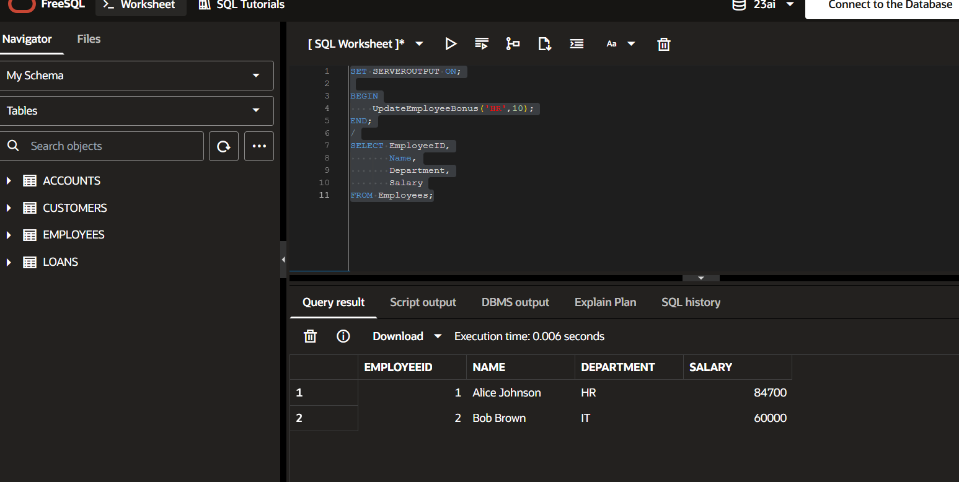

Scenario 3: Transfer Funds
Question
Write a stored procedure TransferFunds that transfers a specified amount from one account to another, checking that the source account has sufficient balance before making the transfer.
Code
CREATE OR REPLACE PROCEDURE TransferFunds(
p_from_account IN NUMBER,
p_to_account IN NUMBER,
p_amount IN NUMBER
)
IS
v_balance NUMBER;
BEGIN

SELECT Balance
INTO v_balance
FROM Accounts
WHERE AccountID = p_from_account;

IF v_balance >= p_amount THEN

UPDATE Accounts
SET Balance = Balance - p_amount
WHERE AccountID = p_from_account;

UPDATE Accounts
SET Balance = Balance + p_amount
WHERE AccountID = p_to_account;

COMMIT;

DBMS_OUTPUT.PUT_LINE(
'Funds transferred successfully.'
);

ELSE

DBMS_OUTPUT.PUT_LINE(
'Insufficient balance.'
);

END IF;

END;
/
Execute
SET SERVEROUTPUT ON;

BEGIN
TransferFunds(1,2,500);
END;
/
Check Output
SELECT * FROM Accounts;
