Question:
Hands-on 1: Create a Spring Web Project using Maven.

SpringLearnApplication.java

package com.cognizant.springlearn;

import org.slf4j.Logger;
import org.slf4j.LoggerFactory;
import org.springframework.boot.SpringApplication;
import org.springframework.boot.autoconfigure.SpringBootApplication;

@SpringBootApplication
public class SpringLearnApplication {

private static final Logger LOGGER =
LoggerFactory.getLogger(SpringLearnApplication.class);

public static void main(String[] args) {

LOGGER.info("START");

SpringApplication.run(SpringLearnApplication.class, args);

LOGGER.info("END");
}
}
Output:
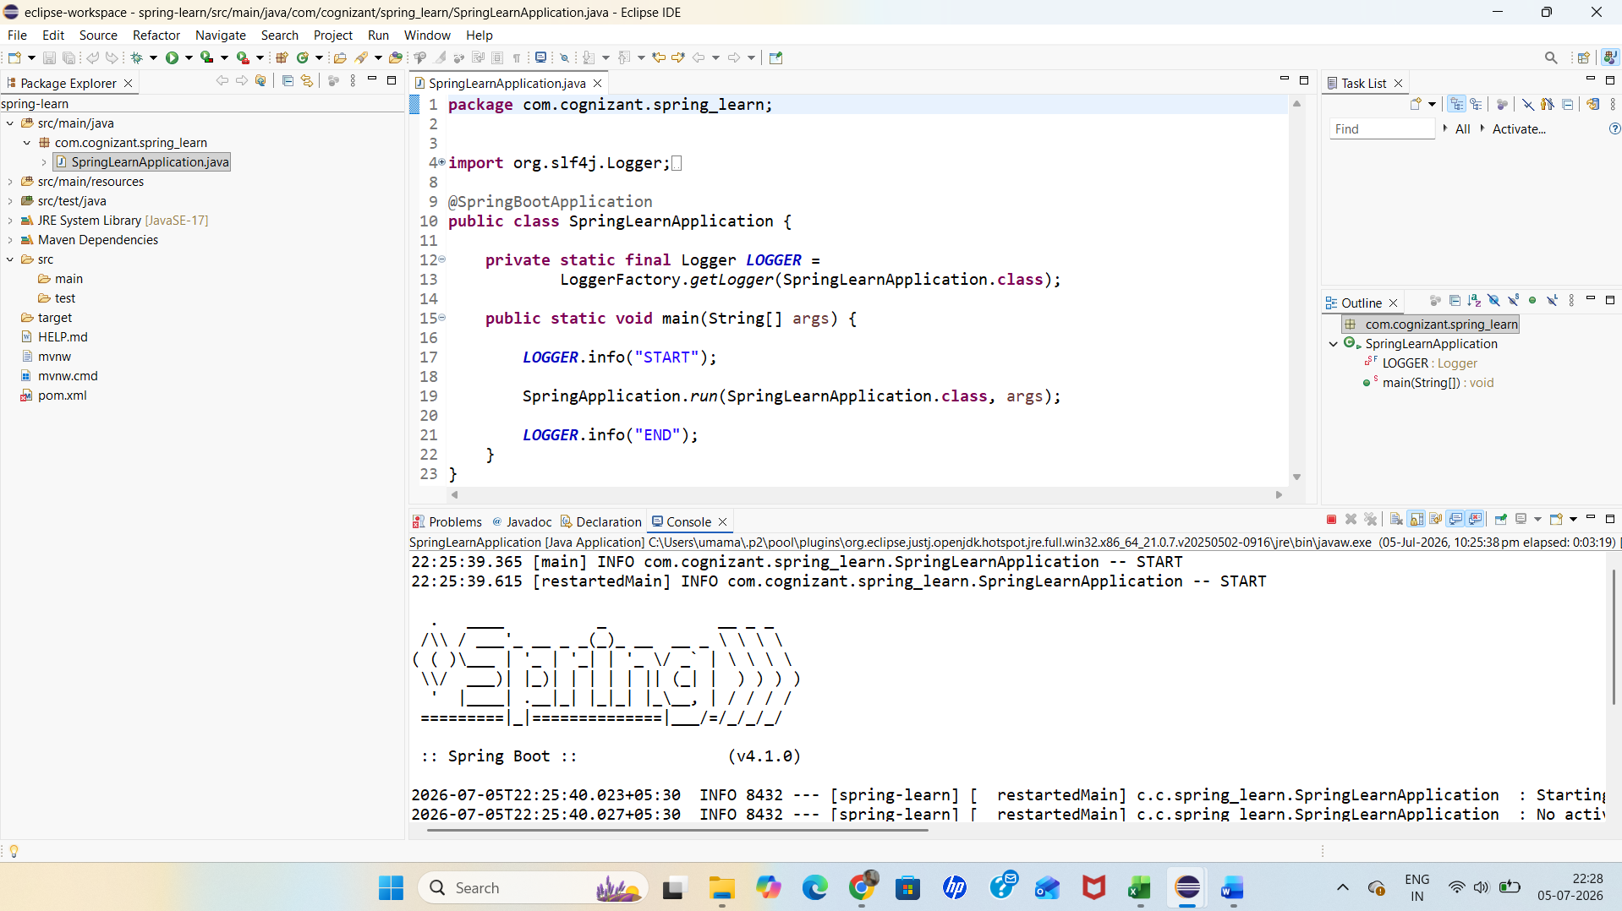

Question:
Hands-on 4: Spring Core – Load Country from Spring Configuration XML

SpringLearnApplication.java

```java
package com.cognizant.spring_learn;

import org.slf4j.Logger;
import org.slf4j.LoggerFactory;
import org.springframework.boot.SpringApplication;
import org.springframework.boot.autoconfigure.SpringBootApplication;
import org.springframework.context.ApplicationContext;
import org.springframework.context.support.ClassPathXmlApplicationContext;

@SpringBootApplication
public class SpringLearnApplication {

private static final Logger LOGGER =
LoggerFactory.getLogger(SpringLearnApplication.class);

public static void main(String[] args) {

LOGGER.info("START");

SpringApplication.run(SpringLearnApplication.class, args);

displayCountry();

LOGGER.info("END");
}

public static void displayCountry() {

LOGGER.info("START");

ApplicationContext context =
new ClassPathXmlApplicationContext("country.xml");

Country country = context.getBean("country", Country.class);

LOGGER.info("Country : {}", country);

LOGGER.info("END");
}
}
```

Country.java

```java
package com.cognizant.spring_learn;

import org.slf4j.Logger;
import org.slf4j.LoggerFactory;

public class Country {

private static final Logger LOGGER =
LoggerFactory.getLogger(Country.class);

private String code;
private String name;

public Country() {
LOGGER.info("Inside Country Constructor.");
}

public String getCode() {
LOGGER.info("Inside getCode()");
return code;
}

public void setCode(String code) {
LOGGER.info("Inside setCode()");
this.code = code;
}

public String getName() {
LOGGER.info("Inside getName()");
return name;
}

public void setName(String name) {
LOGGER.info("Inside setName()");
this.name = name;
}

@Override
public String toString() {
return "Country [code=" + code + ", name=" + name + "]";
}
}
```

country.xml

```xml
<?xml version="1.0" encoding="UTF-8"?>

<beans xmlns="http://www.springframework.org/schema/beans"
xmlns:xsi="http://www.w3.org/2001/XMLSchema-instance"
xsi:schemaLocation="
http://www.springframework.org/schema/beans
https://www.springframework.org/schema/beans/spring-beans.xsd">

<bean id="country" class="com.cognizant.spring_learn.Country">
<property name="code" value="IN"/>
<property name="name" value="India"/>
</bean>

</beans>
```
Output:
