Exercise 1: Configuring a Basic Spring Application

Question:
Your company is developing a web application for managing a library. You need to use the Spring Framework to handle the backend operations.
------------------------------------------------------------
pom.xml
------------------------------------------------------------

```xml
<project xmlns="http://maven.apache.org/POM/4.0.0"
xmlns:xsi="http://www.w3.org/2001/XMLSchema-instance"
xsi:schemaLocation="http://maven.apache.org/POM/4.0.0
https://maven.apache.org/xsd/maven-4.0.0.xsd">

<modelVersion>4.0.0</modelVersion>

<groupId>com.library</groupId>
<artifactId>LibraryManagement</artifactId>
<version>0.0.1-SNAPSHOT</version>

<properties>
<maven.compiler.source>1.8</maven.compiler.source>
<maven.compiler.target>1.8</maven.compiler.target>
</properties>

<dependencies>

<dependency>
<groupId>org.springframework</groupId>
<artifactId>spring-context</artifactId>
<version>5.3.30</version>
</dependency>

</dependencies>

<build>
<plugins>

<plugin>
<groupId>org.apache.maven.plugins</groupId>
<artifactId>maven-compiler-plugin</artifactId>
<version>3.11.0</version>

<configuration>
<source>1.8</source>
<target>1.8</target>
</configuration>

</plugin>

</plugins>
</build>

</project>
```

------------------------------------------------------------
BookRepository.java
------------------------------------------------------------

```java
package com.library.repository;

public class BookRepository {

public void display() {
System.out.println("Book Repository Created");
}

}
```

------------------------------------------------------------
BookService.java
------------------------------------------------------------

```java
package com.library.service;

public class BookService {

public void service() {
System.out.println("Book Service Created");
}

}
```

------------------------------------------------------------
applicationContext.xml
------------------------------------------------------------

```xml
<?xml version="1.0" encoding="UTF-8"?>

<beans xmlns="http://www.springframework.org/schema/beans"
xmlns:xsi="http://www.w3.org/2001/XMLSchema-instance"
xsi:schemaLocation="
http://www.springframework.org/schema/beans
https://www.springframework.org/schema/beans/spring-beans.xsd">

<bean id="bookRepository"
class="com.library.repository.BookRepository"/>

<bean id="bookService"
class="com.library.service.BookService"/>

</beans>
```

------------------------------------------------------------
LibraryManagementApplication.java
------------------------------------------------------------

```java
package com.library.main;

import org.springframework.context.ApplicationContext;
import org.springframework.context.support.ClassPathXmlApplicationContext;

import com.library.service.BookService;

public class LibraryManagementApplication {

public static void main(String[] args) {

ApplicationContext context =
new ClassPathXmlApplicationContext("applicationContext.xml");

BookService service =
context.getBean("bookService", BookService.class);

service.service();

}
}
```

Output:
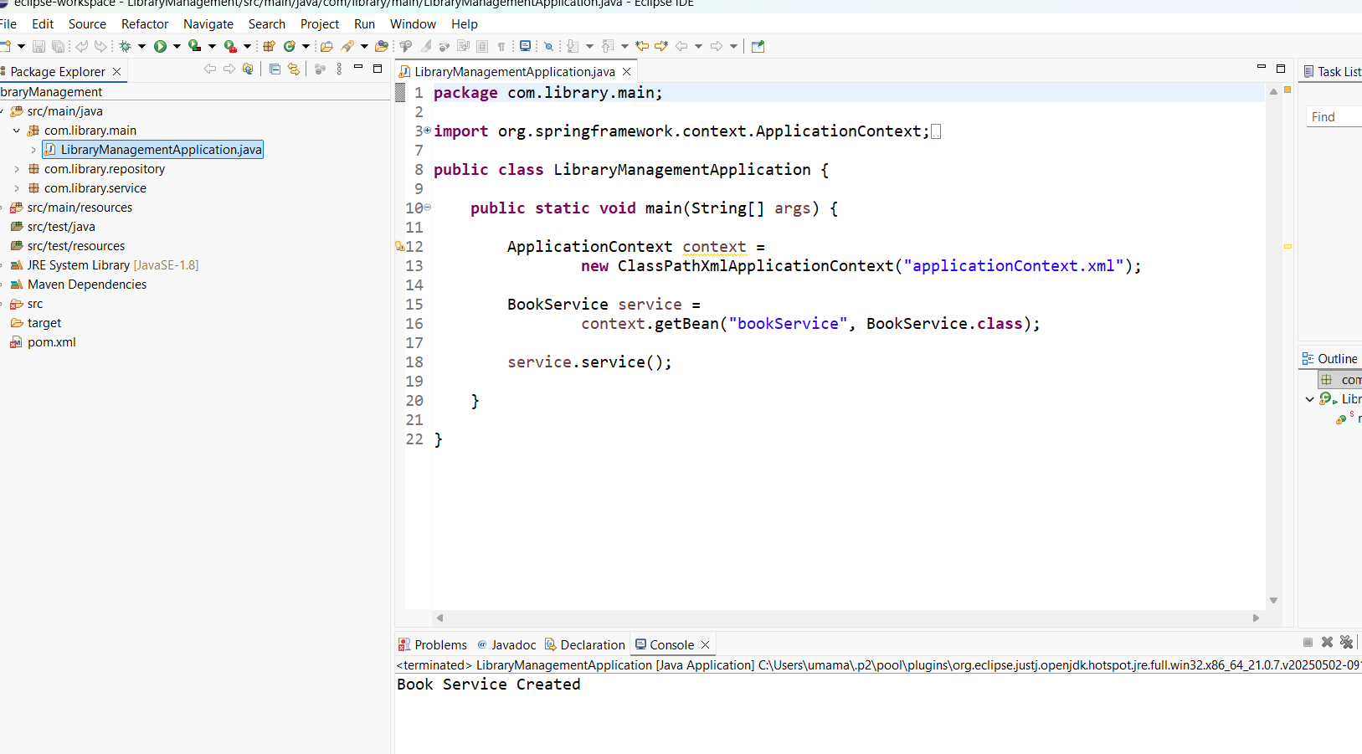

Exercise 2: Implementing Dependency Injection

Question:
In the library management application, you need to manage the dependencies between the BookService and BookRepository classes using Spring's IoC and Dependency Injection (DI).

------------------------------------------------------------
BookRepository.java
------------------------------------------------------------

```java
package com.library.repository;

public class BookRepository {

public void display() {
System.out.println("Book Repository Created");
}

}
```

------------------------------------------------------------
BookService.java
------------------------------------------------------------

```java
package com.library.service;

import com.library.repository.BookRepository;

public class BookService {

private BookRepository bookRepository;

public void setBookRepository(BookRepository bookRepository) {
this.bookRepository = bookRepository;
}

public void service() {

System.out.println("Book Service Running");

bookRepository.display();

}

}
```

------------------------------------------------------------
applicationContext.xml
------------------------------------------------------------

```xml
<?xml version="1.0" encoding="UTF-8"?>

<beans xmlns="http://www.springframework.org/schema/beans"
xmlns:xsi="http://www.w3.org/2001/XMLSchema-instance"
xsi:schemaLocation="
http://www.springframework.org/schema/beans
https://www.springframework.org/schema/beans/spring-beans.xsd">

<bean id="bookRepository"
class="com.library.repository.BookRepository"/>

<bean id="bookService"
class="com.library.service.BookService">

<property name="bookRepository"
ref="bookRepository"/>

</bean>

</beans>
```

------------------------------------------------------------
LibraryManagementApplication.java
------------------------------------------------------------

```java
package com.library.main;

import org.springframework.context.ApplicationContext;
import org.springframework.context.support.ClassPathXmlApplicationContext;

import com.library.service.BookService;

public class LibraryManagementApplication {

public static void main(String[] args) {

ApplicationContext context =
new ClassPathXmlApplicationContext("applicationContext.xml");

BookService service =
context.getBean("bookService", BookService.class);

service.service();

}
}
```

Output:

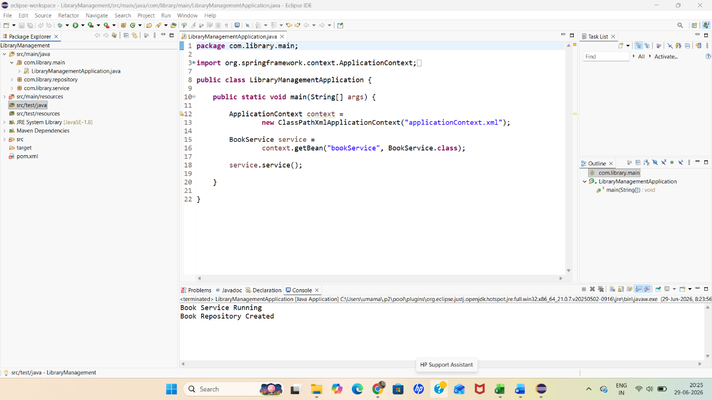

Exercise 4: Creating and Configuring a Maven Project

Question:
You need to set up a new Maven project for the library management application and add Spring dependencies.

------------------------------------------------------------
pom.xml
------------------------------------------------------------

```xml
<project xmlns="http://maven.apache.org/POM/4.0.0"
xmlns:xsi="http://www.w3.org/2001/XMLSchema-instance"
xsi:schemaLocation="http://maven.apache.org/POM/4.0.0
https://maven.apache.org/xsd/maven-4.0.0.xsd">

<modelVersion>4.0.0</modelVersion>

<groupId>com.library</groupId>
<artifactId>LibraryManagement</artifactId>
<version>0.0.1-SNAPSHOT</version>

<properties>
<maven.compiler.source>1.8</maven.compiler.source>
<maven.compiler.target>1.8</maven.compiler.target>
</properties>

<dependencies>

<dependency>
<groupId>org.springframework</groupId>
<artifactId>spring-context</artifactId>
<version>5.3.30</version>
</dependency>

<dependency>
<groupId>org.springframework</groupId>
<artifactId>spring-aop</artifactId>
<version>5.3.30</version>
</dependency>

<dependency>
<groupId>org.springframework</groupId>
<artifactId>spring-webmvc</artifactId>
<version>5.3.30</version>
</dependency>

</dependencies>

<build>
<plugins>

<plugin>
<groupId>org.apache.maven.plugins</groupId>
<artifactId>maven-compiler-plugin</artifactId>
<version>3.11.0</version>

<configuration>
<source>1.8</source>
<target>1.8</target>
</configuration>

</plugin>

</plugins>
</build>

</project>
```

Output:
