QUESTION:
Spring Data JPA - Quick Example

===========================================================
STEP 1 : Create Database
===========================================================

CREATE DATABASE ormlearn;

USE ormlearn;

===========================================================
STEP 2 : Create Table
===========================================================

CREATE TABLE country(
co_code VARCHAR(2) PRIMARY KEY,
co_name VARCHAR(50)
);

===========================================================
STEP 3 : Insert Data
===========================================================

INSERT INTO country VALUES ('IN','India');
INSERT INTO country VALUES ('US','United States');

===========================================================
STEP 4 : application.properties
===========================================================

logging.level.org.springframework=info
logging.level.orm_learn=debug

spring.datasource.url=jdbc:mysql://localhost:3306/ormlearn
spring.datasource.username=root
spring.datasource.password=YOUR_PASSWORD
spring.datasource.driver-class-name=com.mysql.cj.jdbc.Driver

spring.jpa.hibernate.ddl-auto=validate
spring.jpa.show-sql=true
spring.jpa.properties.hibernate.dialect=org.hibernate.dialect.MySQLDialect

===========================================================
STEP 5 : Country.java
Package : orm_learn.model
===========================================================

package orm_learn.model;

import jakarta.persistence.Column;
import jakarta.persistence.Entity;
import jakarta.persistence.Id;
import jakarta.persistence.Table;

@Entity
@Table(name = "country")
public class Country {

@Id
@Column(name = "co_code")
private String code;

@Column(name = "co_name")
private String name;

public Country() {
}

public String getCode() {
return code;
}

public void setCode(String code) {
this.code = code;
}

public String getName() {
return name;
}

public void setName(String name) {
this.name = name;
}

@Override
public String toString() {
return "Country [code=" + code + ", name=" + name + "]";
}
}

===========================================================
STEP 6 : CountryRepository.java
Package : orm_learn.repository
===========================================================

package orm_learn.repository;

import org.springframework.data.jpa.repository.JpaRepository;
import org.springframework.stereotype.Repository;

import orm_learn.model.Country;

@Repository
public interface CountryRepository extends JpaRepository<Country, String> {

}

===========================================================
STEP 7 : CountryService.java
Package : orm_learn.service
===========================================================

package orm_learn.service;

import java.util.List;

import org.springframework.beans.factory.annotation.Autowired;
import org.springframework.stereotype.Service;

import jakarta.transaction.Transactional;
import orm_learn.model.Country;
import orm_learn.repository.CountryRepository;

@Service
public class CountryService {

@Autowired
private CountryRepository countryRepository;

@Transactional
public List<Country> getAllCountries() {

return countryRepository.findAll();
}
}

===========================================================
STEP 8 : OrmLearnApplication.java
===========================================================

package orm_learn;

import java.util.List;

import org.slf4j.Logger;
import org.slf4j.LoggerFactory;
import org.springframework.boot.SpringApplication;
import org.springframework.boot.autoconfigure.SpringBootApplication;
import org.springframework.context.ApplicationContext;

import orm_learn.model.Country;
import orm_learn.service.CountryService;

@SpringBootApplication
public class OrmLearnApplication {

private static final Logger LOGGER =
LoggerFactory.getLogger(OrmLearnApplication.class);

private static CountryService countryService;

public static void main(String[] args) {

ApplicationContext context =
SpringApplication.run(OrmLearnApplication.class, args);

countryService = context.getBean(CountryService.class);

testGetAllCountries();
}

private static void testGetAllCountries() {

LOGGER.info("Start");

List<Country> countries = countryService.getAllCountries();

LOGGER.info("Countries : {}", countries);

LOGGER.info("End");
}
}

===========================================================
OUTPUT
===========================================================
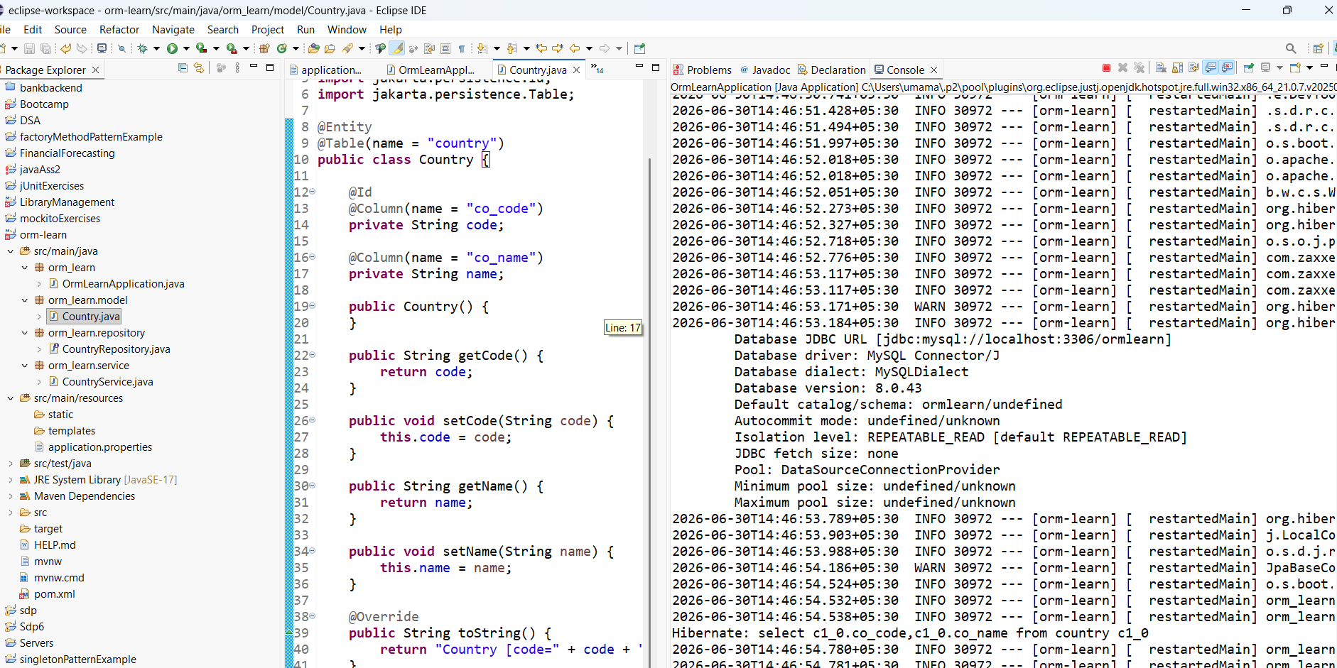
QUESTION:
Difference between JPA, Hibernate and Spring Data JPA

Java Persistence API (JPA)
• JPA stands for Java Persistence API.
• It is a specification used to persist, retrieve and manage Java objects.
• It does not provide any implementation.
• Hibernate is one of the implementations of JPA.

Hibernate
• Hibernate is an ORM (Object Relational Mapping) framework.
• It implements the JPA specification.
• It maps Java objects to database tables.
• It provides features like Session, Transaction and Query Language (HQL).

Spring Data JPA
• Spring Data JPA is built on top of JPA.
• It reduces boilerplate code.
• It provides JpaRepository for CRUD operations.
• It automatically manages transactions and repository implementations.

Difference

JPA
• Specification
• No implementation
• Defines standard persistence APIs

Hibernate
• ORM Framework
• Implements JPA
• Provides HQL and database mapping

Spring Data JPA
• Abstraction over JPA
• Uses Hibernate internally
• Simplifies database operations using JpaRepository

