Exercise 2: E-commerce Platform Search Function
Understanding Asymptotic Notation
Big O notation is used to measure the efficiency of an algorithm and how its performance changes as the input size increases.
- Best Case: The element is found immediately.
- Average Case: The element is found after checking some elements.
- Worst Case: The element is found at the end or is not present in the data.
Code
Product.java
public class Product {

int productId;
String productName;
String category;

public Product(int productId, String productName, String category) {
this.productId = productId;
this.productName = productName;
this.category = category;
}
}
Main.java
public class Main {

public static int linearSearch(Product[] products, String target) {

for (int i = 0; i < products.length; i++) {
if (products[i].productName.equalsIgnoreCase(target)) {
return i;
}
}
return -1;
}

public static int binarySearch(Product[] products, String target) {

int low = 0;
int high = products.length - 1;

while (low <= high) {

int mid = (low + high) / 2;

int result = products[mid].productName.compareToIgnoreCase(target);

if (result == 0)
return mid;

if (result < 0)
low = mid + 1;
else
high = mid - 1;
}

return -1;
}

public static void main(String[] args) {

Product[] products = {
new Product(1, "Apple", "Fruit"),
new Product(2, "Banana", "Fruit"),
new Product(3, "Laptop", "Electronics"),
new Product(4, "Mobile", "Electronics")
};

int linearResult = linearSearch(products, "Laptop");
System.out.println("Linear Search Index: " + linearResult);

int binaryResult = binarySearch(products, "Laptop");
System.out.println("Binary Search Index: " + binaryResult);
}
}
Analysis
Algorithm | Time Complexity
Linear Search | O(n)
Binary Search | O(log n)
Binary Search is more suitable for an e-commerce platform because it provides faster search performance for large sorted datasets by reducing the search space in each iteration.
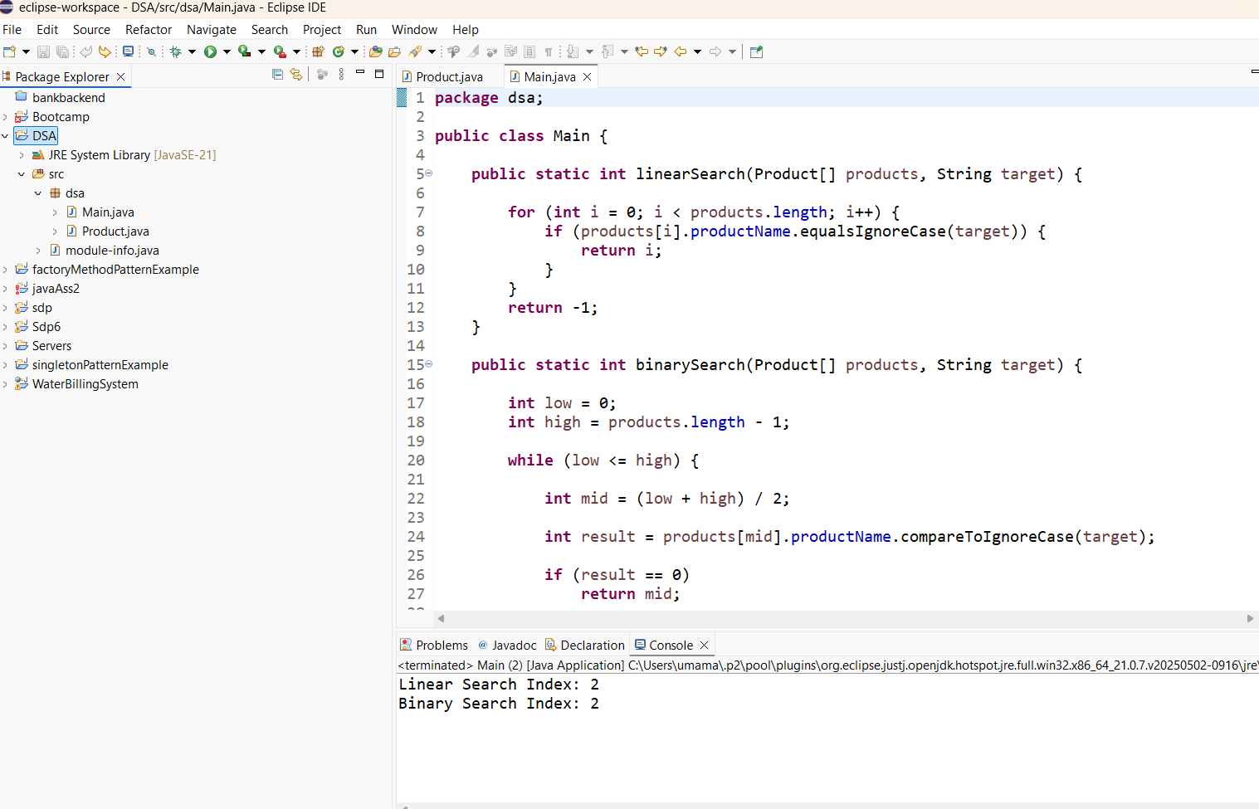

Exercise 7: Financial Forecasting
Understanding Recursion
Recursion is a technique in which a method calls itself to solve a problem. It helps simplify problems that can be broken down into smaller subproblems. In this exercise, recursion is used to calculate future values based on a fixed growth rate.
Code
Main.java
public class Main {

public static double forecast(double currentValue, double growth, int years) {
if (years == 0)
return currentValue;

return forecast(currentValue * (1 + growthRate), growthRate, years - 1);

}

public static void main(String[] args) {

double currentValue = 10000;
double growthRate = 0.10;
int years = 5;

double futureValue =forecast(currentValue, growthRate, years);

System.out.println("Future Value: " + futureValue);
}
}
Analysis
The time complexity of the recursive algorithm is O(n), where n is the number of years. The recursive solution can be optimized using techniques such as memoization or by using a direct mathematical formula to avoid repeated computations.

