EXERCISE 1: SETTING UP JUNIT
Code:
Calculator.java
package jUnitExercises;
public class Calculator {
public int add(int a, int b) {
return a + b;
}
}
CalculatorTest.java
package jUnitExercises;
import static org.junit.Assert.*;
import org.junit.Test;
public class CalculatorTest {
@Test
public void testAdd() {
Calculator calc = new Calculator();

int result = calc.add(2, 3);

assertEquals(5, result);
}
}
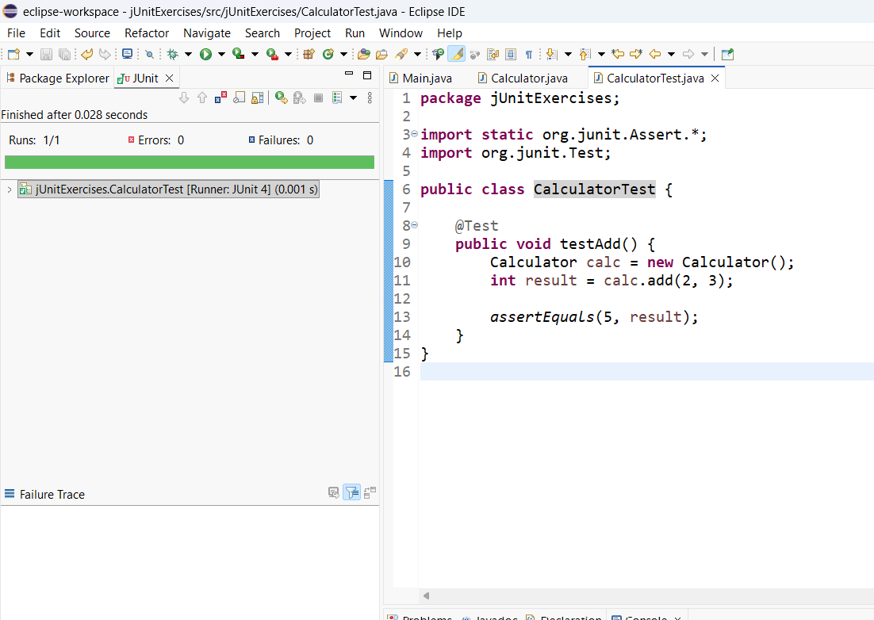

EXERCISE 3: ASSERTIONS IN JUNIT
Code:
package jUnitExercises;
import static org.junit.Assert.*;
import org.junit.Test;
public class CalculatorTest {
@Test
public void testAssertions() {

assertEquals(5, 2 + 3);

assertTrue(5 > 3);

assertFalse(5 < 3);

assertNull(null);

assertNotNull(new Object());
}
}
Output:
Runs: 1/1
Errors: 0
Failures: 0
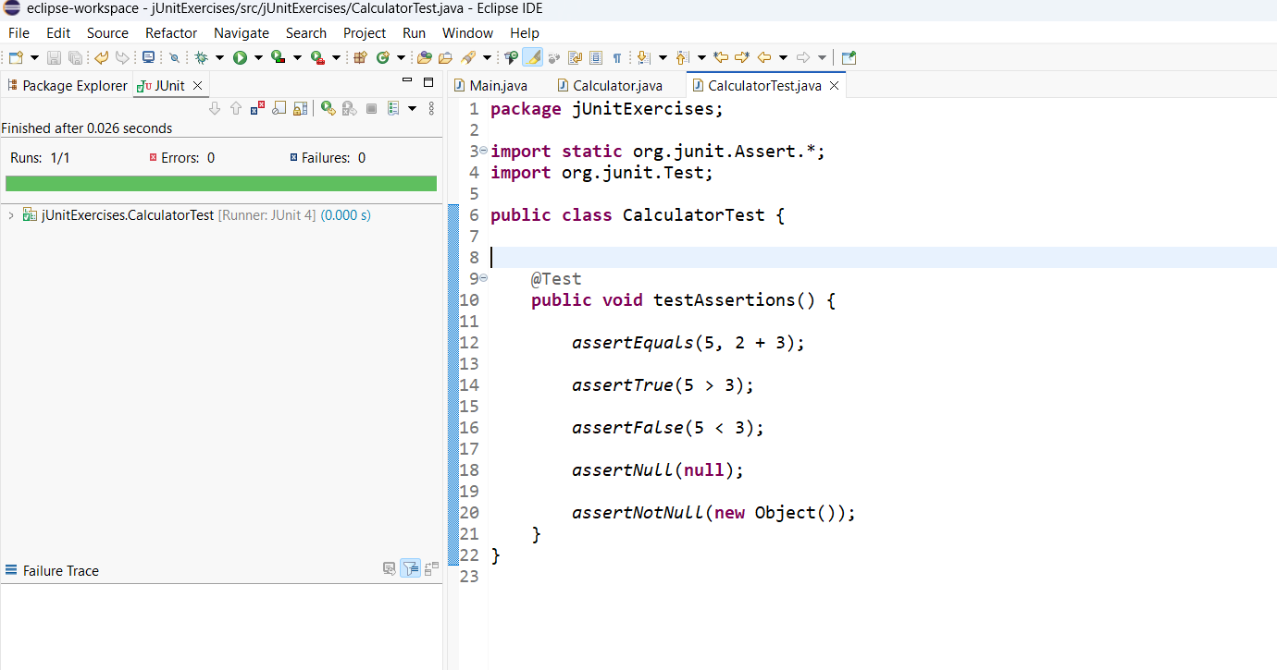

EXERCISE 4: ARRANGE-ACT-ASSERT (AAA) PATTERN, TEST FIXTURES, SETUP AND TEARDOWN METHODS IN JUNIT
Calculator.java
package jUnitExercises;
public class Calculator {
public int add(int a, int b) {
return a + b;
}
}
CalculatorTest.java
package jUnitExercises;
import static org.junit.Assert.*;
import org.junit.After;
import org.junit.Before;
import org.junit.Test;
public class CalculatorTest {
private Calculator calc;

@Before
public void setUp() {
calc = new Calculator();
System.out.println("Setup");
}

@After
public void tearDown() {
System.out.println("Teardown");
}

@Test
public void testAdd() {

// Arrange
int a = 2;
int b = 3;

// Act
int result = calc.add(a, b);

// Assert
assertEquals(5, result);
}
}
Console Output:
Setup
Teardown
JUnit Output:
Runs: 1/1
Errors: 0
Failures: 0
