Question:
Hello World RESTful Web Service

SpringLearnApplication.java

```java
package com.cognizant.spring_learn;

import org.slf4j.Logger;
import org.slf4j.LoggerFactory;
import org.springframework.boot.SpringApplication;
import org.springframework.boot.autoconfigure.SpringBootApplication;

@SpringBootApplication
public class SpringLearnApplication {

private static final Logger LOGGER =
LoggerFactory.getLogger(SpringLearnApplication.class);

public static void main(String[] args) {

LOGGER.info("START");

SpringApplication.run(SpringLearnApplication.class, args);

LOGGER.info("END");
}
}
```

HelloController.java

```java
package com.cognizant.spring_learn.controller;

import org.slf4j.Logger;
import org.slf4j.LoggerFactory;
import org.springframework.web.bind.annotation.GetMapping;
import org.springframework.web.bind.annotation.RestController;

@RestController
public class HelloController {

private static final Logger LOGGER =
LoggerFactory.getLogger(HelloController.class);

@GetMapping("/hello")
public String sayHello() {

LOGGER.info("START");

LOGGER.info("END");

return "Hello World!!";
}
}
```
Output:
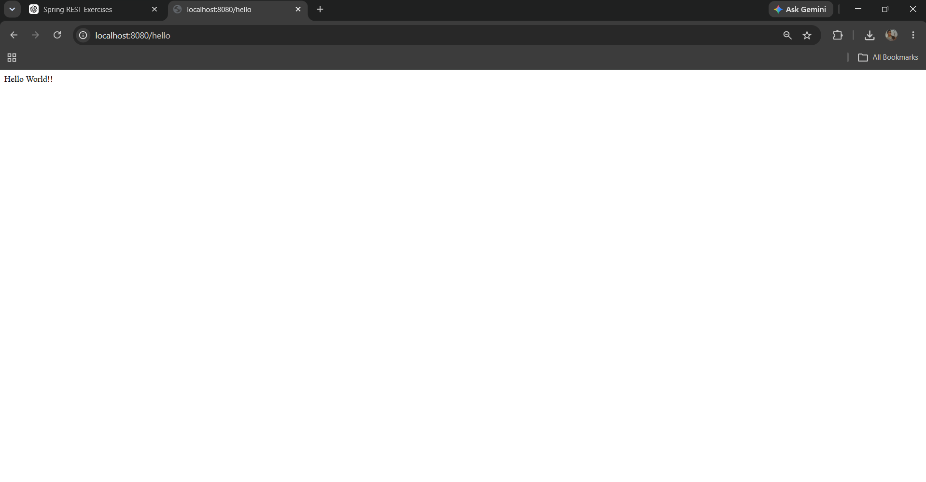
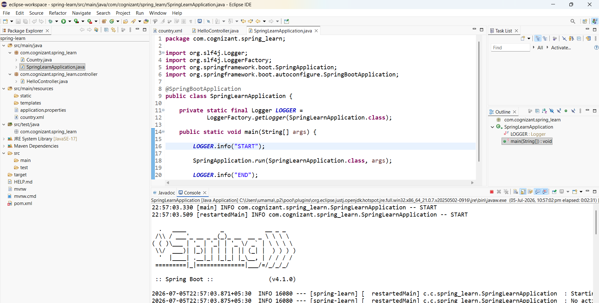

Question:
REST - Country Web Service

Country.java

```java
package com.cognizant.spring_learn;

public class Country {

private String code;
private String name;

public Country() {
}

public String getCode() {
return code;
}

public void setCode(String code) {
this.code = code;
}

public String getName() {
return name;
}

public void setName(String name) {
this.name = name;
}

@Override
public String toString() {
return "Country [code=" + code + ", name=" + name + "]";
}
}
```

country.xml

```xml
<?xml version="1.0" encoding="UTF-8"?>

<beans xmlns="http://www.springframework.org/schema/beans"
xmlns:xsi="http://www.w3.org/2001/XMLSchema-instance"
xsi:schemaLocation="
http://www.springframework.org/schema/beans
https://www.springframework.org/schema/beans/spring-beans.xsd">

<bean id="country" class="com.cognizant.spring_learn.Country">
<property name="code" value="IN"/>
<property name="name" value="India"/>
</bean>

</beans>
```

CountryController.java

```java
package com.cognizant.spring_learn.controller;

import org.slf4j.Logger;
import org.slf4j.LoggerFactory;
import org.springframework.context.ApplicationContext;
import org.springframework.context.support.ClassPathXmlApplicationContext;
import org.springframework.web.bind.annotation.RequestMapping;
import org.springframework.web.bind.annotation.RestController;

import com.cognizant.spring_learn.Country;

@RestController
public class CountryController {

private static final Logger LOGGER =
LoggerFactory.getLogger(CountryController.class);

@RequestMapping("/country")
public Country getCountryIndia() {

LOGGER.info("START");

ApplicationContext context =
new ClassPathXmlApplicationContext("country.xml");

Country country = context.getBean("country", Country.class);

LOGGER.info("END");

return country;
}
}
```
Output:
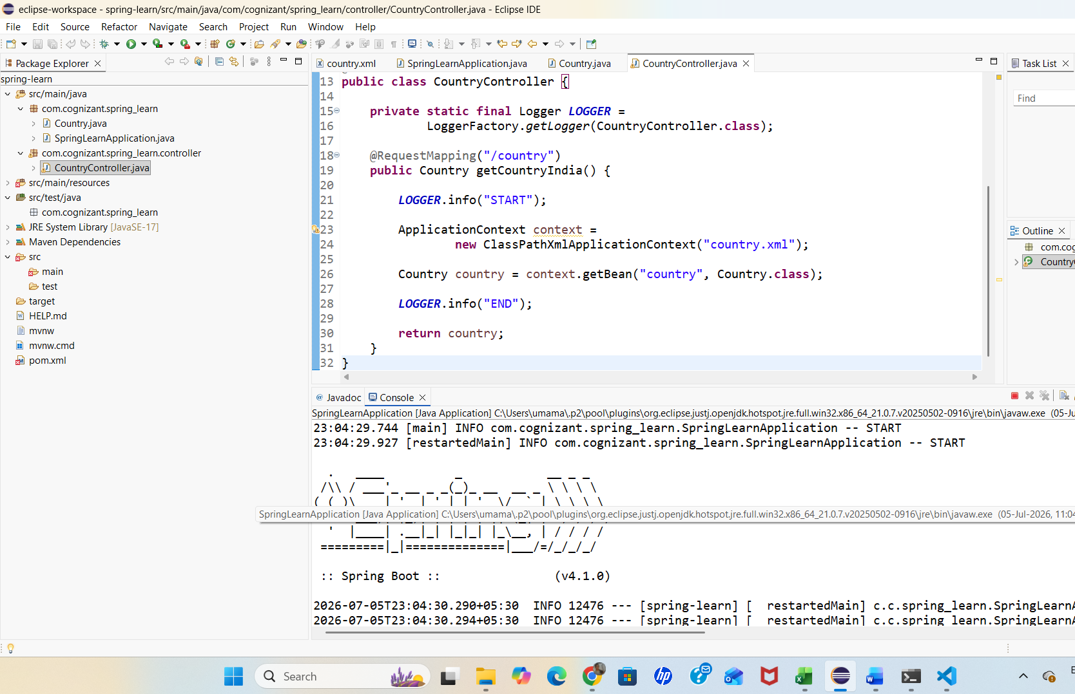
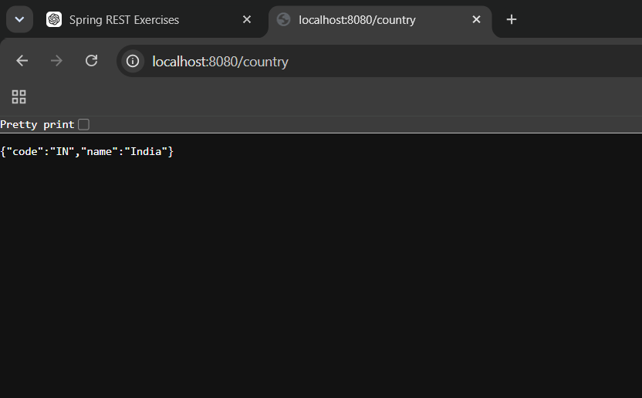
Question:
REST - Get Country Based on Country Code

Country.java

```java
package com.cognizant.spring_learn;

public class Country {

private String code;
private String name;

public Country() {
}

public String getCode() {
return code;
}

public void setCode(String code) {
this.code = code;
}

public String getName() {
return name;
}

public void setName(String name) {
this.name = name;
}

@Override
public String toString() {
return "Country [code=" + code + ", name=" + name + "]";
}
}
```

country.xml

```xml
<?xml version="1.0" encoding="UTF-8"?>

<beans xmlns="http://www.springframework.org/schema/beans"
xmlns:xsi="http://www.w3.org/2001/XMLSchema-instance"
xsi:schemaLocation="
http://www.springframework.org/schema/beans
https://www.springframework.org/schema/beans/spring-beans.xsd">

<bean id="countryList" class="java.util.ArrayList">
<constructor-arg>
<list>

<bean class="com.cognizant.spring_learn.Country">
<property name="code" value="IN"/>
<property name="name" value="India"/>
</bean>

<bean class="com.cognizant.spring_learn.Country">
<property name="code" value="US"/>
<property name="name" value="United States"/>
</bean>

<bean class="com.cognizant.spring_learn.Country">
<property name="code" value="JP"/>
<property name="name" value="Japan"/>
</bean>

<bean class="com.cognizant.spring_learn.Country">
<property name="code" value="DE"/>
<property name="name" value="Germany"/>
</bean>

</list>
</constructor-arg>
</bean>

</beans>
```

CountryService.java

```java
package com.cognizant.spring_learn.service;

import java.util.List;

import org.springframework.context.ApplicationContext;
import org.springframework.context.support.ClassPathXmlApplicationContext;
import org.springframework.stereotype.Service;

import com.cognizant.spring_learn.Country;

@Service
public class CountryService {

@SuppressWarnings("unchecked")
public Country getCountry(String code) {

ApplicationContext context =
new ClassPathXmlApplicationContext("country.xml");

List<Country> countries =
(List<Country>) context.getBean("countryList");

for (Country country : countries) {
if (country.getCode().equalsIgnoreCase(code)) {
return country;
}
}

return null;
}
}
```

CountryController.java

```java
package com.cognizant.spring_learn.controller;

import org.slf4j.Logger;
import org.slf4j.LoggerFactory;
import org.springframework.beans.factory.annotation.Autowired;
import org.springframework.web.bind.annotation.GetMapping;
import org.springframework.web.bind.annotation.PathVariable;
import org.springframework.web.bind.annotation.RestController;

import com.cognizant.spring_learn.Country;
import com.cognizant.spring_learn.service.CountryService;

@RestController
public class CountryController {

private static final Logger LOGGER =
LoggerFactory.getLogger(CountryController.class);

@Autowired
private CountryService countryService;

@GetMapping("/countries/{code}")
public Country getCountry(@PathVariable String code) {

LOGGER.info("START");

Country country = countryService.getCountry(code);

LOGGER.info("END");

return country;
}
}
```
Output:
