Correlated Authorization
Igor Zboran
izboran@gmail.com
August 22, 2021
Abstract
Correlated Authorization is a cross-domain authorization protocol built on top of OAuth2 and User-Managed Access (UMA) protocols that allows users (resource owners) to delegate access to other users (requesting parties) across security and network domains. The requesting party is responsible for creating the request, while the resource owner approves the transaction asynchronously. The resource owner and the requesting party may belong to different security domains (realms) or may use mutually isolated instances of the authorization server residing on different network domains. They may also use independent identity providers, there is no need to share an OIDC provider or use federated OIDC providers. This concept uses a permission ticket as a correlation handler between two authorization processes and an e-mail address as a unique requesting party identifier for cross-domain access control.
Introduction
In ...
Problem
...
Current Situation
...
Current Flaws
cross-domain scenarios

Proposed Solution
.
Motivation
.
Main Concept
...

Sequence diagrams
There are two versions of the sequence diagram that describe the Correlated Authorization mechanism. The first version represents the Correlated Authorization profile of the UMA protocol. The second version profiles the OAuth2 protocol. Both profiles rely on the token exchange extension of OAuth2, where an access token is used to obtain a claims token from the authorization server.
UMA profile
This diagram is in full compliance with the UMA specification.
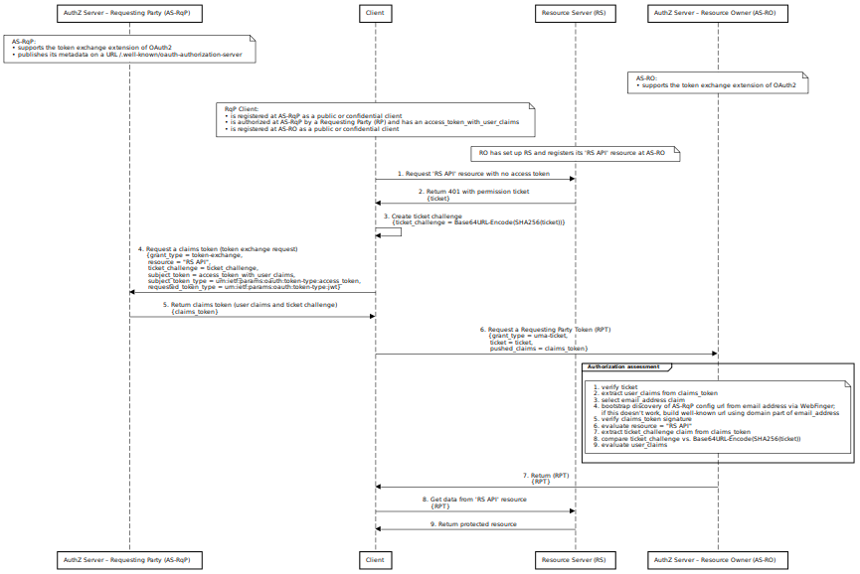

OAuth2 profile
This diagram represents a profile of the OAuth2 protocol and lacks some UMA features.
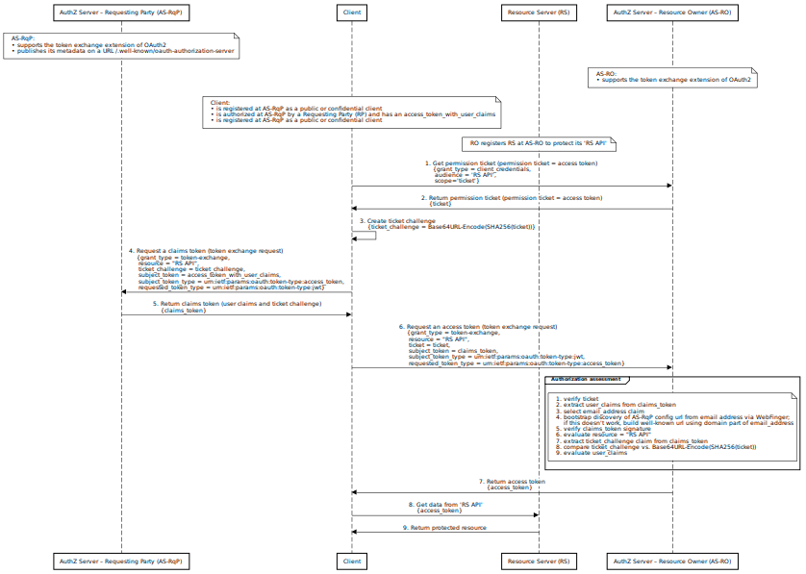

About the Author
Igor Zboran is a mechanical engineer by education with professional experience as a software engineer, solutions architect and security architect. He'd like to transform his knowledge into a useful system or service that people would love to use.
Igor received Ing. degree in Mechanical Engineering from the University of Žilina, Slovakia in 1988. After graduating, he worked in several small private companies as a software developer. From 2008 to 2009, he provided expert advice to Prague City Hall IT department, Czech Republic as an external consultant. He invented a new decentralized Identity-Based Privacy (IBP) trusted model built around OAuth2 and OpenID Connect standards. Igor is a strong proponent of open source software and open standards.
References
[1] OpenID Connect (OIDC) https://openid.net/connect/
[2] User-Managed Access (UMA) https://en.wikipedia.org/wiki/User-Managed_Access
[3] WG - User Managed Access https://kantarainitiative.org/confluence/display/uma/Home
[4] OAuth 2.0 Token Exchange https://datatracker.ietf.org/doc/html/rfc8693

