Authorization-Enhanced Mail System
Igor Zboran
izboran@gmail.com
March 22, 2021
Abstract
Electronic mail (email) is the most pervasive form of business information exchange. Email is often used not only as an interpersonal communication tool, but also as the default choice to send files. In this paper the User-Managed Access (UMA) authorization framework is proposed to address data storage, access control and data transfer limitations of the current mail system. Outgoing mail is typically transferred from the source system to the destination system as a single text-encoded file using Simple Mail Transfer Protocol (SMTP). SMTP is a push protocol only. The UMA framework introduces a resource server and an authorization server into the mail system. The resource server is accessed generally by HTTP pull protocol. The two-way push-pull data transfer in combination with a data storage system controlled by the standardized authorization framework significantly leverages email security, enhances mail system utilization and elevates the email ecosystem to the ubiquitous Content Services platform.
Introduction
The main components of the mail system have been designed between 1971 and 1992 by many inventors. In the course of time, email has become the most commonly used application of the Internet. Nowadays email is the only truly decentralized communication system of the Internet and the email infrastructure forms the backbone of the worldwide digital identity.
Problem
Despite the importance of email infrastructure, the whole ecosystem still relies on over 40 year-old architecture and protocol design. There are spam and attachment issues from the very beginning. The mail system, while conceptually sound as a communication means, is structurally obsolete and functionally deficient.
Current Situation
With the rising popularity of free email providers, such as Gmail or Outlook.com, web-browsers are increasingly being used to access the mail server. From a user standpoint, it is easy to read and send emails via web-browser on any device, from anywhere in the world. Centralized access to the mailboxes, increases the security of web-based mail systems.
Current Flaws
Even though the main email service providers claim email accounts to be safe, the fact remains that major security and functional flaws are not fixed. There is still an attachments delivery dichotomy; bulky files are not transferred as an attachment but are shared via links. An “attachment sharing” is not natural for current mail systems where each message with attachments is expected to be time-consistent. Shared links pose a consent phishing attack threat where attacker tricks users into granting a malicious application access to sensitive resources. This is known as an OAuth 2.0 authorization exploit. The Authorization-Enhanced Mail System is resistant to this security exploit as there are no direct user involvement in access granting.

Proposed Solution
Given that the mail system is lagging behind modern communication and collaboration tools, we propose an OAuth-based access control management and consequently a new data exchange channel for the email ecosystem.
Motivation
Email still the most popular communication tool is lacking an important part of today's modern systems – an authorization framework. Understanding this lead us to implement the UMA authorization framework into the mail system. At the core of the proposed solution is an attempt to improve the usability of email – not only as an interpersonal communication tool, but also as the default choice to send and store files.
Main Concept
The Authorization-Enhanced Mail System is designed to follow the Identity and Access Management (IAM) best practices while keeping compatibility with the current mail system. We propose to incorporate the UMA framework between the mail system with standardized SMTP/POP3/IMAP interface and the proprietary RESTful web-based email application as it is illustrated in Figure 1.

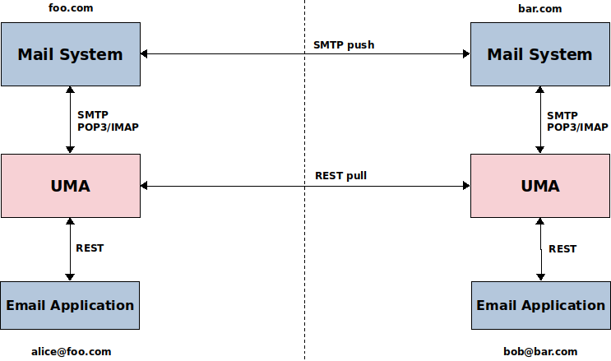
Figure 1. Main concept

The UMA framework plays its role during the data exchange process between mailboxes. The Email Application – with an UMA email extension – gives the sender a user-centric approach to manage and protect his/her ready-to-send email resources while the Mail Retrieval Agent is used to access and download temporarily shared sender’s email resources as it is schematically illustrated in Figure 2.
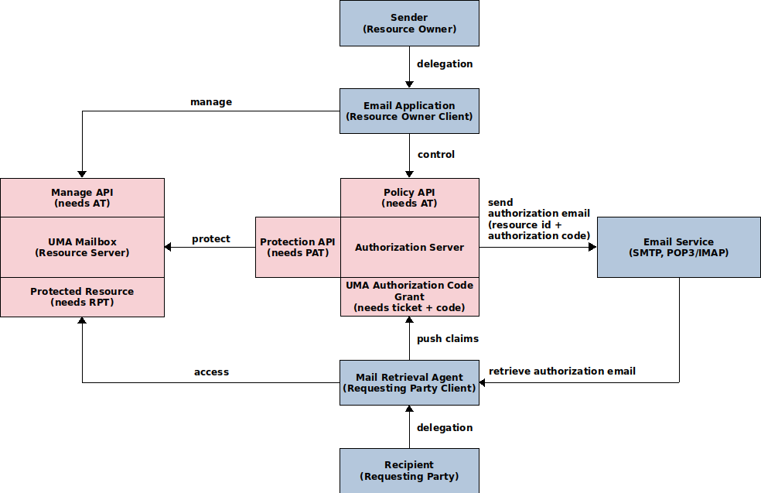
Figure 2. AEMS – schematic flow during the data transit from sender to recipient
Key points
- An email consists of resources (message and attachments) stored in an UMA Mailbox – an email-specific UMA Resource Server.
- The email resources owned by the sender stored in the sender’s UMA Mailbox are temporarily shared with the recipient. Following a successful sharing process, an authorization email with the authorization code and the email resources identifier is sent to the recipient via the standard mail system.
- The recipient’s Mail Retrieval Agent that acts on behalf of the recipient retrieves the authorization email, gets delegated access using UMA Authorization Code Grant, and downloads the email resources from the sender’s UMA Mailbox. The downloaded data are stored in the recipient's UMA Mailbox.
During the data transit from sender to recipient, AEMS uses the existing email infrastructure to ensure authenticity of the authorization email, and the UMA protocol to control the recipient's access to the sender's email resources.

UMA Authorization Code Grant
The UMA Authorization Code Grant defines a mechanism for user-to-user (sender-to-recipient) delegation of access. Figure 3 provides the sequence diagram for the UMA Authorization Code Grant that delegates the Requesting Party Client to access the sender's resources on behalf of the recipient.

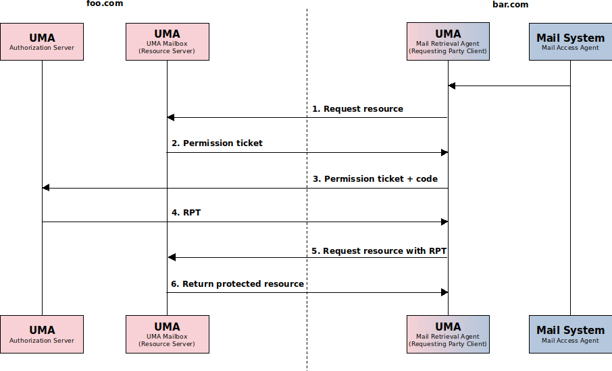
Figure 3. UMA Authorization Code Grant sequence diagram

The following is a description of steps to get access to a protected resource:
- The Requesting Party Client (aka Mail Retrieval Agent) that acts on behalf of the recipient is trying to access an UMA protected resource in the UMA Mailbox.
- Without an access token, the UMA Mailbox returns a permission ticket.
- The client presents the permission ticket and authorization code along with client credentials at the UMA Authorization Server token endpoint (the authorization code is generated by the UMA Authorization Server during the sharing process and is sent to the Requesting Party Client via email).
- The Authorization Server returns the Requesting Party Token (RPT) on successful evaluation of the policies.
- The client again tries to obtain the resource.
- The UMA Mailbox returns the protected resource after validating the access token.

UMA uses a special jargon. For the sake of brevity of this proposal, the following list of acronyms will be used:
- AS Authorization Server
- RS Resource Server
- RO Resource Owner
- RqP Requesting Party
- PAT Protection API (access) Token
- RPT Requesting Party Token
- PCT Persisted Claims Token
Here are a few more acronyms and short forms:
- AEMS (pronounced “aims”) Authorization-Enhanced Mail System
- MBX Mailbox
- MRA Mail Retrieval Agent
- MAA Mail Access Agent
- AT Access Token
- Email App Email Application

Trust Model
AEMS uses a decentralized two-way trust model through two separate communication channels for unidirectional data flow:
- Email Trust System – To ensure authenticity of the registration and authorization email (see “Scenarios and Flows” section) AEMS relies on existing email authentication SPF, DKIM and DMARC techniques.
- UMA Trust Relationship – The UMA 1.0 authorization framework – built around the OAuth-like protocol standard – was originally designed for Business-to-Consumer (B2C) scenarios. In UMA the roles of the AS, RS, RO and RqP client are co-located, they are all under the realm of a single trust domain. Fortunately during the development of UMA 2.0, the working group also considered a wide ecosystem where you can access a previously unknown UMA-protected RS.
AEMS combines a decentralized email ecosystem with the UMA wide ecosystem to satisfy both the B2C and Business-to-Business (B2B) scenarios. This concept authenticate the email sender and authorize the recipient’s access to email resources. Figure 4 illustrates the two-way trust model established via the email infrastructure.

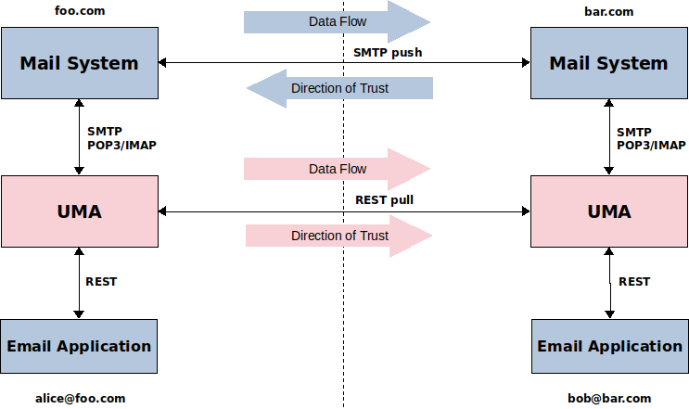
Figure 4. alice@foo.com to bob@bar.com trust model
There is no direct contract between authorization servers themselves and the UMA roles remain co-located. While delivering data from Alice to Bob, the bar.com domain trusts the foo.com domain and vice versa. This model ensures that every email resources originates from a trusted sender.

Scenarios and Flows
The following scenario represents an email sent from alice.foo.com address to bob.bar.com address assuming that this is the first ever communication between the foo.com and bar.com security domains and no previous trust relationship was established between them. Trusted communication between users in the two security domains can be divided into an one-time initial registration action and three main phases.
Registration action - get authorization, register, set up relationship
Before the communication itself, a trust relationship governed by a contract must be established between the bar.com RqP client (aka MRA) and the foo.com AS. To set up a relationship, a registration email – in the AEMS registration email format – must be sent from foo.com domain to the bar.com domain. The sending of the registration email must be authorized by the foo.com AS. To make this process streamlined OAuth 2.0 Dynamic Client Registration Management Protocol (RFC 7592) is used to avoid manual registration workflow as it is illustrated in Figure 5. The Initial Access Token and the Software Statement are sent in the registration email. The registration email is generated by the foo.com AS. This registration workflow is typically initiated by the email sender by pressing the “Send” button on the “Email Compose” form in the Email Application.

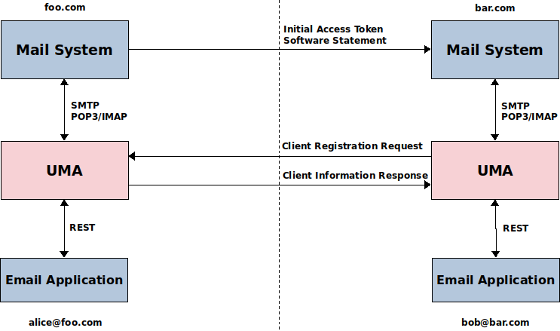
Figure 5. alice@foo.com to bob@bar.com dynamic client registration
After registration a trust relationship is set up between the bar.com RqP client and foo.com AS. The bar.com RqP client (aka MRA) now has access controled by the foo.com AS to the email resources stored on the foo.com RS.

AEMS registration email format specification
Subject: [No-reply] System message from AEMS
Body: Type: Registration email
Software Statement: …
Attachment name: Initial Access Token
Attachment body: Access Token...

Phase I - put resources under protection, create policy, send authorization email
Let us assume the sender Alice – the resource owner (RO) – has prepared a draft email with an attachment. The draft message and the attachment are stored separately on the UMA/MBX. The draft resources are not protected by UMA framework at this stage; data are considered inactive and are referred to as “data at rest”.
Before Alice presses the “Send” button, she fills in the “To” field with the recipient’s email address – bob@bar.com. This value will be used to set up an access to the email resources.
After Alice presses the “Send” button, the mutable draft resources become immutable email resources protected by UMA framework; at this stage data are considered active and are referred to as “data in transfer”. The email resources are registered at the AS resource registration endpoint. Next, a policy is created that gives Bob access to Alice’s email resources. Finally the authorization email with the authorization code and the email resources identifier – in the AEMS authorization email format – is automatically created by Alice’s AS, and sent to the recipient Bob. The data flow is illustrated in Figure 6.

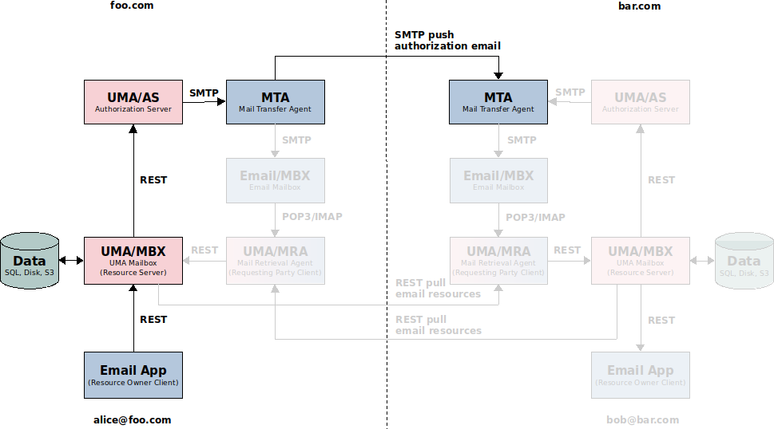
Figure 6. alice@foo.com to bob@bar.com – send authorization email

AEMS authorization email format specification
Subject: [No-reply] System message from AEMS
Body: Type: Authorization email
Category: Official/Business/Personal/Healthcare
Attachment name: Code and identifier
Attachment body: authorization code…, resources identifier…, hash code...

Phase II – retrieve authorization email, get authorization
An authorization email from Alice with the authorization code and the email resources identifier has just reached Bob’s Email/MBX. The RqP client (aka MRA) – connected to Email/MBX via POP3/IMAP protocol – is notified of incoming email, retrieves the authorization email and checks its format. The data flow is illustrated in Figure 7. If the email is in the AEMS authorization email format, an authorization process – using the UMA Authorization Code Grant – will proceed to get access to Alice’s email resources. The UMA Authorization Code Grant sequence diagram is illustrated in Figure 3.

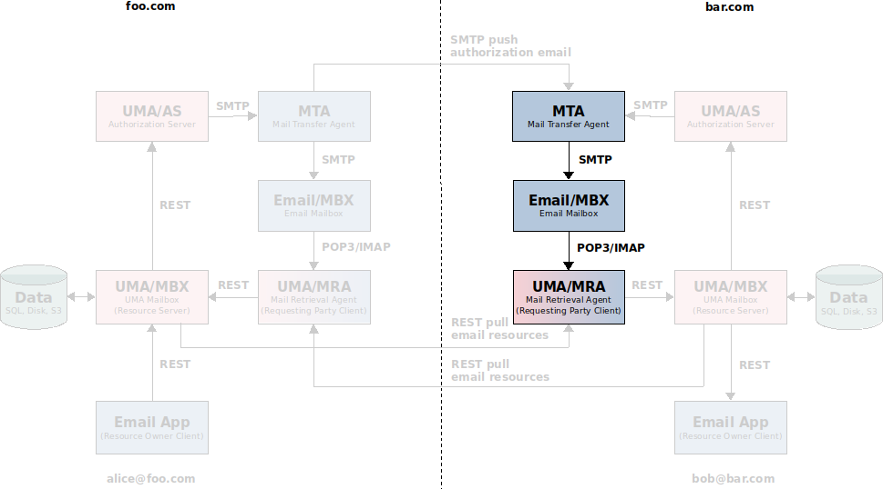
Figure 7. alice@foo.com to bob@bar.com – retrieve authorization email

Phase III - get email resources, notify email application
After authorization using the UMA Authorization Code Grant, Alice’s email resources are downloaded as it is illustrated in the last section of sequence diagram in Figure 3. The RqP client (aka MRA) must store the downloaded data on Bob’s UMA/MBX as it is illustrated in Figure 8. Bob’s Email Application should be notified of Alice’s incoming email.

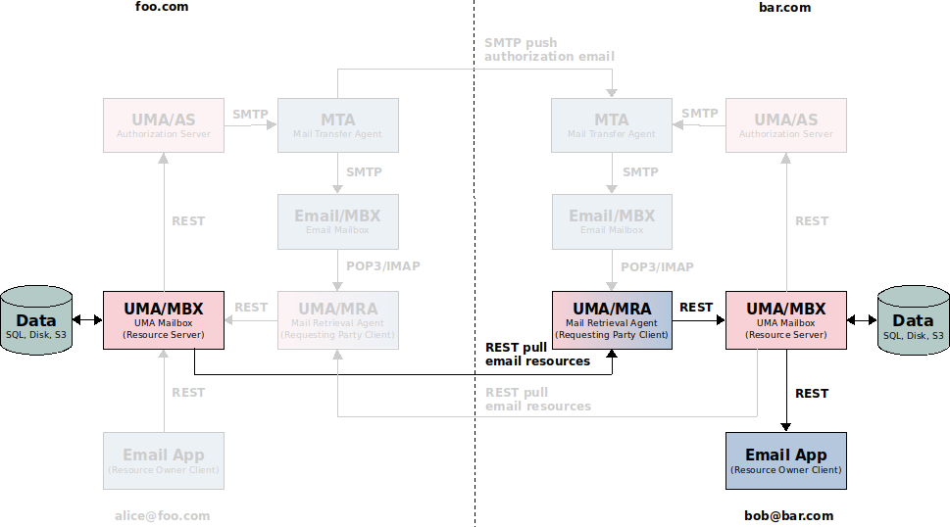
Figure 8. alice@foo.com to bob@bar.com – get email resources

Features and Comparison with Current Mail System
The novelty of the proposed solution approach can be assessed by comparison with the current mail system.
New Features
The proposed AEMS solution provides several new features that are lacking in the current mail system:
- Intrinsic privacy-preserving properties. Each user can have their own separate UMA/MBX as an email repository. The user can run his own UMA/MBX, even his own AS.
- Single UMA/MBX for both incoming and outgoing emails.
- Multiple UMA/MBXs per one email address.
- Built-in cross-domain autonomic (without conscious user intervention) access control using the standardized UMA framework.
- Autonomous (without interfering with the mail system) data exchange channel.
- No attachments size limit. Attachments are transferred as separate files without size limit.
- Linked content using a clickable hyperlinks.
- Instant messages. Messages and attachments are transferred separately, there is no need to wait for incoming bulky message-with-attachments file. Attachments-stripped bare messages are transferred with a higher priority.
Comparison with Current Mail System
The use of AEMS has many advantages over the current mail system. The AEMS architecture increases the robustness and performance of the existing mail system. In the following we highlight the advantages of the proposed solution compared to the current mail system.
1. Security and Privacy
User correspondence takes place between UMA Mailboxes. The mailbox of the standard email system becomes redundant and is only used for system (registration, authorization) emails. This architecture guarantees more control over potential security and privacy issues such as leakage of intellectual property or loss of confidential content and makes the system compatible with enterprise security policies.
2. Usability
The UMA Mailbox is decoupled from the email address. This allows a user with a single email address to use simultaneously multiple UMA Mailboxes. To separate official, business, personal and healthcare correspondence, AEMS provides the flexibility for storing emails according to various criteria within an appropriate UMA Mailbox provider.
3. Platform
With the capability to store, locate, send and receive any content including documents, images, audios and videos, the proposed solution can be considered a promising platform for Content Services.
4. Integrations
AEMS provides a standardized Restful/GraphQL application interface to ease the integrations with external marketing, sales, Enterprise Content Management (ECM) or Customer Relationship Management (CRM) systems.

Conclusion
AEMS can play an important role in communication across various industries in the public and private sectors. Consolidation of repository, communication and identity represents a central source of information within any organization.
Overall Summary
The email system technology in combination with the UMA framework creates a composite architecture that meets the needs of the modern communication tool. The proposed solution can be used as a Content Services platform to provide the e-records storage, exchange and retrieval system protected by the standardized authorization framework utilized by users through the email application.
A consolidated access control and a new data exchange mechanism leverages email security and enhances the mail system utilization. The question arises as to whether the standard implementation of UMA 2.0 will fit into the current mail system and how difficult it will be to build the UMA email extension.
Future Work
The UMA framework brings into the email ecosystem a new data storage and exchange technology that predestine the mail system to become more than a bare messaging tool.
The following are potential future R&D areas:
- Use an autoforwarding feature of existing mail system to loose bundling between AEMS and the standard mail system to drive the AEMS adoption.
- Explore the possibility of delivering the authorization code via SMS; use phone numbers instead of email addresses.
- Consider a Consent mechanism extension design.
- Explore linked content using a clickable hyperlinks – linking content across the business.
- Design an extension for exchanging tagged messages and attachments – grouping content across the business.
- Design an attachment versioning extension – managing the attachment content changes.
- Explore health information exchange between healthcare professionals and inspect use of email communication between patients and healthcare professionals.
- Employ regular email clients and applications using JMAP protocol to support a standardized email API.
- Design and use a proprietary GraphQL API to replace the poorly adopted JMAP protocol.
- Incorporate an electronic mailing/discussion list system into the proposed solution to extend the basic email functionality.
- Explore other ways of data origin authenticity (WebFinger, WebFist), replace SMTP with a web-based protocol.

A prototype implementation of the proposed solution, working as a proof of concept, would be interesting to build.

About the Author
Igor Zboran is a mechanical engineer by education with professional experience as a software engineer and solutions architect. He'd like to transform his knowledge into a useful system or service that people would love to use.
Igor received Ing. degree in Mechanical Engineering from the University of Žilina, Slovakia in 1988. After graduating, he worked in several small private companies as a software developer. From 2008 to 2009, he provided expert advice to Prague City Hall IT department, Czech Republic as an external consultant. He invented a new decentralized Identity-Based Privacy (IBP) trusted model built around OAuth2 and OpenID Connect standards. Igor is a strong proponent of open source software and open standards.

