Identity-Based Network
Igor Zboran
izboran@gmail.com
July 23, 2021
Abstract
The Internet is a complex interconnection of people and services with the ability to exchange data. The networking industry has to agree on how to assemble a trusted, secure infrastructure for connecting these entities. In this paper the OpenID Connect (OIDC) protocol in combination with the User-Managed Access (UMA) protocol is proposed to overcome the identity management, access control and decentralized data storage issues of the current Internet.
Introduction
In the early days the Internet was a protocol driven – FTP, SMTP, HTTP, XMPP – decentralized ecosystem. Today's Internet has turned into a centralized group of cloud services. There is no easy way to run a widely accessible service without being tied to a specific cloud provider. The real cloud lock-in is an Identity and Access Management (IAM) with a Single-Sign On (SSO) authentication service.
Problem
IAM services were built for internal use behind the firewall. They were not designed to manage identity and access control across corporate boundaries. In the new cloud, social and mobile era, many enterprises now find themselves with more identity silos than ever.
Current Situation
.
Current Flaws
.

Proposed Solution
.
Motivation
.
Main Concept
There are five principal issues that are going to have to be resolved.
- Connectivity
- Identity
- Manageability
- Data Storage
- Interoperability

RESTful Flows
UMA/GET
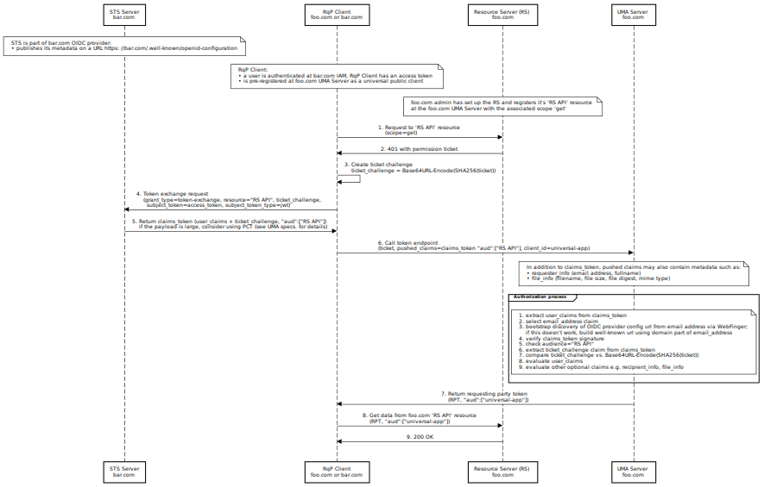

OAuth2/GET
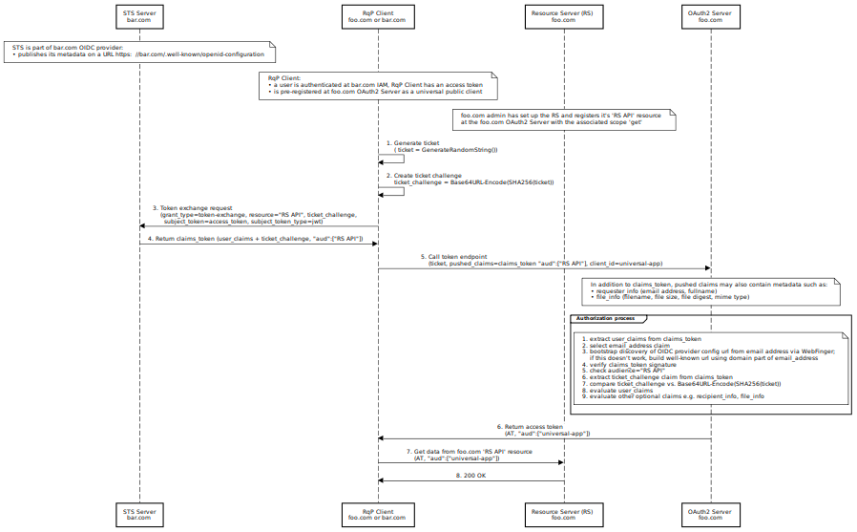

About the Author
Igor Zboran is a mechanical engineer by education with professional experience as a software engineer and solutions architect. He'd like to transform his knowledge into a useful system or service that people would love to use.
Igor received Ing. degree in Mechanical Engineering from the University of Žilina, Slovakia in 1988. After graduating, he worked in several small private companies as a software developer. From 2008 to 2009, he provided expert advice to Prague City Hall IT department, Czech Republic as an external consultant. He invented a new decentralized Identity-Based Privacy (IBP) trusted model built around OAuth2 and OpenID Connect standards. Igor is a strong proponent of open source software and open standards.
References
[1] OpenID Connect (OIDC) https://openid.net/connect/
[2] User-Managed Access (UMA) https://en.wikipedia.org/wiki/User-Managed_Access
[3] WG - User Managed Access https://kantarainitiative.org/confluence/display/uma/Home
[4] OAuth 2.0 Token Exchange https://datatracker.ietf.org/doc/html/rfc8693

