Usability Testing & Analysis
Project: Recipe Book Web Application Prototype
Purpose: Evaluate usability, navigation, accessibility, and overall user experience of the Recipe Book application prototype.

1. Test Plan
The prototype was evaluated through task-based usability testing. Users were asked to navigate the application, browse recipes, view recipe details, and interact with key interface elements.

2. Test Scenarios
Launch the application and explore the home screen.
Browse available recipes.
Open a recipe and review ingredients and instructions.
Navigate between screens using available controls.
Evaluate clarity of content, layout, and actions.

3. Prototype Screens
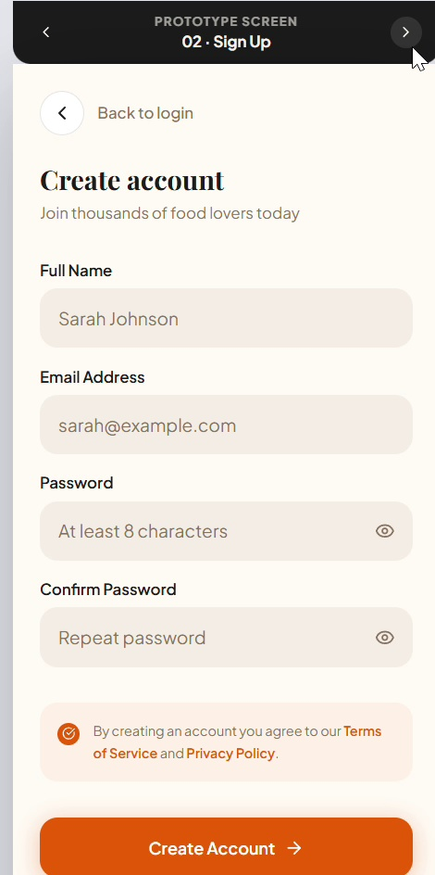
Figure 1: Screen captured from the interactive prototype.
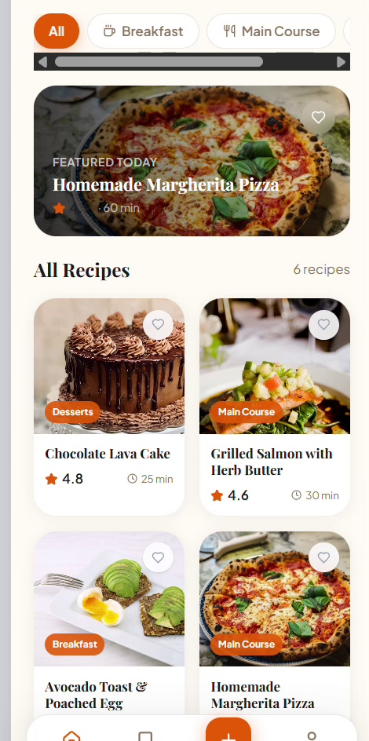
Figure 2: Screen captured from the interactive prototype.
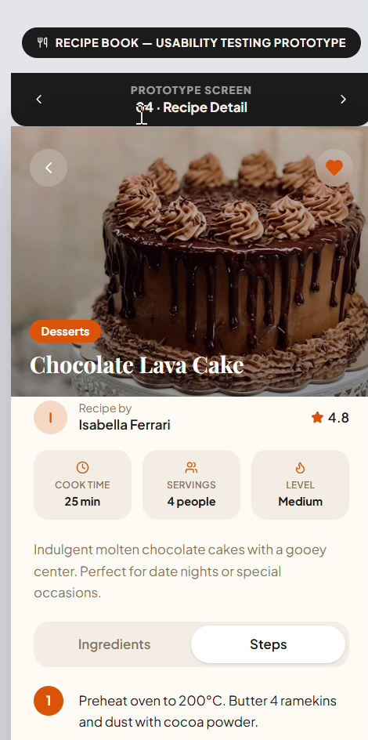
Figure 3: Screen captured from the interactive prototype.
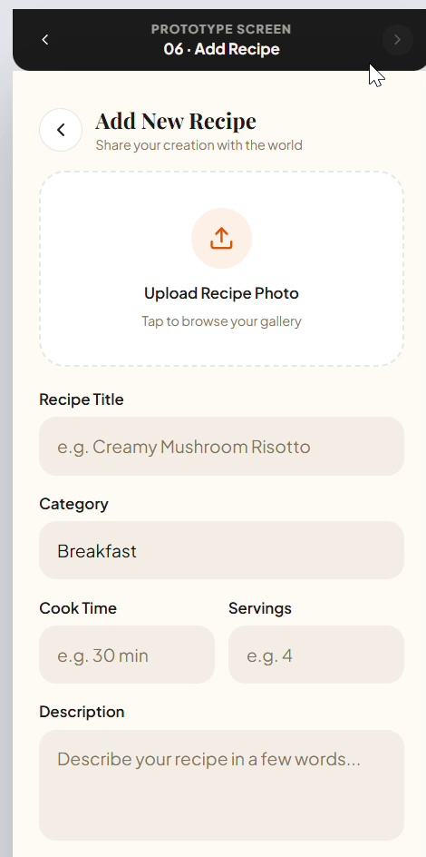
Figure 4: Screen captured from the interactive prototype.
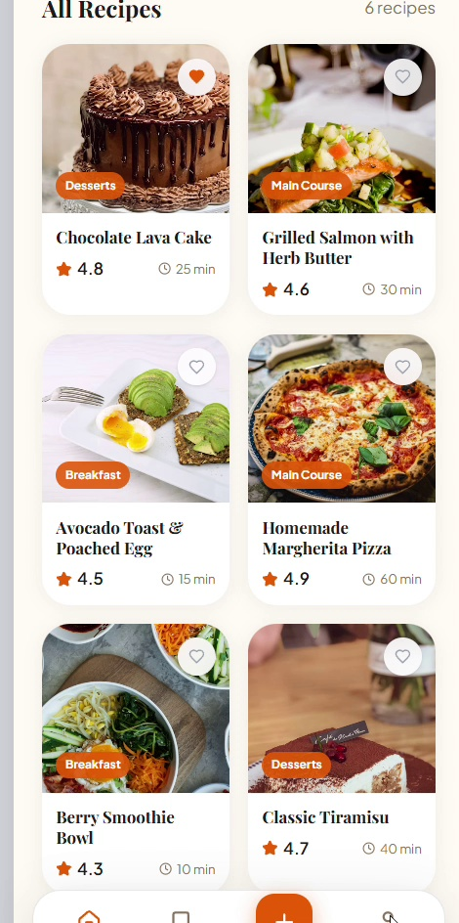
Figure 5: Screen captured from the interactive prototype.
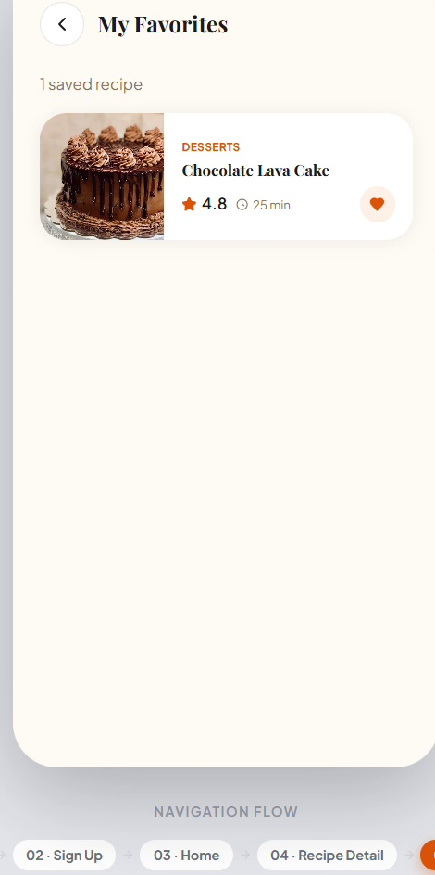
Figure 6: Screen captured from the interactive prototype.

4. Observations
• Navigation flow was intuitive and easy to follow.
• Recipe information was organized in a readable format.
• Visual consistency was maintained across screens.
• Important actions were generally easy to identify.

5. Usability Findings
Strengths:
- Clean and modern interface.
- Consistent layout and spacing.
- Easy access to recipe content.
Areas for Improvement:
- Increase prominence of primary action buttons.
- Provide clearer feedback after user actions.
- Add accessibility considerations such as stronger contrast and larger touch targets.

6. Design Improvement Suggestions
1. Add success notifications for completed actions.
2. Improve button visibility through stronger contrast.
3. Add helper text where necessary.
4. Ensure responsive behavior across devices.
5. Conduct additional testing with a larger user group.

7. Conclusion
The Recipe Book prototype demonstrates a user-friendly design with clear navigation and content organization. The recommended improvements focus on feedback, accessibility, and discoverability, which would further enhance the overall user experience.

