**1.**

**package** com;

**public** **class** Candidate

{

String name;

**int** age;

String address;

// Create one method to print the default values.

**void** display()

{

System.***out***.println(name+ " \n" +age+ " \n" +address );

}

// Static method or main method.

**public** **static** **void** main(String[] args)

{

Candidate C = **new** Candidate(); // Calling default constructor.

C.display(); // Calling display method.

}

}

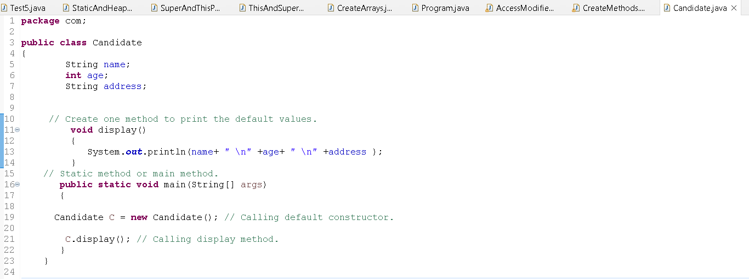

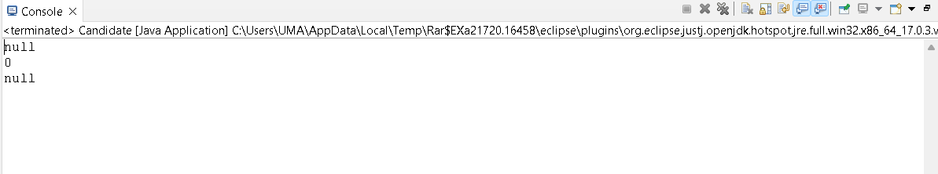

**2.**

**package** com;

//Method, empty constructor and parameterized constructor

**class** Operation {

**int** a,b,sum;

Operation() {

a=10;

b=20;

}

Operation(**int** x, **int** y){

a=x;

b=y;

}

**void** setValue(**int** x, **int** y) {

a=x;

b=y;

}

**void** add() {

sum = a+b;

}

**void** display() {

System.***out***.println("sum is "+sum);

}

}

**public** **class** Constructor {

**public** **static** **void** main(String args[]) {

Operation op1 = **new** Operation(); op1.display();

Operation op2 = **new** Operation(); op2.add(); op2.display();

Operation op3 = **new** Operation(); op3.setValue(100,200); op3.add(); op3.display();

Operation op4 = **new** Operation(11,22); op4.add(); op4.display();

Operation op5 = **new** Operation();

op5.setValue(1,2);

op5.setValue(3,4);

op5.setValue(5,6);

op5.add();

op5.setValue(7,8);

op5.display();

Operation op6 = **new** Operation(100,200);

op6.setValue(2,3);

op6.add();

op6.display();

}

}

**1.**

**package** com;

**public** **class** Candidate

{

String name;

**int** age;

String address;

// Create one method to print the default values.

**void** display()

{

System.***out***.println(name+ " \n" +age+ " \n" +address );

}

// Static method or main method.

**public** **static** **void** main(String[] args)

{

Candidate C = **new** Candidate(); // Calling default constructor.

C.display(); // Calling display method.

}

}





**2.**

**package** com;

**class** Operation {

**int** c,d,sum;

Operation() {

c=30;

d=10;

}

Operation(**int** x, **int** y){

c=x;

d=y;

}

**void** setValue(**int** x, **int** y) {

c=x;

d=y;

}

**void** add() {

sum = c+d;

}

**void** display() {

System.***out***.println("sum is "+sum);

}

}

**public** **class** Constructor {

**public** **static** **void** main(String args[]) {

Operation op1 = **new** Operation(); op1.display();

Operation op2 = **new** Operation(); op2.add(); op2.display();

Operation op3 = **new** Operation(); op3.setValue(100,200); op3.add(); op3.display();

Operation op4 = **new** Operation(15,22); op4.add(); op4.display();

Operation op5 = **new** Operation();

op5.setValue(1,7);

op5.setValue(7,2);

op5.setValue(2,6);

op5.add();

op5.setValue(7,8);

op5.display();

Operation op6 = **new** Operation(300,200);

op6.setValue(1,3);

op6.add();

op6.display();

}

}



