**Module 6 React**

1. **Create a new React Application with the name “myfirstreact”, Run the application to print “welcome to the first session of React” as heading of that page.**

**myfirstreact 🡪 App.js**

import React from 'react';

function App() {

return (

<div>

<h1>Welcome to the first session of React</h1>

</div>

);

}

export default App;

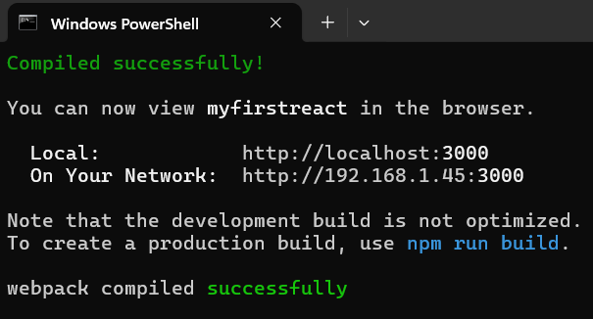

**Output:**

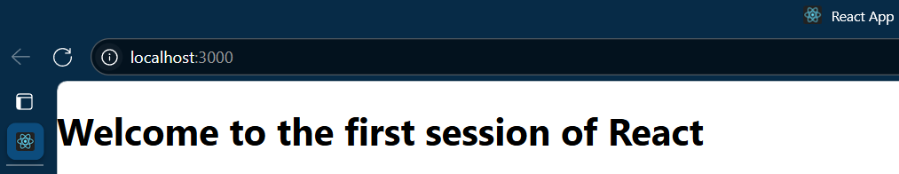

1. **Create a react app for Student Management Portal named StudentApp**

**StudentApp**

import React from 'react';

import Home from './Components/Home';

import About from './Components/About';

import Contact from './Components/Contact';

function App() {

  return (

    <div>

      <Home />

      <About />

      <Contact />

    </div>

  );

}

export default App;

**About.js**

import React from 'react';

function About() {

  return (

    <div>

      <h3>Welcome to the About page of Student Management Portal</h3>

    </div>

  );

}

export default About;

**Contact.js**

import React from 'react';

function Contact() {

  return (

    <div>

      <h3>Welcome to the Contact page of Student Management Portal</h3>

    </div>

  );

}

export default Contact;

**Home.js**

import React from 'react';

function Home() {

  return (

    <div>

      <h3>Welcome to the Home page of Student Management Portal</h3>

    </div>

  );

}

export default Home;

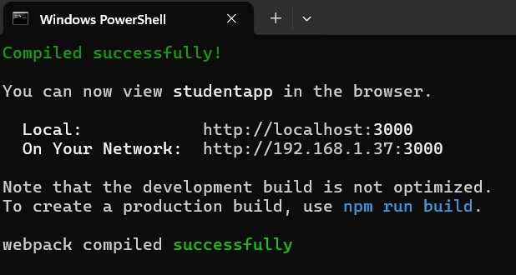

**Output:**

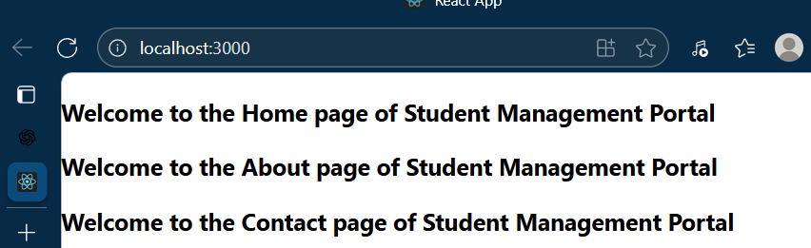

1. **Create a react app for Student Management Portal named scorecalculatorapp and create a function component named “CalculateScore” which will accept Name, School, Total and goal in order to calculate the average score of a student and display the same.**

**CalculateScore.js**

import React from 'react';

import '../Stylesheets/mystyle.css';

function CalculateScore() {

  const name = "Steeve";

  const school = "DNV Public School";

  const total = 284;

  const maxMarks = 300;

  const score = ((total / maxMarks) * 100).toFixed(2);

  return (

    <div className="score-box">

      <h2 className="heading">Student Details:</h2>

      <p><strong className="label name">Name:</strong> <span className="value name">{name}</span></p>

      <p><strong className="label school">School:</strong> <span className="value school">{school}</span></p>

      <p><strong className="label total">Total:</strong> <span className="value total">{total} Marks</span></p>

      <p><strong className="label score">Score:</strong> <span className="value score">{score}%</span></p>

    </div>

  );

}

export default CalculateScore;

**App.js**

import React from 'react';

import CalculateScore from './Components/CalculateScore';

function App() {

  return (

    <div className="App">

      <CalculateScore />

    </div>

  );

}

export default App;

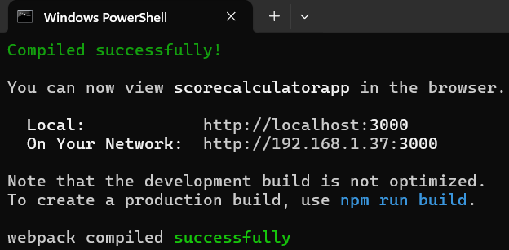

**Output:**

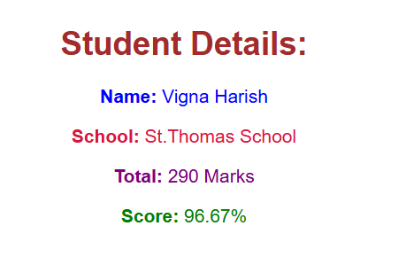

1. **Create a new react application using *create-react-app* tool with the name as “blogapp”**

**Posts.js**

// src/Posts.js

import React, { Component } from 'react';

import Post from './Post';

class Posts extends Component {

  constructor(props) {

    super(props);

    this.state = {

      posts: [],

      error: null,

    };

  }

  componentDidMount() {

    this.loadPosts();

  }

  loadPosts() {

    fetch('https://jsonplaceholder.typicode.com/posts')

      .then(response => response.json())

      .then(data => this.setState({ posts: data }))

      .catch(error => this.setState({ error }));

  }

  componentDidCatch(error, info) {

    alert('An error occurred: ' + error);

  }

  render() {

    const { posts, error } = this.state;

    if (error) {

      return <p>Error loading posts!</p>;

    }

    return (

      <div>

        <h2>Blog Posts</h2>

        {posts.map(post => (

          <Post key={post.id} title={post.title} body={post.body} />

        ))}

      </div>

    );

  }

}

export default Posts;

**Post.js**

// src/Post.js

import React from 'react';

function Post(props) {

  return (

    <div style={{ marginBottom: '20px', padding: '10px', border: '1px solid #ddd' }}>

      <h3>{props.title}</h3>

      <p>{props.body}</p>

    </div>

  );

}

export default Post;

**Output**

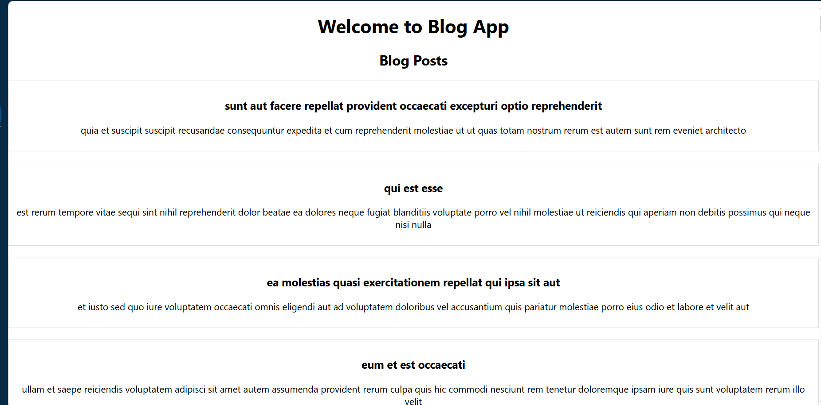

1. **My Academy team at Cognizant want to create a dashboard containing the details of ongoing and completed cohorts. A react application is created which displays the detail of the cohorts using react component. You are assigned the task of styling these react components.**

**Cohortdetails.css**

.box {

width: 300px;

display: inline-block;

margin: 10px;

padding: 10px 20px;

border: 1px solid black;

border-radius: 10px;

}

dt {

font-weight: 500;

}