**Module 7 – React**

**Exercise 10: OfficespacerentalApp**

**App.css**

.App {

text-align: center;

padding: 20px;

font-family: Arial, sans-serif;

}

.office-card {

border: 1px solid #ccc;

border-radius: 10px;

margin: 20px auto;

width: 300px;

padding: 15px;

box-shadow: 2px 2px 10px rgba(0, 0, 0, 0.1);

}

**App.js**

import logo from './logo.svg';

import React from 'react';

import './App.css';

const App = () => {

// Office list

const officeList = [

{

id: 1,

name: "DBS",

rent: 45000,

address: "Guindy, Chennai",

image: "https://www.chennaiproperties.in/propertyrent/9267/gallery/6280-Sqft-Commercial-Office-Space-in-OMR-9267-1.jpg"

},

{

id: 2,

name: "Bangalore WorkHub",

rent: 75000,

address: "Electronic City, Bangalore",

image: "https://5.imimg.com/data5/EF/QC/TU/SELLER-80689678/individual-office-space-for-rent-in-chennai-500x500.JPG"

},

{

id: 3,

name: "Hyderabad Innovation Center",

rent: 58000,

address: "HiTech City, Hyderabad",

image: "https://offices.co/officeimages/IN/52633_5.jpg"

}

];

return (

<div className="App">

<h1>Office Space Rental</h1>

{officeList.map((office) => (

<div key={office.id} className="office-card">

<img src={office.image} alt={office.name} width="250" />

<h2>{office.name}</h2>

<p><strong>Address:</strong> {office.address}</p>

<p style={{ color: office.rent < 60000 ? 'red' : 'green' }}>

<strong>Rent:</strong> ₹{office.rent}

</p>

</div>

))}

</div>

);

};

export default App;

**Output:**

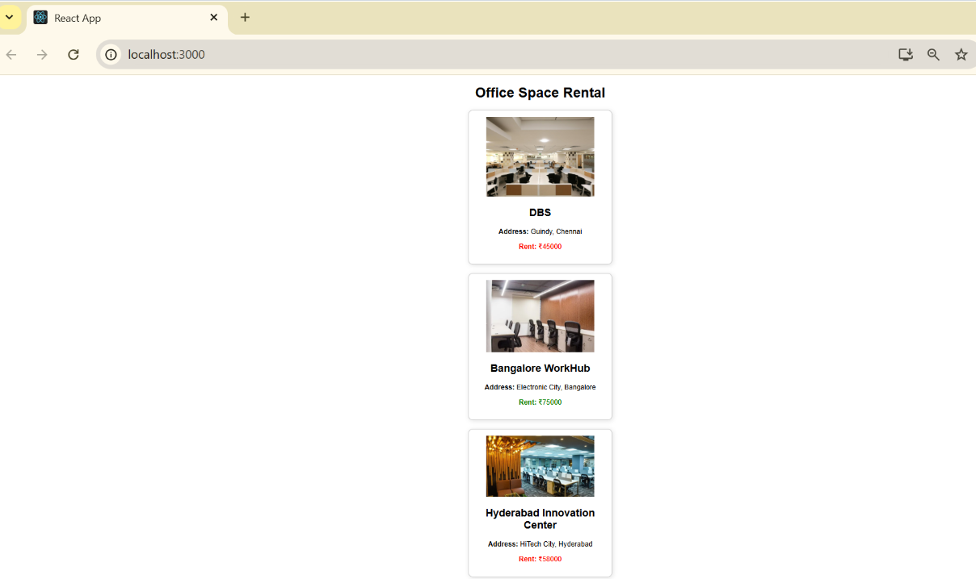

**Exercise 11: EventExamplesApp**

**App.css**

.App {

padding: 20px;

font-family: Arial;

text-align: left;

margin-left: 20px;

}

button {

margin: 5px;

padding: 8px 12px;

font-size: 14px;

}

input, select {

margin-left: 10px;

padding: 6px;

font-size: 14px;

}

**App.js**

import React, { useState } from 'react';

import './App.css';

import CurrencyConverter from './CurrencyConverter';

function App() {

const [count, setCount] = useState(1);

const increment = () => {

sayHello();

setCount(count + 1);

};

const decrement = () => {

setCount(count - 1);

};

const sayHello = () => {

console.log("Hello from React!");

};

const sayWelcome = (msg) => {

alert(msg);

};

const handleClick = () => {

alert("I was clicked");

};

return (

<div className="App">

<p>{count}</p>

<button onClick={increment}>Increment</button>

<button onClick={decrement}>Decrement</button>

<br /><br />

<button onClick={() => sayWelcome("Welcome to React!")}>Say welcome</button>

<br /><br />

<button onClick={handleClick}>Click on me</button>

<br /><br />

<CurrencyConverter />

</div>

);

}

export default App;

**CurrencyConverter.js**

import React, { useState } from 'react';

const CurrencyConverter = () => {

const [amount, setAmount] = useState('');

const [currency, setCurrency] = useState('Euro');

const handleSubmit = (e) => {

e.preventDefault();

let convertedAmount;

if (currency === 'Euro') {

convertedAmount = amount * 80;

} else {

convertedAmount = amount;

}

alert(`Converting to ${currency} Amount is ${convertedAmount}`);

};

return (

<div>

<h2 style={{ color: 'green' }}>Currency Convertor!!!</h2>

<form onSubmit={handleSubmit}>

<label>

Amount:

<input

type="number"

value={amount}

onChange={(e) => setAmount(e.target.value)}

/>

</label>

<br /><br />

<label>

Currency:

<select value={currency} onChange={(e) => setCurrency(e.target.value)}>

<option value="Euro">Euro</option>

<option value="USD">USD</option>

<option value="Yen">Yen</option>

</select>

</label>

<br /><br />

<button type="submit">Submit</button>

</form>

</div>

);

};

export default CurrencyConverter;

**Output:**

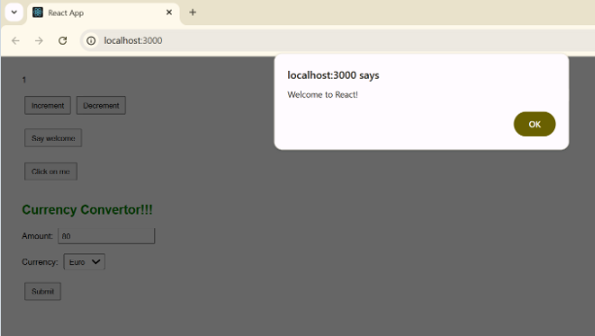

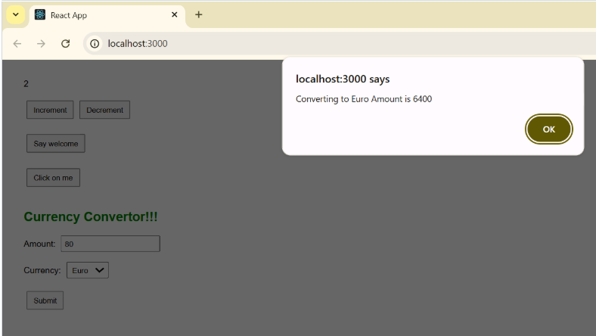

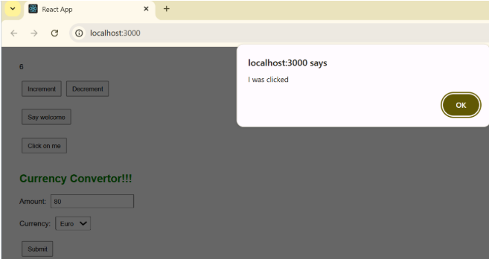

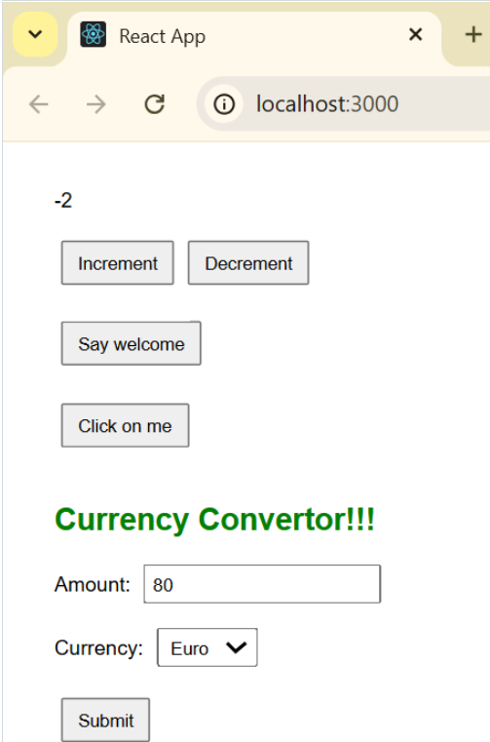

**Exercise 12: TicketBookingApp**

**App.css**

.App {

text-align: center;

margin-top: 100px;

font-family: Arial, sans-serif;

}

button {

margin-top: 20px;

font-size: 16px;

padding: 10px 20px;

}

**App.js**

import React, { useState } from 'react';

import './App.css';

function Greeting(props) {

const isLoggedIn = props.isLoggedIn;

if (isLoggedIn) {

return <h1>Welcome back</h1>;

}

return <h1>Please sign up.</h1>;

}

function LoginButton(props) {

return (

<button onClick={props.onClick}>

Login

</button>

);

}

function LogoutButton(props) {

return (

<button onClick={props.onClick}>

Logout

</button>

);

}

function App() {

const [isLoggedIn, setIsLoggedIn] = useState(false);

const handleLoginClick = () => {

setIsLoggedIn(true);

};

const handleLogoutClick = () => {

setIsLoggedIn(false);

};

let button;

if (isLoggedIn) {

button = <LogoutButton onClick={handleLogoutClick} />;

} else {

button = <LoginButton onClick={handleLoginClick} />;

}

return (

<div className="App">

<Greeting isLoggedIn={isLoggedIn} />

{button}

</div>

);

}

export default App;

**Output:**

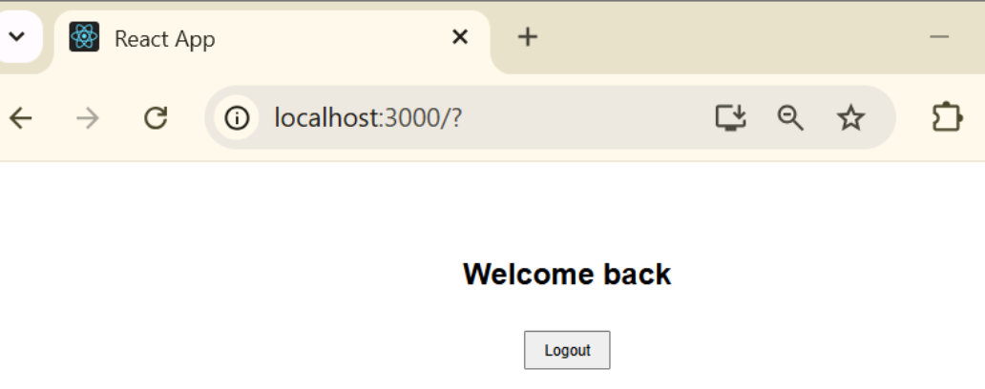

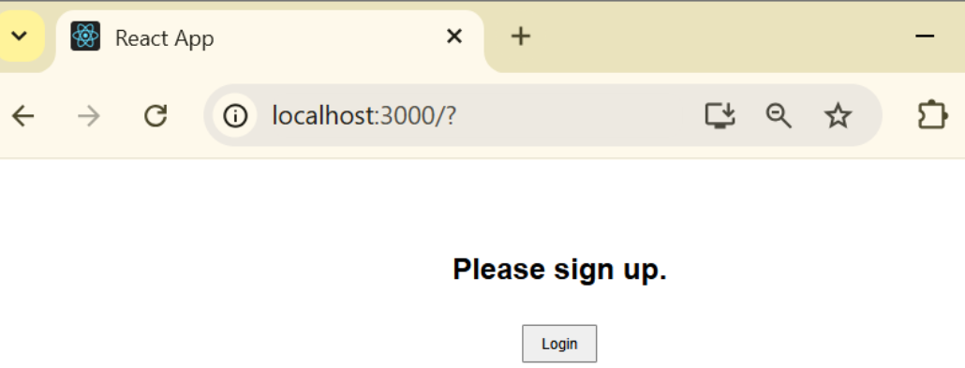

**Exercise 13: BloggerApp**

**App.js**

import React from 'react';

import './App.css';

import CourseDetails from './CourseDetails';

import BookDetails from './BookDetails';

import BlogDetails from './BlogDetails';

function App() {

return (

<div className="App">

<h1>Blogger App</h1>

<div className="container">

<div className="column">

<CourseDetails />

</div>

<div className="column divider">

<BookDetails />

</div>

<div className="column">

<BlogDetails />

</div>

</div>

</div>

);

}

export default App;

**BlogDetails.js**

import React from 'react';

const BlogDetails = () => {

const blogs = [

{

title: 'React Learning',

author: 'Stephen Biz',

content: 'Welcome to learning React!'

},

{

title: 'Installation',

author: 'Schwerzdenier',

content: 'You can install React from npm.'

}

];

return (

<div>

<h2>Blog Details</h2>

<ul>

{blogs.map((blog, index) => (

<li key={index}>

<span style={{ fontWeight: 'bold', fontSize: '18px' }}>{blog.title}</span> <br />

<span style={{ fontSize: '14px' }}>{blog.author}</span> <br />

<span style={{ fontSize: '14px' }}>{blog.content}</span>

</li>

))}

</ul>

</div>

);

};

export default BlogDetails;

**BookDetails.js**

import React from 'react';

const BookDetails = () => {

const books = [

{ title: 'Master React', price: 670 },

{ title: 'Deep Dive Into Angular 11', price: 800 },

{ title: 'Mongo Essentials', price: 450 }

];

return (

<div>

<h2>Book Details</h2>

<ul>

{books.map((book, index) => (

<li key={index}>

<span style={{ fontWeight: 'bold', fontSize: '18px' }}>{book.title}</span> <br />

<span style={{ fontSize: '14px' }}>₹{book.price}</span>

</li>

))}

</ul>

</div>

);

};

export default BookDetails;

**CourseDetails.js**

import React from 'react';

const CourseDetails = () => {

const courses = [

{ name: 'Angular', date: '4/5/2021' },

{ name: 'React', date: '6/3/2020' }

];

return (

<div>

<h2>Course Details</h2>

<ul>

{courses.map((course, index) => (

<li key={index}>

<span style={{ fontWeight: 'bold', fontSize: '18px' }}>{course.name}</span> <br />

<span style={{ fontSize: '14px' }}>{course.date}</span>

</li>

))}

</ul>

</div>

);

};

export default CourseDetails;

**Output:**

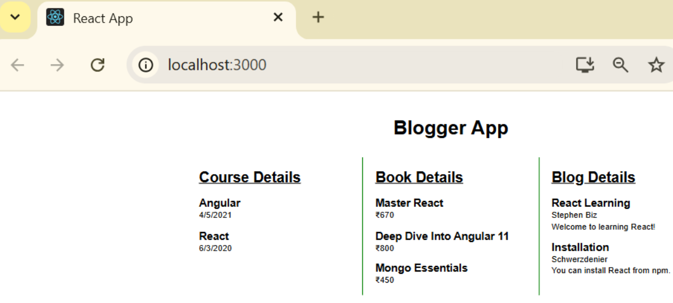

**Exercise 9: CricketApp**

**App.js**

import React from 'react';

import ListofPlayers from './ListofPlayers';

import IndianPlayers from './IndianPlayers';

function App() {

const flag = true;

return (

<div className="App">

<h1>Cricket App</h1>

{flag ? <ListofPlayers /> : <IndianPlayers />}

</div>

);

}

export default App;

**IndianPlayers.js**

import React from 'react';

function IndianPlayers() {

const oddPlayers = ['Sachin1', 'Virat3', 'Yuvaraj5'];

const evenPlayers = ['Dhoni2', 'Rohit4', 'Raina6'];

const mergedPlayers = [

'Mr. First Player',

'Mr. Second Player',

'Mr. Third Player',

'Mr. Fourth Player',

'Mr. Fifth Player',

'Mr. Sixth Player'

];

return (

<div>

<h2>Odd Players</h2>

<ul>

<li>First : {oddPlayers[0]}</li>

<li>Third : {oddPlayers[1]}</li>

<li>Fifth : {oddPlayers[2]}</li>

</ul>

<h2>Even Players</h2>

<ul>

<li>Second : {evenPlayers[0]}</li>

<li>Fourth : {evenPlayers[1]}</li>

<li>Sixth : {evenPlayers[2]}</li>

</ul>

<h2>List of Indian Players Merged:</h2>

<ul>

{mergedPlayers.map((player, index) => (

<li key={index}>{player}</li>

))}

</ul>

</div>

);

}

export default IndianPlayers;

**ListofPlayers.js**

import React from 'react';

function ListofPlayers() {

const players = [

{ name: 'Mr. Jack', score: 50 },

{ name: 'Mr. Michael', score: 70 },

{ name: 'Mr. John', score: 40 },

{ name: 'Mr. Ann', score: 61 },

{ name: 'Mr. Elisabeth', score: 61 },

{ name: 'Mr. Sachin', score: 95 },

{ name: 'Mr. Dhoni', score: 100 },

{ name: 'Mr. Virat', score: 84 },

{ name: 'Mr. Jadeja', score: 64 },

{ name: 'Mr. Raina', score: 75 },

{ name: 'Mr. Rohit', score: 80 },

];

const lowScorers = players.filter(player => player.score < 70);

return (

<div>

<h2>List of Players</h2>

<ul>

{players.map((p, index) => (

<li key={index}>

{p.name} {p.score}

</li>

))}

</ul>

<h2>List of Players having Scores Less than 70</h2>

<ul>

{lowScorers.map((p, index) => (

<li key={index}>

{p.name} {p.score}

</li>

))}

</ul>

</div>

);

}

export default ListofPlayers;

**Output:**



