Student Internship Evaluation Form

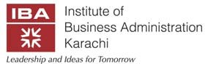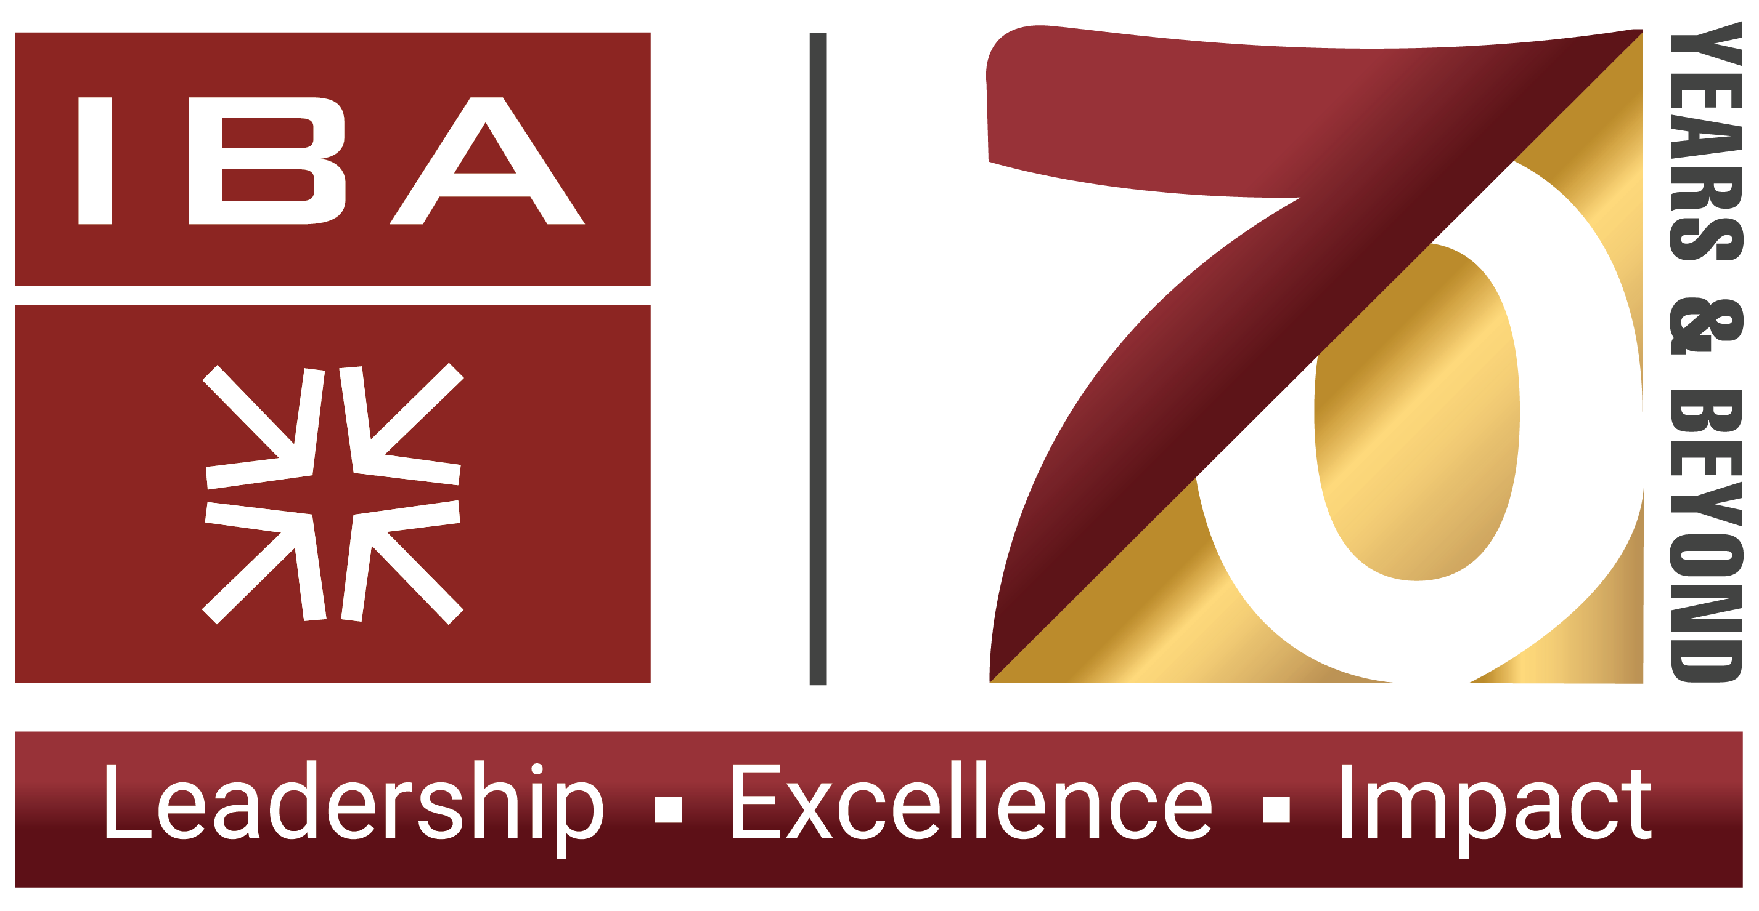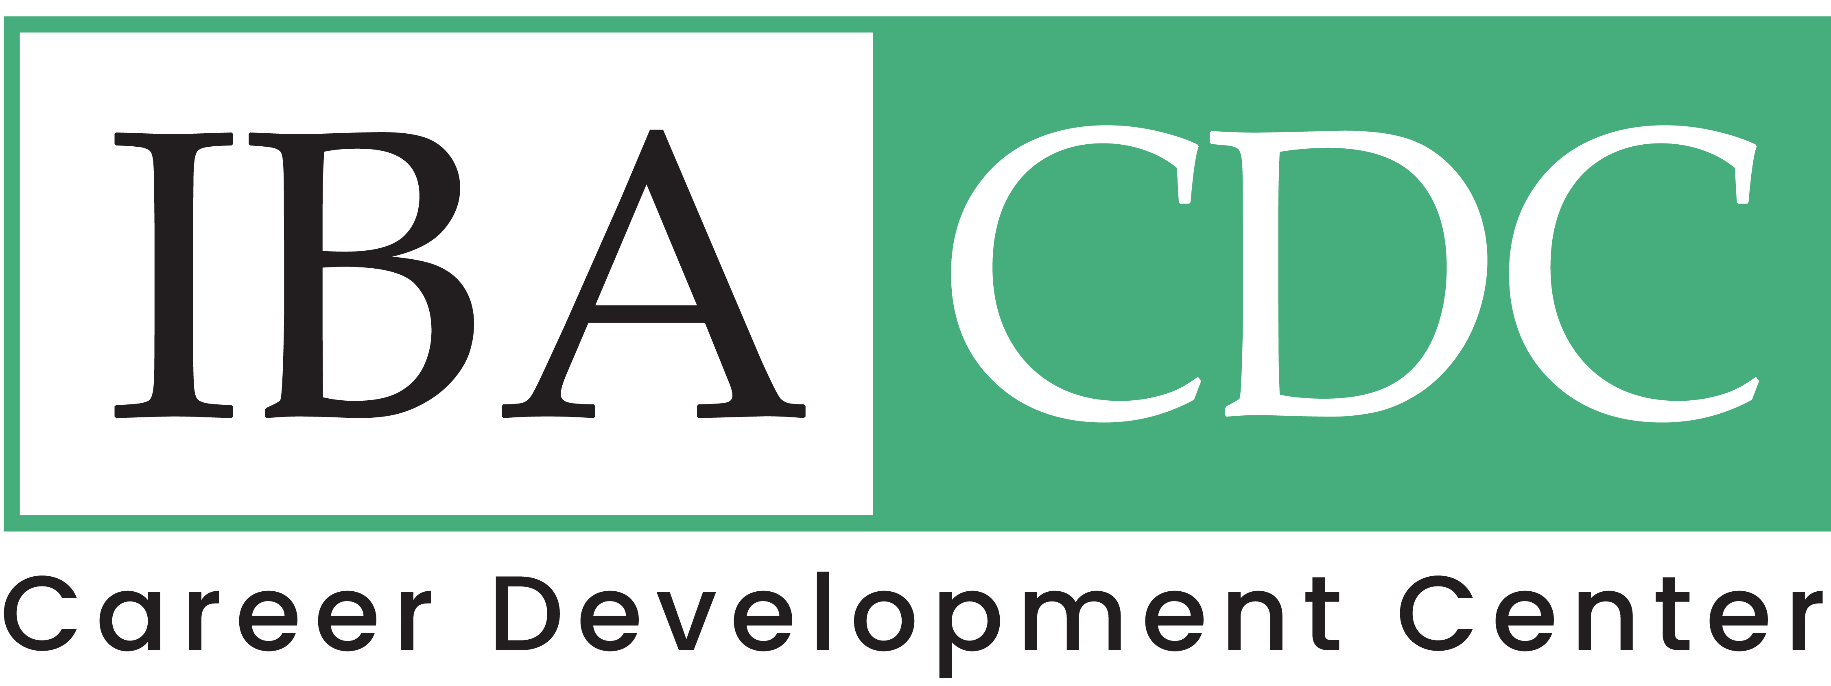

**To be filled in by the Mentor / Supervisor**

**GENERAL INFORMATION**  
  
Organization Name:

Mentor / Supervisor Name:

Designation and Department: Email:

Student Name:

ERP # as per the IBA Records: Academic Program:

Internship Commencement Date: Internship End Date:



Supervisors are requested to assess the student candidly on the following attributes *(specifications are mentioned below each)*:

|  |  |  |  |  |  |
| --- | --- | --- | --- | --- | --- |
| **Attributes** | **Grading Scale** | | | | |
| **Excellent** | **Good** | **Satisfactory** | **Poor** | **Not Assessed** |
| **Punctuality & Regularity**  On time arrival at workplace consistently. Working  without delays. |  |  |  |  |  |
| **Interpersonal skills**  Ability to interact and communicate with others including  both the verbal and nonverbal aspects. |  |  |  |  |  |
| **Team Work**  Collaborative skills while working in a team setting. Ability  to manage team building process. |  |  |  |  |  |
| **Business Knowledge**  Understand the application and limitations of business models and operations. Ability to understand the professional integrity and competencies of their  respective fields/academic programs. |  |  |  |  |  |
| **Analytical, Critical Thinking and Problem Solving Ability** Critically reflect on the use of theory to understand practices and processes. Evaluation of complex and systematic situations to generate alternate solutions.  Analyse problems and apply appropriate problem solving  approaches. Ability to take initiatives. |  |  |  |  |  |
| **Glocal Approach**  Ability to understand and enhance the awareness of global business management. Awareness of local business practices. Ability to differentiate between local and global  business practices in cultural contexts/cultural sensitivity. |  |  |  |  |  |
| **Ethics & Professionalism**  Understand ethical responsibility towards society. Able to understand the principles of fairness while dealing with  all stakeholders. |  |  |  |  |  |

|  |  |  |  |  |  |
| --- | --- | --- | --- | --- | --- |
| **Attributes** | **Grading Scale** | | | | |
| **Excellent** | **Good** | **Satisfactory** | **Poor** | **Not Assessed** |
| **Presentation of work/assignments**  Presents oral & written work in a logical and structured manner. Coherent and clear delivery, time management and logical flow of ideas in verbal communication.  Interpret data to appraise evidence and evaluate arguments. Exhibit clear and precise use of language, structured arguments and appropriate referencing of  sources. |  |  |  |  |  |
| **ICT Skills**  Using technology effectively. Effective use of presentation  tools and IT equipment. |  |  |  |  |  |
| **Productivity**  Effectiveness of efforts. Output brings out by the student  during the internship period. |  |  |  |  |  |





Supervisor’s Signature: Date:



This is to certify that Mr. / Ms.

has completed weeks internship at our organization from to

Name of HR Person: Designation

Signature and Stamp: Date:

On behalf of the IBA, we would like to thank you for providing our students a chance to learn about practical aspects of professional life. Feel free to reach out us in case you have further such opportunities.

Career Development Center Institute of Business Administration

Room no. 212, 2nd Floor, Fauji Foundation Building, IBA Main Campus, Karachi University, University Road, Karachi − 75270

Phone # +9221−38104700 Ext: 1176/1177/1179/1183

Email: [cdc@iba.edu.pk](mailto:cdc@iba.edu.pk)

Job portal: https://jobportal.iba.edu.pk Website: https://cdc.iba.edu.pk/