Diamond sizes

Uma Mahesh

2021

We have data about 53940 diamonds. Only 126 are larger than 2.5 carats. The distribution of the remainder is shown below:

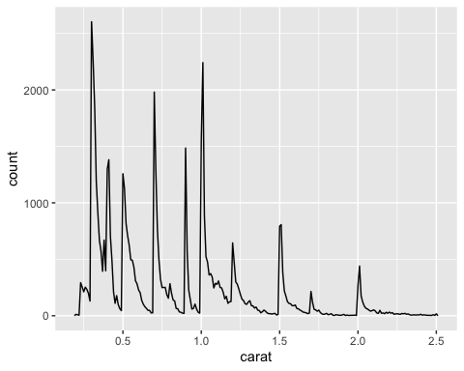

library(skimr)  
skim(diamonds)

Data summary

|  |  |
| --- | --- |
| Name | diamonds |
| Number of rows | 53940 |
| Number of columns | 10 |
| _______________________ |  |
| Column type frequency: |  |
| factor | 3 |
| numeric | 7 |
| ________________________ |  |
| Group variables | None |

**Variable type: factor**

| skim_variable | n_missing | complete_rate | ordered | n_unique | top_counts |
| --- | --- | --- | --- | --- | --- |
| cut | 0 | 1 | TRUE | 5 | Ide: 21551, Pre: 13791, Ver: 12082, Goo: 4906 |
| color | 0 | 1 | TRUE | 7 | G: 11292, E: 9797, F: 9542, H: 8304 |
| clarity | 0 | 1 | TRUE | 8 | SI1: 13065, VS2: 12258, SI2: 9194, VS1: 8171 |

**Variable type: numeric**

| skim_variable | n_missing | complete_rate | mean | sd | p0 | p25 | p50 | p75 | p100 | hist |
| --- | --- | --- | --- | --- | --- | --- | --- | --- | --- | --- |
| carat | 0 | 1 | 0.80 | 0.47 | 0.2 | 0.40 | 0.70 | 1.04 | 5.01 | ▇▂▁▁▁ |
| depth | 0 | 1 | 61.75 | 1.43 | 43.0 | 61.00 | 61.80 | 62.50 | 79.00 | ▁▁▇▁▁ |
| table | 0 | 1 | 57.46 | 2.23 | 43.0 | 56.00 | 57.00 | 59.00 | 95.00 | ▁▇▁▁▁ |
| price | 0 | 1 | 3932.80 | 3989.44 | 326.0 | 950.00 | 2401.00 | 5324.25 | 18823.00 | ▇▂▁▁▁ |
| x | 0 | 1 | 5.73 | 1.12 | 0.0 | 4.71 | 5.70 | 6.54 | 10.74 | ▁▁▇▃▁ |
| y | 0 | 1 | 5.73 | 1.14 | 0.0 | 4.72 | 5.71 | 6.54 | 58.90 | ▇▁▁▁▁ |
| z | 0 | 1 | 3.54 | 0.71 | 0.0 | 2.91 | 3.53 | 4.04 | 31.80 | ▇▁▁▁▁ |

ggplot(data=diamonds) +   
 geom_bar(mapping = aes(x =cut, fill =clarity))

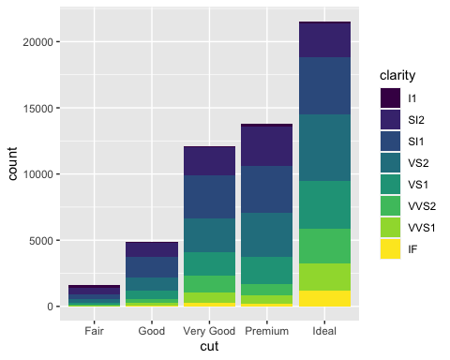

ggplot(data = diamonds) +  
 geom_bar(mapping = aes(x=cut, fill=color))

