1. /Create a directory /hadoop/hdfs/ in HDFS

**hadoop fs -mkdir -p /hadoop/hdfs**

b. Create a temp directory in Hadoop. Run HDFS command to delete “temp” directory.

command- **hadoop fs -mkdir /temp**

delete command- **hadoop fs -rm -r /temp**

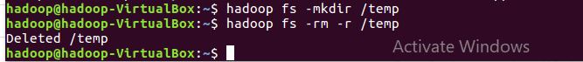

c) List all the files/directories for the given hdfs destination path.

**Hadoop fs -R /hadoop/hdfs**

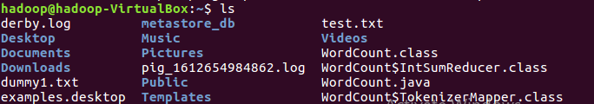

d) Command that will list the directories in /hadoop folder.

**hdfs dfs -ls /hadoop**

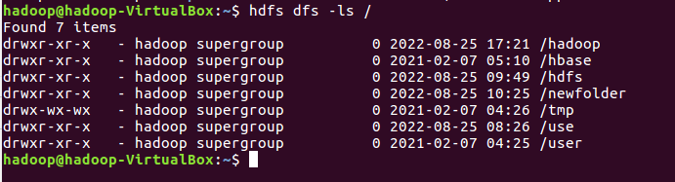

e) Command to list recursively all files in hadoop directory and all subdirectories in hadoop directory

**Hadoop fs -ls -R /hadoop**

**f)**List all the files inside /hadoop/hdfs/ directory which starts with 'dir'.

g) Create a temp.txt file. Copies this file from local file system to HDFS

**touch temp.txt**

**Hdfs dfs -copyFromLocal -f temp.txt /hadoop/hdfs**

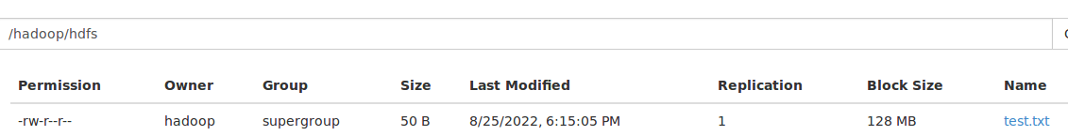



h) Copies the file from HDFS to local file system.

**Hdfs dfs -copyToLocal /hadoop/hdfs/temp.txt**

**k)** Command to move from local directory source to Hadoop directory



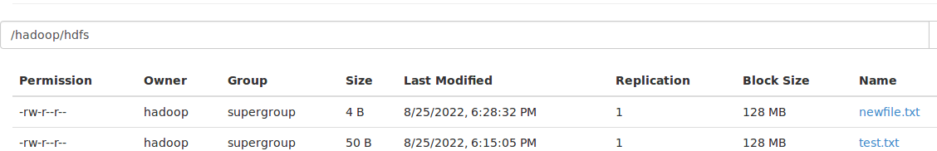

l)Deletes the directory and any content under it recursively.

Hdfs dfs -rm hadoop/hdfs/temp.txt



j)Command to copies to local directory with the source being restricted to a local file reference.



m)List the files and show Format file sizes in a human-readable fashion.

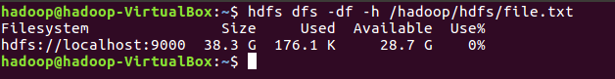

o)Display the content of the HDFS file test on your /user/hadoop2 directory.

**Hadoop fs -appendToFile temp.txt /hadoop/hdfs/test.txt**

p)Append the content of a local file test1 to a hdfs file test2.

Hadoop fs -appendToFile file.txt test.txt hadoop/hdfs/file.txt

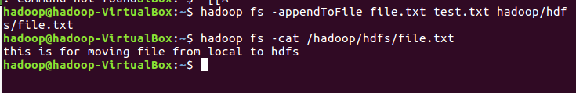

q)Show the capacity, free and used space of the filesystem

**Command - df**

r) Shows the capacity, free and used space of the filesystem. Add parameter Formats the sizes of files in a human-readable fashion.

**Command - hdfs dfs -df**

s)Show the amount of space, in bytes, used by the files that match the specified file pattern.

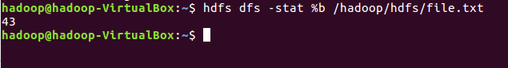

t)Show the amount of space, in bytes, used by the files that match the specified file pattern. Formats the sizes of files in a human-readable fashion.

**Command - hdfs dfs -du -h /**

**u)**Check the health of the Hadoop file system.

**Command -Hdfs fsch /hadoop/hdfs**

**v)**Command to turn off the safemode of Name Node.

**Command - hadoop dfsadmin -safemode leave**

w)HDFS command to format NameNode.

**Command- hadoop namenode -format**

x)Create a file named hdfstest.txt and change it number of replications to 3.

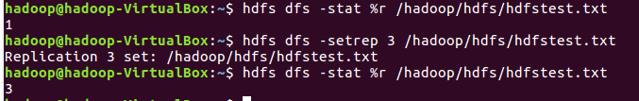

y)Write command to display number of replicas for hdfstest.txt file.

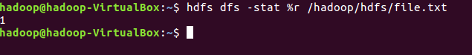

z)Write command to Display the status of file “hdfstest.txt” like block size, filesize in bytes.

**Hdfs dfs -stat %r /hadoop/hdfs/hdfstest.txt**

**Hdfs dfs -stat %o /hadoop/hdfs/hdfstest.txt**

**aa)**Write HDFS command to change file permission from   
 rw – r – r to rwx-rw-x for hdfstest.txt.

**Hdfs dfs -chmod /hadoop/hdfs/hdfstest.txt**

