HR WORKFORCE ANALYTICS DASHBOARD

CodeAlpha Data Analytics Internship – Task 2
Submitted By

Umamani Singh

Internship Organization

CodeAlpha

Project Title

HR Workforce Analytics Dashboard using Microsoft Power BI

TABLE OF CONTENTS

1. Introduction ....................................................... 1

2. Project Objectives ................................................. 2

3. Dataset Overview ................................................... 3

4. Dashboard Development Process ............................... 4

5. Dashboard Features ................................................. 5
5.1 KPI Cards ...................................................... 5
5.2 Employees by Department ............................... 5
5.3 Gender Distribution ....................................... 6
5.4 Recruitment Sources ..................................... 6
5.5 Employees by Location .................................. 7
5.6 Average Salary by Department ....................... 7
5.7 Interactive Filters .......................................... 8

6. Dashboard Screenshot ........................................... 9

7. Key Insights ......................................................... 10

8. Business Benefits ................................................. 11

9. Conclusion .......................................................... 12

10. GitHub Repository .............................................. 13

1. Introduction

Human Resource Analytics (HR Analytics) is the process of collecting, analyzing, and visualizing employee-related data to improve workforce management and support strategic business decisions.

This project presents an interactive HR Workforce Analytics Dashboard developed in Microsoft Power BI. The dashboard enables HR managers to monitor employee distribution, satisfaction, performance, recruitment sources, salary trends, and attrition rates using dynamic visualizations.

The dashboard is designed to simplify HR reporting and assist organizations in making informed decisions regarding employee management and organizational planning.

2. Project Objectives

The main objectives of this project are:

Analyze employee distribution across departments.
Measure employee satisfaction and performance.
Monitor employee attrition rate.
Compare salaries across different departments.
Evaluate recruitment sources.
Provide interactive filtering using slicers.
Support data-driven HR decision making.

3. Dataset Overview

The HR dataset contains information about 250 employees working across multiple departments.

Dataset Fields
Employee ID
Employee Name
Department
Gender
Location
Salary
Satisfaction Score
Performance Rating
Recruitment Source
Experience
Attrition
Hiring Cost

The dataset was imported into Microsoft Power BI, where data cleaning and visualization were performed.

4. Dashboard Development Process

The following steps were performed while developing the dashboard:

Imported HR dataset into Power BI.
Verified data types and removed inconsistencies.
Created calculated measures for KPIs.
Designed KPI cards to display key metrics.
Built charts to analyze workforce trends.
Added interactive slicers for dynamic filtering.
Applied a clean and professional dashboard layout.

5. Dashboard Features

KPI Cards

The dashboard displays four key performance indicators:

👥 Total Employees: 250
⭐ Average Satisfaction: 7.50
🏆 Average Performance: 3.38
📉 Attrition Rate: 22.40%

These KPIs provide a quick overview of workforce performance.

Employees by Department

A horizontal bar chart displays employee distribution across departments such as Support, Marketing, R&D, HR, and Finance.

This visualization helps identify departments with higher workforce strength.

Gender Distribution

A donut chart represents the gender ratio of employees.

This helps evaluate workforce diversity and inclusion.

Recruitment Sources

Another donut chart compares different recruitment channels such as:

Campus
Indeed
Referral
Naukri
LinkedIn

This helps HR identify the most effective hiring source.

Employees by Location

A clustered column chart shows employee distribution across multiple cities including:

Noida
Lucknow
Delhi
Kolkata
Pune
Bangalore
Chennai
Mumbai
Hyderabad
Ahmedabad

This provides geographical workforce analysis.

Average Salary by Department

A clustered column chart compares the average salary offered in different departments.

It helps management understand salary distribution and departmental compensation.

Interactive Filters

The dashboard includes slicers for:

Department
Gender
Location

These filters allow users to explore specific employee groups interactively.

6. Dashboard Screenshot

HR Workforce Analytics Dashboard

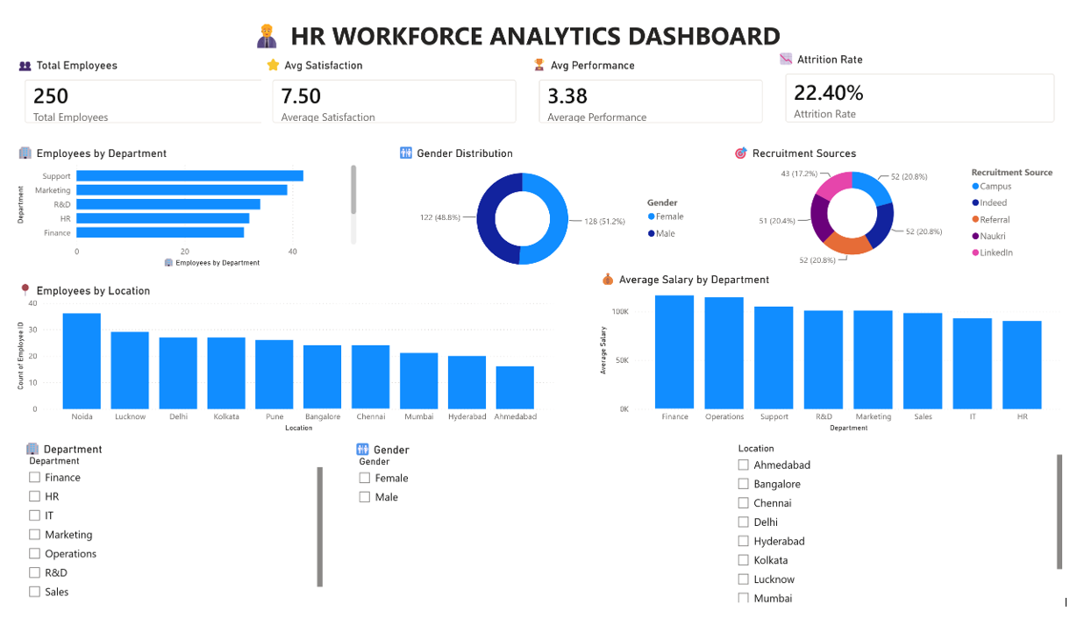

Figure 1: Interactive HR Workforce Analytics Dashboard developed using Microsoft Power BI.

7. Key Insights

Based on the dashboard analysis:

The organization consists of 250 employees.
The average employee satisfaction score is 7.50, indicating a generally positive work environment.
The average performance rating is 3.38, reflecting stable employee performance.
The attrition rate is 22.40%, highlighting opportunities to improve employee retention.
Support and Marketing departments have comparatively higher employee counts.
Recruitment is distributed across multiple hiring platforms, reducing dependency on a single source.
Salary varies by department, supporting role-based compensation strategies.
Workforce is spread across multiple locations, providing regional diversity.

8. Business Benefits

This dashboard enables organizations to:

Monitor workforce performance efficiently.
Improve employee retention strategies.
Evaluate recruitment effectiveness.
Compare departmental salary trends.
Analyze employee satisfaction levels.
Support strategic HR planning.
Make data-driven management decisions.

9. Conclusion

The HR Workforce Analytics Dashboard successfully transforms employee data into meaningful business insights using Microsoft Power BI.

By integrating KPIs, interactive charts, and slicers, the dashboard enables HR professionals to monitor workforce performance, recruitment effectiveness, salary distribution, and attrition trends in a user-friendly interface.

This project demonstrates the practical application of Business Intelligence tools in Human Resource Management and supports informed organizational decision-making.

GitHub Repository

Repository Name

CodeAlpha_HR_Workforce_Analytics

