Instructions to install data model

# Register for Salesforce DEV ORG

You’ll need a Force.com environment that supports Force.com development. The data model is designed to work with a Force.com Developer Edition environment, which you can get for free at <https://developer.salesforce.com/signup?d=70130000000hUZp>.

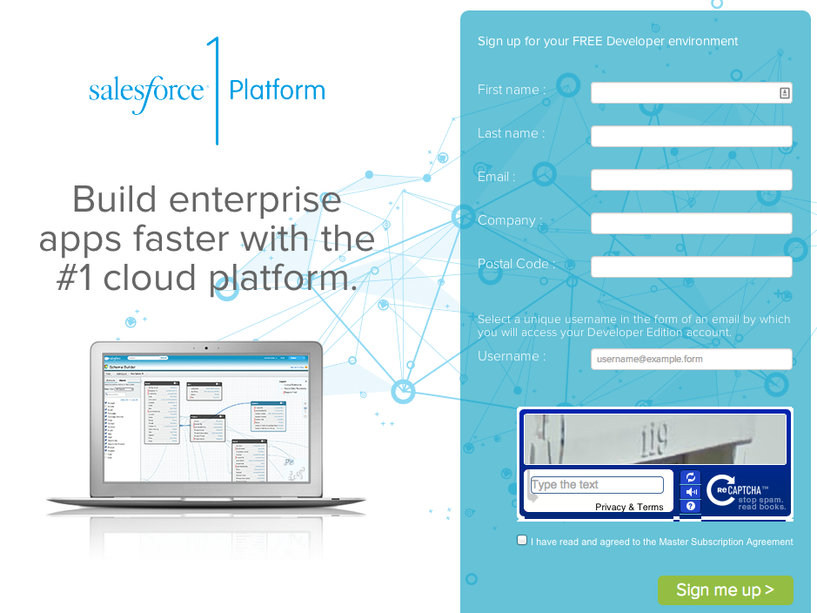

* Fill in the fields about you and your company
* In the Email Address field, make sure to use a public address you can easily check from a Web browser.
* Type a unique Username. Note that this field is also in the form of an email address, but it does not have to be the same as your email address, and in fact, it’s usually better if they aren’t the same. Your username is your login and your identity on developer.force.com, so you’re often better served by choosing a username such as [firstname@lastname.com](mailto:firstname@lastname.com) (example: trinity@thematrix.bl)
* Read and then select the checkbox for the Master Subscription Agreement. and then click Submit Registration.
* In a moment you’ll receive an email with a login link. Click the link and change your password.

Go to your email account and wait until you receive a confirmation email:

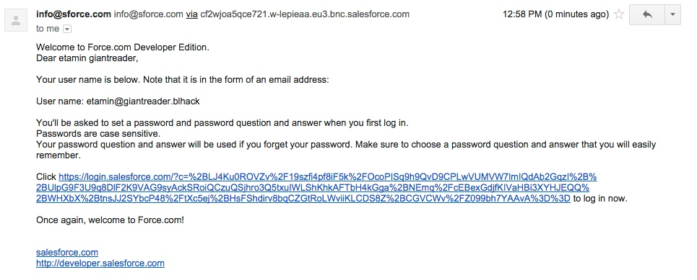

Copy and paste the URL in another browser window, complete the registration process

# Setting up your Organization

After you login in your DEV ORG you can [start developing right away](https://developer.salesforce.com/docs/atlas.en-us.workbook.meta/workbook/workshops_intro.htm). But we recommend to follow these quick steps to setup your instance.

Go to Setup > Company Profile > Language Settings, and set:

* Enable End User Languages
* In the List Add or Remove languages, find Hebrew and add it
* Click Save

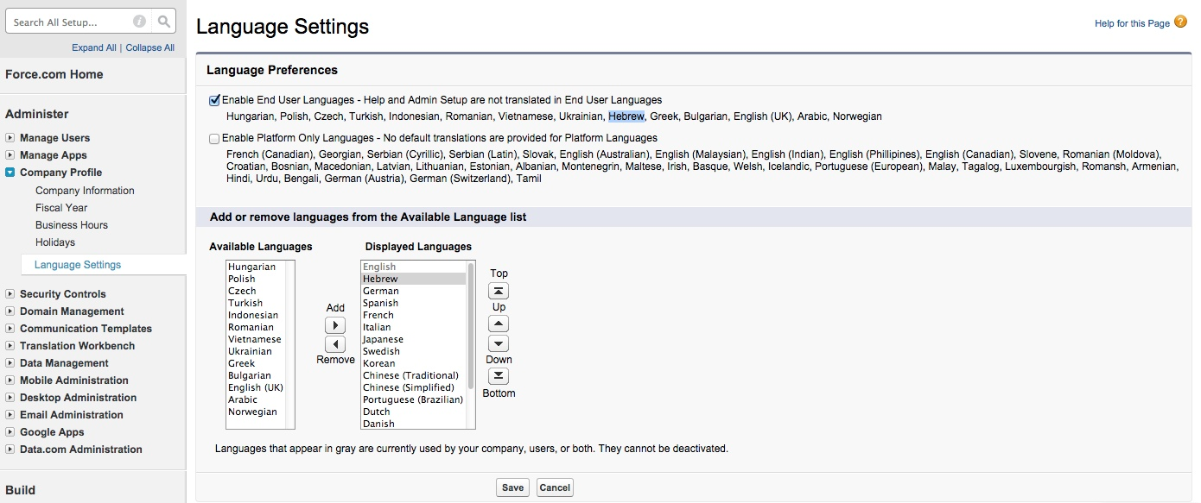

Finish Configuration

To complete the tasks now you need to:

* change company information and user settings
* install the Bank Leumi Hackathon package
* import translation labels
* import/load the data
* test!

## Change Company Information Settings

Go to Setup > Administer > Company Profile > Company Information

Click on Edit and Change:

Country = IL

Default Locale = Hebrew

Default Language = Hebrew

Default Time Zone = (GMT+3) Israel Daylight Time

Currency Locale = Hebrew

Un check newsletters check boxes

Click Save

## Change User Settings

Go to Setup > Administer > Manage Users > Users

In the list click on Edit on the row of the user just created and change

Country = IL

Time Zone = (GMT+3) Israel Daylight Time

Locale = Hebrew

Language = Hebrew

Un check newsletters check boxes

Click Save

## Add other Users

Go to Setup > Administer > Manage Users > Users

Click New User

You can create up to 2 System Administrators, but the DEV ORG includes other licenses:

A number of licenses are provided for other salesforce.com products as well:

* Salesforce Customer Portal
* 2 Salesforce CRM licenses
* 2 Salesforce Mobile licenses
* 3 Salesforce Platform licenses
* 5 Salesforce Partner licenses
* 10 Salesforce Customer Portal Manager licenses

For more information on Developer ORG Edition check the [following document](https://developer.salesforce.com/page/Developer_Edition).

Also check the [User Licenses Overview](https://help.salesforce.com/HTViewHelpDoc?id=users_understanding_license_types.htm&language=en_US). And the [Standard User Licenses](https://help.salesforce.com/HTViewHelpDoc?id=users_license_types_available.htm&language=en_US) document to understand which license define for each user you create.

# Install Bank Leumi Hackathon Salesforce package

Follow these steps to add the package with the data model:

Login into your Salesforce Developer ORG

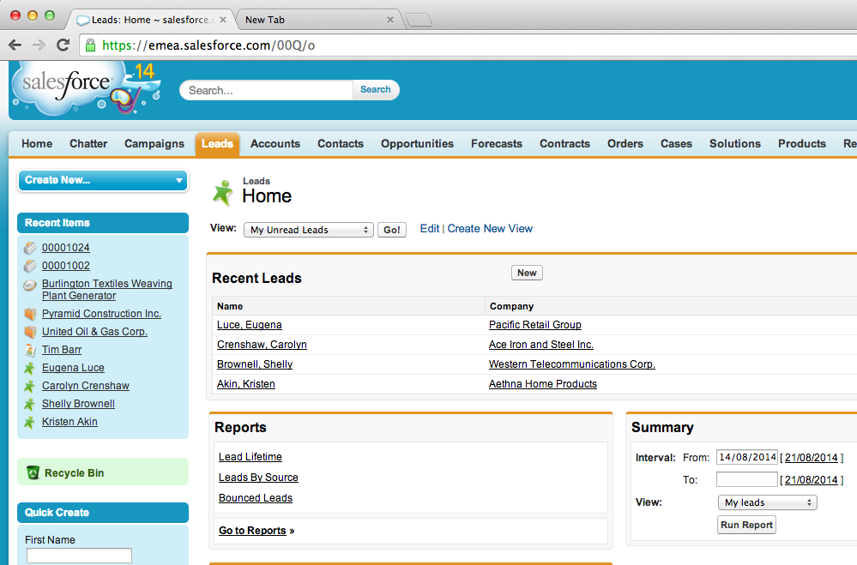

Open a new tab in the same browser window and use it to load the following URL <https://login.salesforce.com/packaging/installPackage.apexp?p0=04t200000006Vut>

The package name should be LeumiHackaton, version name BL-HACK, version number 2.1

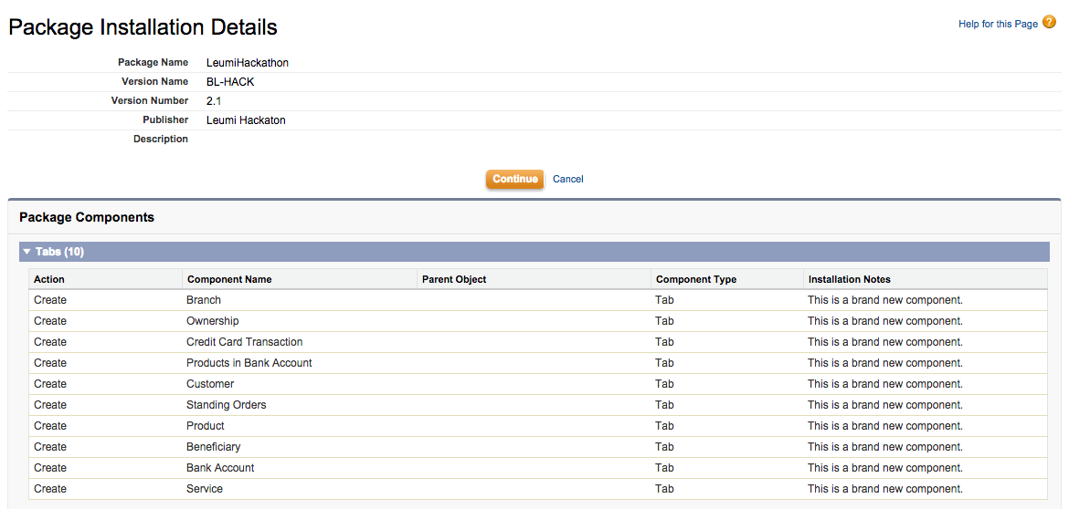

Click Continue and then make sure to select the option to stop installation if there are installation conflicts.

The installation will take a few seconds and you will receive an email with the status[1].

To check that the package has been installed correctly go to the App menu and select the Hackathon option

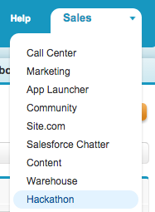

And you will have access to the tabs and objects created for the Hackathon

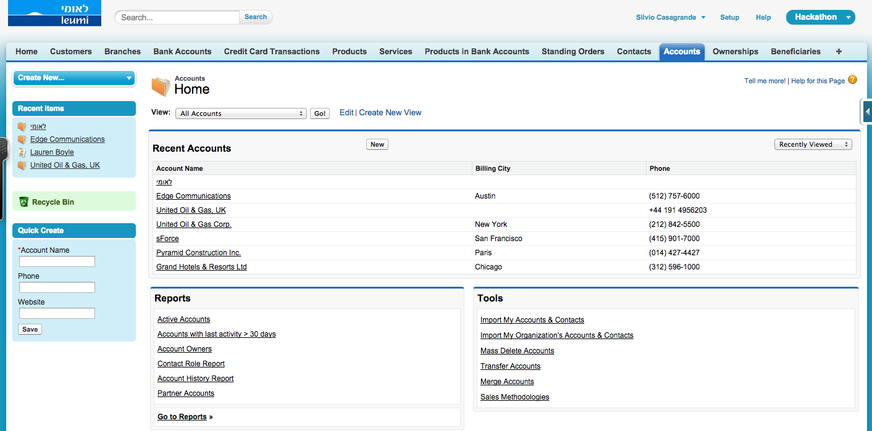

# Where to check the contents of the package?

Go to Setup -> Build -> Installed Packages

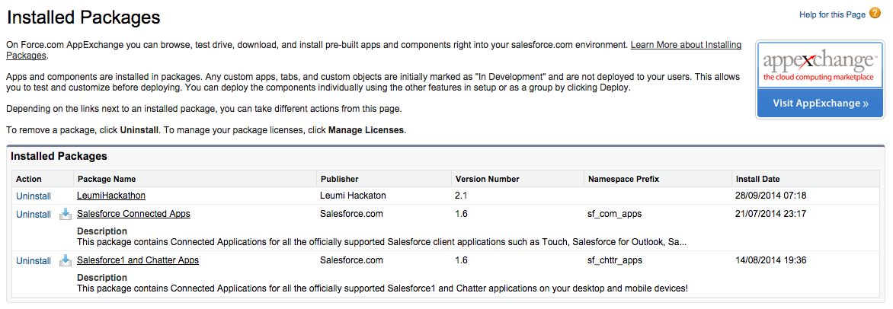

Click on the LeumiHackathon package:

In the next page click the button View Components:

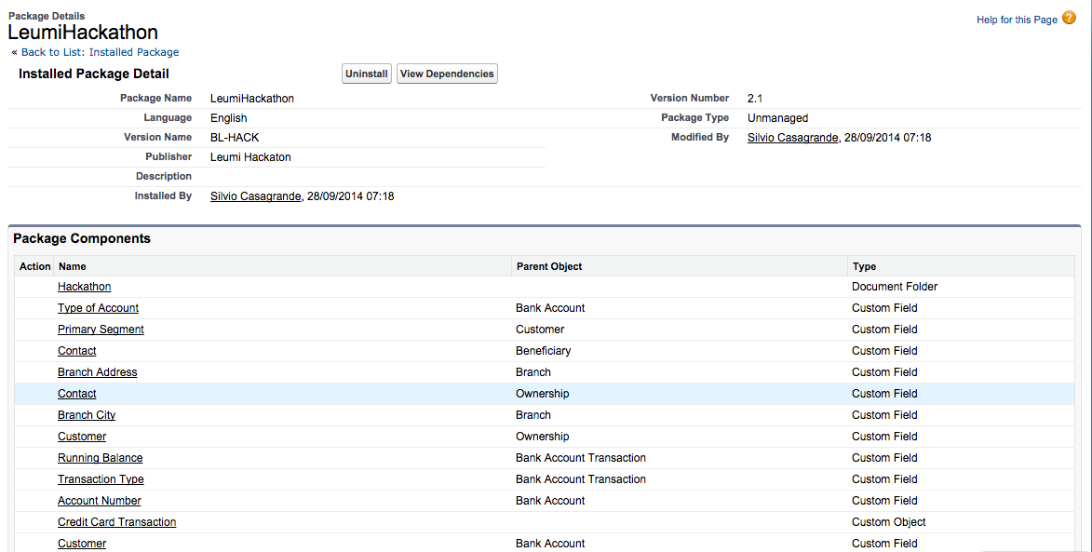

Page down the page to study the components included in the package

# Import Translation Labels

Go to Setup > Administer > Translation Workbench

Click on Translations Settings

Enable the Translation Workbench

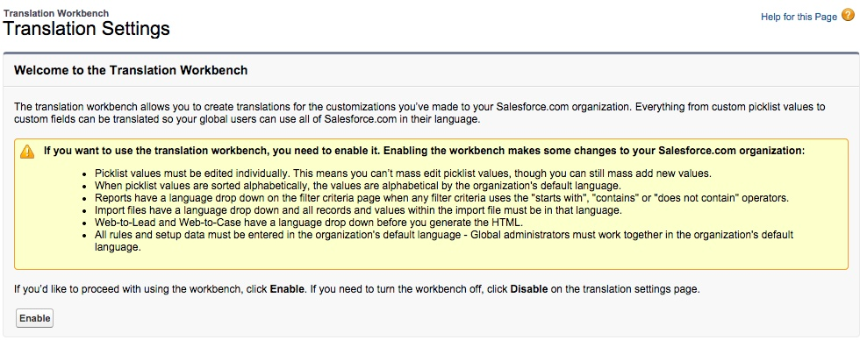

In the next screen Click Add to add a translator (existing user) to the Supported Language (Hebrew)

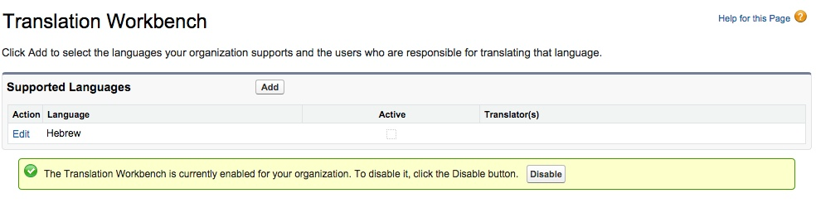

The translated labels are provided in a file. Now you have to import it:

* Download the file [Bilingual_iw_2014-09-28 0825.stf](https://github.com/umabot/bkleumi-hack/blob/master/translation/Bilingual_iw_2014-09-28%200825.stf) from <https://github.com/umabot/bkleumi-hack/tree/master/translation>
* Go to Setup > Administer > Translation Workbench > Import
* At Step 3 (read the Step 1 and 2), click Choose File and select the file [Bilingual_iw_2014-09-28 0856.stf](https://github.com/umabot/bkleumi-hack/blob/master/translation/Bilingual_iw_2014-09-28%200825.stf) downloaded
* Click Import

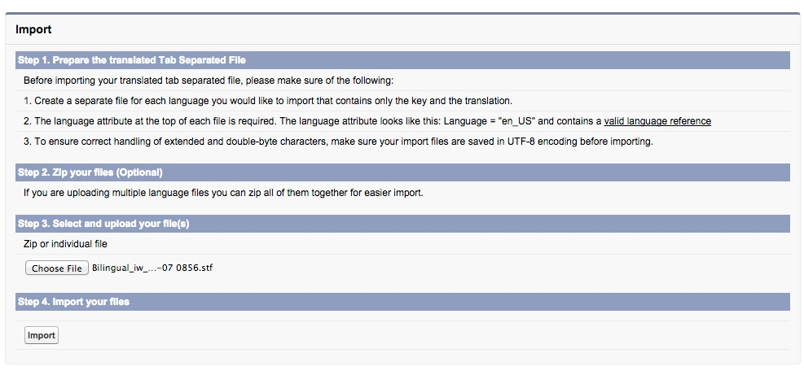

You will receive an email with the results of the import:

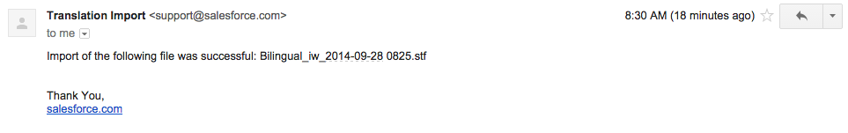

# Import/Load Data

Go to Setup > Build > Schema Builder and you can browse the data model:

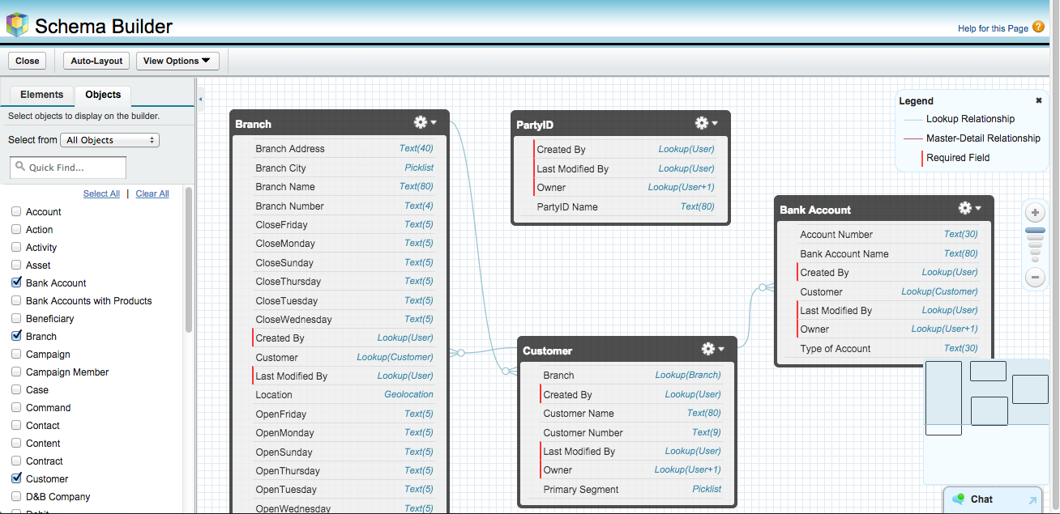

But the objects are empty! Yes, no data. And this is the first step after you have your Object Model ready: you need to upload data.

So close the Schema Builder and go to Setup > Build > Develop > Static Resources:

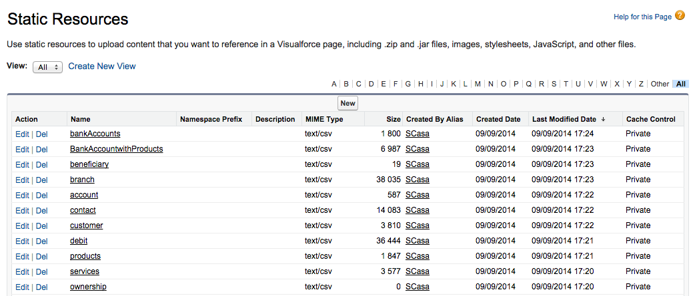

Yes, all the sample data for each object is stored in CSV files. You can download them and import.

## How?

The CSV files are UTF-8 formatted and you have many options to upload data into a Force.com ORG. You can use the [Data Import Wizard](https://help.salesforce.com/HTViewHelpDoc?id=data_import_wizard.htm&language=en_US) (Setup > Administer > Data Management), or use the Salesforce [Data Loader](https://help.salesforce.com/apex/HTViewHelpDoc?id=data_loader.htm&language=en_US), or several other tools for importing/exporting data to/from a Force.com ORG:

* [dataloader.io](https://appexchange.salesforce.com/listingDetail?listingId=a0N30000009w8ZBEAY)
* [Jitterbit](https://appexchange.salesforce.com/listingDetail?listingId=a0N300000016ZoVEAU)
* more from the [Appexchange](https://appexchange.salesforce.com/results?keywords=data%20loader)!

Or you can try to import the data from the CSV files as Static Resources. See these examples for inspiration:

* [Importing large CSV files via APEX](http://developer.financialforce.com/customizations/importing-large-csv-files-via-batch-apex/)
* [Programmatically Populating Sample Data](http://th3silverlining.com/2011/01/28/salesforce-programmatically-populating-sample-data-post-deployment/)
* [Parse a CSV file using APEX code](https://developer.salesforce.com/page/Code_Samples#Parse_a_CSV_with_APEX)

Other tips:

<http://blogs.salesforce.com/company/2013/01/new-video-series-data-import.html>

And this video on how to import data in the right order in Salesforce: <http://youtu.be/pozXkBMkSYM>

More here: <https://help.salesforce.com/HTViewQuickStarts?id=000113376>

For a comparison between several tools and APIs for data loading see here: <https://help.salesforce.com/apex/HTViewHelpDoc?id=import_which_data_import_tool.htm&language=en_US>

Using the workbench along your ORG ([workbench.salesforce.org](http://workbench.salesforce.org/)) is a great way to explore your model and metadata, run queries, export/import

# Test!

1. the email will be sent to the email registered for the ORG with a System Admin profile