PRC–2: IMPLEMENTATION REVIEW
1. Updated Project Abstract
The Tourism Guide Chatbot using Retrieval-Augmented Generation (RAG) is an AI-powered conversational system developed to provide accurate, context-aware, and user-friendly travel assistance. The system addresses the limitations of traditional chatbots, which often generate generic or incorrect responses due to lack of real-time or domain-specific knowledge.
The proposed solution integrates a Retrieval-Augmented Generation (RAG) architecture, where relevant tourism-related data is first retrieved from a vector database and then used by a Large Language Model (LLM) to generate meaningful and fact-based responses. This ensures higher accuracy and reliability in answering user queries.
In the current implementation phase, the system has been partially developed with core functionalities successfully integrated. These include document ingestion, text preprocessing, embedding generation using sentence-transformer models, and semantic search using a vector database such as Chroma or Qdrant. The chatbot interface has been implemented using a web-based frontend, allowing users to interact with the system in real time.
The chatbot is capable of answering queries related to tourist attractions, travel planning, and general location-based information. It also supports document-based question answering, enabling users to upload tourism-related content and retrieve insights from it.
Preliminary results indicate that the RAG-based approach significantly improves response accuracy compared to traditional language model-based chatbots. The system demonstrates efficient retrieval of relevant information and generates context-aware responses.
Future enhancements will focus on improving accuracy, integrating real-time data sources, enhancing user interface design, and deploying the system on cloud platforms for wider accessibility.
2. Implementation Progress Report (50–70%)
The development of the Tourism Guide Chatbot using Retrieval-Augmented Generation (RAG) has progressed significantly and is currently approximately 60–70% complete. The core architecture of the system has been successfully implemented, and major functionalities are operational.
Overall Progress Status
- Project Completion Level: ~65%
- Core System: Implemented
- Advanced Features: In Progress
- Deployment & Optimization: Pending
Modules Completed
The following components have been fully developed and tested:
1. RAG Pipeline Setup
- Successfully implemented using LangChain framework
- Integrated retrieval and generation workflow
- Ensures context-based response generation
2. Data Processing & Document Handling
- Tourism data collected from multiple sources
- Data cleaned, formatted, and split into chunks
- Ready for embedding and retrieval
3. Embedding Generation
- Implemented using sentence-transformers (all-MiniLM-L6-v2)
- Converts textual data into vector representations
4. Vector Database Integration
- Successfully connected with Chroma / Qdrant
- Stores embeddings and supports similarity search
5. Basic Chatbot Functionality
- User query input → processed → response generated
- End-to-end flow working correctly
6. Frontend Interface
- Developed a working chatbot UI (Autara AI interface)
- Supports chat interaction and document-based queries
7. Backend Integration
- Connected frontend with RAG pipeline
- API-based communication established
Modules Currently in Progress
The following features are under development:
- Improving response accuracy and reducing incorrect answers
- Enhancing reasoning capability of chatbot
- UI/UX improvements for better user interaction
- Adding web search or external data integration
- Optimizing retrieval performance

Modules Yet to be Completed
The following tasks are planned for the next phase:
- Final system deployment (cloud-based hosting)
- Advanced testing and validation
- Performance optimization (speed & scalability)
- Multi-language enhancement (full support)
- Integration of real-time data sources (optional)
Challenges Faced During Implementation
- Handling inaccurate responses from LLM
- Managing proper document chunking for better retrieval
- Integration issues between frontend and backend
- Ensuring relevant document retrieval (precision tuning)

3. Module-wise Implementation Details

- The Tourism Guide Chatbot is developed using a modular architecture, where each module performs a specific function in the Retrieval-Augmented Generation (RAG) pipeline.
1. Data Collection & Preprocessing Module: This module collects tourism-related data from websites, documents, and PDFs. It removes HTML tags, unwanted text, and noise, then converts data into a clean structured format. Large documents are split into smaller chunks (500–800 tokens) for efficient processing.
- 2. Embedding Generation Module: This module converts text into vector embeddings using the sentence-transformers model (all-MiniLM-L6-v2). These embeddings capture the semantic meaning of the text and prepare it for similarity search.
- 3. Vector Database Module: This module stores embeddings in Chroma DB or Qdrant along with metadata such as city and place details. It supports fast and efficient similarity-based retrieval.
- 4. Retrieval Module: This module processes the user query by converting it into an embedding and performs similarity search using cosine similarity. It retrieves the top-K most relevant data chunks.
- 5. RAG Pipeline Module: Implemented using LangChain, this module integrates retrieval and generation. It sends retrieved documents as context to the
language model and ensures structured processing.
6. LLM Response Generation Module: This module uses open-source models such as Mistral or LLaMA to generate natural language responses based on retrieved context, improving accuracy and relevance.
7. Backend API Module: Developed using Python (FastAPI/Flask), this module handles communication between frontend and backend, processes user queries, and returns responses in JSON format.
8. Frontend Module: The user interface is developed using React or Streamlit (Autara AI UI). It allows users to input queries, view responses, and interact with the chatbot easily.
9. Document Upload & Q&A Module: This module allows users to upload documents (Markdown/text), processes them into embeddings, and enables document-based question answering.
10. Logging & Monitoring Module: This module tracks system logs, API calls, response times, and errors, helping in debugging and performance monitoring.

4. Algorithms / Models Used

The Tourism Guide Chatbot is developed using a combination of advanced algorithms and machine learning models to ensure accurate and context-aware responses.
1. Retrieval-Augmented Generation (RAG): This is the core algorithm used in the system. It combines information retrieval with text generation. First, relevant documents are retrieved from the vector database, and then a language model generates the final response based on that retrieved context, improving accuracy and reducing incorrect answers.
2. Sentence Transformers (Embedding Model): The system uses the all-MiniLM-L6-v2 model to convert text into vector embeddings. These embeddings represent the semantic meaning of sentences and are used for similarity comparison during retrieval.
3. Semantic Similarity Search (Cosine Similarity): This algorithm is used to measure the similarity between the user query embedding and stored document embeddings. The system retrieves the top-K most relevant results based on similarity scores.
4. Chunking Algorithm: Large documents are divided into smaller chunks (500–800 tokens with overlap) to ensure better retrieval accuracy and efficient processing. This improves the relevance of retrieved information.
5. Large Language Model (LLM): Open-source models such as Mistral or LLaMA are used to generate human-like responses. The LLM takes retrieved data as input and produces context-aware answers.
6. LangChain Framework (Pipeline Orchestration): LangChain is used to integrate all components, including retrieval, embeddings, and LLM. It manages the flow of data between modules and ensures smooth execution of the RAG pipeline.
7. Top-K Retrieval Algorithm: This method retrieves the most relevant K documents from the vector database based on similarity ranking, ensuring that only useful context is passed to the LLM.

5. Screenshots / Prototype / Simulation Results
The developed Tourism Guide Chatbot prototype demonstrates a working implementation of the Retrieval-Augmented Generation (RAG) system with both frontend and backend components integrated. The following screenshots illustrate the current progress of the system.
Figure 1: Chatbot User Interface – The system provides a chat-based interface (Autara AI UI) where users can enter queries related to tourism. The interface is user-friendly and supports real-time interaction. It includes features such as input box, response display area, and chat history.
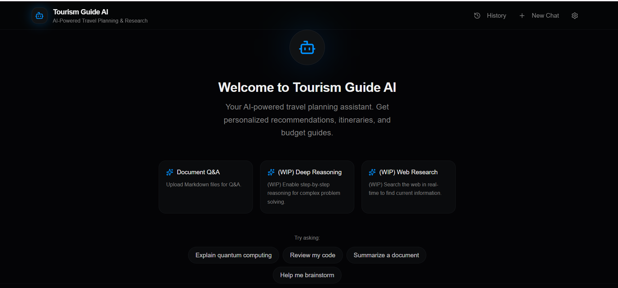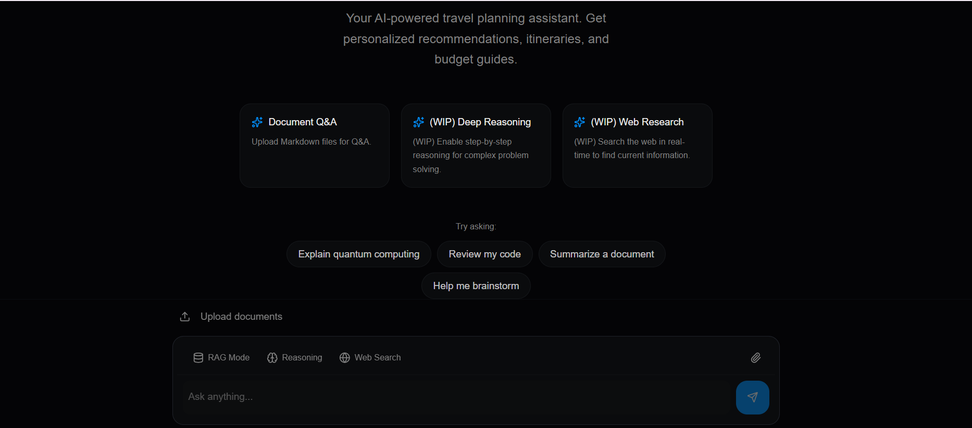

Figure 2: Chat Interaction Output – The chatbot successfully processes user queries and generates context-aware responses using the RAG pipeline. The responses are relevant and based on retrieved tourism data, demonstrating improved accuracy compared to traditional chatbots.

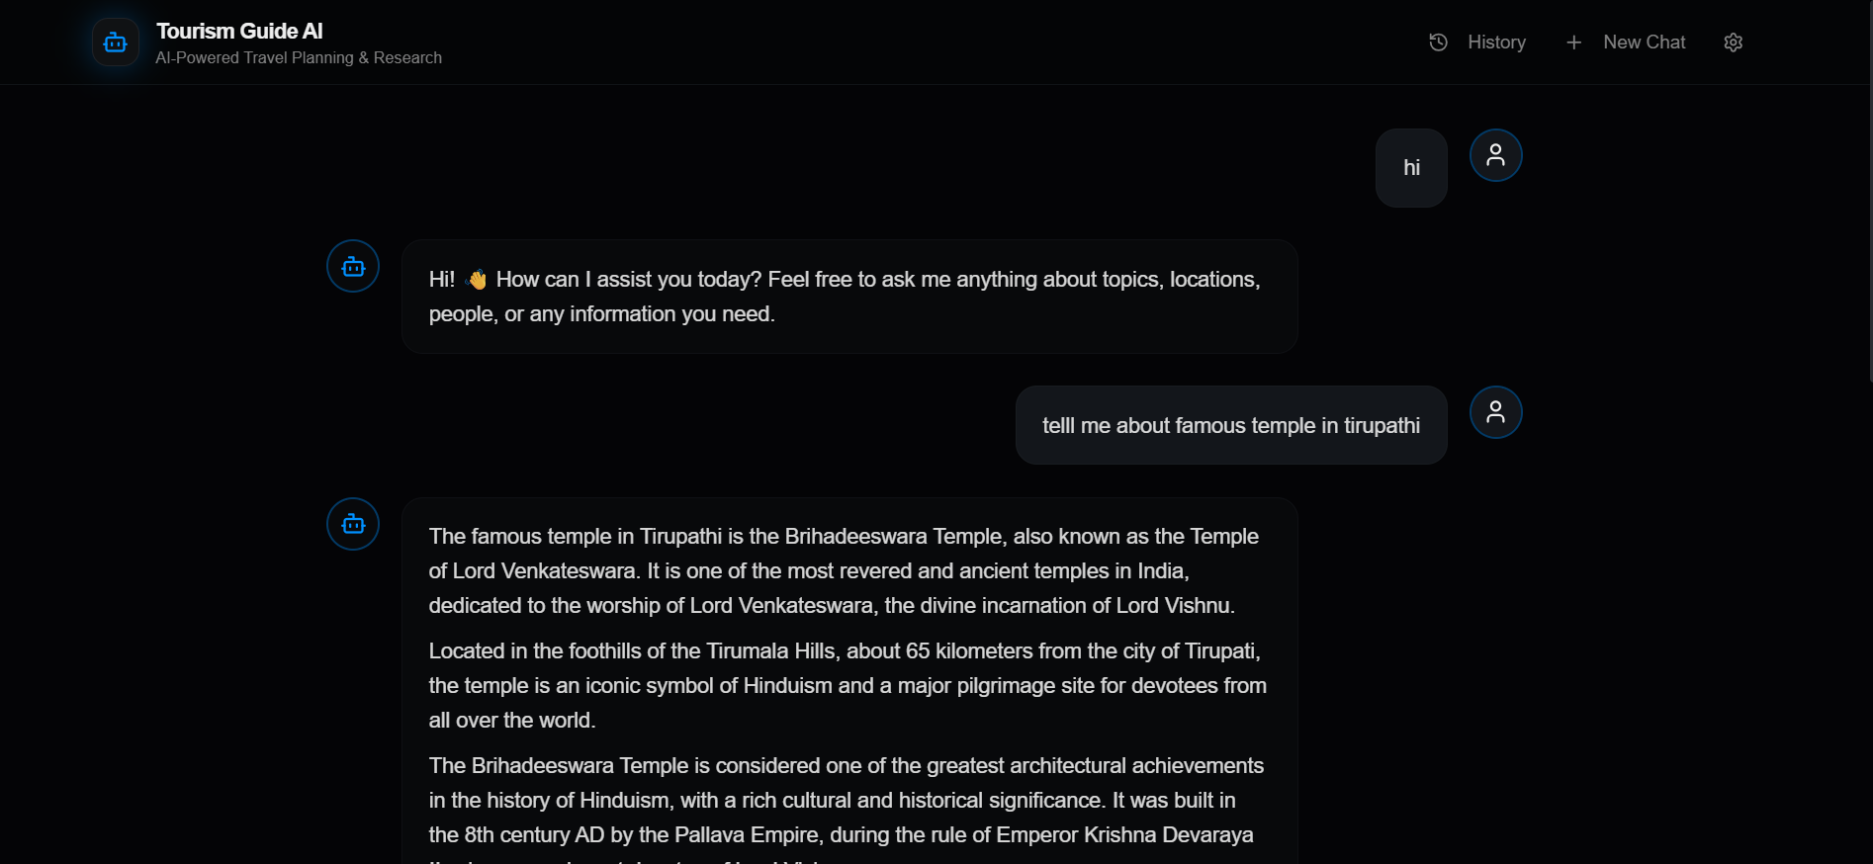

Prototype
The prototype of the Tourism Guide Chatbot using Retrieval-Augmented Generation (RAG) demonstrates a functional system where users can interact with an AI-powered chatbot to retrieve accurate tourism information. The prototype consists of a frontend user interface, backend processing system, and an integrated RAG pipeline.
Prototype Overview:
The system provides a chat-based interface where users can enter queries such as “Tell me about Charminar” or “Plan a 2-day trip.” The query is processed through the backend, converted into embeddings, and matched against stored tourism data in a vector database. The retrieved information is then passed to a language model, which generates a meaningful and context-aware response.
Frontend Prototype:
The frontend is designed as a simple and user-friendly chatbot interface (Autara AI UI). It includes an input text box for user queries, a chat window to display responses, and optional features like document upload. The interface allows real-time interaction and displays responses clearly in conversational format.
Backend Prototype:
The backend is implemented using Python and integrates the LangChain framework. It handles data processing, embedding generation, similarity search, and response generation. The backend connects the frontend with the RAG pipeline through APIs.
RAG Pipeline Prototype:
The core prototype includes the following workflow:
User Query → Text Preprocessing → Embedding Generation → Vector Database Search → Top-K Retrieval → LLM Processing → Response Generation → Display Output
This workflow ensures that responses are based on retrieved data, improving accuracy and reliability.
Simulation Results:
The prototype has been tested with sample queries such as “Explain Charminar” and “Tourist places in Hyderabad.” The system successfully retrieves relevant data and generates accurate responses. Compared to a normal chatbot, the RAG-based system provides more factual and context-aware answers. The response time is acceptable for small datasets, and the system performs efficiently in retrieving relevant information.

6. Preliminary Results
The initial implementation of the Tourism Guide Chatbot using Retrieval-Augmented Generation (RAG) has produced promising results, demonstrating the effectiveness of combining information retrieval with language generation.
The system was tested with various sample queries related to tourism, such as “Tell me about Charminar,” “Best places to visit in Hyderabad,” and “Plan a short trip.” The chatbot successfully retrieved relevant information from the vector database and generated meaningful, context-aware responses.
The results show that the RAG-based approach provides more accurate and reliable answers compared to traditional language model-based chatbots. Since the responses are generated based on retrieved data, the chances of incorrect or irrelevant information are reduced. The system is able to understand user intent and provide structured outputs such as place details, descriptions, and suggestions.
In terms of performance, the chatbot responds within an acceptable time for small datasets, and the retrieval process efficiently identifies relevant documents using semantic similarity. The integration between frontend and backend is functioning correctly, allowing smooth user interaction.
However, some limitations were observed during testing. In a few cases, the chatbot generated incomplete or less precise answers due to limited data in the knowledge base. The accuracy of responses depends heavily on the quality and quantity of the stored documents. Additionally, advanced features such as real-time data integration and optimized reasoning are still under development.
Overall, the preliminary results indicate that the system is working as expected and successfully demonstrates the practical implementation of the RAG architecture. Further improvements will focus on increasing data coverage, enhancing response accuracy, and optimizing system performance.

7. Testing Approach
The Tourism Guide Chatbot was tested using a systematic approach to ensure that all modules function correctly and the system produces accurate and reliable results. Multiple testing methods were applied during the implementation phase.
1. Functional Testing:
Each module of the system was tested individually to verify its functionality. This includes testing data processing, embedding generation, retrieval mechanism, and response generation. The chatbot was tested with different user queries to ensure correct outputs are generated.
2. Integration Testing:
Integration testing was performed to ensure smooth communication between frontend, backend, and the RAG pipeline. The data flow from user input to final response generation was validated to confirm that all components work together properly.
3. Retrieval Accuracy Testing:
The system was tested to evaluate whether the most relevant documents are retrieved from the vector database. Different queries were given, and the retrieved results were checked for relevance and correctness.
4. Response Validation Testing:
The generated responses were compared with expected outputs to check accuracy and contextual relevance. The performance of the RAG-based system was also compared with a normal LLM to observe improvements.
5. Performance Testing:
The response time of the chatbot was measured to ensure that the system provides quick results. Retrieval speed and overall system efficiency were also evaluated.
6. User Testing:
Basic user testing was conducted by interacting with the chatbot using real-world queries. Feedback was observed regarding usability, clarity of responses, and overall experience.
7. Error Handling Testing:
The system was tested with invalid or unclear inputs to check how it handles errors. The chatbot was evaluated for its ability to respond gracefully to unknown queries.

8. Updated Project Plan
The project is being developed in multiple phases, with current progress indicating that the implementation phase is ongoing. The updated plan outlines completed, ongoing, and pending activities.
Phase 1: Requirement Analysis – Completed. Project objectives, problem statement, and requirements were clearly defined.
Phase 2: System Design – Completed. Architecture, modules, and workflow of the RAG-based chatbot were designed.
Phase 3: Implementation – In Progress. Core modules such as RAG pipeline, embeddings, vector database, and chatbot interface have been developed.
Phase 4: Testing – In Progress. Functional, integration, and performance testing are being carried out.
Phase 5: Deployment – Pending. The system will be deployed on a cloud platform for public access.
Phase 6: Documentation – Ongoing. Project documentation and reports are being prepared.
The project is currently on track, with major components implemented and remaining tasks focused on testing, optimization, and deployment.

