EXPERIMENT 1

MINIMIZATION AND IMPLEMENTATION OF BOOLEAN FUNCTION

Aim
To minimize and implement a Boolean function using logic gates and verify the functionality using Synopsys VCS and DVE.

Software Required
- Synopsys VCS
- Synopsys DVE
- Linux Terminal
- Verilog HDL

Boolean Function
Consider the Boolean function:
F(A,B,C,D)=Σm(0,2,5,7,8,10,13,15)
The minimized Boolean expression is: F=B'D'+BD
The function is implemented using Verilog HDL.

Files Used
File | Description
exp1_boolean_min.v | Verilog design file
exp1_boolean_min_tb.v | Verilog testbench
exp1_boolean_min.vcd | VCD waveform dump generated during simulation

1. Verilog Design File

//gedit exp1_boolean_min. v
module boolean(
input A,
input B,
input C,
input D,
output F
);

assign F = (~B & ~D) | (B & D);

endmodule

2. Testbench

// gedit tb.v
module tb;

reg A;
reg B;
reg C;
reg D;

wire F;

exp1_boolean_min dut (
.A(A),
.B(B),
.C(C),
.D(D),
.F(F)
);

initial begin

$dumpfile("exp1_boolean_min.vcd");
$dumpvars(0, tb);

A=0; B=0; C=0; D=0; #10;
$display("A=%b B=%b C=%b D=%b F=%b",A,B,C,D,F);

A=0; B=0; C=0; D=1; #10;
$display("A=%b B=%b C=%b D=%b F=%b",A,B,C,D,F);

A=0; B=0; C=1; D=0; #10;
$display("A=%b B=%b C=%b D=%b F=%b",A,B,C,D,F);

A=0; B=0; C=1; D=1; #10;
$display("A=%b B=%b C=%b D=%b F=%b",A,B,C,D,F);

A=0; B=1; C=0; D=0; #10;
$display("A=%b B=%b C=%b D=%b F=%b",A,B,C,D,F);

A=0; B=1; C=0; D=1; #10;
$display("A=%b B=%b C=%b D=%b F=%b",A,B,C,D,F);

A=0; B=1; C=1; D=0; #10;
$display("A=%b B=%b C=%b D=%b F=%b",A,B,C,D,F);

A=0; B=1; C=1; D=1; #10;
$display("A=%b B=%b C=%b D=%b F=%b",A,B,C,D,F);

A=1; B=0; C=0; D=0; #10;
$display("A=%b B=%b C=%b D=%b F=%b",A,B,C,D,F);

A=1; B=0; C=0; D=1; #10;
$display("A=%b B=%b C=%b D=%b F=%b",A,B,C,D,F);

A=1; B=0; C=1; D=0; #10;
$display("A=%b B=%b C=%b D=%b F=%b",A,B,C,D,F);

A=1; B=0; C=1; D=1; #10;
$display("A=%b B=%b C=%b D=%b F=%b",A,B,C,D,F);

A=1; B=1; C=0; D=0; #10;
$display("A=%b B=%b C=%b D=%b F=%b",A,B,C,D,F);

A=1; B=1; C=0; D=1; #10;
$display("A=%b B=%b C=%b D=%b F=%b",A,B,C,D,F);

A=1; B=1; C=1; D=0; #10;
$display("A=%b B=%b C=%b D=%b F=%b",A,B,C,D,F);

A=1; B=1; C=1; D=1; #10;
$display("A=%b B=%b C=%b D=%b F=%b",A,B,C,D,F);

$finish;

end

endmodule

3. Truth Table
A | B | C | D | F
0 | 0 | 0 | 0 | 1
0 | 0 | 0 | 1 | 0
0 | 0 | 1 | 0 | 1
0 | 0 | 1 | 1 | 0
0 | 1 | 0 | 0 | 0
0 | 1 | 0 | 1 | 1
0 | 1 | 1 | 0 | 0
0 | 1 | 1 | 1 | 1
1 | 0 | 0 | 0 | 1
1 | 0 | 0 | 1 | 0
1 | 0 | 1 | 0 | 1
1 | 0 | 1 | 1 | 0
1 | 1 | 0 | 0 | 0
1 | 1 | 0 | 1 | 1
1 | 1 | 1 | 0 | 0
1 | 1 | 1 | 1 | 1

4. Simulation Procedure

STEP 1 – Open Terminal
Open a terminal in the experiment folder.
bash

STEP 2 – Load Synopsys Environment
source /synopsys/start.sh

STEP 3 – Compile Using VCS
vcs exp1_boolean_min.v exp1_boolean_min_tb.v -full64
If compilation is successful, VCS generates the simulation executable:
simv

STEP 4 – Run Simulation
./simv
The terminal displays the input combinations and corresponding output F.
A VCD waveform file is also generated:
exp1_boolean_min.vcd

STEP 5 – Open DVE
dve -full64

Other option
dve -full64 &
A DVE environment will open.

5. DVE Waveform Verification
In DVE:
- Open the testbench hierarchy.
- Locate the signals:
  - A
  - B
  - C
  - D
  - F
- Add the signals to the waveform window.
- Run/inspect the waveform.
- Verify that F = 1 whenever B and D are equal.
- Verify that F = 0 whenever B and D are different.
The waveform should agree with the truth table.

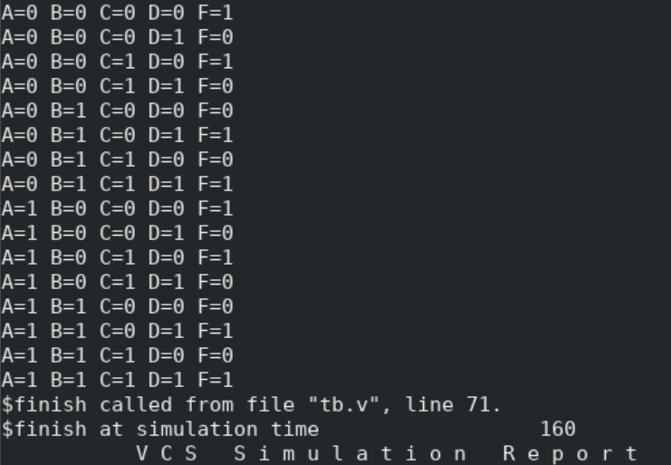

6. Expected Result
The Boolean function
F(A,B,C,D)=Σm(0,2,5,7,8,10,13,15), which simplifies to F=B'D'+BD.
was minimized to F=B'D'+BD.
and successfully implemented using Verilog HDL.
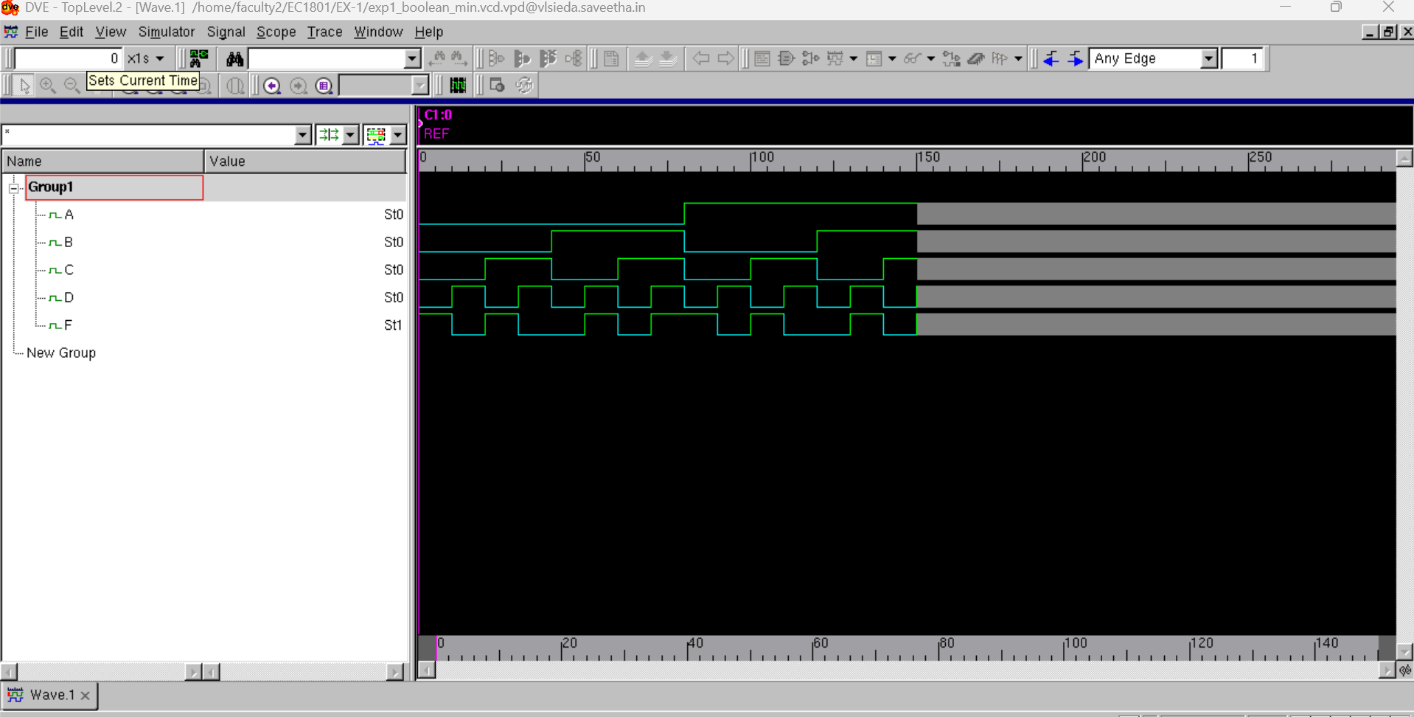
The design was compiled and simulated using Synopsys VCS, and the functionality was verified using DVE waveform analysis.

7. Viva-Voce Questions
- What is Boolean function minimization?
- What is a minterm?
- What is a Karnaugh map?
- Why is Boolean minimization required?
- What are universal gates?
- What is the difference between SOP and POS?
- What is the purpose of a Verilog testbench?
- Why is a VCD file generated?
- What is the purpose of ./simv?
- What is the purpose of DVE?
- What is the difference between simulation and synthesis?
- Why are A and C absent from the minimized expression?
- What is the purpose of $dumpfile?
- What is the purpose of $dumpvars?

Result
Thus, the Boolean function was minimized, implemented using Verilog HDL, successfully simulated using Synopsys VCS, and verified using Synopsys DVE.

