1. List 3 different protocols that appear in the protocol column in the unfiltered packet-listing window in step 7 above. 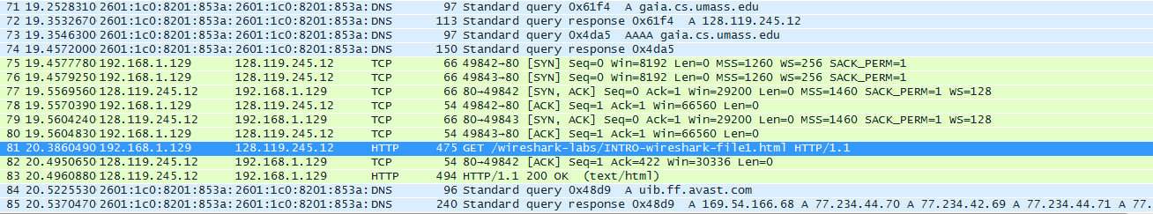

The 3 different protocols could be TCP, DNS, HTTP

2. How long did it take from when the HTTP GET message was sent until the HTTP OK reply was received? (By default, the value of the Time column in the packetlisting window is the amount of time, in seconds, since Wireshark tracing began. To display the Time field in time-of-day format, select the Wireshark View pull down menu, then select Time Display Format, then select Time-of-day.)

HTTP GET:

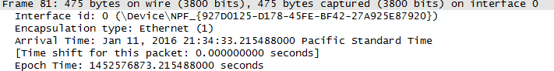

HTTP OK:

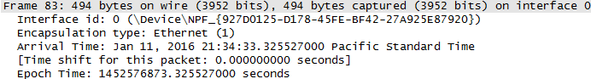

.325527000 - .215488000 = 0.110039 seconds

3. What is the Internet address of the gaia.cs.umass.edu (also known as wwwnet.cs.umass.edu)? What is the Internet address of your computer?

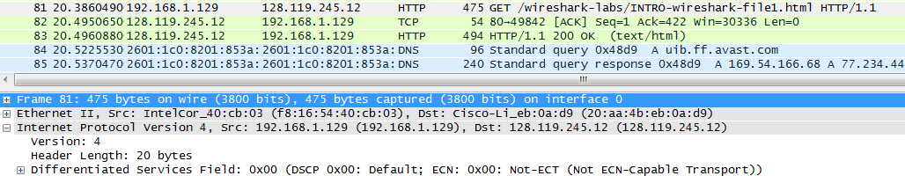

Using HTTP GET, as this was sent from my computer my IP: 192.168.1.129 and the website IP: 128.119.245.12

4. Print the two HTTP messages (GET and OK) referred to in question 2 above. To do so, select Print from the Wireshark File command menu, and select the “Selected Packet Only” and “Print as displayed” radial buttons, and then click OK.

These will be attached