Lab 2: HTTP

1. Is your browser running HTTP version 1.0 or 1.1? What version of HTTP is the server running?

This Picture shows that my browser’s HTTP version is 1.1

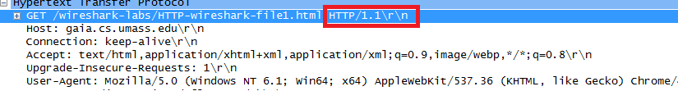

This picture shows the server’s HTTP version is 1.1

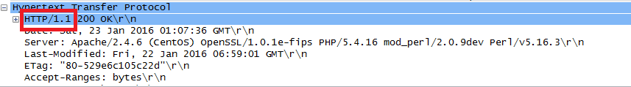

1. What languages (if any) does your browser indicate that it can accept to the server?

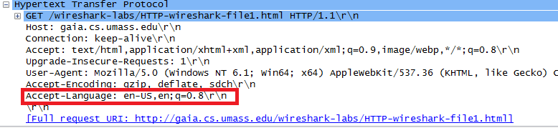

This picture shows Accept-Language states that the accepted language is US english

1. What is the IP address of your computer? Of the gaia.cs.umass.edu server?

The scr is my computer: 10.0.0.40 and the server is the dst: 128.119.245.12



1. What is the status code returned from the server to your browser?

The status code was 200 OK

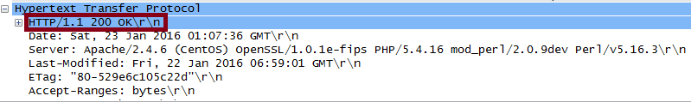

1. When was the HTML file that you are retrieving last modified at the server?

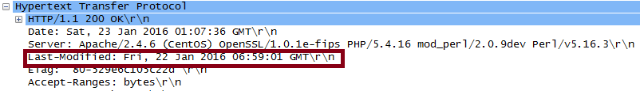

The Html file was last modified Fri, 22 January 2016 06:59:01

1. How many bytes of content are being returned to your browser?

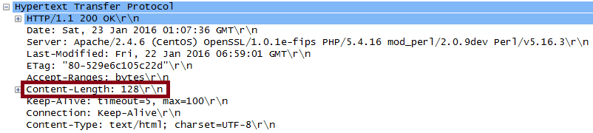

128 bytes of content was returned

1. By inspecting the raw data in the packet content window, do you see any headers within the data that are not displayed in the packet-listing window? If so, name one.

No I don’t see any headers that are displayed in the packet window

1. Inspect the contents of the first HTTP GET request from your browser to the server. Do you see an “IF-MODIFIED-SINCE” line in the HTTP GET?

No, there is no “IF-MODIFIED-SINCE” line in the HTTP GET

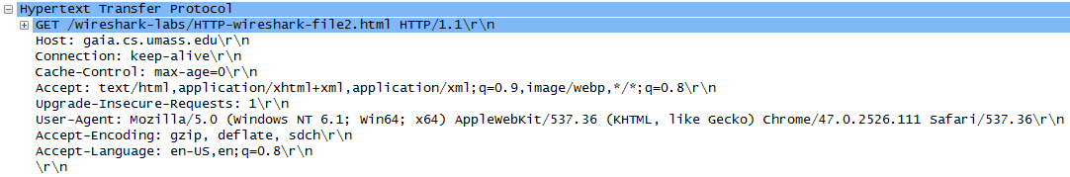

1. Inspect the contents of the server response. Did the server explicitly return the contents of the file? How can you tell?

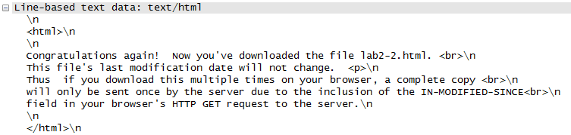

Yes the server explicitly returned the contents of the file. I know this because of the Line-base test data in the OK response to the GET

1. Now inspect the contents of the second HTTP GET request from your browser to the server. Do you see an “IF-MODIFIED-SINCE:” line in the HTTP GET? If so, what information follows the “IF-MODIFIED-SINCE:” header?

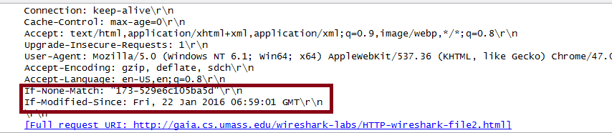

Yes the “IF-MODIFIED-SINCE:” line is present in HTTP GET. The information that followed the “IF-MODIFIED-SINCE:” header that was not present in the other GET was the date it was modified, match query, and cache-control.

1. What is the HTTP status code and phrase returned from the server in response to this second HTTP GET? Did the server explicitly return the contents of the file? Explain.

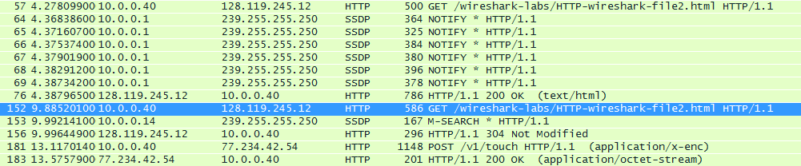

The HTTP status code that the server responded with was 200 OK. This means the server returned the contents of the file. Although after a google search this doesn’t seem like it was supposed to happen.

1. How many HTTP GET request messages did your browser send? Which packet number in the trace contains the GET message for the Bill or Rights?



There was one GET message sent.

The packet number was 16

1. Which packet number in the trace contains the status code and phrase associated with the response to the HTTP GET request?

The packet number is 22

1. What is the status code and phrase in the response?



The status code was 200 and phrase OK

1. How many data-containing TCP segments were needed to carry the single HTTP response and the text of the Bill of Rights

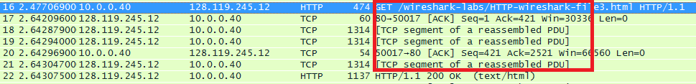

There are 3 data-containing TCP segments were needed to carry the single HTTP response and the test of the Bill of rights

1. How many HTTP GET request messages did your browser send? To which Internet addresses were these GET requests sent?

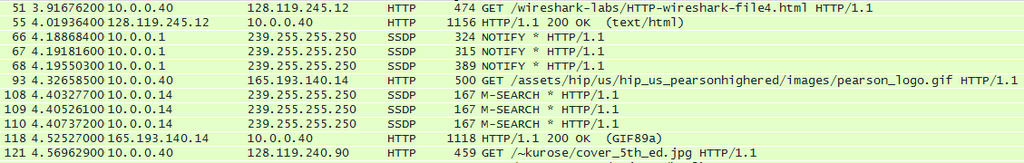

There were 3 GET sent. It sent them to 128.119.245.12, 165.193.140.14, and 128.119.240.90. The last two GETs are for separate locations of the images on the initial web page.

1. Can you tell whether your browser downloaded the two images serially, or whether they were downloaded from the two web sites in parallel? Explain.

From the looks of it, it seems that the images were downloaded serially. This is because the GET was sent out after the OK was seen.

1. What is the server’s response (status code and phrase) in response to the initial HTTP GET message from your browser?



I got 200 OK. Although after checking the provided pre-generated packet listings I found that I should have gotten 401 Authorization Required

1. When your browser’s sends the HTTP GET message for the second time, what new field is included in the HTTP GET message?

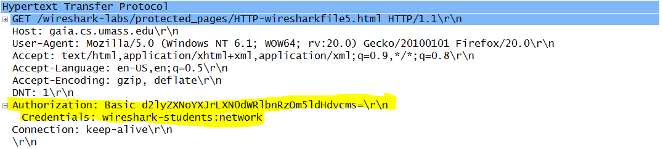

I used the provided pre-generated packet listings. But I from this, there is a new field included is the Authorization field. This provides the user name and password for a secure website.