Lab 5

First release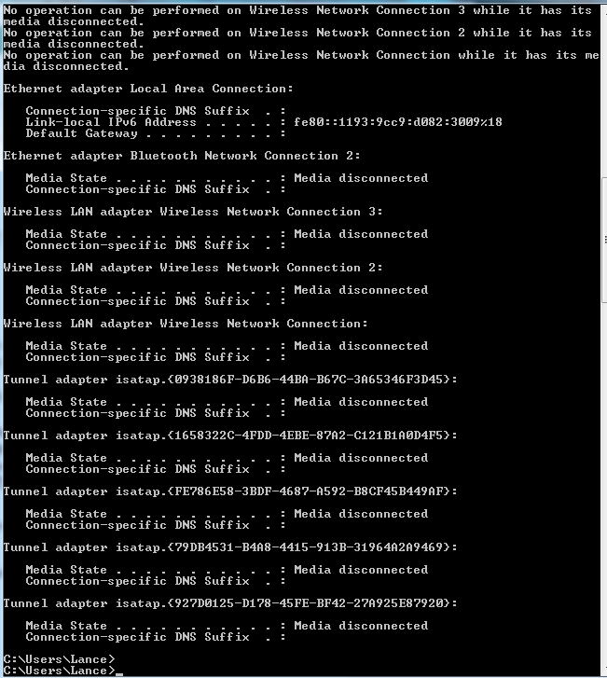

First renew

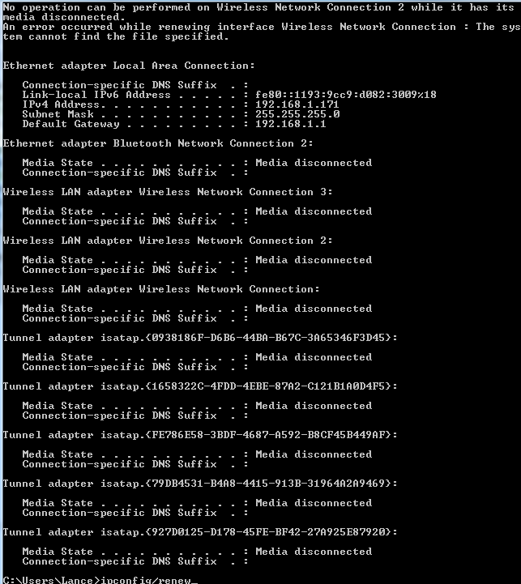

Second renew

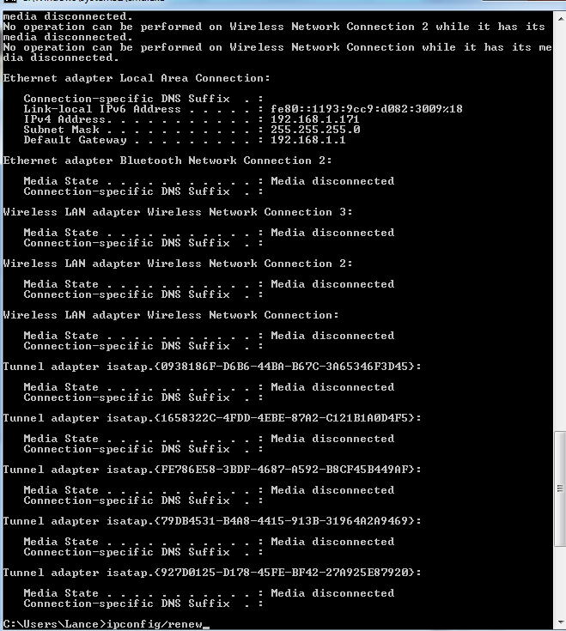

Second release



Last renew

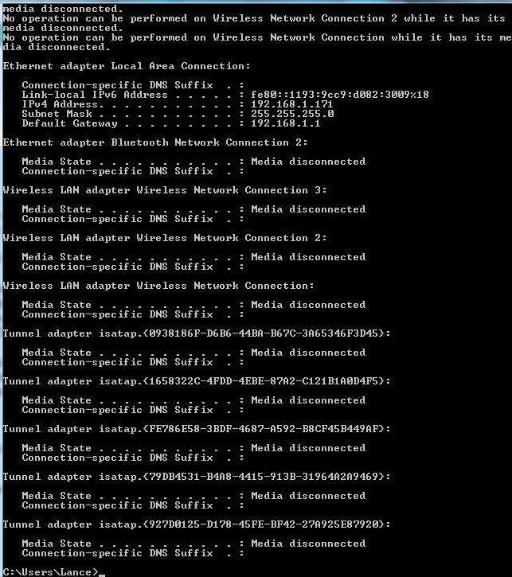

1. They are sent using UDP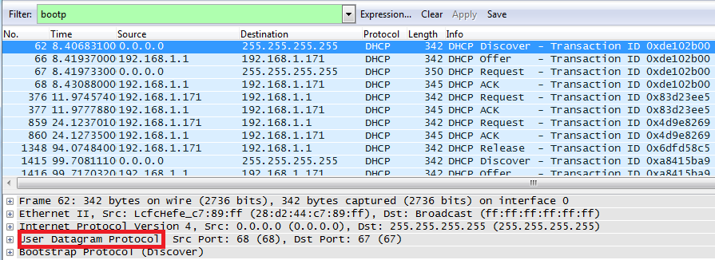
2. 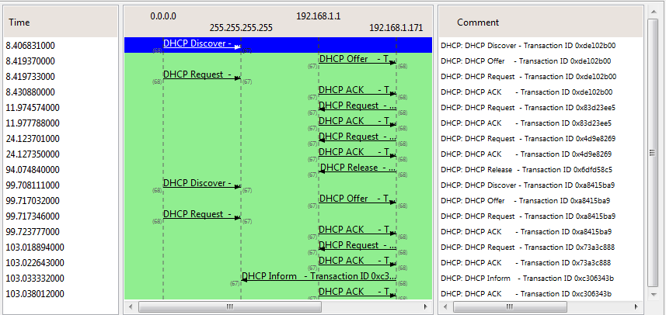

The Discover packet has a source port of 68 and destination port of 67

The Offer packet has a source port of 67 and a destination port of 68

The Request packet has a source port of 68 and a destination of 67

The ACK packet has a source port of 67 and a destination of 68

Yes, they are the same as the provided example.

1. LcfcHefe_c7:89:ff (28:d2:44:c7:89:ff)

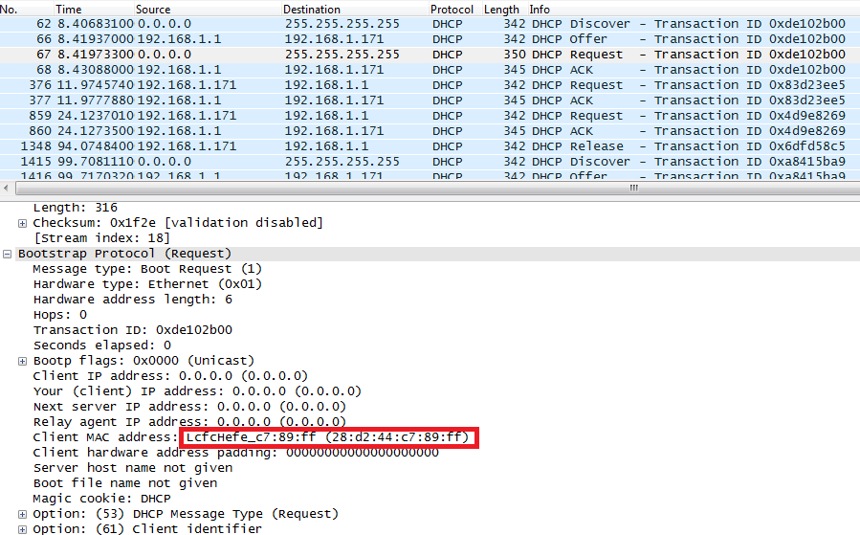

1. They differ because the message type value for a discover message is a 1, but the message type value for a request packet is a 3.
2. The Transaction ID in the first four messages: 0xde102b00  
   The transaction ID in the second set of messages is 0xa8415ba9  
   The transaction ID identifies if a message is part of a set of messages related to one transaction
3. Discover source 0.0.0.0 Destination 255.255.255.255  
   Offer source 192.168.1.1 Destination 255.255.255.255  
   Request source 0.0.0.0 Destination 255.255.255.255  
   Ack DHCP 192.168.1.1 Destination 255.255.255.255
4. 192.168.1.171 (192.168.1.171)

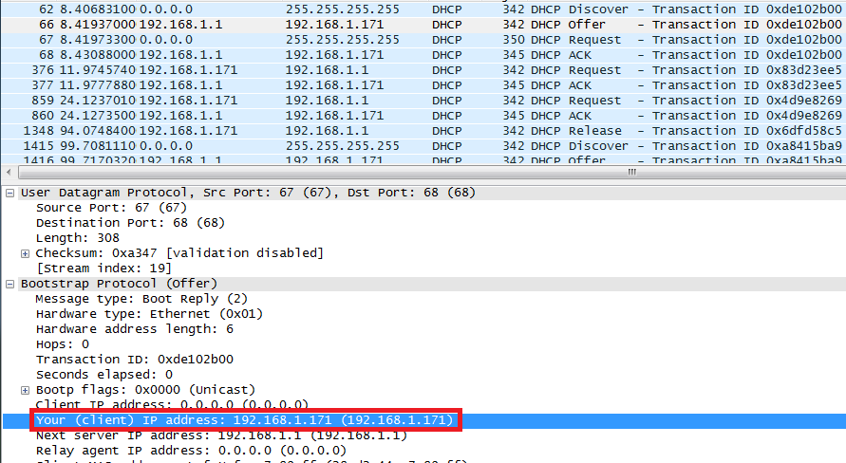

1. The DHCP server offers 192.168.1.1 as the ip address in the DHCP offer message.  
   Option: (t=53,l=1) DHCP Message Type = DHCP Offer
2. The ip address being 0.0.0.0 indicates the absence of a relay agent and is such the case in my experiment.
3. The IP address for the router identifies the default internet gateway. The subnet mask defines the subnet that is available.

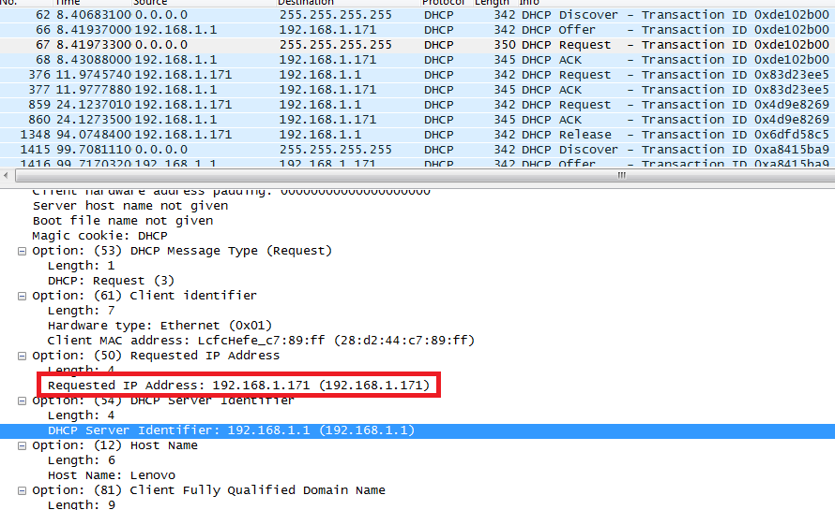

1. The client accepts the IP address is given in the offer message within the request message. After being offered the IP address 192.168.1.101 in the offer message, my client sent back a message further requesting that specific IP address.

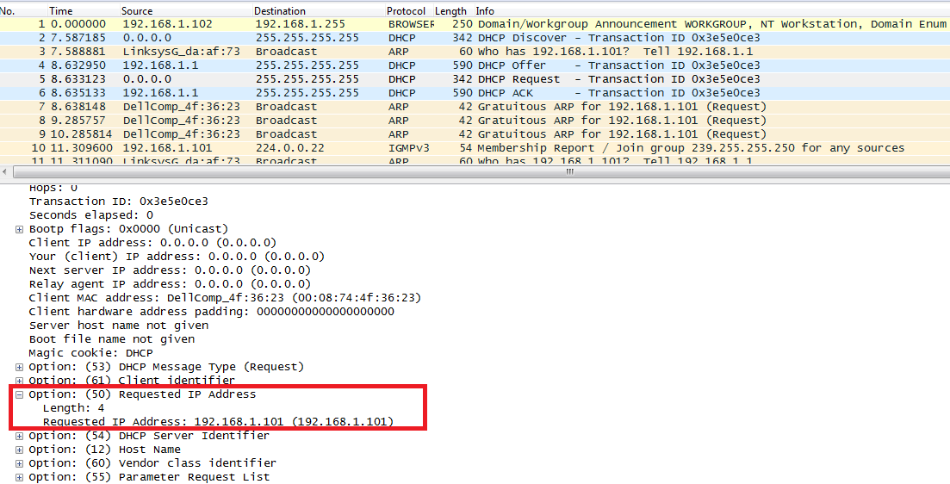

1. The lease time is the amount of the time the user is allowed connection to the router  
   Option: (t=51,l=4) IP Address Lease Time = 1 day

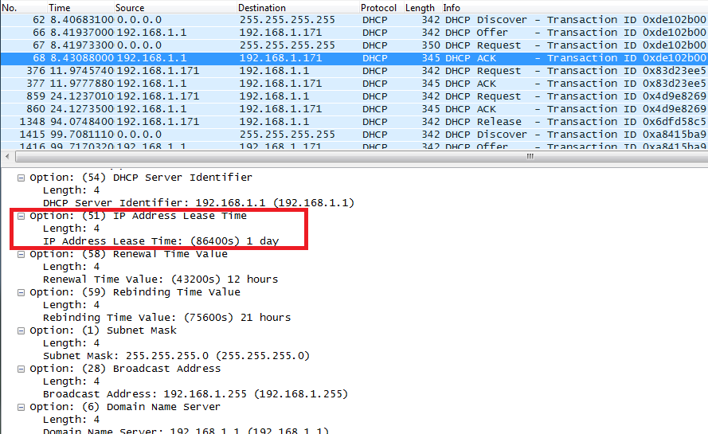

1. The DHCP release message tells the dhcp server that you want to cancel the ip address offered. The DHCP server will not issue an ack of recipt of the client’s DHCP request. If the release message is lost then the dhcp server retains the ip address until the lease time expires.
2. Yes, there was arp packets sent and received to map the mac address with the ip address.