**Project Report**

**Implementing a Firewall in Linux**

**-Vankadara Uma Gayathri**

**Motivation:**

The main motivation for selecting the Configure a firewell in linux project is familiarity with the technologies involved. Working on this project aims to improve skills and upgrade knowledge in these areas. Additionally, this project will facilitate professional growth and bring immediate value to the company by leveraging existing skills to deliver a high-quality product.

**Introduction:**

This project aims to implement a firewall on a Linux system using iptables to control incoming and outgoing network traffic. Iptables is a powerful tool for configuring firewall rules in Linux, allowing control over incoming, outgoing, and forwarded network traffic.

**Objectives:**

* To secure the Linux system by restricting unauthorized access.
* To allow only necessary network services (e.g., YouTube) .
* To understand and apply basic firewall concepts using iptables.

**Methodology:**

**Tools and Technologies:**

* **Linux Operating System:** Ubuntu
* **Firewall Software:** iptables

**Implementation Steps:**

1. **Installation of iptables:**
   * Installed iptables using apt-get if not already present.

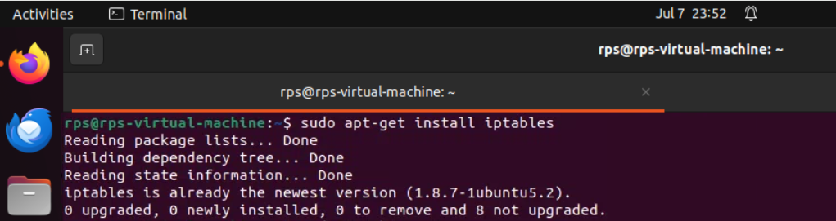

1. **Configuration of Firewall Rules:**
   * Defined default policies for INPUT, FORWARD, and OUTPUT chains.
   * Created specific rules to allow necessary services (e.g., YOUTUBE) and protocols.
   * Tested and adjusted rules to ensure they met security and operational requirements.

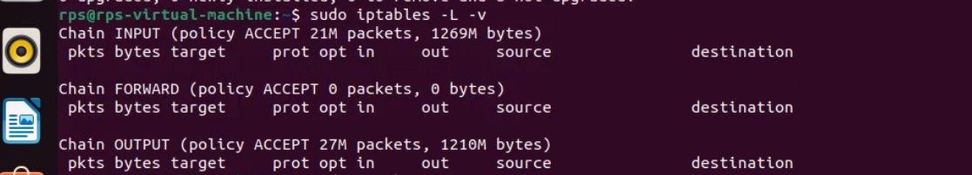

1. **Testing and Validation:**
   * Conducted thorough testing to verify that desired traffic was allowed
   * Utilized logging (-j LOG) to monitor and troubleshoot denied packets.
   * Ensured the firewall configuration did not disrupt essential network services.

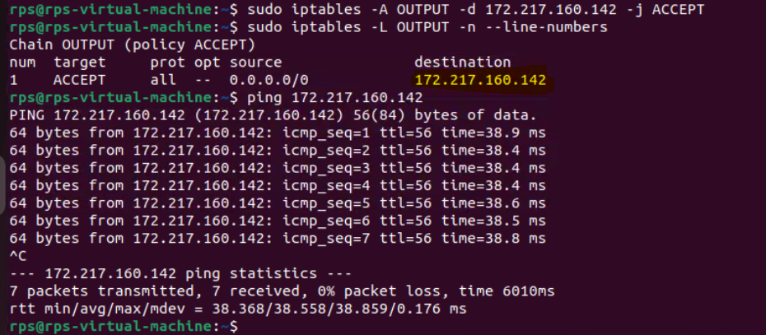

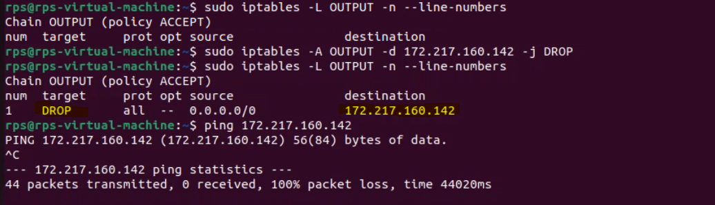

**Results and Discussion:**

**Firewall Configuration:**

* Implemented iptables rules to:
  + Allow specific services (e.g., YouTube).
* Allowing YouTube IP and checking the line numbers.

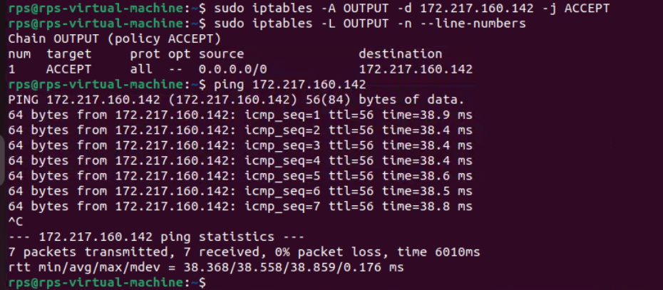

* Restricting YouTube IP

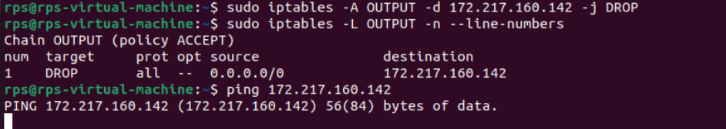

**Testing and Validation:**

* Successfully restricted incoming traffic to only necessary services.
* Validated that outgoing traffic was unrestricted as per policy.

**Conclusion:**

**Achievements**

* Implemented an effective firewall using iptables to enhance system security.
* Gained practical experience in configuring and managing network security policies on Linux.