1)Calculator:

#include<stdio.h>

int main(){

start:

printf("Welcome to the Calculator!\n");

printf("Press 1 to Addition\n");

printf("Press 2 to Subtract\n");

printf("Press 3 to multiply\n");

printf("Press 4 to division\n");

printf("Press 5 to Exit\n");

int ch[1];

printf("----------------------------------------------------------------\n");

printf("Enter your choice\n");

int option;

scanf("%d",&option);

if(option ==5){

printf("Exititing the program..........!\n");

return 0;

}

else if(option>5)

goto enter;

printf("Enter the first Number:");

int a;

scanf("%d",&a);

printf("Enter the second Number:");

int b;

scanf("%d",&b);

switch(option){

case 1:

printf("Sum of a and b: %d\n",a+b);

break;

case 2:

printf("subtraction a and b: %d\n",a-b);

break;

case 3:

printf("multiplication a and b: %d\n",a*b);

break;

case 4:

printf("division a and b: %d\n",a/b);

break;

default:

enter:

printf("Choose the correct option\n");

}

printf("Do you want to continue?\n");

printf("press 1 Yes 0 No:\n");

scanf("%d",&ch[0]);

if(ch[0] ==1){

system("cls");

goto start;

}

else

return 0;

}

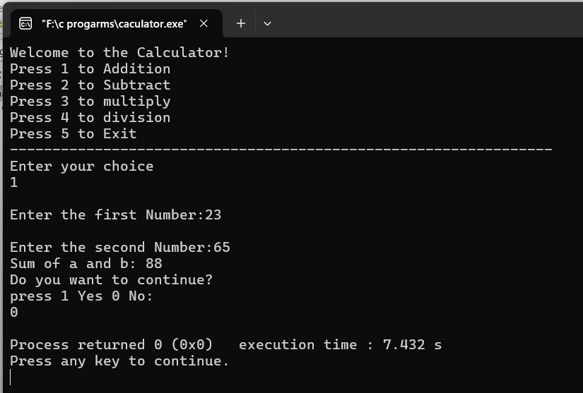

2)Employee details:

#include <stdio.h> ///for input output functions like printf, scanf

#include <stdlib.h>

#include <conio.h>

#include <windows.h> ///for windows related functions (not important)

#include <string.h> ///string operations

/** List of Global Variable */

COORD coord = {0,0}; /// top-left corner of window

/**

function : gotoxy

@param input: x and y coordinates

@param output: moves the cursor in specified position of console

*/

void gotoxy(int x,int y)

{

coord.X = x;

coord.Y = y;

SetConsoleCursorPosition(GetStdHandle(STD_OUTPUT_HANDLE),coord);

}

/** Main function started */

int main()

{

FILE *fp, *ft; /// file pointers

char another, choice;

/** structure that represent a employee */

struct emp

{

char name[40]; ///name of employee

int age; /// age of employee

float bs; /// basic salary of employee

};

struct emp e; /// structure variable creation

char empname[40]; /// string to store name of the employee

long int recsize; /// size of each record of employee

/** open the file in binary read and write mode

* if the file EMP.DAT already exists then it open that file in read write mode

* if the file doesn't exit it simply create a new copy

*/

fp = fopen("EMP.DAT","rb+");

if(fp == NULL)

{

fp = fopen("EMP.DAT","wb+");

if(fp == NULL)

{

printf("Connot open file");

exit(1);

}

}

/// sizeo of each record i.e. size of structure variable e

recsize = sizeof(e);

/// infinite loop continues untile the break statement encounter

while(1)

{

system("cls"); ///clear the console window

gotoxy(30,10); /// move the cursor to postion 30, 10 from top-left corner

printf("1. Add Record"); /// option for add record

gotoxy(30,12);

printf("2. List Records"); /// option for showing existing record

gotoxy(30,14);

printf("3. Modify Records"); /// option for editing record

gotoxy(30,16);

printf("4. Delete Records"); /// option for deleting record

gotoxy(30,18);

printf("5. Exit"); /// exit from the program

gotoxy(30,20);

printf("Your Choice: "); /// enter the choice 1, 2, 3, 4, 5

fflush(stdin); /// flush the input buffer

choice = getche(); /// get the input from keyboard

switch(choice)

{

case '1': /// if user press 1

system("cls");

fseek(fp,0,SEEK_END); /// search the file and move cursor to end of the file

/// here 0 indicates moving 0 distance from the end of the file

another = 'y';

while(another == 'y') /// if user want to add another record

{

printf("\nEnter name: ");

scanf("%s",e.name);

printf("\nEnter age: ");

scanf("%d", &e.age);

printf("\nEnter basic salary: ");

scanf("%f", &e.bs);

fwrite(&e,recsize,1,fp); /// write the record in the file

printf("\nAdd another record(y/n) ");

fflush(stdin);

another = getche();

}

break;

case '2':

system("cls");

rewind(fp); ///this moves file cursor to start of the file

while(fread(&e,recsize,1,fp)==1) /// read the file and fetch the record one record per fetch

{

printf("\n%s %d %.2f",e.name,e.age,e.bs); /// print the name, age and basic salary

}

getch();

break;

case '3': /// if user press 3 then do editing existing record

system("cls");

another = 'y';

while(another == 'y')

{

printf("Enter the employee name to modify: ");

scanf("%s", empname);

rewind(fp);

while(fread(&e,recsize,1,fp)==1) /// fetch all record from file

{

if(strcmp(e.name,empname) == 0) ///if entered name matches with that in file

{

printf("\nEnter new name,age and bs: ");

scanf("%s%d%f",e.name,&e.age,&e.bs);

fseek(fp,-recsize,SEEK_CUR); /// move the cursor 1 step back from current position

fwrite(&e,recsize,1,fp); /// override the record

break;

}

}

printf("\nModify another record(y/n)");

fflush(stdin);

another = getche();

}

break;

case '4':

system("cls");

another = 'y';

while(another == 'y')

{

printf("\nEnter name of employee to delete: ");

scanf("%s",empname);

ft = fopen("Temp.dat","wb"); /// create a intermediate file for temporary storage

rewind(fp); /// move record to starting of file

while(fread(&e,recsize,1,fp) == 1) /// read all records from file

{

if(strcmp(e.name,empname) != 0) /// if the entered record match

{

fwrite(&e,recsize,1,ft); /// move all records except the one that is to be deleted to temp file

}

}

fclose(fp);

fclose(ft);

remove("EMP.DAT"); /// remove the orginal file

rename("Temp.dat","EMP.DAT"); /// rename the temp file to original file name

fp = fopen("EMP.DAT", "rb+");

printf("Delete another record(y/n)");

fflush(stdin);

another = getche();

}

break;

case '5':

fclose(fp); /// close the file

exit(0); /// exit from the program

}

}

return 0;

}

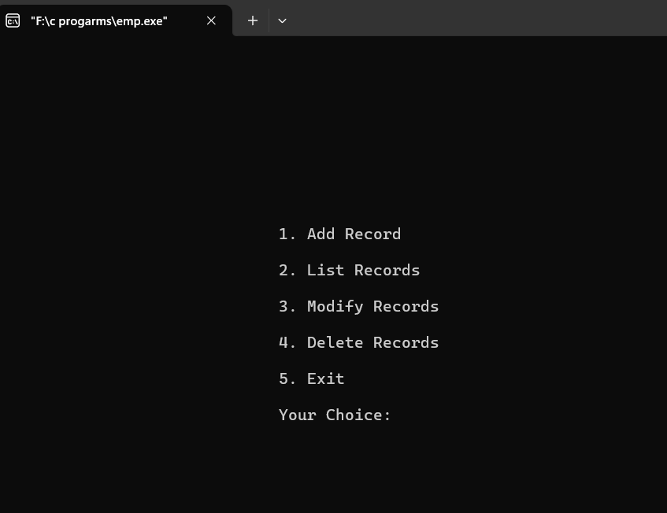

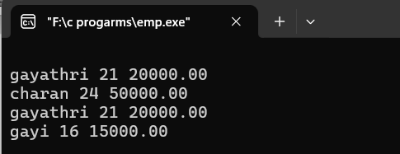

3)Conversions:

#include<stdio.h>

#include<string.h>

#include<math.h>

void start();

void convert();

void binary_Values();

int bin_to_dec();

void bin_to_oct();

void bin_to_hexa();

void decimal_values();

void dec_to_binary();

void dec_to_oct();

void dec_to_hexa();

void octal_values();

void oct_bin();

void hexa_values();

void hexa_bin();

void wish();

void wish(){

wis:

printf("----------------------------------\n");

printf("Do you wish to Continue?\n");

printf("Press 1 to continue or press 0 to cancel.\n");

printf("----------------------------------\n");

int c;

scanf("%d", &c);

if (c == 1)

{

// system("cls");

start();

}

else if(c==0) {

printf("Exiting...\n");

return ;

}

else{

printf("Please enter a valid Keyword.\n");

goto wis;

}

}

void start(){

start:

printf("press 1 for Binary Conversions\n");

printf("Press 2 for Decimal Conversions\n");

printf("Press 3 for Octal Conversions\n");

printf("Press 4 for HexDecimal Conversions\n");

printf("Press 5 for Exit Conversions\n");

printf("----------------------------------\n");

int option;

scanf("%d", &option);

if(option ==5){

printf("Exiting.....!\n");

return ;

}

else if(option>4){

printf("Choose the correct option\n");

printf("----------------------------------\n");

goto start;

}

else{

convert(option);

}

}

void convert(int a){

switch (a)

{

case 1:

binary_Values();

wish();

break;

case 2:

decimal_values();

wish();

break;

case 3:

octal_values();

wish();

break;

case 4:

hexa_values();

wish();

break;

default:

break;

}

}

void binary_Values(){

bin:

printf("Please Enter the Binary Value\n");

char a[20];

scanf("%s",a);

for(int i=0;i<20;i++)

{

if(!a[i]==0 && !a[i]==1){

printf("Enter the Binary Values only\n");

goto bin;

}

}

printf("Decimal value of %s is : %d\n",a,bin_to_dec(a));

bin_to_oct(a);

bin_to_hexa(a);

}

int bin_to_dec(char a[]){

int dec=0;

int c=0;

for(int i=strlen(a)-1;i>=0;i--){

dec=dec+(a[i]-'0')*(int)pow(2,c);

c++;

}

return dec;

}

void bin_to_oct(char a[]){

int dec=bin_to_dec(a);

char a1[20];

sprintf(a1,"%o",dec);

printf("Octal value of %s is : %s\n",a,a1);

}

void bin_to_hexa(char a[]){

int dec=bin_to_dec(a);

char a1[20];

sprintf(a1,"%x",dec);

printf("Hexa value of %s is: %s\n",a,a1);

}

void decimal_values(){

printf("Enter a decimal value:\n");

int i;

scanf("%d",&i);

if(!i>0){

printf("Enter a decimal value\n");

}

dec_to_binary(i);

dec_to_oct(i);

dec_to_hexa(i);

}

void dec_to_binary(int a){

int c=0;

int bin[20];

while(a>0){

bin[c++]=a%2;

a=a/2;

}

printf("Binary value of %d is :",a);

for(int i=c-1;i>=0;i--){

printf("%d",bin[i]);

}

printf("\n");

}

void dec_to_oct(int a){

char dec[20];

sprintf(dec, "%o",a);

printf("Octal value of %d is :%s\n",a,dec);

}

void dec_to_hexa(int a){

char hex[20];

sprintf(hex, "%x",a);

printf("Hexadecimal value of %d is :%s\n",a,hex);

}

void octal_values(){

printf("Enter your Octal Number:\n");

char i[20];

scanf("%s",i);

oct_bin(i);

}

void oct_bin(char a[]){

int dec=0;

int c=0;

for(int i=strlen(a)-1;i>=0;i--){

dec=dec+(a[i]-'0')*(int)pow(8,c);

c++;

}

printf("Decimal Value of %s is :%d\n",a,dec);

dec_to_binary(dec);

dec_to_hexa(dec);

}

void hexa_values(){

hexa:

printf("Enter the hexadecimal Values\n");

char c[20];

scanf("%s",c);

for(int i=0;i<strlen(c);i++){

if((c[i]>='0' && c[i]<='9') || (c[i]>='a' && c[i]<='f')){

}

else{

printf("Invalid hexadecimal value\n");

// system("cls");

goto hexa;

}

}

hexa_bin(c);

}

void hexa_bin(char a[]){

int dec=0;

int c=0;

for(int i=strlen(a)-1;i>=0;i--){

if((a[i]>='0' && a[i]<='9')){

dec=dec+(a[i]-'0')*(int)pow(16,c);

}

else{

dec=dec+(a[i]-'a'+10)*(int)pow(16,c);

}

c++;

}

printf("Decimal Value of %s is: %d\n",a,dec);

dec_to_binary(dec);

dec_to_oct(dec);

}

int main(){

printf("Welcome to OMG Conversions!\n");

start();

}

