Task 1: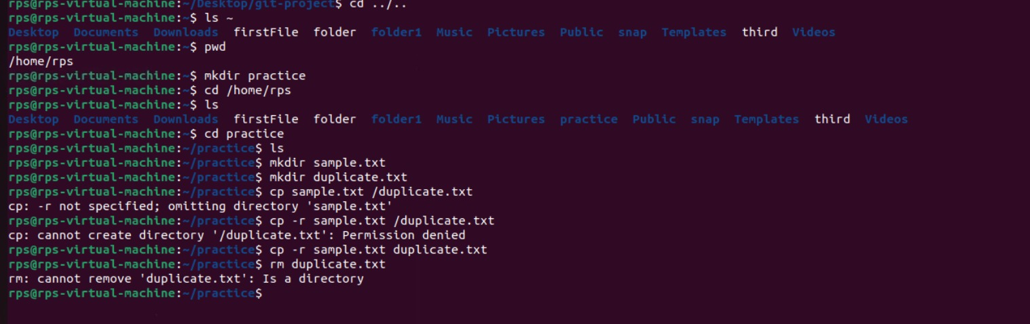

Task 2:

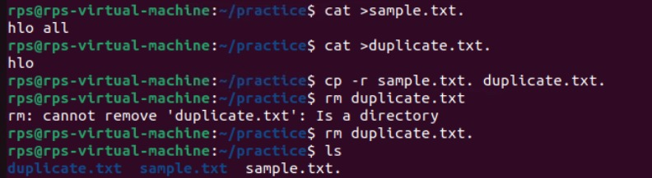

Task 3 & 4:

