Interpretable Machine Learning for Satellite Conjunction Risk Prediction: A Cross-Model SHAP Comparison on the ESA Kelvins Dataset
Umaha Tokula • July 2026

Abstract
Machine learning models are increasingly being proposed to classify satellite conjunction events, however, there are two connected challenges to their adoption in the operational environment: models are often not interpretable, and there is a lack of research comparing what different models learn from the same conjunction-assessment data. We address both by training logistic regression, random forest, and XGBoost to predict high-risk conjunctions (Pc > 10−6) on the ESA Kelvins Collision Avoidance Challenge dataset (13,154 events), and by applying SHAP to each model so that the features driving predicted risk can be compared directly. In the process, we detect and discard two CDM-native fields that are nearly perfect mappings of the target; the leakage source a conventional correlation-threshold screen would not have detected. They are removed in order to achieve the best leakage-free performance for XGBoost (ROC-AUC = 0.947, PR-AUC = 0.436). The rankings of the SHAP values are moderately well correlated between the two tree-based models (Spearman ρ = 0.569) and poorly correlated with either of the tree models and logistic regression (ρ = 0.253, 0.336), indicating that the choice of model significantly affects which features are viewed as risk drivers. This is not a result of a single split as a 10-fold repeated stratified cross-validation yields similar results (mean ρ = 0.551 ± 0.027 for XGBoost–RF vs. 0.215 ± 0.047 and 0.226 ± 0.088 for either tree model, respectively, against logistic regression). We further describe the empirically observed probability dilution effect (PDE) in the conjunction-assessment literature, as described by a raw covariance component, c_sigma_t, which is the top-ranked feature of XGBoost, and outranks the more principle Mahalanobis distance, since it is non-monotonic and thus cannot be captured by logistic regression. These findings suggest cross-model validation and grounding in domain knowledge to provide trust towards operational usage of ML safety-critical conjunction-risk models to be interpreted by ML.
Keywords: satellite conjunction assessment; collision probability; explainable AI; SHAP; XGBoost; probability dilution; data leakage; cross-model agreement

1. Introduction
As the number of tracked objects in Earth orbit has grown, the difficulty of conjunction assessment (CA), the process by which satellite operators assess close approaches based on conjunction data messages (CDMs) reporting miss distance, relative velocity, and position-covariance uncertainty, and combine these to arrive at a probability of collision (Pc), has increased. There are now many CDMs being received by operators every day from each satellite, prompting the development of machine learning (ML) models to triage events to identify the truly high-risk ones.
why an event is risky?
We answer this directly. We fit logistic regression, random forest and XGBoost using the same leakage-checked feature set, use the SHAP explainer that is suitable for each model, and we quantify cross-model agreement by Spearman rank correlation instead of reporting the importances of a single model. We also address a real-life problem: XGBoost puts the raw covariance term c_sigma_t above Mahalanobis distance or miss distance. This is attributed to a well-documented non-monotonic effect found in the CA literature, namely probability dilution (Hejduk & Johnson, 2016; Balch et al., 2018; Lee & Lee, 2025; Parker et al., 2024), which we confirm empirically.
Contributions: (1) a leakage-free benchmark of three model families on the ESA Kelvins high-risk classification task; (2) the first systematic evaluation of cross-model explanation stability for satellite conjunction risk prediction, validated via repeated cross-validation and a paired significance test rather than a single split; and (3) an empirically grounded, literature-tied explanation for a tree model's counterintuitive top feature.

2. Data and Methods
Dataset. ESA Kelvins Collision Avoidance Challenge (Zenodo record 4463683): 103 raw features including relative geometry, chaser/target position-covariant components, and space-weather indices and 13,154 unique conjunction events, of which 162,634 CDM rows were provided. We retain the last CDM per event — the one closest to the time of closest approach (TCA) — and split by event_id, giving one row per event. The continuous target (risk, following the standard conjunction-assessment probability-of-collision formulations, e.g., Alfano, 2005) is binarized at the threshold risk > −6, leading to 12,789 low-risk vs. 365 high-risk events (a class imbalance of 35:1).
Leakage check. max_risk_estimate and max_risk_scaling are native CDM Pc estimates calculated from the same underlying geometry as the target, and are self-reported. There was no automated warning for either field against |Pearson r| > 0.9 and the Pearson r was 0.0999 and −0.0805. However, a preliminary model that contained them had an implausible ROC-AUC of 0.9996, showing that while the linear correlation is low, the fields allow a nonlinear model to reconstruct the target almost perfectly. Both on the domain-provenance side and not only the statistical side. This is not just our case, and a linear-correlation threshold is inadequate leakage protection for CDM-based fields, as the candidate features can be risk estimates disguised.
Preprocessing and models. Once data have been anonymized and identifiers, targets and the two leaky fields removed, and after one-hot-encoding the single categorical field, the resulting feature matrix is 104 columns by 13154 events, with 292/10523 (28%) events in the train set and 73/2631 (3%) events in the test set being in the high-risk class, split 80/20 in a stratified way and with missing values imputed using the median. All models were trained using scikit-learn (Pedregosa et al., 2011): logistic regression (standardized features, balanced class weights), random forest (Breiman, 2001; 300 trees, max depth 10, balanced class weights), and XGBoost (Chen & Guestrin, 2016; 300 trees, max depth 6, learning rate 0.05, scale_pos_weight set to the training class ratio). We employed class weighting instead of SMOTE oversampling specifically to maintain the real distribution of features for fair SHAP interpretations.
SHAP methodology. For random forest and XGBoost, we used TreeExplainer (Lundberg et al., 2020) and for logistic regression, we used LinearExplainer (standardized feature space). The global importance is the averaged out of |SHAP value| on the held-out test set across the models, ranked and compared using pairwise Spearman correlation. We did not use SHAP's dependence_plot() function to generate the plot in Section 3.3 as it sets the axis ranges at plot time and cannot be rescaled on the fly after a log scale change.

3. Results

3.1 Predictive Performance

XGBoost outperformed the other models on all three measures (Table 1, Figure 1). Although modest in absolute terms, all three models strongly beat chance in the test set (73 high-risk vs 2,631 normal) demonstrating that there is genuine information even after the leakage is removed. The single-split numbers reported here are not higher than the full cross-validated ones, but lie in the same range, as shown by 10-fold repeated stratified cross-validation (see Table 2), and are not caused by leakage (explanation in Section 3.5).

Model | ROC-AUC | PR-AUC | F1
Logistic Regression | 0.837 | 0.136 | 0.164
Random Forest | 0.929 | 0.350 | 0.311
XGBoost | 0.947 | 0.436 | 0.409
Table 1. Single held-out split performance (n = 2,631; 73 high-risk).
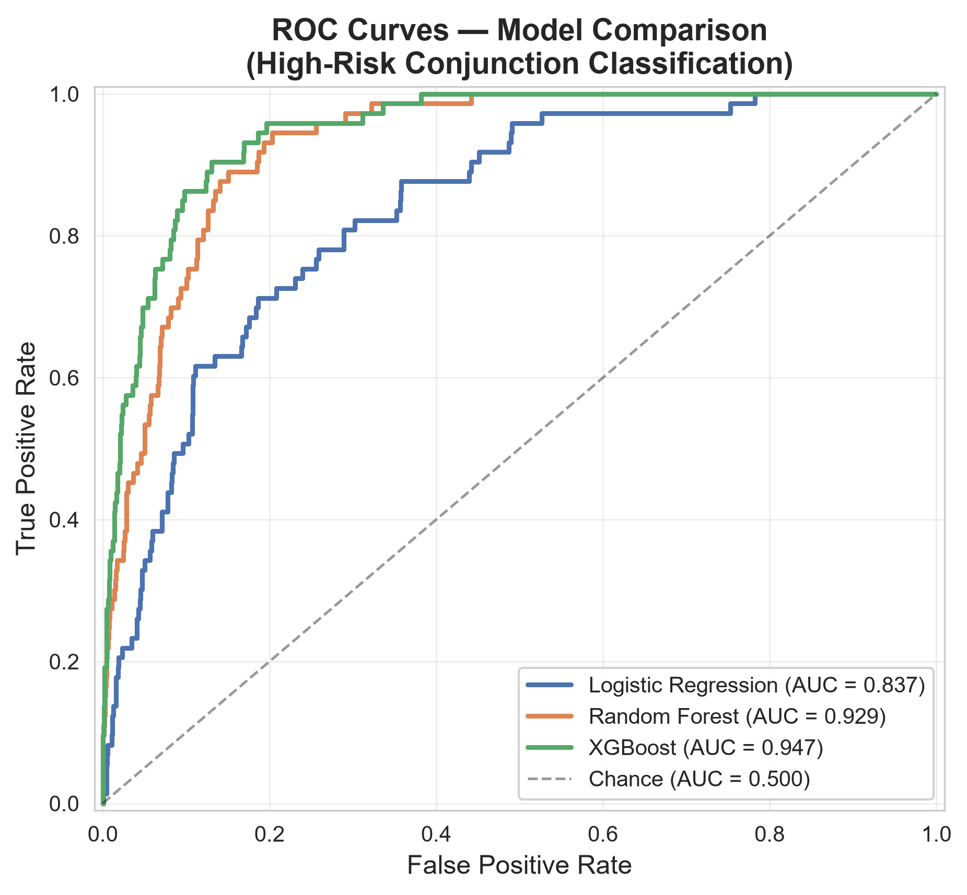
Figure 1. ROC curves, held-out test set.

3.2 SHAP Importance and Cross-Model Agreement
As expected, all three models have mahalanobis_distance, c_sigma_t, miss_distance, c_position_covariance_det, and time_to_tca among their top features (XGBoost is shown in Figure 2). However, moderate to weak agreement exists for the one split – Spearman ρ = 0.569 (XGBoost–RF), 0.253 (XGBoost–LogReg), and 0.336 (RF–LogReg). Repeated 10-fold cross-validation (Section 3.5) confirms this pattern and sharpens it: mean ρ = 0.551 ± 0.027 (XGBoost–RF) versus 0.215 ± 0.047 (XGBoost–LogReg) and 0.226 ± 0.088 (RF–LogReg). The two tree models always stick together, and logistic regression is the outlier in each fold, with no overlap between the distribution of logistic-regression models and the distribution of XGBoost–RF models.
Model architecture, that is, the physical specification of which features to identify as risk drivers, changes the list of risk drivers beyond the few that all models concur. This is shown in Figure 3 for each of the top-15 features, according to at least one of the models; indeed, features such as the relative position of the feature (relative_position_r) rank high under tree models, but don't rank very high under logistic regression, a consistent pattern with tree models that take advantage of non-linear interactions which a linear model simply cannot capture, such as c_ctdot_rdot which is ranked 2nd by logistic regression and 51st by XGBoost.
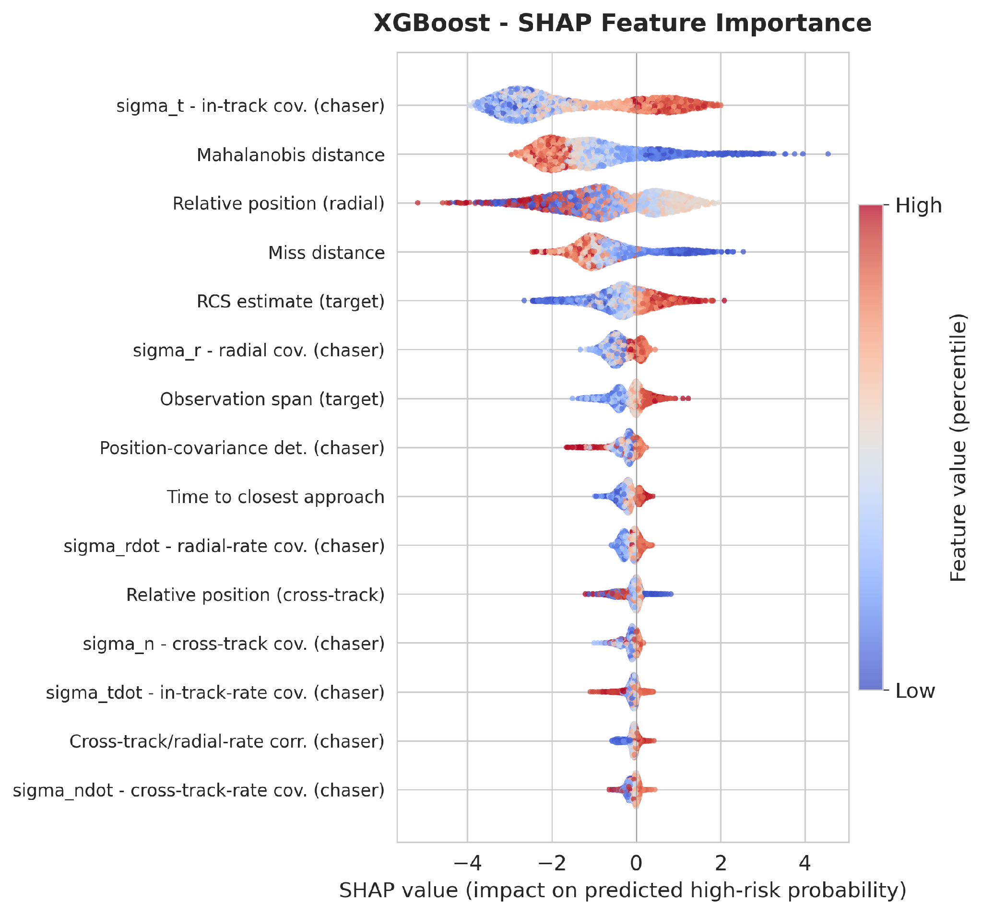
Figure 2. XGBoost SHAP summary (top 15 features).
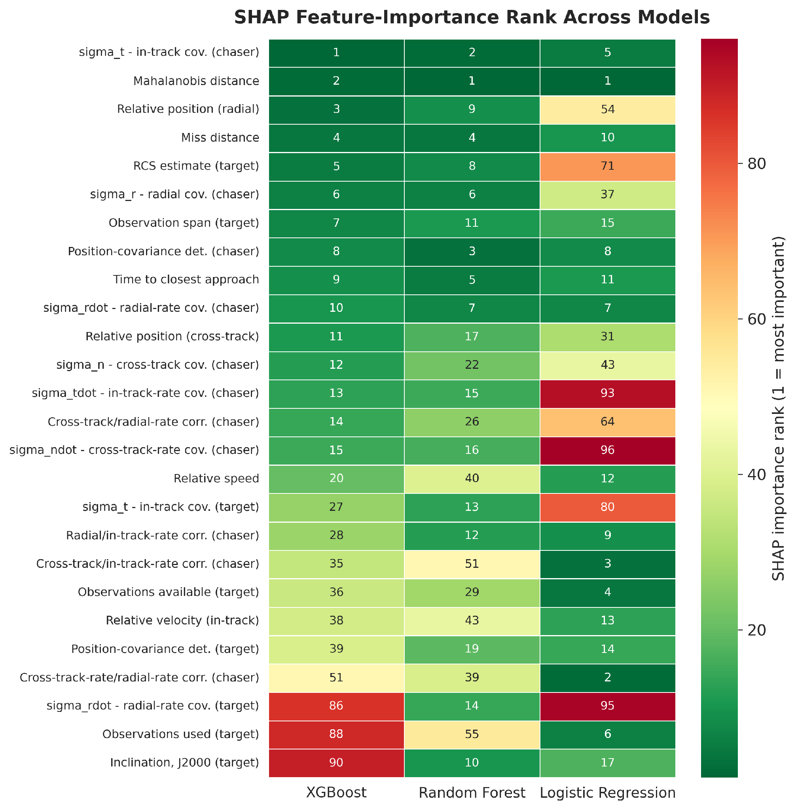
Figure 3. SHAP importance rank across models, every feature top-15 in at least one model.

3.3 The c_sigma_t Anomaly and Probability Dilution
The best performing feature in XGBoost is, counterintuitively, c_sigma_t (chaser in-track covariance), which already includes miss distance and covariance information. Multicollinearity does not explain this: c_sigma_t correlates only weakly with miss_distance (r = 0.124) and mahalanobis_distance (r = −0.067), and more strongly with c_position_covariance_det (r = 0.759, which is expected, since sigma_t feeds directly into that determinant; Figure 4). Nor is the effect due to the raw discriminative power. The point-biserial correlation between c_sigma_t with the risk label is not significant and is weak (r = −0.024, p = 0.227), while miss_distance, mahalanobis_distance and c_position_covariance_det are all significant (p < 0.001). This is an example of the interaction effect that only a tree model can take advantage of.
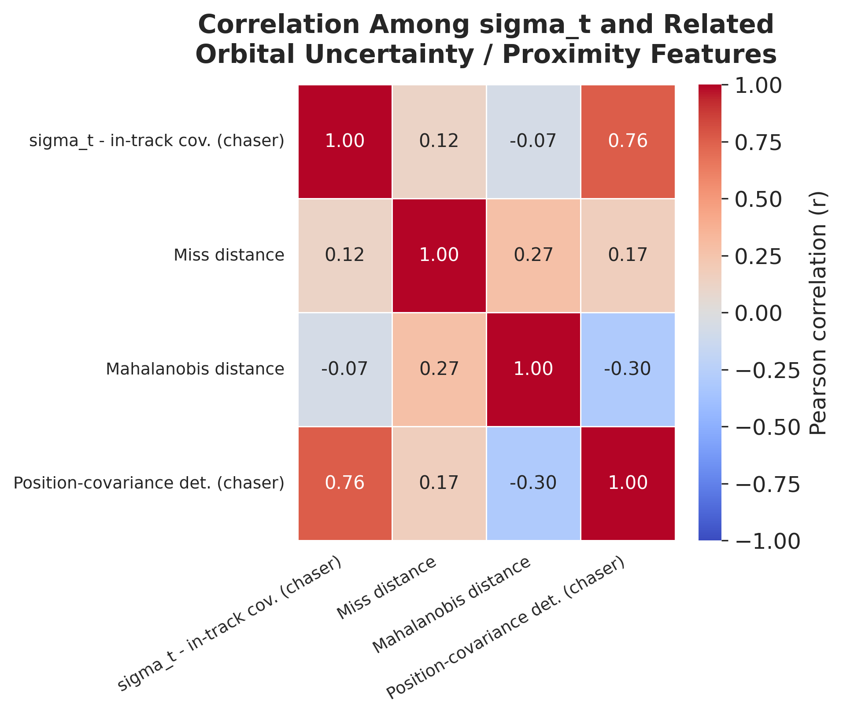
Figure 4. Correlation among c_sigma_t and related features.
This is confirmed by the SHAP dependence plot (Figure 5). The SHAP value for c_sigma_t has a sharp increase from approximately −3 at around 10²–10³ m, to approximately +1 to +2 at around 10⁴–10⁵ m, and then levels off and decreases slightly beyond 10⁷ m (Spearman ρ = 0.810 between c_sigma_t and its SHAP value, p < 0.001). This increasing, decreasing, and then decreasing trend is observed in probability dilution, which has been long described in the CA literature, not created for this paper (Hejduk & Johnson, 2016; Balch et al., 2018; Lee & Lee, 2025; Parker et al., 2024). We consider this to be consistent with the model learning that the mechanism, but not proof. The direction is confirmed by a distributional check, which shows that the median c_sigma_t for high-risk test events is higher than it is for low-risk ones, which is the opposite of the behavior exhibited by miss_distance and mahalanobis_distance (Figure 6).
Interpretation: As reported above, the agreement between XGBoost and LogReg is weak, but this is well explained by the fact that XGBoost recovered a real, non-monotonic physical relationship that logistic regression structurally cannot: namely, c_sigma_t.
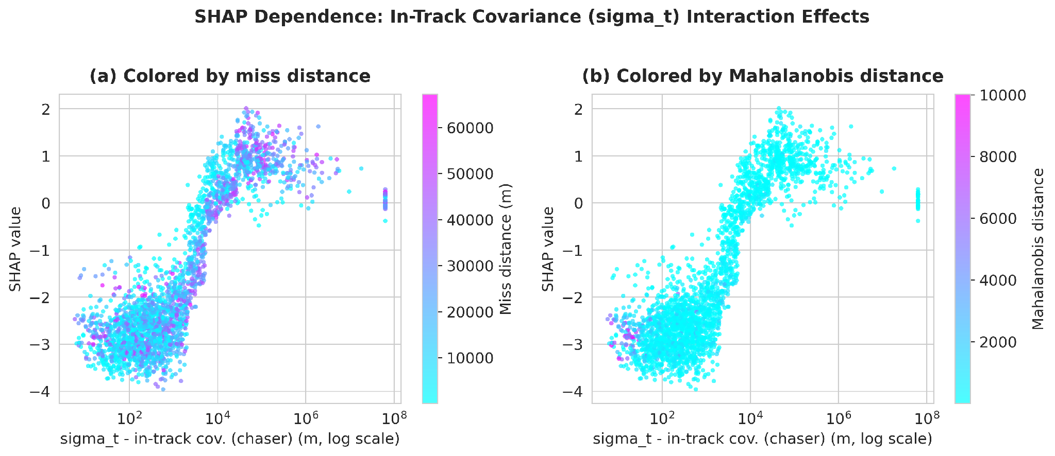
Figure 5. SHAP dependence, c_sigma_t (log scale), colored by miss distance (a) and Mahalanobis distance (b).
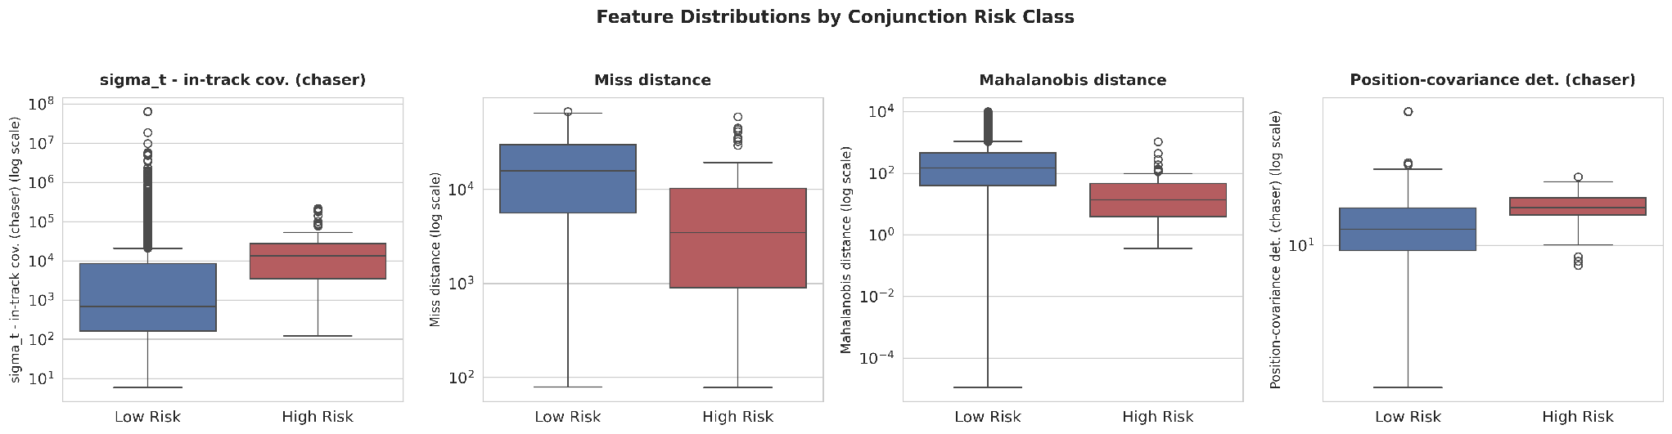
Figure 6. Feature distributions by risk class (log scale).

3.4 Case Studies
Given the 73 events, XGBoost identified 28 as high risk and left 45 unclassified. In a correctly flagged event (Figure 7a), the c_sigma_t score (-36,486.8 m) is the most significant contributor (+1.58 log-odds), more than double the next largest. In the case of a missed event (Figure 7b), the mahalanobis_distance (+1.78) and t_rcs_estimate (+1.46) correctly force the prediction closer to high risk, however 8 moderate negative contributors and a diffuse −2.03 from the remaining 95 features dominate. Unlike the hit, there is no single feature causing the miss, but rather it is spread across many low-information-value features, indicating that such misses are not readily correctable on a per-feature basis, but rather by adjusting thresholds and/or ensemble calibration.
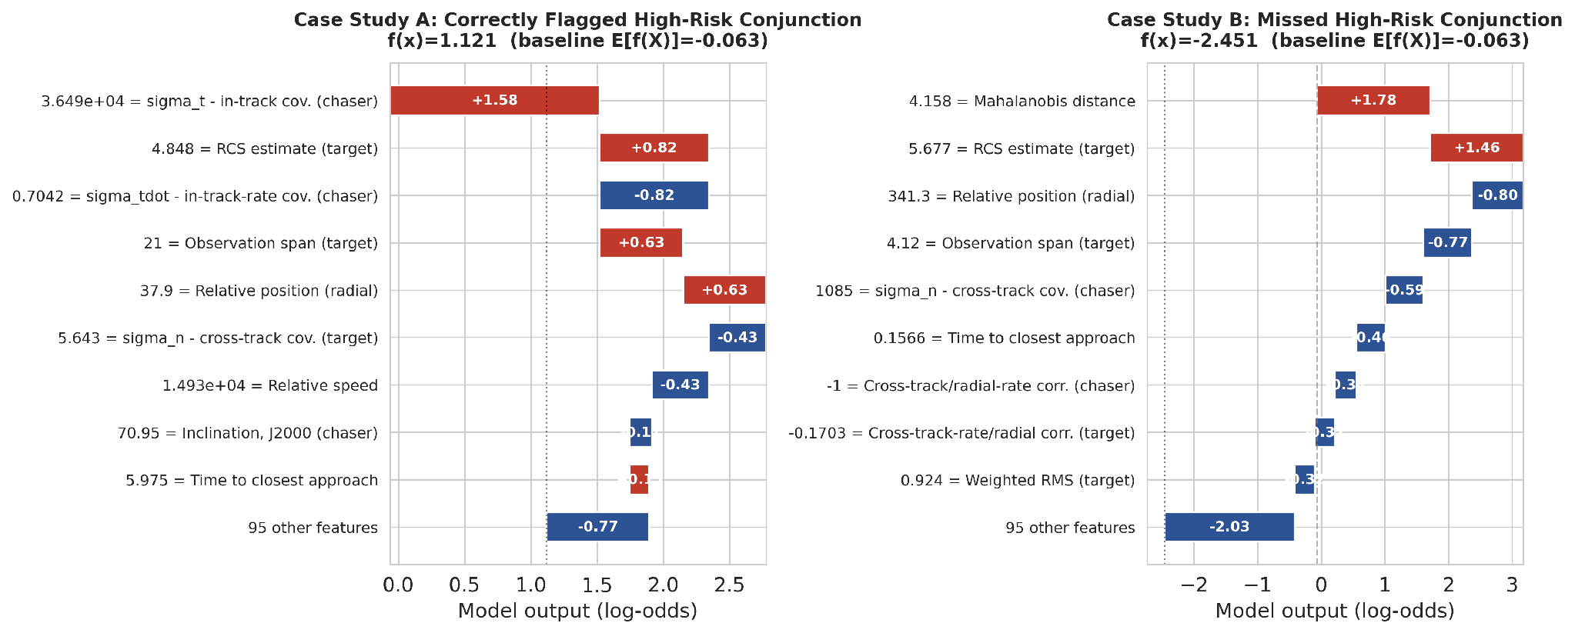
Figure 7. SHAP waterfalls: (a) correctly flagged high-risk event; (b) missed (false-negative) high-risk event.

3.5 Robustness: Repeated Stratified Cross-Validation
The reported metrics and Spearman correlations are derived from a single 80/20 split above, and it is not hard to imagine that the results will vary depending on which test events fall into that split. We repeated the entire impute–fit–SHAP procedure for 10 stratified folds (5 splits × 2 replications) and recalculated each quantity. Table 2 shows that performance was stable and that, for every model, the single-split numbers sit at or below the cross-validated mean — that is, the headline numbers were not inflated by a lucky split. Feature-ranking stability is high for the tree models and lower for logistic regression: the mean pairwise Jaccard overlap of each model's top-10 SHAP features across the 10 folds is 1.000 for random forest (an identical top-10 set in every fold), 0.862 ± 0.108 for XGBoost, and 0.687 ± 0.140 for logistic regression, consistent with a linear model being more sensitive to exactly which rare high-risk events appear in a given fold.
Model | ROC-AUC (mean ± sd) | PR-AUC (mean ± sd) | F1 (mean ± sd)
Logistic Regression | 0.868 ± 0.023 | 0.173 ± 0.030 | 0.180 ± 0.012
Random Forest | 0.942 ± 0.008 | 0.381 ± 0.049 | 0.377 ± 0.036
XGBoost | 0.965 ± 0.007 | 0.558 ± 0.047 | 0.531 ± 0.060
Table 2. 10-fold repeated stratified cross-validation, mean ± standard deviation across folds.
The gap between single-split and cross-validated numbers is greater than usual for ROC-AUC, and it really needs to be explained outright, not to be relegated to a footnote. For XGBoost, none of these are inflated metrics, but they are all lower than typical split metrics (ROC-AUC, PR-AUC, F1) across the 10 folds (0.947–0.977, 0.436–0.651, 0.409–0.654) and are not evidence that leakage re-entered the pipeline because the same code for imputing the data, fitting the model, and computing SHAP runs independently for each fold with no shared state across folds. The size of the gap is actually a function of which measure is compared. The coefficient of variation across folds is 0.007–0.026 for ROC-AUC but 0.085–0.171 for PR-AUC and 0.066–0.113 for F1, for all three models. PR-AUC and F1 are both computed largely from the minority class, and with only roughly 30-73 high-risk events per fold both are highly sensitive to the exact distribution of rare events within a test fold, and have a much greater variance from one fold to another. A leakage artifact, on the other hand, would be expected to result both in a high ROC-AUC and a huge PR-AUC/F1 gain (as was the case for the excluded max_risk_estimate/max_risk_scaling fields, in Section 2: ROC-AUC 0.9996), not a two-point gain on the ROC-AUC and a much larger gain on the PR-AUC/F1. We report this pattern not only because of the information it provides, but also because it is informative in itself, and should not be averaged away in the same way as it appears in the data.
We also determined whether the cross-model agreement pattern presented in Section 3.2 is statistically consistent and not simply numerically consistent. Indeed, a paired Wilcoxon signed ranked test of the 10 folds shows that the XGBoost–RF correlation is significantly higher than the correlations of XGBoost–LogReg and RF–LogReg (p = 0.002 and p = 0.002, respectively), and the two correlations between RF and LogReg are not significantly different (p = 0.846). The two tree models are significantly more similar than either of them is to the linear model, and the disagreements between logistic regression and the tree methods are not specific to either tree method.

3.6 Operational Threshold and Recall
In fact, at the default threshold of 0.5, XGBoost fails to predict a high-risk test event in 45 of 73 test events, giving it a false negative rate of 61.6% (Section 3.4), which seems alarming on its own. A 0.5 cut-off is not used as it would be in a safety-critical triage: the operators adjust the thresholds to favour recall and allow more FPs, as a missed conjunction is more expensive than a spurious review. Sweeping the decision threshold down to 0.01 (Figure 8) raises recall to only 86.3% (63/73) at 19.4% precision (261 false positives). 95% recall is not reached anywhere in the threshold range we tested, meaning that closing the remaining gap would require an even lower threshold and a correspondingly steep further rise in false alarms. That's a more honest and more useful operational picture than just a single F1 number: it shows the precision that an operator would have to tolerate in order to capture almost all high-risk events using this feature set and model, and it makes a case for reporting the entire threshold curve (not just a default-threshold F1) when any such model is suggested for deployment.
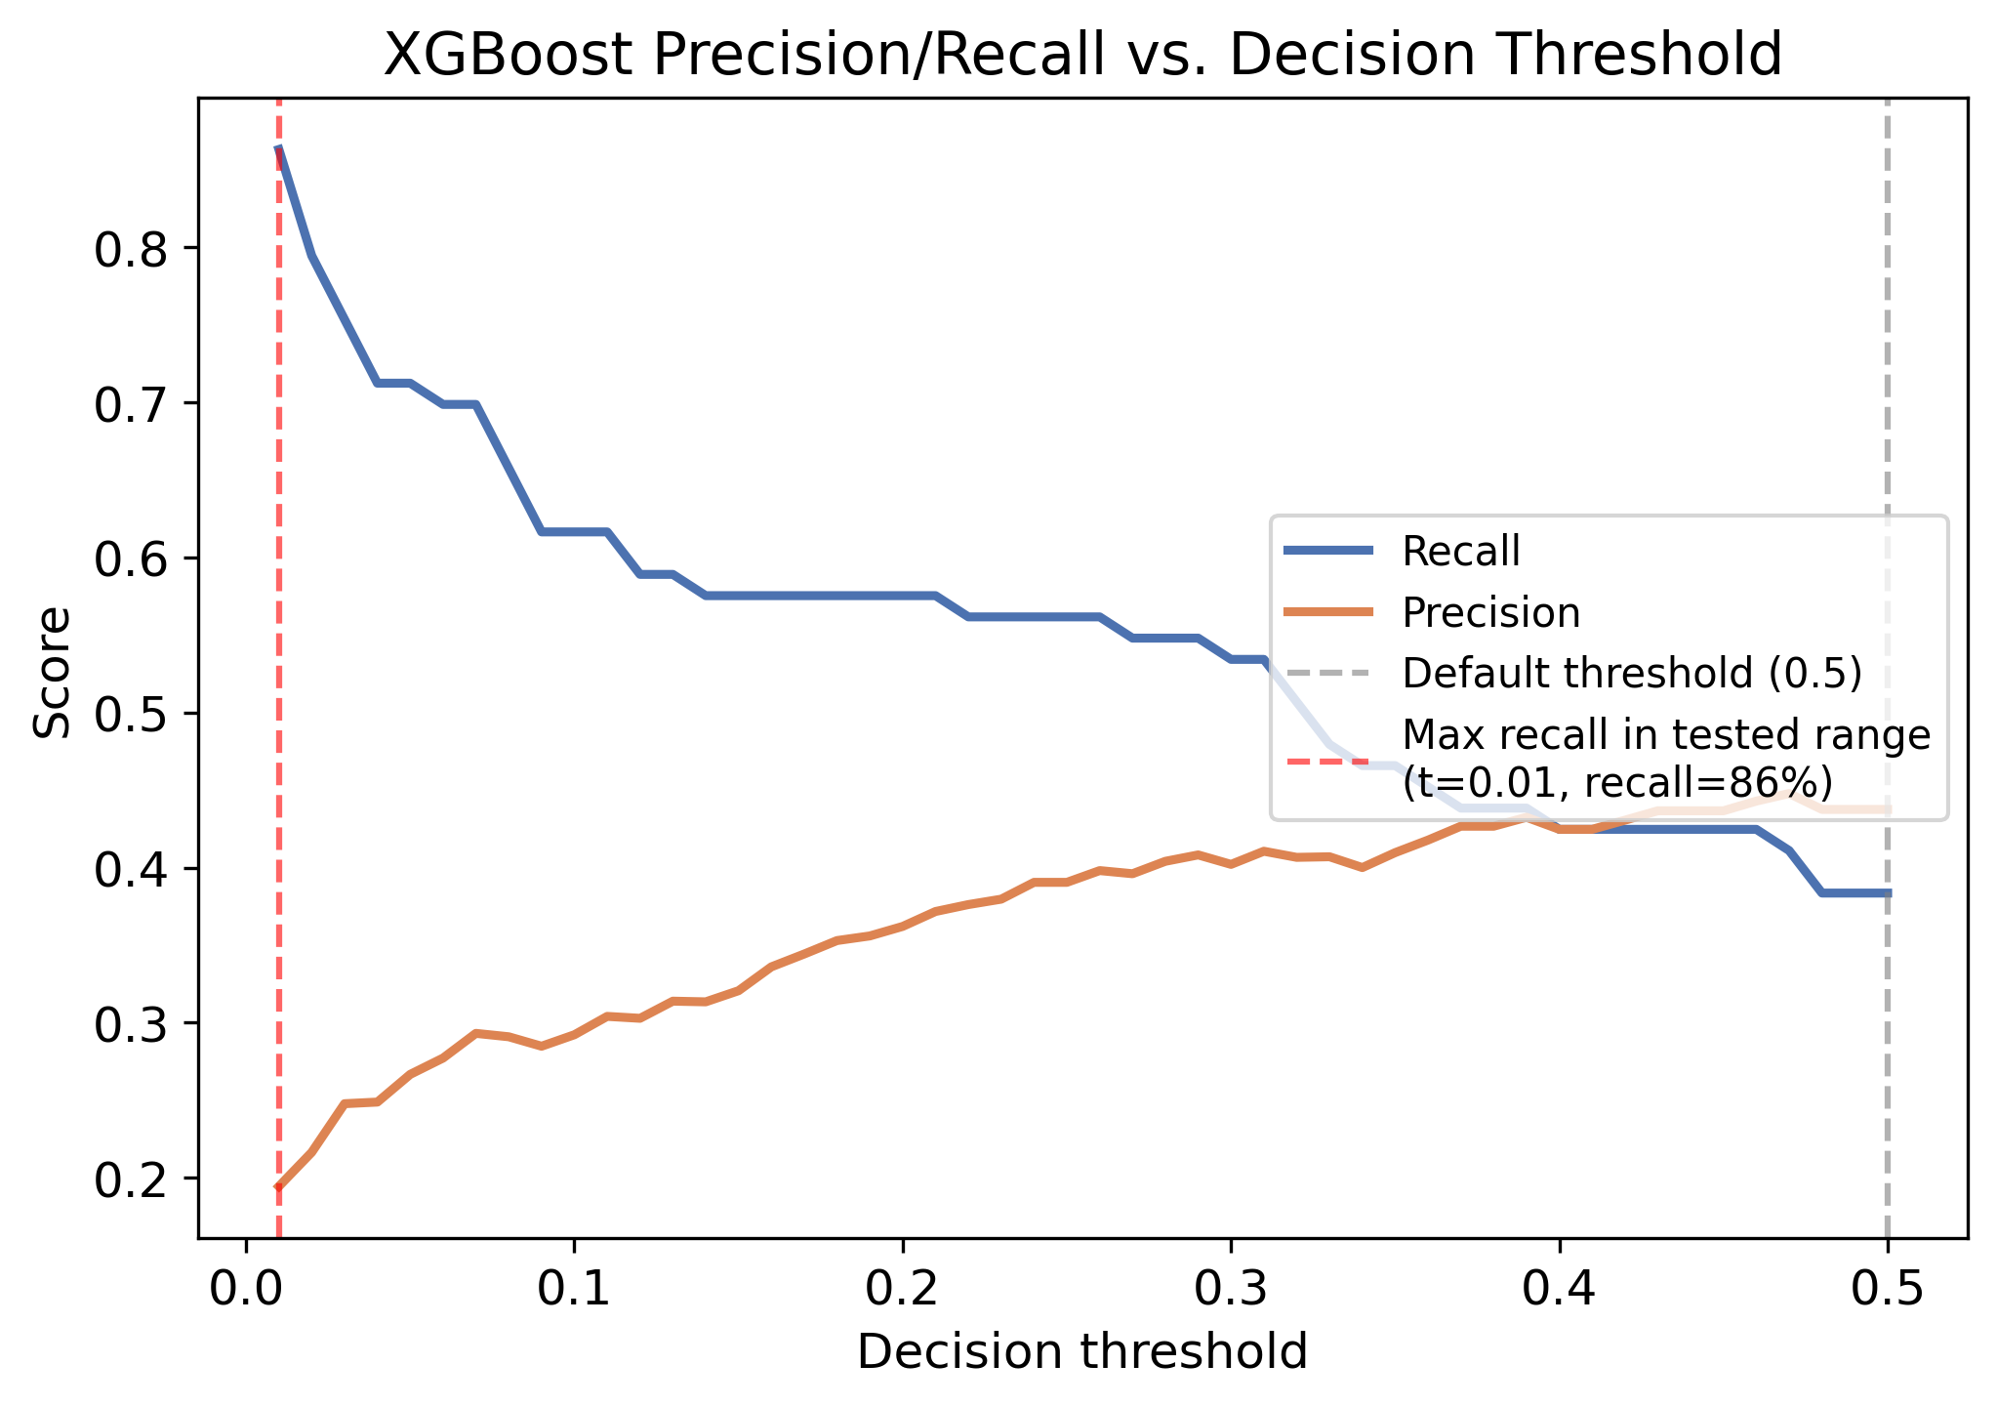
Figure 8. XGBoost precision and recall vs. decision threshold, held-out test set.

4. Discussion
Moderate-to-weak cross-model Spearman agreement (0.253–0.569) indicates that operators with varying model architectures would likely receive essentially different risk explanations for the same underlying data even if the predictions made by the models were in agreement. Deployments should, therefore, include cross-model SHAP agreement with point predictions, instead of an explanation from one model as a fixed property of the data. The c_sigma_t finding is model-based, not the most important risk driver in general. It does support, however, that a flexible model can learn a known physical non-linearity as an emergent property, without it being directly encoded — mild evidence that the model does not learn noise. The leakage case study applies to this data-set but not exclusively to it: any data-set derived from CDM will probably contain derived estimates of risk, and risk estimates derived from correlation-threshold screens will not be sufficient to protect against them.
These results are not a quirk of this specific dataset, but are part of a larger theme in the explainable-AI literature. In this disagreement problem (ρ = 0.551 between XGBoost and RF for the same prediction task, whereas 0.215–0.226 for the other pairs of methods), post-hoc explanation methods often give conflicting rankings of features for the same prediction task, and there is presently no principled way for practitioners to determine which explanation to believe (cf. Krishna et al. 2022). Our contribution is to demonstrate that this disagreement is not only cross-method (e.g., comparing SHAP to LIME; Ribeiro et al., 2016), but also cross-model within a single explanation method, and that it is consistent enough under resampling to be considered a characteristic of the model–data pairing, not sampling noise. This is an interpretability claim that is falsifiable and quantitative, not an informal call to plausibility, as Doshi-Velez and Kim (2017) call for.
A direct consequence of this result for Rudin's (2019) argument that high stakes decisions should favor inherently interpretable models over post-hoc explanations of black boxes. The seemingly interpretable output (SHAP importance) is a concrete example of a concern raised by her: there is substantial difference in the importance depending on the model used, and the operator cannot determine if the importance of a c_sigma_t is actually meaningful, or it is caused by the inductive bias of XGBoost. Regarding safety-critical conjunction assessment systems, this means that the instability of explanations must be considered as a first class validation criterion, rather than as a secondary ad hoc post hoc concern raised when a reader asks the question.

Limitations
We performed repeated cross-validation (Section 3.5) to validate stability given the relatively small size of the positive class (365 events, 73 in the test set), while the single split was used for the negative class. But concern is not completely ruled out, even 10 folds drawn from a 365-event positive class have residual variance, as seen in the wider variance of the RF–LogReg correlation (0.088 ± 0.088) than the other two pairs. The impact of SHAP is correlation, not causation, but it is supported by three independent checks, which support the concept of dilution. The results are dependent on the threshold Pc > 10-6, and Section 3.6 demonstrates that the results are sensitive to this threshold. Finally, TreeExplainer and LinearExplainer are not only different models being explained, but also different explainers, for which we have not used a model-agnostic explainer such as KernelSHAP to remove this confound, but rather leave it as an open validation step.

5. Conclusion
We observed only moderate-to-weak cross-model agreement with repeated cross-validation between the SHAP importance of three model families trained on the same, leakage-checked conjunction data (mean ρ = 0.551 ± 0.027 for SHAP of XGBoost and RF, and 0.215 ± 0.047 and 0.226 ± 0.088 for SHAP of logistic regression). This demonstrates that the model architecture impacts on what is deemed to be collision-risk drivers. We followed this counterintuitive top feature to the documented probability-dilution phenomenon (ρ = 0.810 between the feature and its own SHAP value), showing that a tree model can recover this non-linear relationship between the feature and the SHAP value that a linear model cannot. A threshold analysis also reveals that the model's false negative rate is not a hard ceiling, but a default-threshold artifact; in other words, a default threshold implies a lower precision that no single F1 number would imply. In addition to a leakage case study that extends beyond this dataset, the results here suggest that interpretability claims for conjunction risk models based on ML should be tested across different architectures, stressed in splits, and verified in the light of theory about the domain.

Declarations
Data Availability Statement: The ESA Kelvins Collision Avoidance Challenge dataset used in this study is openly available via Zenodo (record 4463683). [Author to confirm and add: repository or DOI for the analysis code and trained models, e.g., a GitHub/Zenodo release, so results are independently reproducible — most Q1 venues now require this.]
Declaration of Competing Interests: [Author to confirm: e.g., “The author declares no competing financial or personal interests that could have influenced the work reported in this paper.”]
Funding: [Author to add funding/grant information, or state that no external funding was received.]

References
Alfano, S. (2005). A numerical implementation of spherical object collision probability. Journal of the Astronautical Sciences, 53(1), 103–109.
Balch, M. S., Martin, R., & Ferson, S. (2018). Satellite conjunction analysis and the false confidence theorem. Proceedings of the Royal Society A, 475(2227), 20180565. arXiv:1706.08565.
Breiman, L. (2001). Random forests. Machine Learning, 45, 5–32.
Chen, T., & Guestrin, C. (2016). XGBoost: A scalable tree boosting system. Proceedings of the 22nd ACM SIGKDD International Conference on Knowledge Discovery and Data Mining, 785–794.
Doshi-Velez, F., & Kim, B. (2017). Towards a rigorous science of interpretable machine learning. arXiv:1702.08608.
Hejduk, M. D., & Johnson, L. C. (2016). Approaches to evaluating probability of collision uncertainty. 2016 AAS/AIAA Space Flight Mechanics Meeting, Paper AAS 16-241. NASA CARA; NTRS 20160005313 / 20160001643.
Krishna, S., Han, T., Gu, A., Pombra, J., Jabbari, S., Wu, S., & Lakkaraju, H. (2022). The disagreement problem in explainable machine learning: A practitioner's perspective. arXiv:2202.01602.
Lee, H., & Lee, Y. (2025). Overcoming dilution of collision probability in satellite conjunction analysis via confidence distribution. Entropy, 27(4), 329. https://doi.org/10.3390/e27040329
Lundberg, S. M., Erion, G., Chen, H., et al. (2020). From local explanations to global understanding with explainable AI for trees. Nature Machine Intelligence, 2, 56–67.
Lundberg, S. M., & Lee, S.-I. (2017). A unified approach to interpreting model predictions. Advances in Neural Information Processing Systems 30 (NeurIPS 2017).
Parker, W. E., Freeman, M., Chisham, G., Kavanagh, A., Siew, P. M., Rodriguez-Fernandez, V., & Linares, R. (2024). Influences of space weather forecasting uncertainty on satellite conjunction assessment. Space Weather, 22(7), e2023SW003818.
Pedregosa, F., Varoquaux, G., Gramfort, A., et al. (2011). Scikit-learn: Machine learning in Python. Journal of Machine Learning Research, 12, 2825–2830.
Ribeiro, M. T., Singh, S., & Guestrin, C. (2016). “Why should I trust you?”: Explaining the predictions of any classifier. Proceedings of the 22nd ACM SIGKDD International Conference on Knowledge Discovery and Data Mining, 1135–1144.
Rudin, C. (2019). Stop explaining black box machine learning models for high stakes decisions and use interpretable models instead. Nature Machine Intelligence, 1(5), 206–215.
Uriot, T., Izzo, D., Simoes, L. F., et al. (2020). Spacecraft collision avoidance challenge: Design and results of a machine learning competition. Astrodynamics, 4(4), 1–16.

