**SKILL BASED PROJECT REPORT**

**On**

**Expert system for Ayurvedic medical prescription (includes diagnosis)**

**Submitted in partial fulfilment of the**

**Requirements for the award of the Degree of**

**Bachelor of Technology**

**In**

**Computer Science & Engineering**

**By**

|  |  |  |  |  |  |
| --- | --- | --- | --- | --- | --- |
| |  |  | | --- | --- | | **University ID** | **Name of the student** | | **170031326** | **U. MAHESH** | |  |



**DEPARTMENT OF COMPUTER SCIENCE AND ENGINEERING**

**(DST-FIST Sponsored Department)**

**K L University**

Green Fields, Vaddeswaram, Guntur District-522 502

**2018-2019**

**K L University**

**DEPARTMENT OF COMPUTER SCIENCE AND ENGINEERING**

**(DST-FIST Sponsored Department)**



**CERTIFICATE**

This is to certify that the skill-based project entitled “Expert system for Ayurvedic medical prescription (includes diagnosis)” is a bonafide work done by U. Mahesh, in partial fulfillment of the requirement for the award of degree in BACHELOR OF TECHNOLOGY in Computer Science Engineering during the academic year 2018-2019.

**Faculty In Charge Head of the Department**

**Dr. P. Raja Rajeshwari**  **Mr. V. Hari Kiran**

**K L University**

**DEPARTMENT OF COMPUTER SCIENCE AND ENGINEERING**

**(DST-FIST Sponsored Department)**

**DECLARATION**

We hereby declare that this skill-based project report entitled **“Expert system for Ayurvedic medical prescription (includes diagnosis)”** has been prepared by us in partial fulfillment of the requirement for the award of degree “**BACHELOR OF TECHNOLOGY in COMPUTER** **SCIENCE AND ENGINEERING**” during the academic year 2018-2019.

we also declare that this skill-based project report is of our own effort and it has not been submitted to any other university for the award of any degree.

**Date:**

**Place: Vaddeswaram.**

**Submitted by :**

**170031326**

**ACKNOWLEDGEMENT**

Our sincere thanks to **Dr. P. Raja Rajeshwari** for rendering outstanding support throughout the project for the successful completion of the work.

We express our gratitude to **Mr.V. Harikiran,** Head of the Department for Computer Science and Engineering for providing us with adequate facilities, ways and means by which we are able to complete this project work.

We would like to place on record the deep sense of gratitude to the honourable Vice Chancellor, K L University for providing the necessary facilities to carry the concluded project work.

Last but not the least, we thank all Teaching and Non-Teaching Staff of our department and especially my classmates and my friends for their support in the completion of our project work.

**Submitted by :**

**170031326**

**INDEX**

**ABSTRACT…………………………………………………………………….6**

**INTRODUCTION……………………………………………………………..7**

**PROJECT DESCRIPTION…………………………………………………8-9**

**LITERATURE SURVEY………………………………………………...10-11**

**COMPARATIVE STUDY………………………………………...13**

**SOURCE CODE………………………………………………..14-24**

**OUTPUT SCREENSHOT………………………………………...25**

**FUTURE ENHANCEMENTS……………………………………………….26**

**CONCLUSION……………………………………………………………….26**

**REFERENCES………………………………………………………………..27**

**ABSTRACT**

The chief aim of any medical expert system is identification and cure of diseases. A medical expert system is built up of programs and medical knowledge base. The information obtained from medical expert system is similar to the information given by proficient in that particular area.

Ayurveda is a unique legacy of Indian system of medicine. In ancient times Ayurveda was the only tool to fight against different ailments. Even today there are a number of diseases in which treatment by Ayurveda is a better option. Currently, Medicine is one of the segment where Artificial Intelligence is widely used for diagnosis as well as treatment of various diseases. A few expert systems have also been developed for this purpose. In this project we have conducted a comparative analysis of expert systems created for disease diagnosis and tried to evaluate the strength and weakness of these expert systems.

**INTRODUCTION**

Artificial intelligence (AI) is the simulation of human intelligence processes by machines, especially computer systems. These processes include learning (the acquisition of information and rules for using the information), reasoning (using rules to reach approximate or definite conclusions) and self-correction. Particular applications of AI include expert systems, Intelligent systems, speech recognition and machine vision.

AI can be categorized as either weak or strong. Weak AI, also known as narrow AI, is an AI system that is designed and trained for a particular task. Virtual personal assistants, such as Apple's Siri, are a form of weak AI. Strong AI, also known as artificial general intelligence, is an AI system with generalized human cognitive abilities. When presented with an unfamiliar task, a strong AI system is able to find a solution without human intervention.

**APPLICATIONS**

**Reasoning:** The ability to solve problems through logical deduction. e.g. financial asset management, legal assessment, financial application processing, autonomous weapons systems, game.

**Knowledge:** The ability to present knowledge about the world. e.g. financial market trading, purchase prediction, fraud prevention, drug creation, medical diagnosis, media recommendation

**Planning:**The ability to set and achieve goals. e.g. inventory management, demand forecasting, predictive maintenance, physical and digital network optimization, navigation, scheduling, logistics

**Communication:** The ability to understand spoken and written language. e.g. real-time translation of spoken and written languages, real-time transcription, intelligent assistants, voice control

**Perception:** The ability to infer things about the world via sounds, images, and other sensory inputs. e.g. medical diagnosis, autonomous vehicles, surveillance.

**PROJECT DESCRIPTION**

**EXPERT SYSTEM:**

The expert systems are the computer applications developed to solve complex problems in a particular domain, at the level of extra ordinary human intelligence and expertise.

**CHARACTERISTICS:**

high performance

understandable

reliable

highly responsive

**CAPABILITIES OF EXPERT SYSTEM:**

Advising

assisting and instructing human in decision making

demonstrating

deriving a solution

diagnosing

explaining

interpreting input

predicting results

justify the conclusion

suggesting alternative options to a problem

**EXPERT SYSTEMS ARE INCAPABLE OF:**

Substituting human decision makers

Possessing human capabilities

Producing accurate output for inadequate knowledge base

Refining their own knowledge

**COMPONENTS OF EXPERT SYSTEM:**

* knowledge base
* interface engine
* user interface

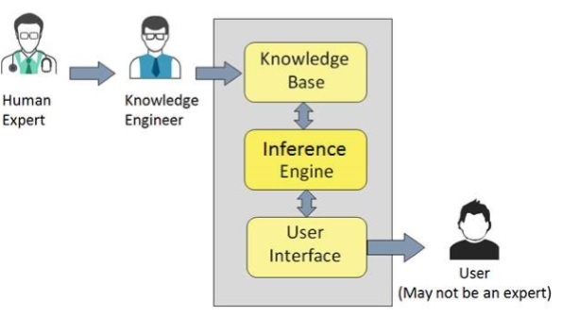

**Block diagram for expert system**

**Knowledge Base**

It contains domain-specific and high-quality knowledge. Knowledge is required to exhibit intelligence. The success of any ES majorly depends upon the collection of highly accurate and precise knowledge.

**Inference Engine**

Use of efficient procedures and rules by the Inference Engine is essential in deducting a correct, flawless solution. In case of knowledge-based ES, the Inference Engine acquires and manipulates the knowledge from the knowledge base to arrive at a particular solution.

**User Interface**

User interface provides interaction between user of the ES and the ES itself. It is generally Natural Language Processing so as to be used by the user who is well-versed in the task domain. The user of the ES need not be necessarily an expert in Artificial Intelligence.

**LITERATURE SURVEY**

|  |  |  |  |  |
| --- | --- | --- | --- | --- |
| YEAR | AUTHOR | OBJECTIVE  /TITLE | METHOLOGY_PART | CONCLUSION/RESULT |
|  |  | A Medical expert system for diagnosis of ear problems | Two basic ways a rule-based system operates backward chaining or goal driven inference and forward chaining or data driven inference. | This clinical expert system provides greater diagnostic accuracy to physicians across a wide range of medical speciality. |
|  | Dr. pooja Raundle | Successful expert systems in Ayurveda: A Comparative Study | Also in the expert system developed by Masizanakatongo and et al. The inference engine uses the problem-solving logic to emulate the decision making of domain experts. | These various expert systems equip human with an exceptional tool that would make the better interpretation and treat the diseases through Indian system of medicine i.e., Ayurveda. |
| May-June  2016 | Hetal-Amin,  Ayurveda | How data mining is useful in Ayurveda | To achieve valuable information in context of data mining, it follows three major steps i.e. Data collection, Data Shrink and Data valuable Data quest. Other approaches are association analysis Explorative modelling data base. Fragmentation and divergence detection | This information base is accessible through decision support system(DSS), data mining tool and digitized searchable texts. The data mining tool enables precise knowledge searches using Boolean operators. |
| October  5  2017 | Pradeep Tiwari, Rintu- Kutum | Recapitulation of Ayurveda constitution types by machine learning of phenotypic traits | We followed both unsupervised and supervised machine learning approaches using phenotype data from two colours from different geographical locations. | This study reveals that the clinical methods of prakriti evaluation are non-empirical and further it can be recapitulated and formalized through advanced machine learning approaches. |
| August  8  2014 | Tanzeem Khan Mansoori,  Amrit Syman | Application of genetic algorithm for cancer diagnosis by Feature selection | Feature selection algorithms fall under two categories- feature ranking and set selection.  There are two approaches  Forward selection,  Backward selection. | It is necessary for cancer patient to detect disease at very initial stage to survive and for better treatment. For this purpose feature selection play important role for detecting cancer at initial stage to diagnose at correct time. |
|  | H.A Guher,  N. Emeksiz | An expert system for the differential diagnosis of erythemato-squamous disease | In this section we describe the three classification algorithms used int= the tool;  Namely NN, NBC and the VFI-5 classifier  NN- nearest neighbour  VFI-5 voting feature intervals  NBC- naïve Bayesian classifier | DES is an expert system that presents a dermatologist or a student with diagnostic results of three classification algorithms.  DES also stores the patient records for further reference. |
|  | Igor-Konomeko | Inductive and Bayesian learning in medical diagnosis | Both, Assistant and the Naïve Bayesian classifier, outperformed physicians specialist but naïve Bayes was also better than Assistant. | Surprisingly, the Naïve Bayesian classifier is superior to Assistant in classification accuracy and explanation ability, while the interpretation of the acquired knowledge seems to be equally valuable. |

From the above literature survey, we are going to take one of the study based on our need and requirement for this project. That is Successful expert systems in Ayurveda: A Comparative Study by Dr. pooja Raundle.

**INTRODUCTION:**

Ayurveda word is from Sanskrit which means Ayur as life and “Veda” means the knowledge. So “Ayurveda’ is ‘Science of life’. It integrates different phases of life whether physical, psychological, and spiritual or social. Ayurvedic medicine has a very strong bearing on the concept of Prakurthi, which means natural form of the build and constitution of the human body [1]. According to Ayurvedic classification individuals can be grouped into 7 types of their dominancy of components such as Vata, Pita, Kapha, Vata Pita, Vata Kapha, Pita Kapha, or Vata Pita Kapha. In general population, human constitution is combination of Vata, Pita, and Kapha. A balanced state of the Prakurthi makes a healthy and balanced person (physically and mentally). The diagnosis of prakruti offers unique insights into understanding and assessing one’s health. It assesses the, dominance of Prakurthi and gives advice for preventive and primitive health care. For example unbalance vata shows anxiety disorders, pittha - anger disorders and kapha depression disorders.

**COMPARATIVE STUDY ON**

**Successful expert systems in Ayurveda: A Comparative Study**

|  |  |
| --- | --- |
| SCIENTIST | STUDY |
| D. S Kalana Mendis  Et al | Tacit Knowledge modelling using PC (Principal Component) and Fuzzy logic these are linked with in the expert system technology it consists of Interface, Inference engine, Knowledge base, Fuzzy logic module, PC analyser and the database. |
| D. S Kalana Mendis  Et al | Suggested another new approach enhancing the ability of classifying human constituents using an expert system based on the pc analysis and Fuzzy logic. |

Common sense knowledge has been extracted from the expert and formulated in a questionnaire it is evaluated using the Likert Sale Technology

|  |  |
| --- | --- |
| A.N Mansizana-Kotongo  Et al | This will provide general information of a HIV and AIDS to the public. This proposed system was framed to act as online ‘expert’. This system will accept as input on FAQ from the user and provide the most relevant answer to the question. The system was developed using EXSYS CORVID development tool. |

It is a powerful extensively proven tool for building and fielding interactive expert system applications online. It is designed to be easy and to learn and aimed to non-programmers.

|  |  |
| --- | --- |
| Masizana-Katongo  Et al | Expert system developed by these two have the inference engine uses the problem-solving logic to emulate the decision making of domain experts.  Uses the decision-making using tree-structured logic diagrams described as rules. |

**SOURCE CODE:**

print('--------------------------------------------------------')

print('--------WELCOME TO AYURVEDIC EXPERT SYSTEM---------- |')

print('enter which category do you want diagnosis |')

print('1.children |')

print('2.digestive |')

print('3.fever and general |')

print('4.joints and muscles |')

print('5.respiratory diseases |')

print('6.skin diseases |')

print('7.Lifestyle diseses |')

print('--------------------------------------------------------')

b=[]

while(1):

a=int(input())

if(a==1):

print('enter in which problems you want diagnosis')

print('1.hyper active')

print('2.bedwetting')

print('3.cold')

print('4.growth deficiency')

print('5.fever')

print('6.clacium deficiency')

print('7.cough')

b1=input().split(' ')

if '1' in b1:

b.append('CHANDERPRABHA')

if '2' in b1:

b.append('ALLEN A83')

if '3' in b1:

b.append('NASHA MUKTAM')

if '4' in b1:

b.append('SARPGANDHAGHAN VATI')

if '5' in b1:

b.append('ALLASMA')

if '6' in b1:

b.append('PURAYATI')

if '7' in b1:

b.append('TUSSIKIND')

print('the count is ',len(b))

print('the medicine list is ',b)

print('even after the use of medicines you are not comfortable consult the doctor')

f = open('doctors.txt','r')

fcontents = f.read()

a=list(fcontents.split('\n'))

print(a[0])

break

elif(a==3):

print('enter which in which problems you want diagnosis')

print('1.fever')

print('2.immune boosters')

print('3.tonsilities')

print('4.vomiting sensation')

print('5.chill')

print('6.cold')

print('7.cough')

b1=input().split()

if '1' in b1:

b.append('KALYANKA GHRITHAN')

if '2' in b1:

b.append('AMRUTHAM GOLD MALT')

if '3' in b1:

b.append('YOGI KANTHIKA')

if '4' in b1:

b.append('GAUSUDHA')

if '5' in b1:

b.append('SHATAVARI PLUS')

if '6' in b1:

b.append('HONITUS')

if '7' in b1:

b.append('KOFPAUSE-H')

print('the count is ',len(b))

print('the medicine list is ',b)

print('even after the use of medicines you are not comfortable consult the doctor')

f = open('doctors.txt','r')

fcontents = f.read()

a=list(fcontents.split('\n'))

print(a[2])

break

elif(a==2):

print('enter which in which problems you want diagnosis')

print('1.diarrhoea')

print('2.vomitings')

print('3.acidity')

print('4.colic')

print('5.nausea')

print('6.motion sickness')

print('7.loss of apetetite')

print('8.travel sickness')

print('9.constipation')

print('10.dysentry')

b1=input().split()

if '1' in b1:

b.append('Jeerakarishtam')

if '2' in b1:

b.append('AVIPATTTIKAR CHURNA')

if '3' in b1:

b.append('JIVA TRIPHALA')

if '4' in b1:

b.append('SHARANGDHAR')

if '5' in b1:

b.append('Bhaskaralavanachurna')

if '6' in b1:

b.append('PROMETHAZINE')

if '7' in b1:

b.append('DRAKSHARISHTAM')

if '8' in b1:

b.append('BALAKALPAM')

if '9' in b1:

b.append('ukhasarak Vati')

if '10' in b1:

b.append('NORMACT')

print('the count is ',len(b))

print('the list is ',b)

print('even after the use of medicines you are not comfortable consult the doctor')

f = open('doctors.txt','r')

fcontents = f.read()

a=list(fcontents.split('\n'))

print(a[1])

break

elif(a==4):

print('enter which in which problems you want diagnosis')

print('1.cramps')

print('2.muscular pain')

print('3.rheamtic pain')

print('4.bone problems')

print('5.body ache')

print('6.joints')

print('7.inflammation')

print('8.muscles')

print('9.spasms')

print('10.Osteoarthritis')

b1=input().split()

if '1' in b1:

b.append('CHITRAKADIVATI')

if '2' in b1:

b.append('MONISONS')

if '3' in b1:

b.append('AYURVIT')

if '4' in b1:

b.append('GANDHA THILAM')

if '5' in b1:

b.append('ROOP MANTRA')

if '6' in b1:

b.append('RG PLUS')

if '7' in b1:

b.append('GILOY')

if '8' in b1:

b.append('ASHWAGANDHA')

if '9' in b1:

b.append('LAKSHADIGUGGUL')

if '10' in b1:

b.append('SUGAR KNOCKER')

print('the count is ',len(b))

print('the list is ',b)

print('even after the use of medicines you are not comfortable consult the doctor')

f = open('doctors.txt','r')

fcontents = f.read()

a=list(fcontents.split('\n'))

print(a[3])

break

elif(a==5):

print('enter which in which problems you want diagnosis')

print('1.Chronic Cough')

print('2.Spasmodic cough')

print('3.Cough syrup')

print('4.Irritating cough')

print('5.Nasal congestion')

print('6.Sneezing')

print('7.Stuffiness of nostrils')

print('8.Breathlessness')

print('9.Coryza')

print('10.respiratory congestion')

b1=input().split()

if '1' in b1:

b.append('HONEY AND GINGER')

if '2' in b1:

b.append('BAIDYANATH SWARNA MAKAR D')

if '3' in b1:

b.append('AMRIT KALASH')

if '4' in b1:

b.append('TUSSNIL')

if '5' in b1:

b.append('CEPHAGRAINE')

if '6' in b1:

b.append('NEERI KFT')

if '7' in b1:

b.append('TALISULE')

if '8' in b1:

b.append('JUNAID_SR')

if '9' in b1:

b.append('HONITUS')

if '10' in b1:

b.append('LAVANGADI VATI')

print('the count is ',len(b))

print('the list is ',b)

print('even after the use of medicines you are not comfortable consult the doctor')

f = open('doctors.txt','r')

fcontents = f.read()

a=list(fcontents.split('\n'))

print(a[4])

break

elif(a==6):

print('enter in which of the following you want diagnosis')

print('1.Acne')

print('2.pimples')

print('3.psoriasis')

print('4.bed sores')

print('5.boils')

print('6.cuts')

print('7.itching')

print('8.scabies')

print('9.dermatities')

print('10.fungal infection')

b1=input().split()

if '1' in b1:

b.append('KAISHORA GUGGUL')

if '2' in b1:

b.append('ACNOVIN')

if '3' in b1:

b.append('GANDHAKRASAYAN')

if '4' in b1:

b.append('ALOEVERA')

if '5' in b1:

b.append('PILORUTE CREAM')

if '6' in b1:

b.append('KAPIVA JUICE')

if '7' in b1:

b.append('VYADHIHARAN')

if '8' in b1:

b.append('CLOVE OIL')

if '9' in b1:

b.append('HISTANTIN')

if '10' in b1:

b.append('FUNGICROS CREAM')

print('the count is ',len(b))

print('the list is ',b)

print('even after the use of medicines you are not comfortable consult the doctor')

f = open('doctors.txt','r')

fcontents = f.read()

a=list(fcontents.split('\n'))

print(a[5])

break

elif(a==7):

print('enter in which of the following you want diagnosis')

print('1.weight loss')

print('2.tension and stress')

print('3.insomnia')

print('4.erectile disfunction')

print('5.hyper tension')

print('6.mental stress')

print('7.obesity')

print('8.alcoholism')

print('9.thyroid disorder')

print('10.stress bustor')

b1=input().split()

if '1' in b1:

b.append('VIDANGADI LAUH')

if '2' in b1:

b.append('AMRIT KALASH')

if '3' in b1:

b.append('VATCHINTAMANI RAS')

if '4' in b1:

b.append('SATRITHA SHAMPOO')

if '5' in b1:

b.append('KAPIVA ASHWAGANDHA')

if '6' in b1:

b.append('CHITRAKADI VATI')

if '7' in b1:

b.append('MEDOHAR VIDANGADI LAUH')

if '8' in b1:

b.append('INDUKANTHAN KASHAYAM')

if '9' in b1:

b.append('ASHWAGANDHA')

if '10' in b1:

b.append('KAPIVA')

print('the count is ',len(b))

print('the list is ',b)

print('even after the use of medicines if you are not comfortable consult the doctor')

f = open('doctors.txt','r')

fcontents = f.read()

a=list(fcontents.split('\n'))

print(a[6])

break

else:

print('please enter a valid option')

**OUTPUT SCREENSHOT**

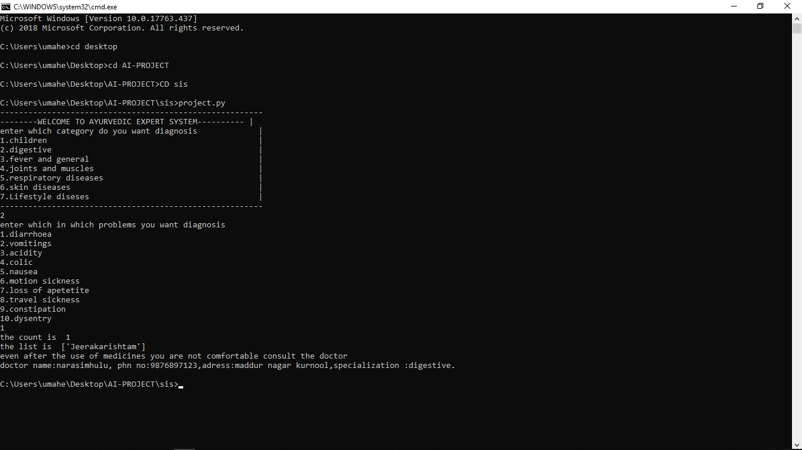

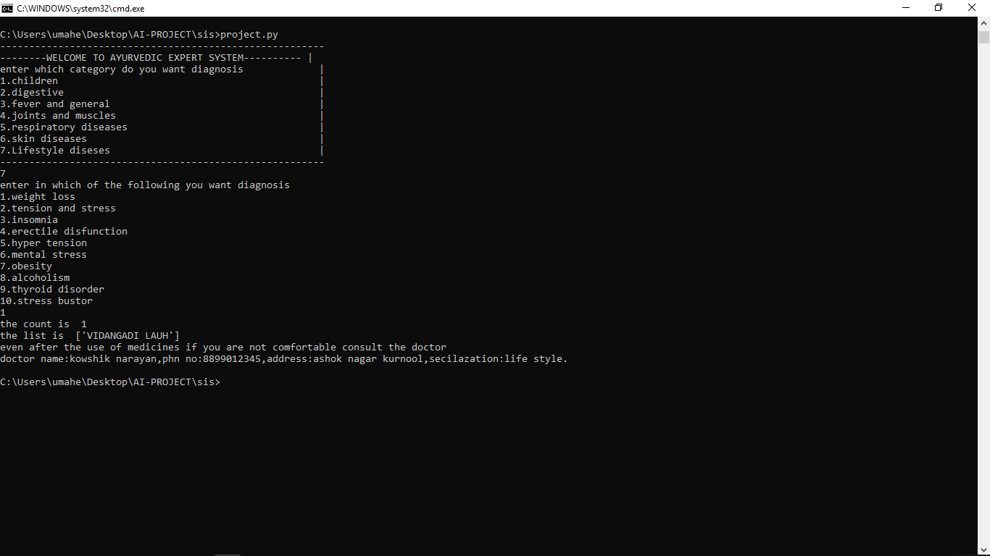

**FUTURE ENHANCEMENT:**

The diagnosis made during the Ayurvedic clinical evaluation of a patient should be consistent; Ayurvedic diagnostic variables are only justifiable if they are reproducible by different physicians for the same group of patients. Evidence of high reliability will improve the confidence among the doctors and these methods will possibly be incorporated into the clinical trials. If diagnosis is variable across different physicians, there is a need to understand the reason behind this variability. Moreover, to improve the quality and value of patient care, it is important to assess physician's performance in the clinical practice. Based on the reliability results, clinical reliance should be given on reliable variables or methods.

**CONCLUSION:**

These various expert systems equip human with an exceptional tool that would make the better interpretation and treat the diseases through Indian system of medicine i.e. Ayurveda. The survey also helps us in understanding that artificial intelligence can be used as a very strong tool for expert systems development. The human body, according to Ayurveda is classified as three categories i.e. VATA, PITTA, KALPA. The body is basically combination of these three Tatvas. The treatment to the patient can be formulated according to classification of the person. The Ayurveda strongly believes that the food also has to be eaten according to Tatvas of the person. The Expert systems can also incorporate the diet management of the patient to make it complete system of diagnosis and cure.

**REFERENCES**

* J. Liyanaratne, Nosology (1999) in Ayurveda: Data from a Pali Canonical Text, Buddhism and Traditional Medicine in Sri Lanka, Kelaniya University Press, Ragama, Sri Lanka.
* Shajahan, (1998) M.A. “Computer and Ayurveda. Apta” 5 (1): 5-17 • Gorman, P.N. (1995) “Information needs of physicians”. Journal of the American Society for Information Science. 46: 729-736
* Nair, Hemachandran(2003) “Application of information technology in the treatment and preparation of medicine in Ayurveda” with special reference to Kerala. Ph. D Thesis. Dept. of L& IS, University of Calicut
* Srinivasan, K et al. (2004) “Ayurveda and information technology: A preventive and curative approach to healthcare. Sajosps”. 4 (2):141-144 • Ram Mohan(1998) “Information technology in Ayurveda. Apta” . 5: 20-25
* “EXYS CORVID Development Environment” available at “http://www.technologyreports.com/company.asp?id=163”,accessed 21 February 2009
* D. Richards, P. Bush,(2003) “Measuring, Formalizing and modeling tacit knowledge,” IEEE/Web Intelligence Conference (WI-2003), Beijing, China.