Phishing Website Detection: Machine Learning Security Analysis
Assignment 5 | Kaggle Cybersecurity Project | Results from uploaded dataset

1. Introduction
Phishing websites imitate legitimate services to steal account credentials, payment details, or personal information. Automated classification can support security warnings and triage, but mistakes can either leave attacks undetected or interrupt safe browsing. This project evaluates two supervised classifiers on labeled website features.

2. Security Problem and Research Question
Research question: How accurately can Logistic Regression and Random Forest distinguish phishing from legitimate websites using URL and webpage features, and how do false alarms and missed attacks differ between the models?
A false negative is a phishing site incorrectly labeled legitimate. A false positive is a legitimate site incorrectly labeled phishing. Both matter, but missed phishing sites may directly expose users to theft.

3. Dataset Description
Source: Phishing Dataset for Machine Learning, Kaggle. https://www.kaggle.com/datasets/shashwatwork/phishing-dataset-for-machine-learning
The uploaded Phishing_Legitimate_full.csv contains 10,000 rows and 50 columns: an ID, 48 numeric predictors, and the CLASS_LABEL target. Label 0 represents legitimate sites; label 1 represents phishing sites. The original dataset contains 5,000 of each class.
Features include URL length (UrlLength), number of dots (NumDots), subdomain depth (SubdomainLevel), external hyperlinks (PctExtHyperlinks), domain mismatch (FrequentDomainNameMismatch), and insecure forms (InsecureForms). Some predictors describe page content, not just the URL.

4. Exploratory Data Analysis
The CSV has zero missing cells. There are 419 duplicate observations when the arbitrary ID is ignored. Removing those duplicates leaves 9,581 records for modeling. The original class balance is exactly 50% phishing and 50% legitimate. The training and testing subsets are stratified to preserve class proportions.
The class-distribution figure shows the original balance. The correlation heatmap shows relationships among selected numerical features. Correlation alone does not establish that any feature causes phishing.
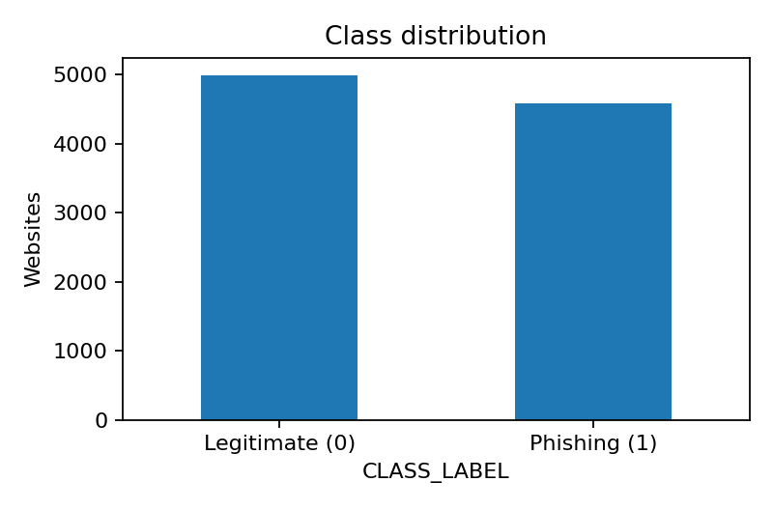
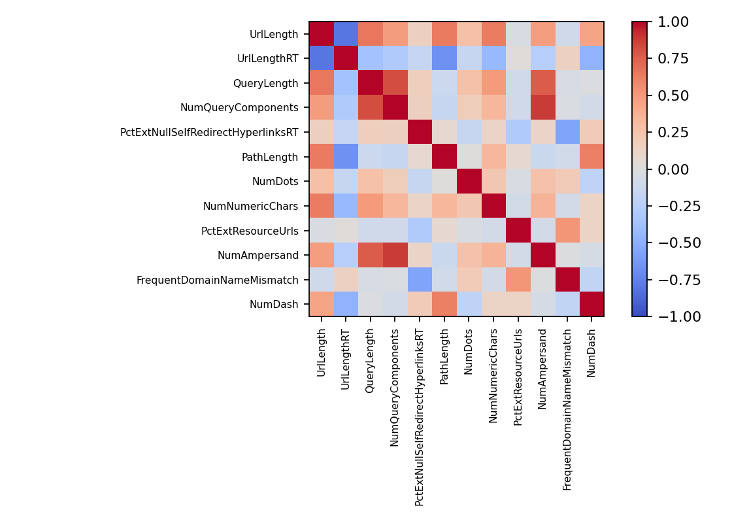

5. Data Preprocessing
The ID was removed because it is an arbitrary record identifier, not a security signal. Exact duplicate feature-and-label rows were removed before splitting to reduce repeated examples across training and testing. All 48 remaining predictors are numeric; no categorical encoding was needed. No missing-value imputation was necessary for this CSV, although a median imputer is retained inside each training pipeline for robustness.
The cleaned data was divided into an 80% training set and a 20% test set (1,917 test examples), using stratification and random_state=42. Logistic Regression uses standard scaling fitted on the training subset; Random Forest uses unscaled predictors.

6. Methodology
Logistic Regression estimates a phishing probability using a weighted combination of predictors. It is a useful baseline but can struggle with complex nonlinear relationships. Random Forest combines 200 decision trees (minimum leaf size two) and can capture interactions among website characteristics.
Both models were trained on the same training data and evaluated on the same untouched test split. Evaluation includes accuracy, phishing precision, phishing recall, F1-score, ROC-AUC, false-positive rate, false-negative rate, and confusion matrices.

7. Experimental Results
Metric | Logistic Regression | Random Forest
Accuracy | 95.20% | 98.38%
Precision | 94.02% | 97.84%
Recall | 96.07% | 98.80%
F1-score | 95.04% | 98.32%
ROC-AUC | 98.84% | 99.91%
False-positive rate | 5.60% | 2.00%
False-negative rate | 3.93% | 1.20%
False positives | 56 | 20
False negatives | 36 | 11
Random Forest achieved 98.38% accuracy versus 95.20% for Logistic Regression. It missed 11 phishing websites versus 36 for Logistic Regression, and falsely flagged 20 legitimate websites versus 56. These are held-out results from this dataset, not a guarantee of live-world performance.
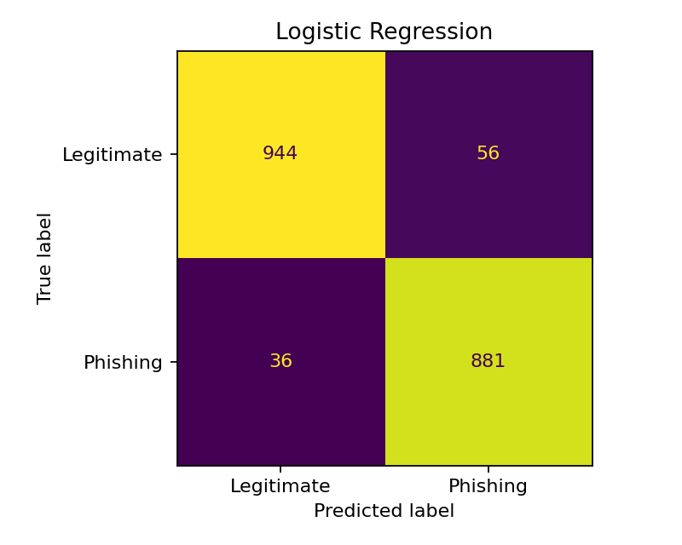
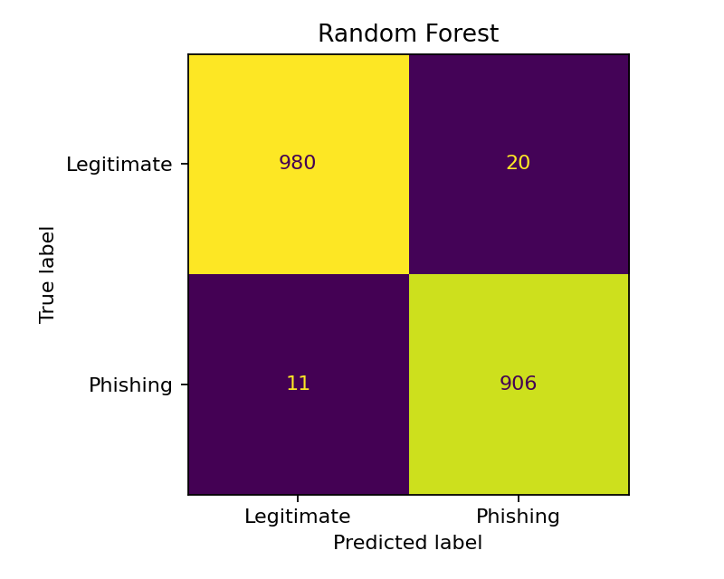

8. Security Analysis
Random Forest performed better on every reported metric. Its phishing recall was 98.80%, compared with 96.07% for Logistic Regression. For a phishing warning system, fewer false negatives are particularly valuable because an undetected attack may reach a user.
False positives also have consequences: users may be prevented from visiting safe websites and security teams may waste time investigating benign traffic. In this test, Random Forest reduced false positives from 56 to 20. The best production decision threshold would depend on the cost of missed threats versus user disruption.
Random Forest feature importance ranked PctExtHyperlinks, PctExtNullSelfRedirectHyperlinksRT, and FrequentDomainNameMismatch highly. This suggests that hyperlink behavior and domain consistency contain useful signals in this dataset; importance scores are not causal explanations.
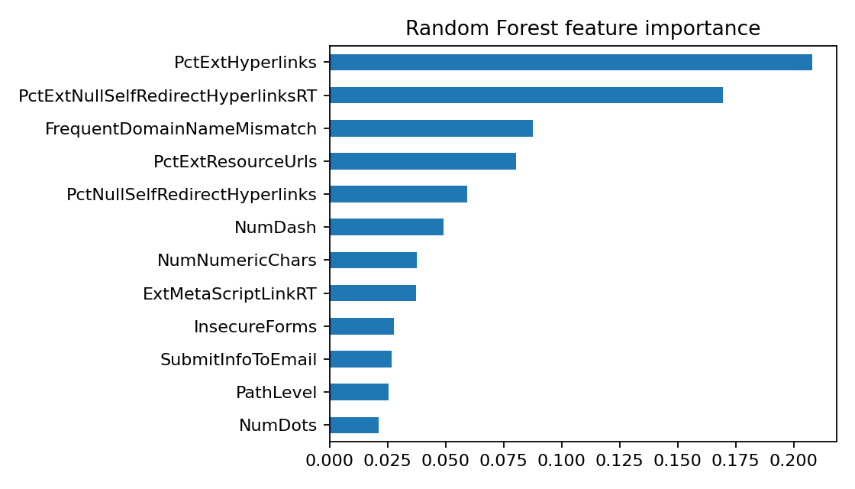

9. Limitations
The dataset is a static sample and may not reflect new phishing techniques. The initial 50/50 class balance differs from many real browsing environments; measured precision may change when phishing is rarer. A random split can still place related websites or campaigns across training and test sets, making performance look optimistic. Some features require inspecting webpage content, which has operational costs and risks.
This analysis used one train/test split, without hyperparameter tuning or independent external validation. Before real deployment, the model should be evaluated on newer datasets, monitored for drift, and integrated with layered security controls and human review.

10. Conclusion
On the held-out test set, Random Forest was the stronger of the two models, reaching 98.38% accuracy and 98.80% phishing recall while producing only 11 missed phishing websites. These results support using nonlinear feature interactions for this benchmark. However, a practical system must also consider changing threats, false alerts, and generalization to unseen websites.

11. References
Kaggle. Phishing Dataset for Machine Learning. https://www.kaggle.com/datasets/shashwatwork/phishing-dataset-for-machine-learning
Scikit-learn developers. User Guide. https://scikit-learn.org/stable/user_guide.html
OWASP Foundation. SQL Injection Prevention Cheat Sheet. https://cheatsheetseries.owasp.org/cheatsheets/SQL_Injection_Prevention_Cheat_Sheet.html

