***Lab#9***

1. Write a C++ program which takes an employee record(Employee ID number, Employee name and department name) in a 2 dimensional array. And then print it accordingly. The ID number should be ins series.

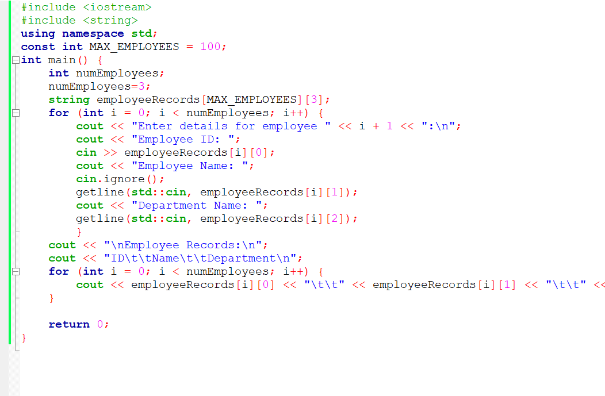

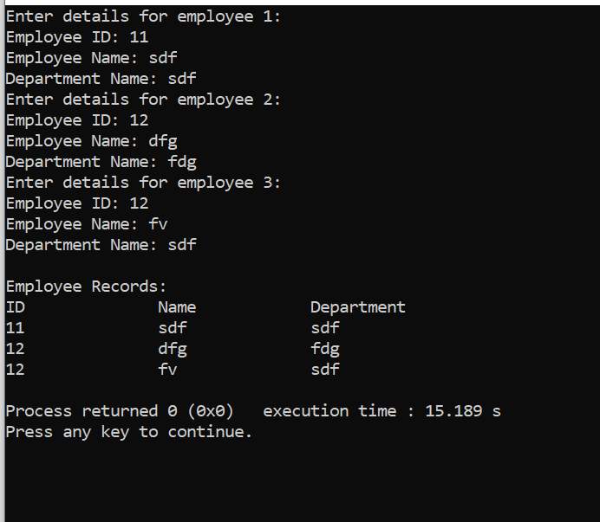

1. Write a C++ program which takes record for 4 students for 3 subjects. Stores the sum of

