Submitted By:
Syed Umaid Gillani
SU92 – BSSEM – S25 – 040
Section: BSSE4-A

Submitted To:
Sir Rasikh Ali

Department of Software Engineering
Superior University, Lahore
LAB 1
Question 2
Program:
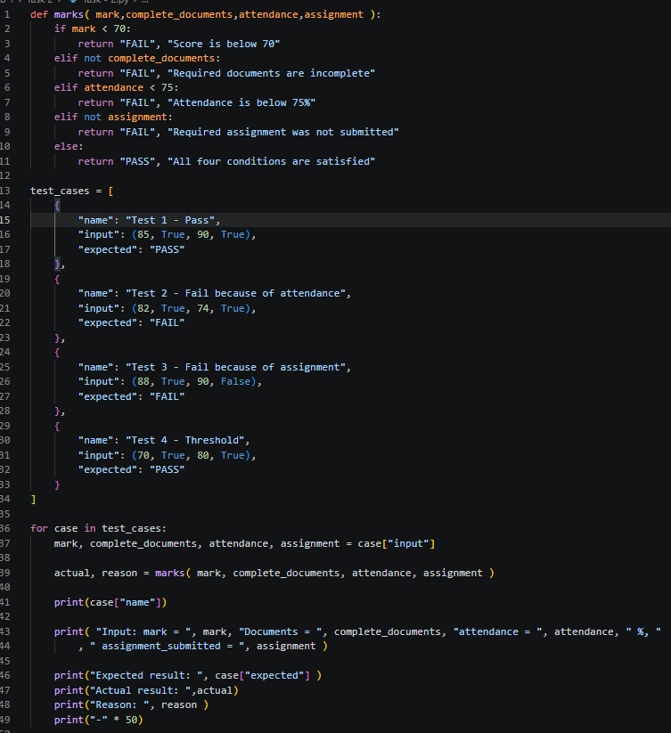
Explanation:

def marks( mark,complete_documents,attendance,assignment ):
if mark < 70:
return "FAIL", "Score is below 70"
elif not complete_documents:
return "FAIL", "Required documents are incomplete"
elif attendance < 75:
return "FAIL", "Attendance is below 75%"
elif not assignment:
return "FAIL", "Required assignment was not submitted"
else:
return "PASS", "All four conditions are satisfied"

We created a function called marks and gave it four input parameters. First, the function checks whether the person's marks are above 70 or not. If the marks are below 70, it returns Fail.
After that, we use elif to check other conditions. The first condition is not complete_documents, which checks whether the person has submitted all the required documents or not. If the documents are incomplete, the condition becomes True, and the function returns Fail.
The next elif statement checks whether the attendance is below 75%. If the attendance is less than 75%, it returns Fail.
After that, another elif statement checks not assignment, which means it checks whether the person has submitted the assignment or not. If the assignment is not submitted, the function returns Fail.
At the end, we use the else statement. If none of the previous conditions is true, the function returns Pass, meaning the person has fulfilled all the requirements.

actual, reason = marks( mark, complete_documents, attendance, assignment )

Here actual is used to store PASS or FAIL while reason stores Required assignment was not submitted.

test_cases = [
{
"name": "Test 1 - Pass",
"input": (85, True, 90, True),
"expected": "PASS"
},

Default values or test cases that are used to test. They are also written in the same order as stated in the parameters of the marks function, def marks( mark, complete_documents, attendance, assignment ):. The name in test case is just a name has to do nothing with parameters or case test solving. The input is what matters, 85 are the marks, True is bassically either a person has complete documents or not in this case yes so True, 90 is attendence which states the attendence of the person and also True is matched with assignement checking that either a person has completed their assignement or not. Expected is passed as PASS because the current condition is true which is being matched or checked with th if – elif condition that we wrote in marks function.

for case in test_cases:

The for loop is used used to check each test case againt the if – elif marks function conditon.

mark, complete_documents, attendance, assignment = case["input"]
actual, reason = marks( mark, complete_documents, attendance, assignment )

As stated above about this each input in matched with mark, complete_documents, attendance, assignment above also how they are matched is explained. Also actual, reason = marks( mark, complete_documents, attendance, assignment ) is also expalined in well manner too.

print(case["name"])

Used to print the name of each test case. Where if case is 1 then 1st case if case is 2 then 2nd case.

print( "Input: mark = ", mark, "Documents = ", complete_documents, "attendance = ", attendance, " %, ", " assignment_submitted = ", assignment )

These statements are also used to print the marks, complete_documents, attendance, assignment.

print("-" * 50)

Makes the code look cleaner by just printing – 50 time at the end of each case.

Output:


