**ASSIGNMENT#3**

**STUDENTS NAME AND REGISTRATION NUMBERS:**

Muhammad Umaid Khakwani i19-0666

Hanzla Sibghat i19-0505

Saad Ahmad Jilani i19-0615

**DEGREE PROGRAM:** BS-CS-2019

**SECTION:** D

**SUBJECT NAME:** Software Engineering

**DATE OF SUBMISSION: April 21, 2022**

**SUBMITTED TO:** Dr. Maryam Abdul Ghafoor

USER STORY: Update User-info

Screens involved: 4 (select admin->update-info->details-updated->updating-database)

EIs =7

Det =5 (id, name, phone number, address, password)

Ret=1

EOs =0

ILF =1

ELF=0

EQ=2

FTR=ILF + ELF = 1+0=1

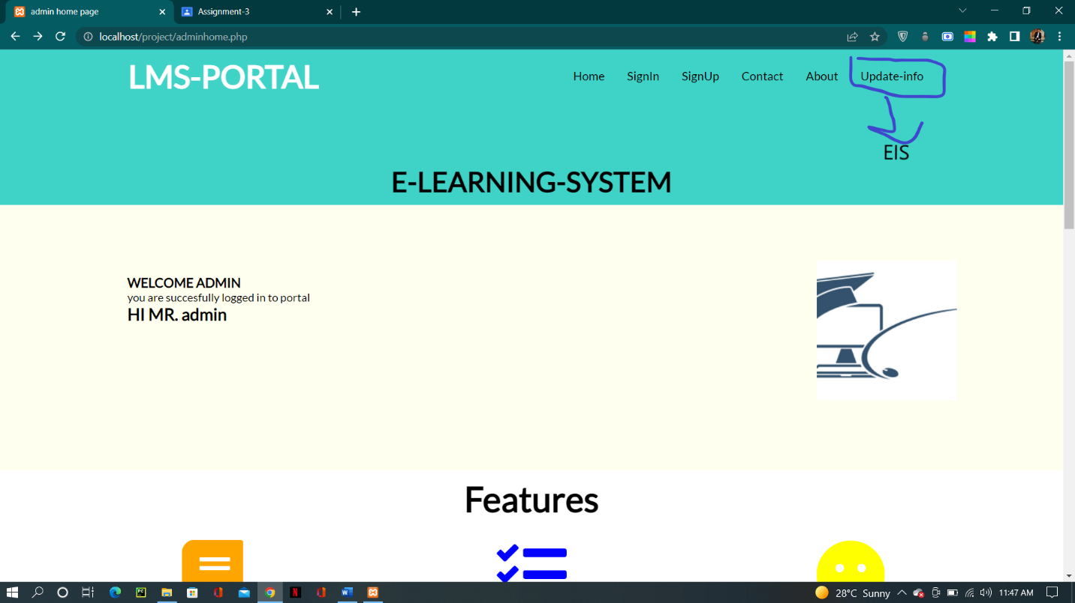

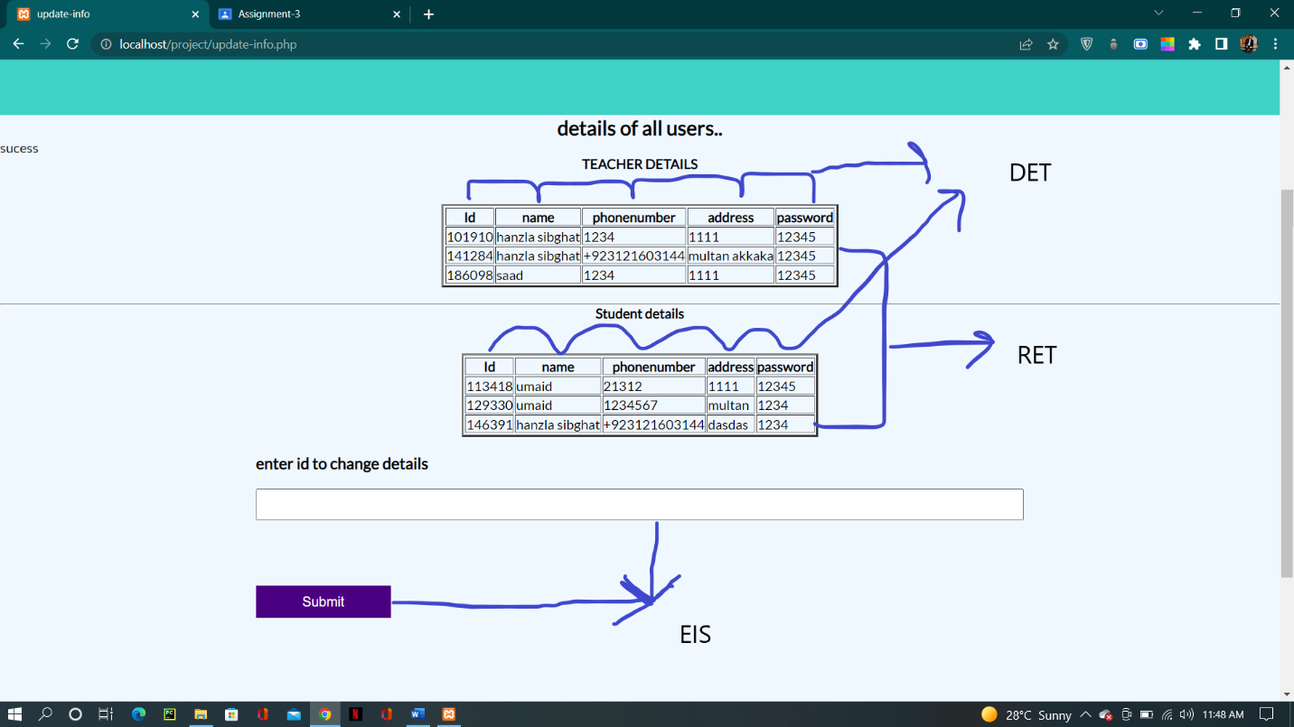

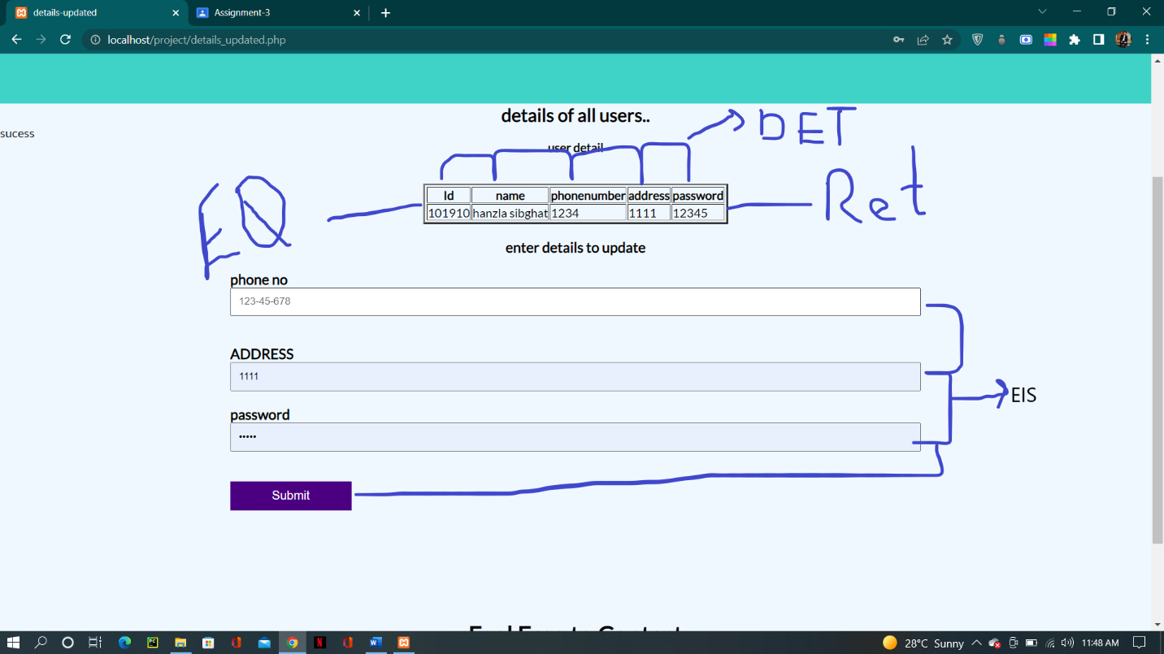

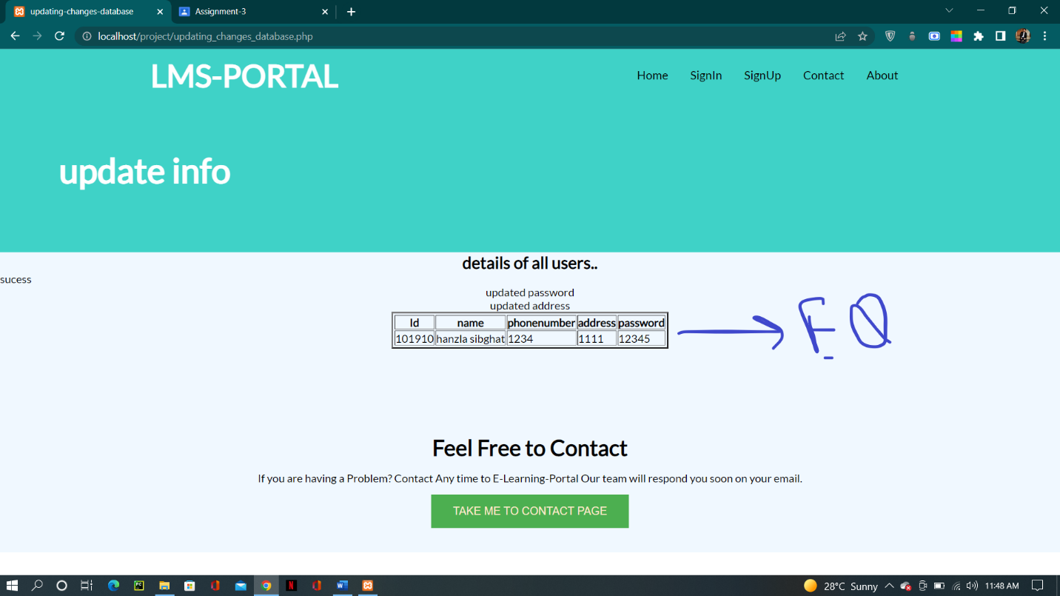

MATRIX USED FOR ILF AND ELF:

|  |  |  |  |
| --- | --- | --- | --- |
| RETs | 1 to 19 DETs | 20 to 50 DETs | 51 or more DETs |
| 1 | Low | Low | Average |
| 2-5 | Low | Average | High |
| 6 or more | Average | High | High |

For ILFs:

|  |  |
| --- | --- |
| COMPLEXITY | POINTS |
| Low | 7 |
| Average | 10 |
| High | 15 |

For ELFs:

|  |  |
| --- | --- |
| COMPLEXITY | POINTS |
| Low | 5 |
| Average | 7 |
| High | 10 |

MATRIX USED FOR EIs:

|  |  |  |  |
| --- | --- | --- | --- |
| FTRs | 1 to 4 DETs | 5 to 15 DETs | 16 or more DETs |
| 0-1 | Low | Low | Average |
| 2 | Low | Average | High |
| 3 or more | Average | High | High |

For EIs:

|  |  |
| --- | --- |
| COMPLEXITY | POINTS |
| Low | 3 |
| Average | 4 |
| High | 6 |

MATRIX USED FOR EOs and EQs:

|  |  |  |  |
| --- | --- | --- | --- |
| FTRs | 1 to 5 DETs | 6 to 19 DETs | 20 or more DETs |
| 0-1 | Low | Low | Average |
| 2-3 | Low | Average | High |
| 4 or more | Average | High | High |

For EOs:

|  |  |
| --- | --- |
| COMPLEXITY | POINTS |
| Low | 4 |
| Average | 5 |
| High | 7 |

For EQs:

|  |  |
| --- | --- |
| COMPLEXITY | POINTS |
| Low | 3 |
| Average | 4 |
| High | 6 |

UNADJUSTED FUNCTION POINT (UFP):

DETS=5

RETs=1

FTR=1

ILFS=1 7*1 7

ELFs=0 0 0

EQs=2 3*2 6

EIs=7 3*7 21

EOs=0 0 0

UFP count: 34

For Value Adjustment Factor:

1. Data Communication? 2
2. Distributed data processing? 1
3. Performance? 4
4. Heavily used configuration? 0
5. Transaction rate? 1
6. Online Data Entry? 5
7. End User Efficiency? 3
8. Online Update? 1
9. Complex Processing 1
10. Reusability? 4
11. Installation ease? 1
12. Operational Ease? 4
13. Facilitate Change? 1
14. Multiple Sites? 2

Total Degree of Influence (TDI) 30

Value adjustment Factor (VAF) Formula Calculation:

VAF=(TDI*0.01) + 0.65

VAF= 0.95

Functional Point Analysis:

FP (estimated)= UFP*VAF

FP= 34*0.95

FP=32.3