Table Of Contents

1- INTRODUCTION —--------------------------------------------------------------------------------------- 1
2- PROJECT SCOPE —---------------------------------------------------------------------------------------- 1
2.1. Project Description —-------------------------------------------------------------- 1
2.2 Program Statement —-------------------------------------------------------------- 1

2.3 Problem Solutions —--------------------------------------------------------------- 1

2.4 Advantages of Proposed System—----------------------------------------------- 1
2.5 List of Features —------------------------------------------------------------------ 2
3. Project Planning Approach —----------------------------------------------------------- 2
4. Detailed Functional Requirements—--------------------------------------------------- 7
5. Entity Relationship Diagram—---------------------------------------------------------- 7
6. Extended Entity Relation Diagram—--------------------------------------------------- 9
7 . Relational Schema —------------------------------------------------------------------- 10
8. Normalization —---------------------------------------------------------------------------------------- 11

TA AND LAB DEMONSTRATOR MANAGEMENT SYSTEM

INTRODUCTION

For proper and efficient management of tasks, assignments and schedules etc. a TA and Lab Demonstrator Database Management System is of prime importance. It not only provides a platform to administrator and faculty to manage tasks and assignments but also streamlines the allocation ,scheduling and management of TAs and Lab Demonstrators.

2. PROJECT SCOPE

2.1 Project Description
The system is exclusively designed to optimize the assignment, scheduling, and administration of Lab Demonstrators and Teacher Assistants (TAs) present in an educational institution. The system allows to enhance overall efficiency in handling scheduling ,staffing assignments within the educational institution. It is a central management system for efficient supervision of all educational activities and lab sessions involving task management of faculty and administrators. It provides a framework for functional monitoring of tasks and their allocation. Secure user authentication, role-based access control, and the opportunity for faculty to provide feedback and evaluate the TAs and Lab Demonstrators profile are a few of its major functionalities .

2.2 Program Statement
The system was designed as there was a need of a well-regulated ,integrated user friendly system feedback system for administrators, faculty and TAs etc. .A deficient task management system may cause potential overlaps .Along with it the important data might be exposed to unauthorized users. Taking all this into account and to improve educational quality a streamlined system was required.

2.3 Problem Solutions

A structured feedback system addresses the issue of regular assessments and constructive feedback for better functioning. An integrated profile management system helps make the profile updating and time management easy. A streamlined task management system through data analysis is made so that the quality of education is maintained. Encryption methods are applies along with role based access to protect important and sensitive information.

2.4 Advantages of Proposed System
Potential overlaps are minimized and tasks are managed effectively through the cooperation of users in this improved system. Administrators and Faculty are provided with a unified view of educational activities. A better evaluation system leads to intensified educational quality .Hazards of miscommunication are lessened through real-time updates. Sensitive information is protected through role-based access .
2.5 List of Features
Users : Administrators, Faculty, TAs and Lab Demonstrators
Modules of project :User authorization and authentication, Profile management ,Report generation, Security measures, notification system, feedback and evaluation ,task management
Functional requirements for users
Administrator:
- Create, edit and manage user accounts
- TAs and lab demonstrators’ performance evaluation
- Report generation
- Develop Task allocation procedure
TAs and Lab demonstrators :
- View and update personal profile
- Access specifically assigned tasks
- Task submission
- Receive feedback after task submission
Faculty Members :
- Evaluate TAs and lab demonstrators’ performance
- Provide feedback for TAs etc.
- Task assignment with deadline
- Access TAs and Lab demonstrators’ profile
3. Project Planning Approach
The planning of the project includes the distribution of questionnaires to faculty ,teacher assistants and lab demonstrators to collect information regarding potential workers’ performance and user faced problems and preferences. Detailed input is gathered from users based on their needs. The feedback procedure, evaluation methods, communication choice(preference) etc. are covered in the questionnaire.
QUESTIONAIRE RESPONSES:

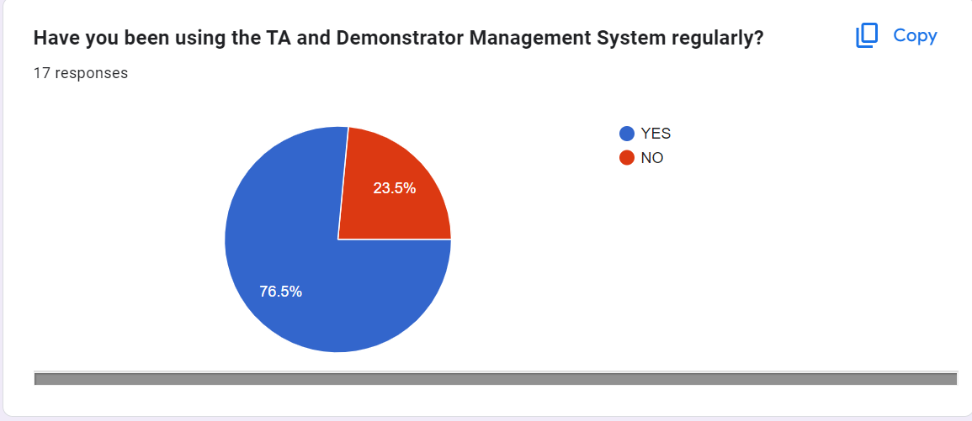

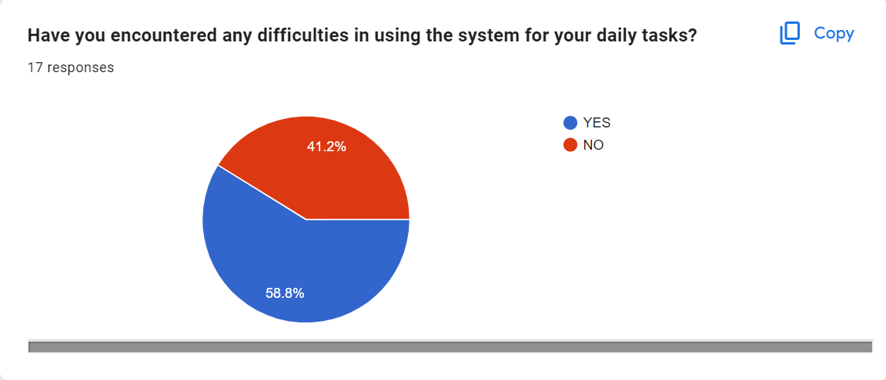
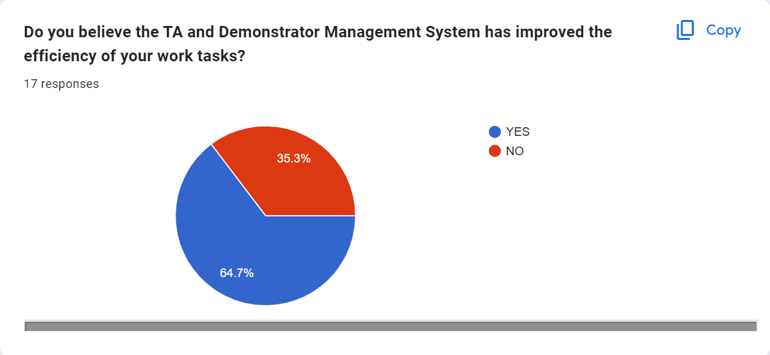

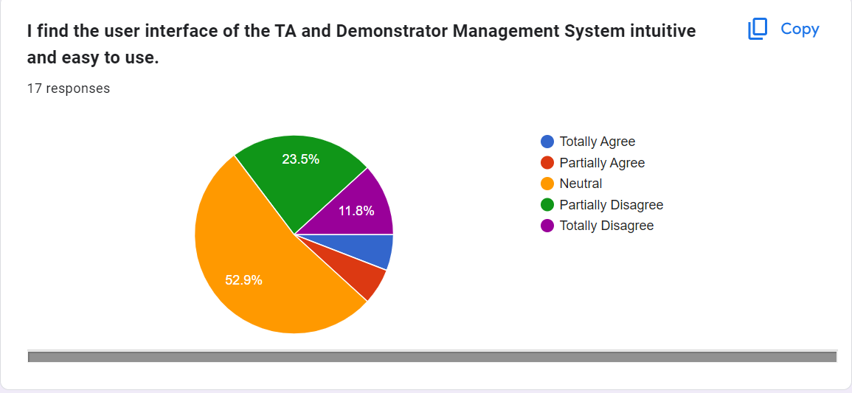
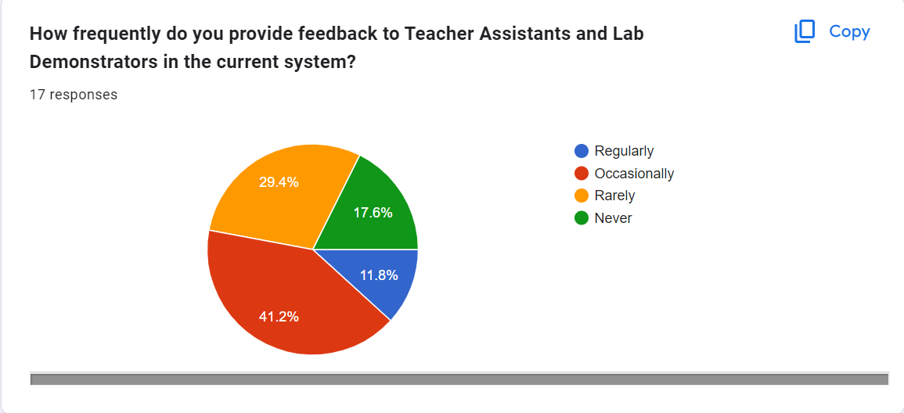

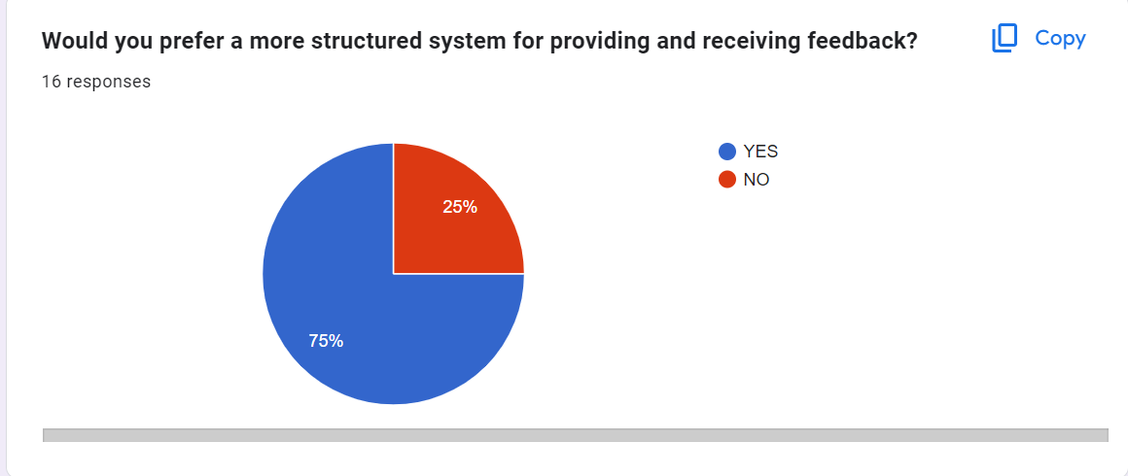
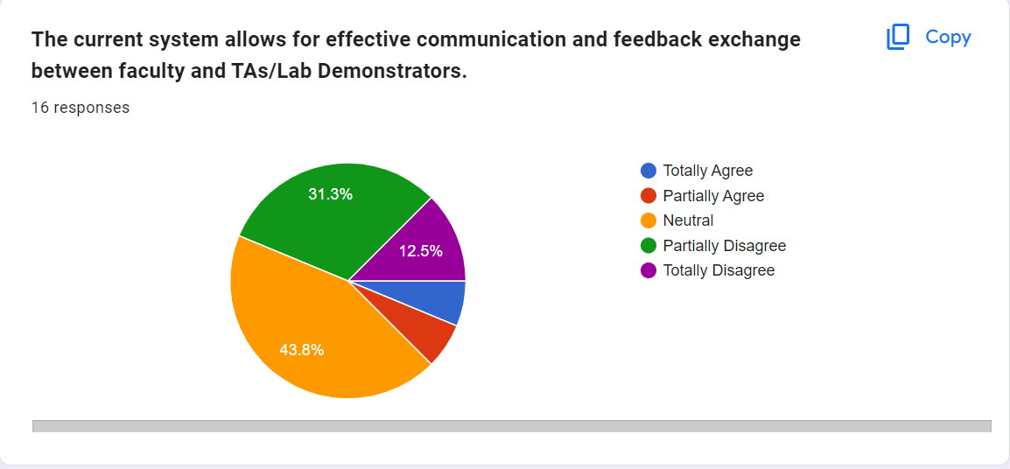

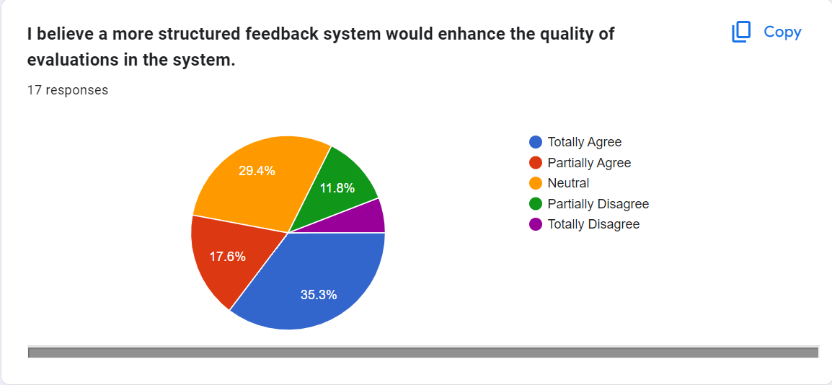

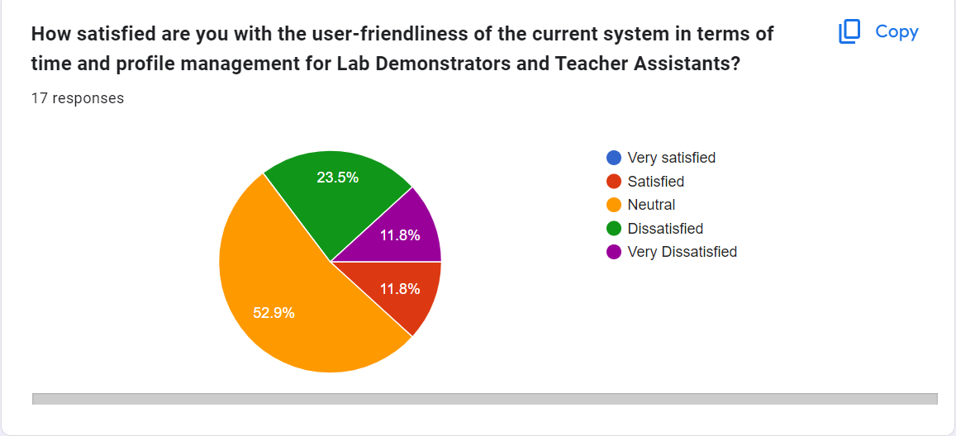
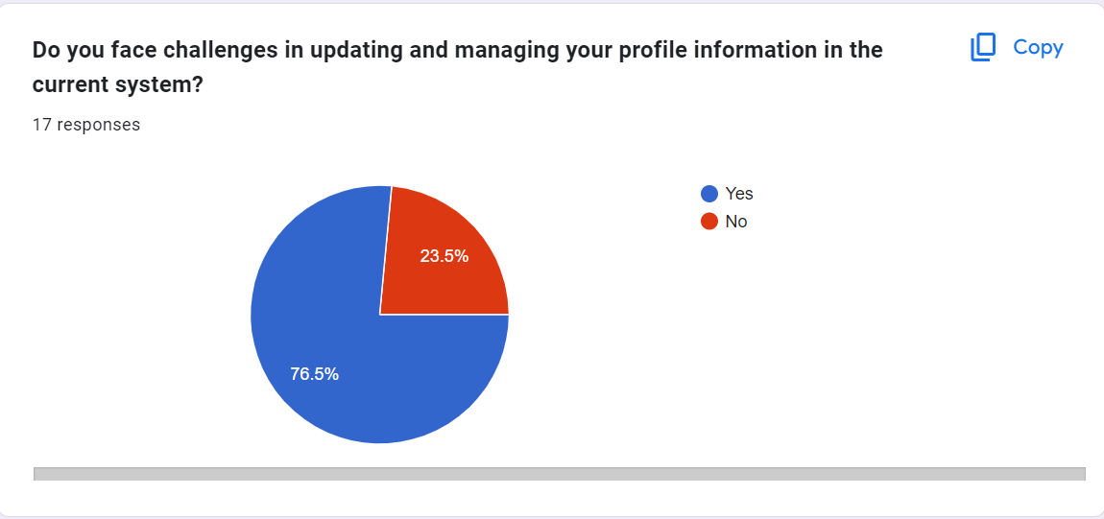
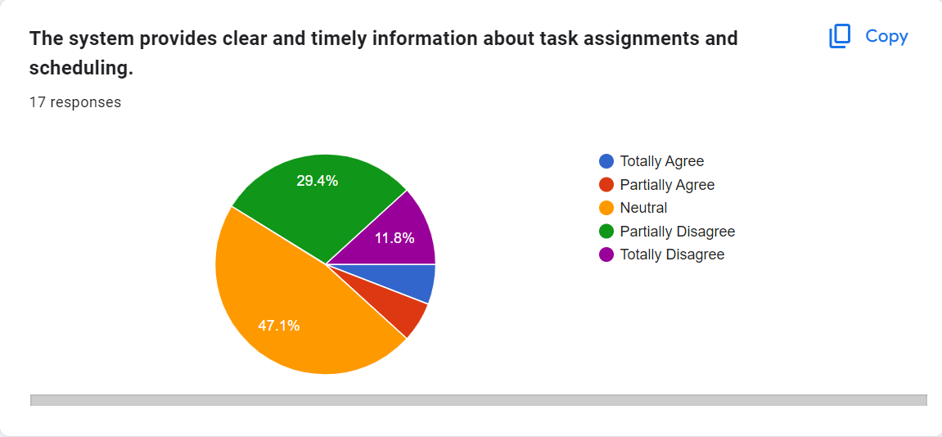
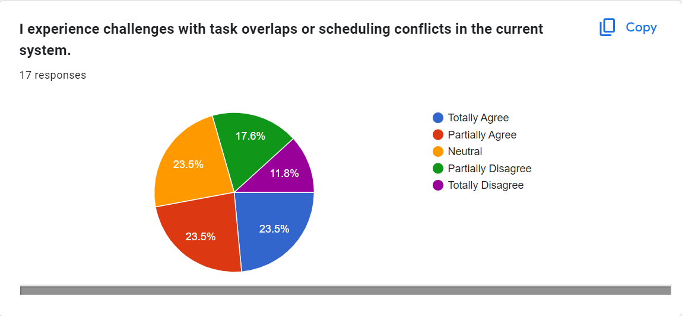
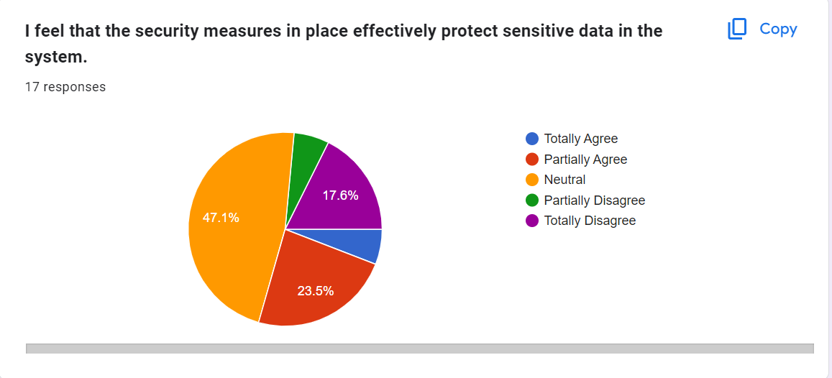

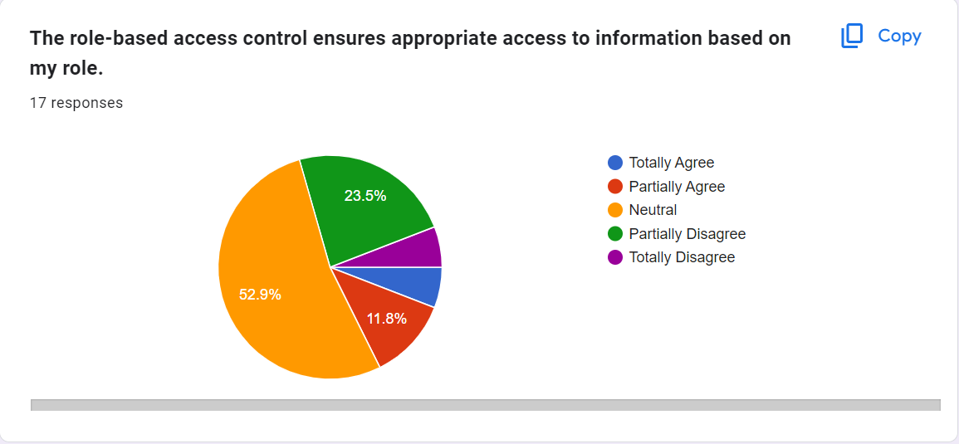

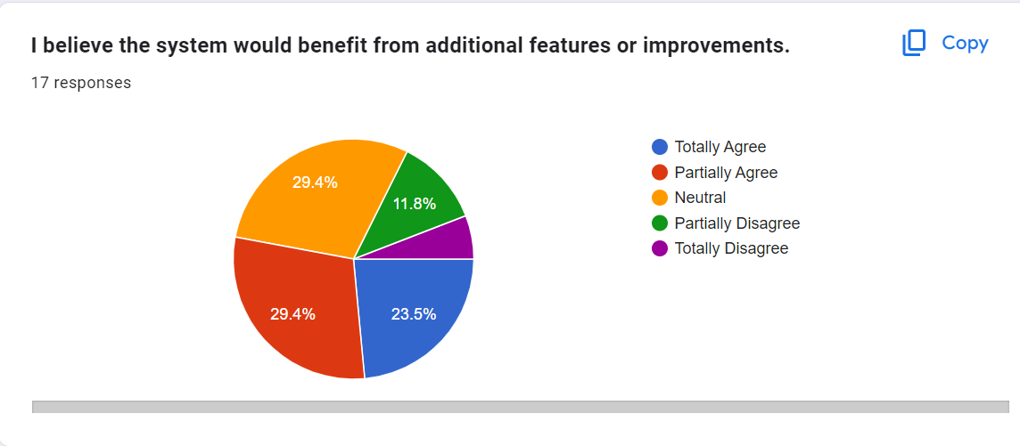

4. Detailed Functional Requirements
It includes secure login, registration of new users, user profiles creation, management, task management and assigning, role-based access and feedback mechanism .
5. Entity Relationship Diagram
It is a visual representation of relationships between entities .ERD illustrates how TAs, Lab Demonstrators ,tasks and other entities are related.

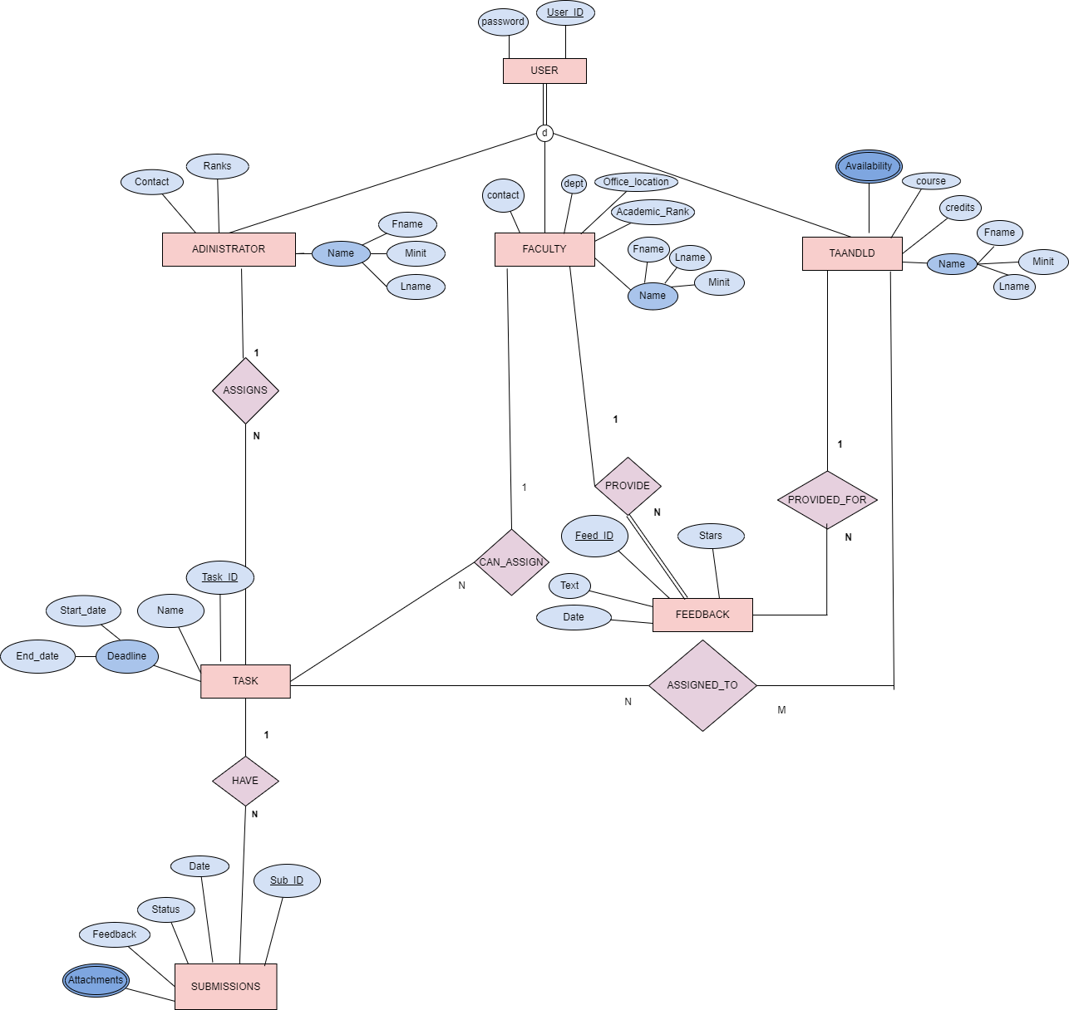
Explanation:
Entities:
User, administrator ,faculty, TA/LD, task, submissions ,feedback
Relationships and Cardinalities :
User Can be administrator (1 to 1)
User could be faculty (1 to 1)
User may be TA/LD( 1 to 1)
Faculty provide feedback( one to many)
Feedback provided for TA/LD (many to one)
Administrator assigns task (one to many)
Tasks have submissions (one to many )
Faculty can assign task (one to many)
Task assigned to TA/LD( many to many)
Participation constraints :
For total we use double line and for partial we used a single line.
6. Extended Entity Relation Diagram
EERD extends ERD by utilizing concepts of specialization etc. This adds granularity to database design .

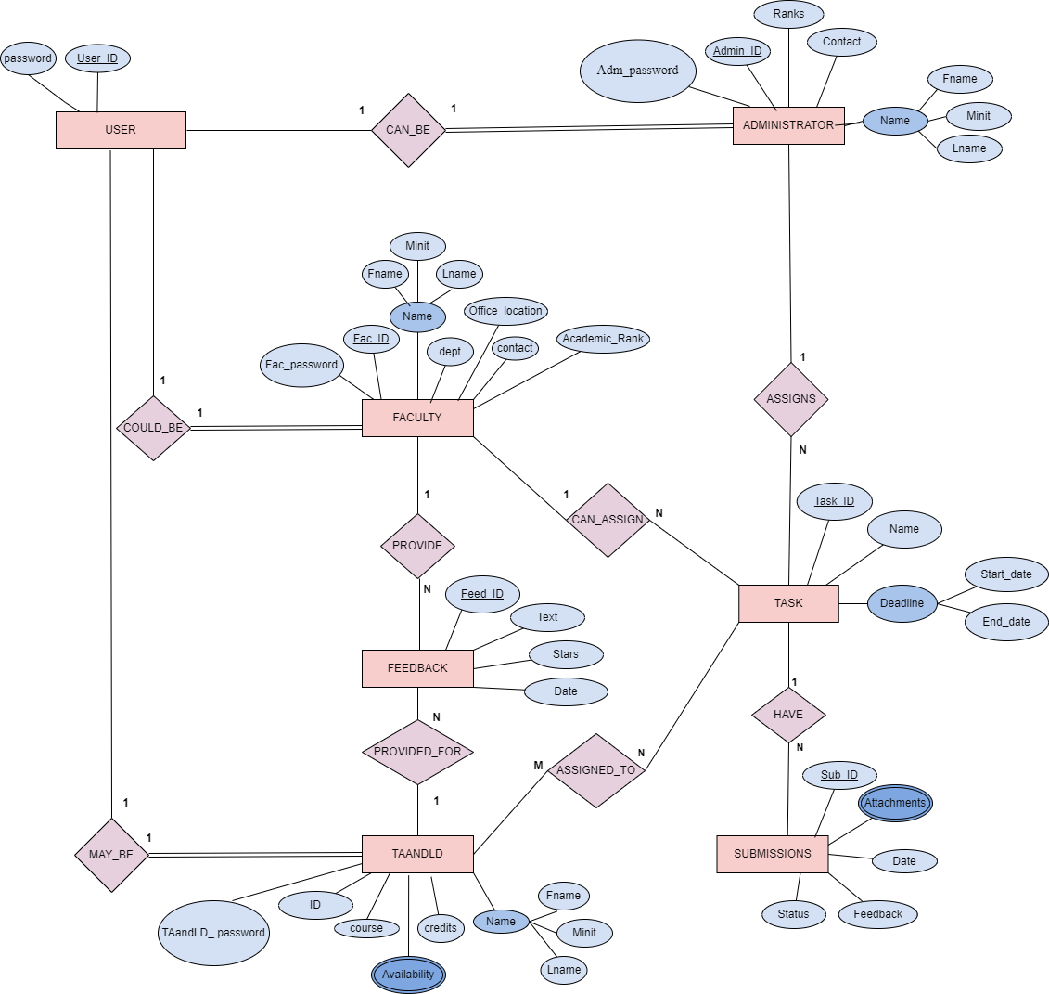
7 . Relational Schema

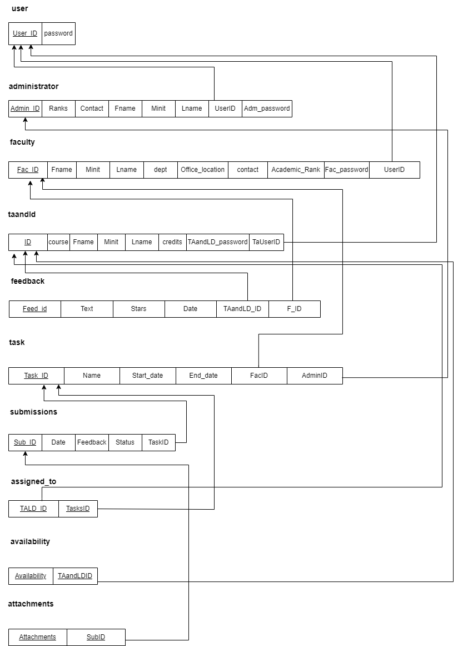
8. Normalization Analysis
1 NF:
All tables are in 1 NF . 1 NF does not allow composite attributes, multivalued attributes or nested attributes.
2 NF:
All tables are in 2 NF .In 2 NF all non-prime key attributes should fully functionally depend on prime key attribute. In short ,we have to remove partial dependencies which were not found here.
3 NF:
All tables are in 3 NF. In 3 NF we have to remove any transitive partial dependencies .In other words no non-prime key attribute should determine another non-prime key attribute which in this case is satisfied.
9. User Documentation and Help
Comprehensive user documentation is necessary for systems effective utilization. It will provide detailed guidelines on system usage to navigate platform easily.
ERD :
 | Entity
 | Relationship
 | Simple attribute
 | Multi-valued attribute
 | Key attribute
 | Composite attribute
R  E | Partial Participation
R  E | Total participation
1 N | Cardinality ratio

EERD:

d | Disjoint Ness constraint
 | Partial participation

Relational schema :
The arrows are used for referencing foreign keys (to primary keys).

