UIT UNIVERSITY
CSC-318 – Mobile Application Development
LAB 2: Adding interactivity to the Flutter app using Stateful widgets

Name: Mustafa Ahmed
Roll No: 23SP-093-CS
Section: BSCS-VI-B
Semester : 6th

FALL 2025
COMPUTER SCIENCE DEPARTMENT

Home Task:
Task 01:
Develop a Flutter application that utilizes a stateful widget to implement a simple counter. The app should allow users to increase and decrease the counter value through button interactions, following the design shown below.

Code:
import 'package:flutter/material.dart';

void main() {
runApp(MaterialApp(home: CounterApp()));
}

class CounterApp extends StatefulWidget {
@override
State<CounterApp> createState() => _CounterAppState();
}

class _CounterAppState extends State<CounterApp> {
int counter = 0;

@override
Widget build(BuildContext context) {
return Scaffold(
appBar: AppBar(title: Text('Simple Counter')),
body: Center(
child: Column(
mainAxisAlignment: MainAxisAlignment.center,
children: [
Text('Counter Value:', style: TextStyle(fontSize: 24)),
Text('$counter', style: TextStyle(fontSize: 48, fontWeight: FontWeight.bold)),
SizedBox(height: 30),
Row(
mainAxisAlignment: MainAxisAlignment.center,
children: [
ElevatedButton(
onPressed: () {
setState(() {
counter--;
});
},
child: Text('Decrement'),
),
SizedBox(width: 20),
ElevatedButton(
onPressed: () {
setState(() {
counter++;
});
},
child: Text('Increment'),
),
],
),
],
),
),
);
}
}

Output:
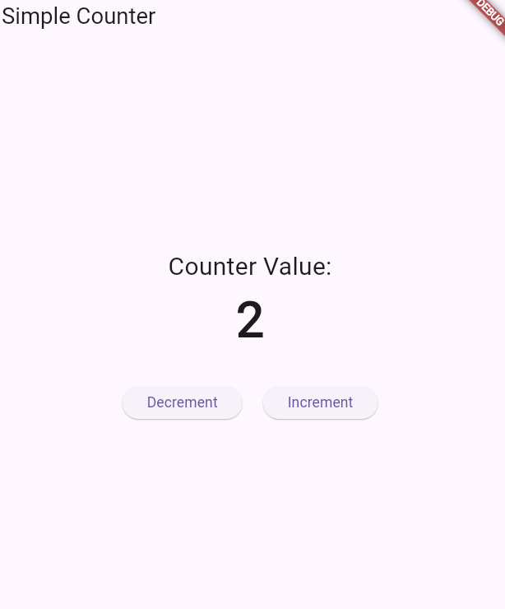
Task 02:
Develop a Flutter project that includes a stateful widget named MyApp with an associated state class called _MyState. This state class should have a changeColor function to manage the widget's state. The application should change the background color of a container from yellow to red when the FloatingActionButton is pressed.
Code:
import 'package:flutter/material.dart';

void main() {
runApp(MyApp());
}

class MyApp extends StatefulWidget {
@override
State<MyApp> createState() => _MyState();
}

class _MyState extends State<MyApp> {
Color bgColor = Colors.yellow;

void changeColor() {
setState(() {
bgColor = (bgColor == Colors.yellow) ? Colors.red : Colors.yellow;
});
}

@override
Widget build(BuildContext context) {
return MaterialApp(
home: Scaffold(
appBar: AppBar(title: Text('Change Color App')),
body: Container(
color: bgColor,
child: Center(
child: Text(
'Tap the button to change color',
style: TextStyle(fontSize: 20, color: Colors.white),
textAlign: TextAlign.center,
),
),
),
floatingActionButton: FloatingActionButton(
onPressed: changeColor,
child: Icon(Icons.color_lens),
),
),
);
}
}

Output:
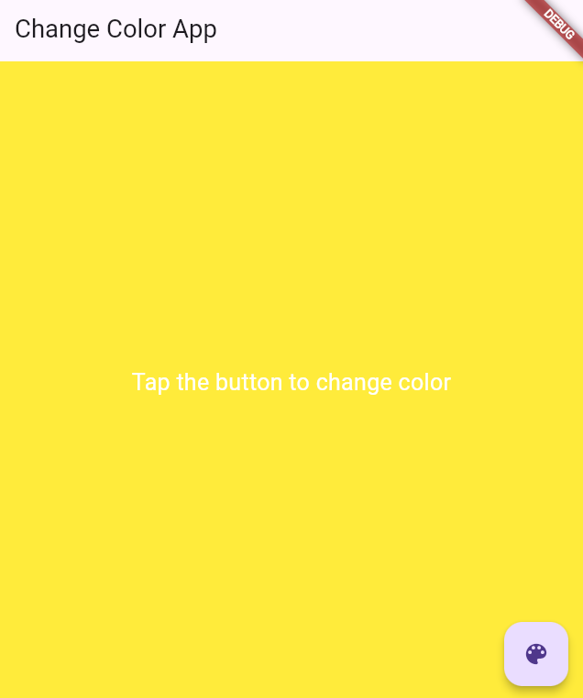
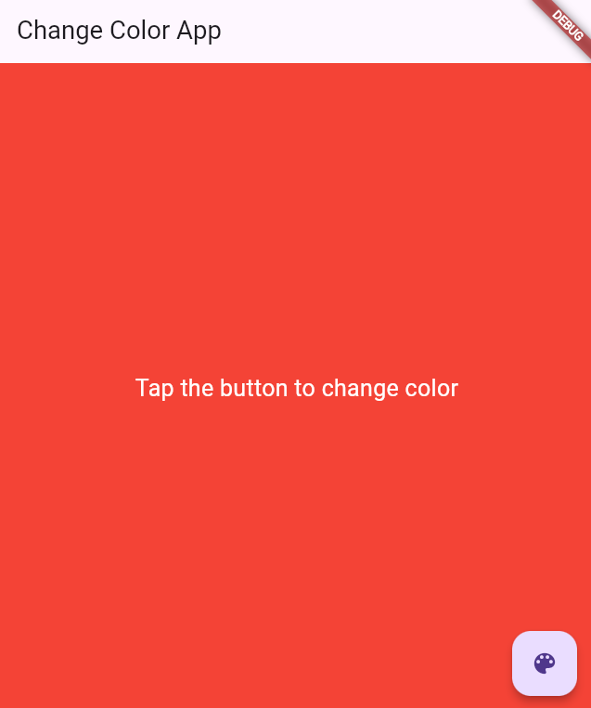

Task 03:
Use below mention material components to enhance interactivity in your Flutter application
- DropdownButton
- TextButton
- IconButton
- Radio
- Slider
- Switch
- Checkbox

Code:
import 'package:flutter/material.dart';

void main() {
runApp(MaterialApp(home: MaterialComponentsDemo()));
}

class MaterialComponentsDemo extends StatefulWidget {
@override
State<MaterialComponentsDemo> createState() => _MaterialComponentsDemoState();
}

class _MaterialComponentsDemoState extends State<MaterialComponentsDemo> {
String dropdownValue = 'Option 1';
int radioValue = 1;
double sliderValue = 50;
bool switchValue = false;
bool checkboxValue = false;

@override
Widget build(BuildContext context) {
return Scaffold(
appBar: AppBar(title: Text('Material Components Demo')),
body: Padding(
padding: EdgeInsets.all(20),
child: Column(
crossAxisAlignment: CrossAxisAlignment.start,
children: [
Text('DropdownButton:'),
DropdownButton<String>(
value: dropdownValue,
items: ['Option 1', 'Option 2', 'Option 3']
.map((e) => DropdownMenuItem(child: Text(e), value: e))
.toList(),
onChanged: (value) {
setState(() {
dropdownValue = value!;
});
},
),
SizedBox(height: 20),
Text('TextButton:'),
TextButton(
onPressed: () {},
child: Text('Click Me'),
),
SizedBox(height: 20),
Text('IconButton:'),
IconButton(
onPressed: () {},
icon: Icon(Icons.thumb_up),
),
SizedBox(height: 20),
Text('Radio Buttons:'),
Row(
children: [
Radio(
value: 1,
groupValue: radioValue,
onChanged: (value) {
setState(() {
radioValue = value!;
});
},
),
Text('Option 1'),
Radio(
value: 2,
groupValue: radioValue,
onChanged: (value) {
setState(() {
radioValue = value!;
});
},
),
Text('Option 2'),
],
),
SizedBox(height: 20),
Text('Slider: ${sliderValue.toInt()}'),
Slider(
value: sliderValue,
min: 0,
max: 100,
divisions: 10,
onChanged: (value) {
setState(() {
sliderValue = value;
});
},
),
SizedBox(height: 20),
Row(
children: [
Text('Switch:'),
Switch(
value: switchValue,
onChanged: (value) {
setState(() {
switchValue = value;
});
},
),
],
),
Row(
children: [
Text('Checkbox:'),
Checkbox(
value: checkboxValue,
onChanged: (value) {
setState(() {
checkboxValue = value!;
});
},
),
],
),
],
),
),
);
}
}

Output:
