**Aura Watches**

# Group Members:

* Amin (1288581)
* Krishna (1288566)
* Sualeh (1288825)
* Abdul Wahab (1288582)
* Jawad (1294945)

Acknowledgment

I would like to acknowledge all those who have given me moral support and helped in making the project a success.

I wish to express my gratitude to E-Project Team at Head Office who guided and helped me. Thanks To Our Faculty Sir Abu Bakar who guided us during the Project. Also, I would like to express my gratitude to all the staff members of my center for not only providing me opportunity to work with them on this project, but also for their support and encouragement throughout the process.

I also express my sincere gratitude to E-Project Team from Aptech Head Office and my project guide at the organization for his valuable guidance and support for completion of this project.

Final, I would like to offer many thanks to all my colleagues for their valuable suggestions and constructive feedback.

HARDWARE & SOFTWARE REQIREMENT

# Hardware:

* Minimum 4 GB ram
* Not less than 2.5 GHZ processor
* A minimum computer system that will help you access all the tools in the courses is a Pentium 166 or better.

# Software:

* Notepad/HTML editor
* Visual studio code
* Opera and Google chrome.

Tasks Completed by

|  |  |
| --- | --- |
| Amin  1288581 | Header, Footer, Home Page, Contact Us Page, Logo, Price List, Word Files, Documentation |
| Sualeh  1288825 | Cards, Word Files |
| Krishna  1288566 | Product Detail Page, Word Files |
| Abdul Wahab  1288582 | Product Detail Page |

Diagram

MEN’S

WOMEN

FEATURED

POPULAR

DOWNLOAD

CONTACT US

Home Krishna

Details

Download

Details

Download

Details

Download

Details

Download

Product Page

Product Page

Product page

Product page

Product Cards

Product Cards

FEATURED PRODUCTS

LATEST PRODCUTS

PRICE LIST

BRANDS

BRANDS

SCREENSHOTS

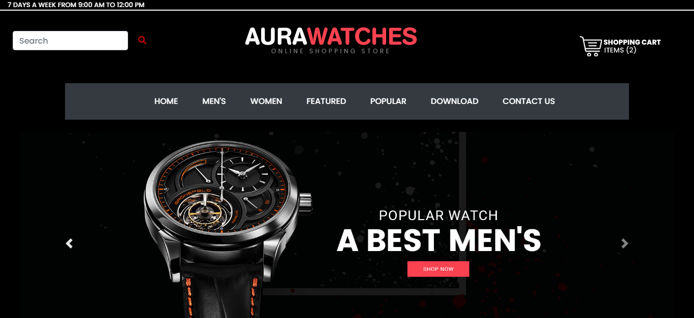

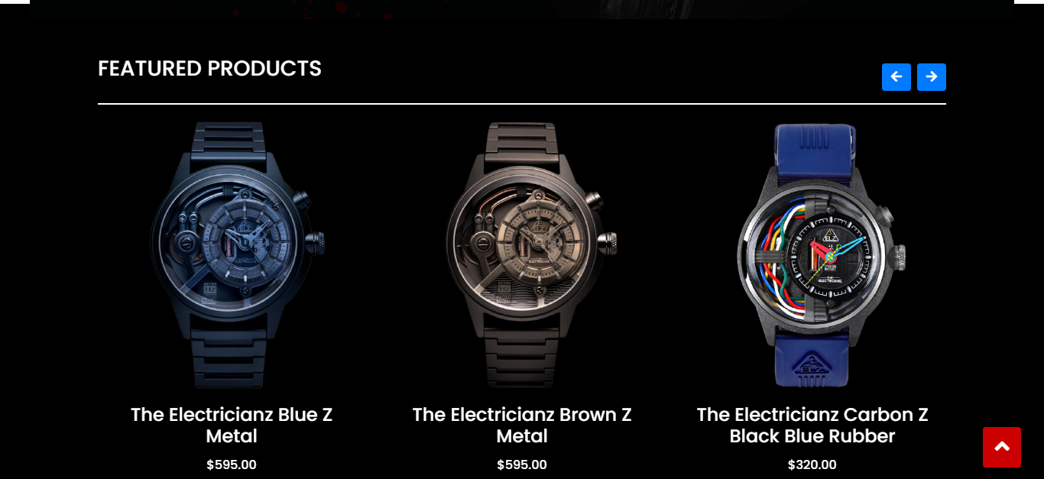

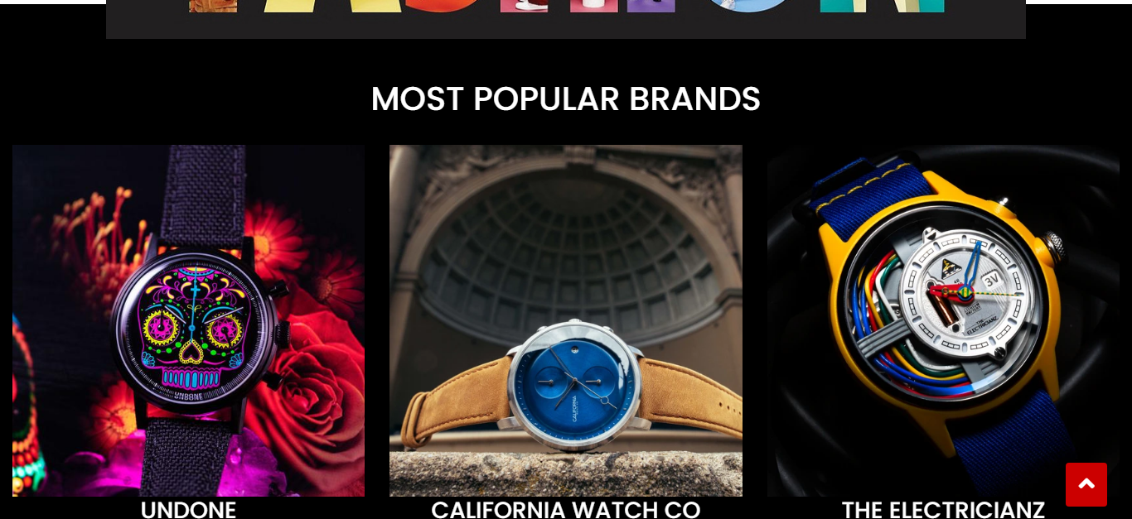

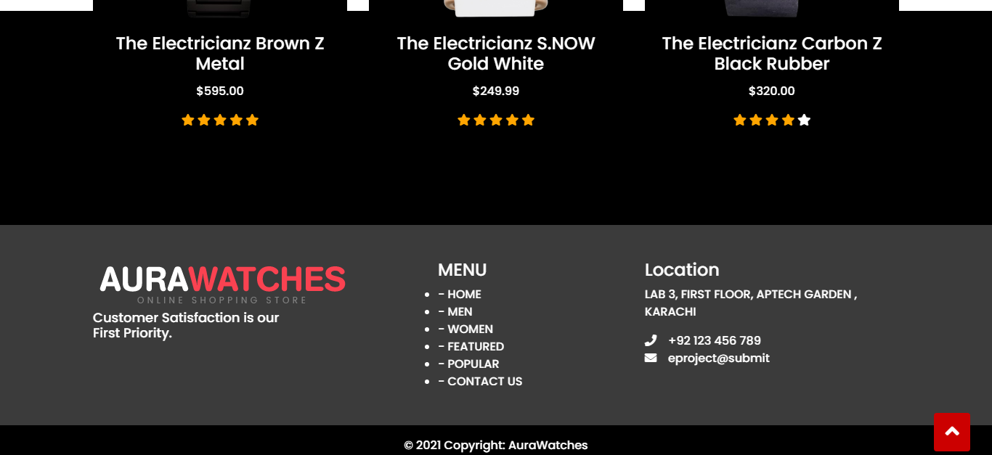

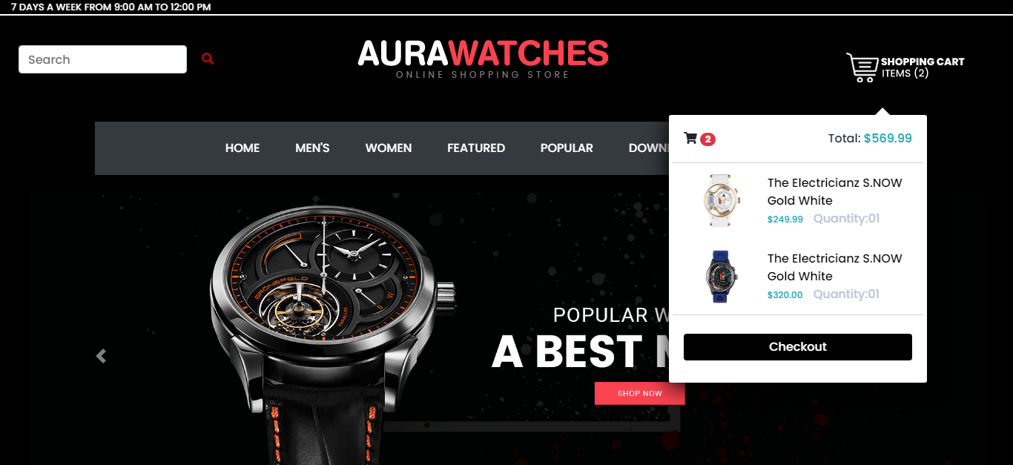

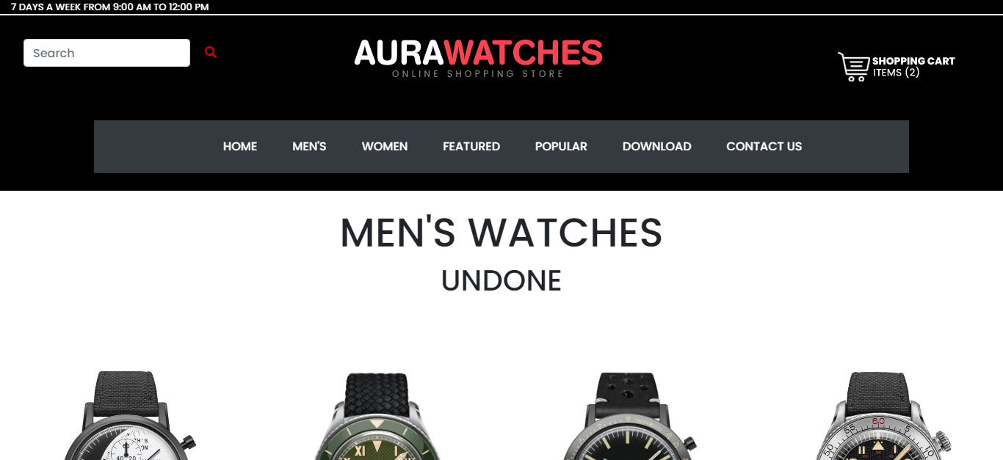

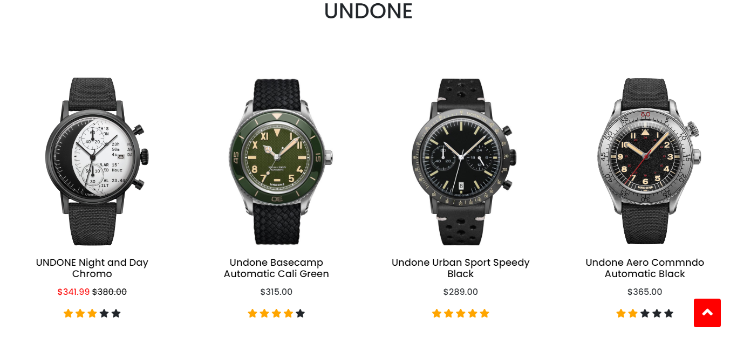

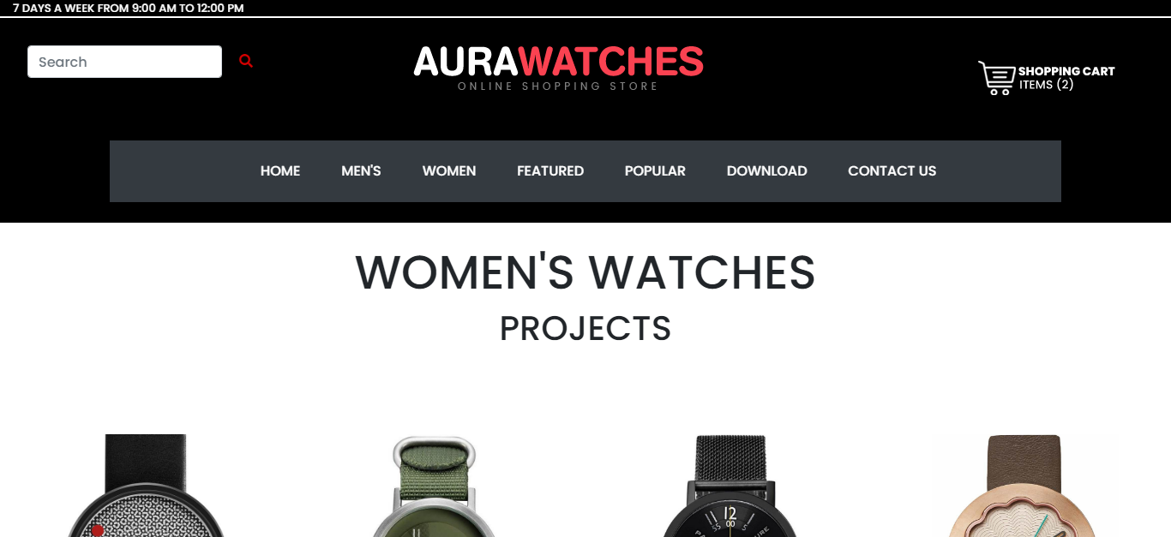

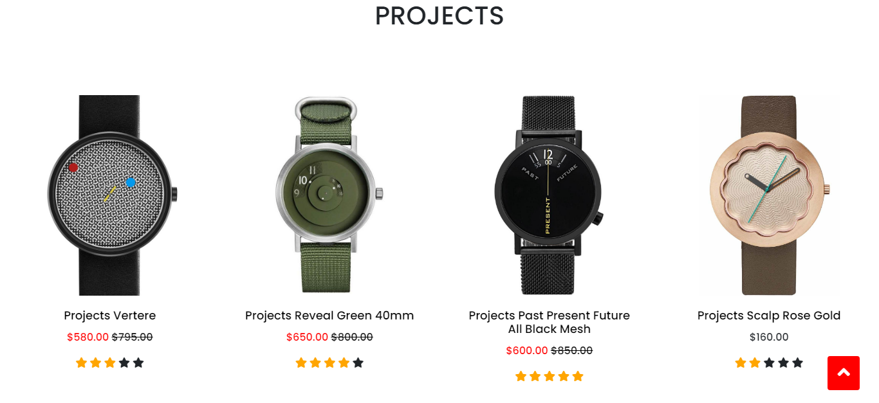

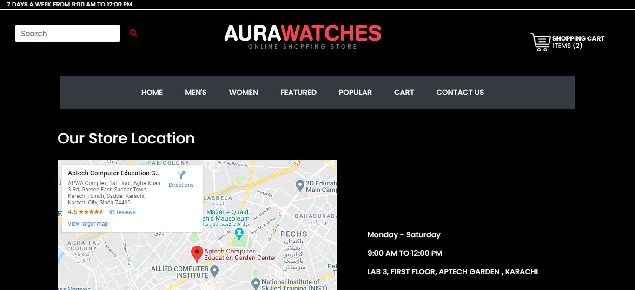

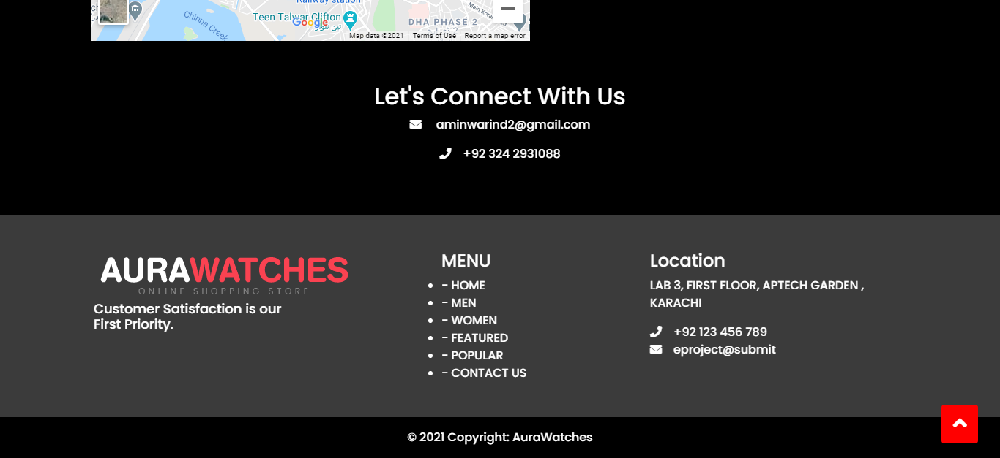

Conclusion

It was a wonderful and learning experience for me while working on this project. This project took us through the various phase of project development and gave me real insight into the world of E.COMMERCE. The joy of working and thrill involved while tackling the various problem and challenge gave us a feel of developers industry.

We enjoy each and every bit of work. We had put into this project. Thank you for each and every person who support us.

THANK YOU