**Carvan**

# Group Members:

|  |  |
| --- | --- |
| * Student1298430 | SAYYAM KHIZER |
| * Student1297937 | HANIA |
| * Student1297932 | MOHAMMAD YOUSUF ZULFIQAR ALI |
| * Student1299967 | UMAIR ALI BHUTTO |

Acknowledgment

I would like to acknowledge all those who have given me moral support and helped in making the project a success.

I wish to express my gratitude to E-Project Team at Head Office who guided and helped me. Thanks To Our Faculty Sir AbuBakar and Sir Zaman who guided us during the Project. Also, I would like to express my gratitude to all the staff members of my center for not only providing me opportunity to work with them on this project, but also for their support and encouragement throughout the process.

I also express my sincere gratitude to E-Project Team from Aptech Head Office and my project guide at the organization for his valuable guidance and support for completion of this project.

Final, I would like to offer many thanks to all my colleagues for their valuable suggestions and constructive feedback.

HARDWARE & SOFTWARE REQIREMENT

# Hardware:

* Minimum 4 GB ram
* Not less than 2.5 GHZ processor
* A minimum computer system that will help you access all the tools in the courses is a Pentium 166 or better.

# Software:

* Notepad/HTML editor
* Visual studio code
* Opera and Google chrome.

Tasks Completed by

|  |  |
| --- | --- |
| UMAIR ALI BHUTTO 1299967 | Header, Footer, Home Page, Contact Us Page, Range of Cars Page, Documentation |
| MOHAMMAD YOUSUF ZULFIQAR ALI  1297932 | About Us Page, Brands Page, Car-Details |
| SAYYAM KHIZER  1298430 | Pre-Owned Cars Page, Logo , Word Files |
| HANIA  1297937 | Word Files |

Diagram

CONTACT US

Home Krishna

About Us

Brands

Range of Cars

Pre-Owned Cars

Toyota

Chinese Cars

Small cars

Honda

Suzuki

Old Cars

Hyundai

Luxury Cars

Audi

Jeep

Kia

Van

SCREENSHOTS

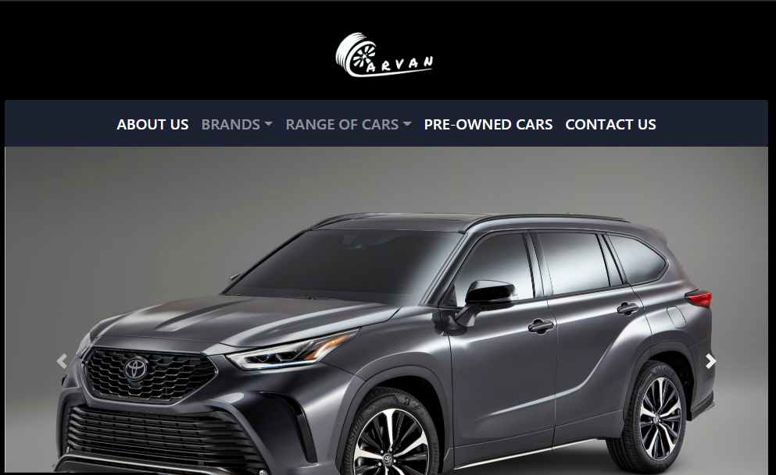

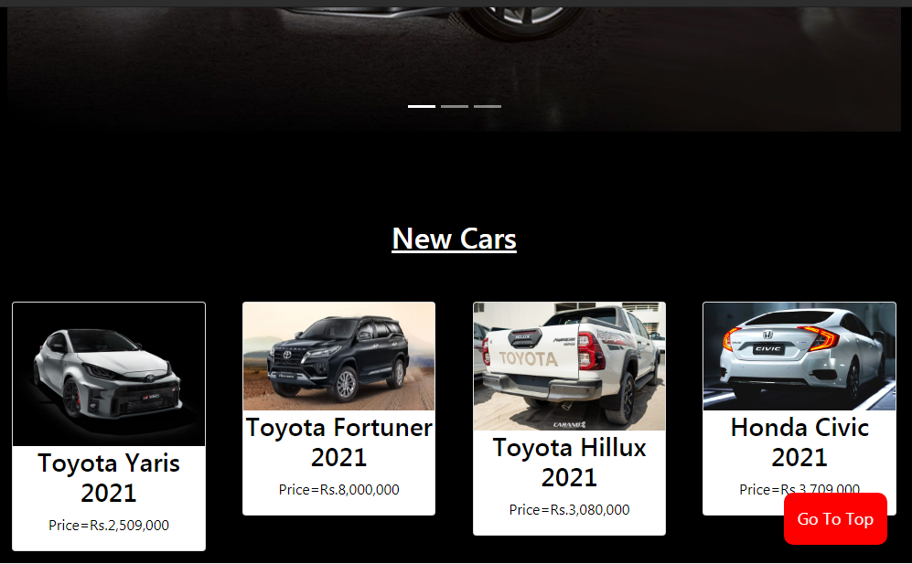

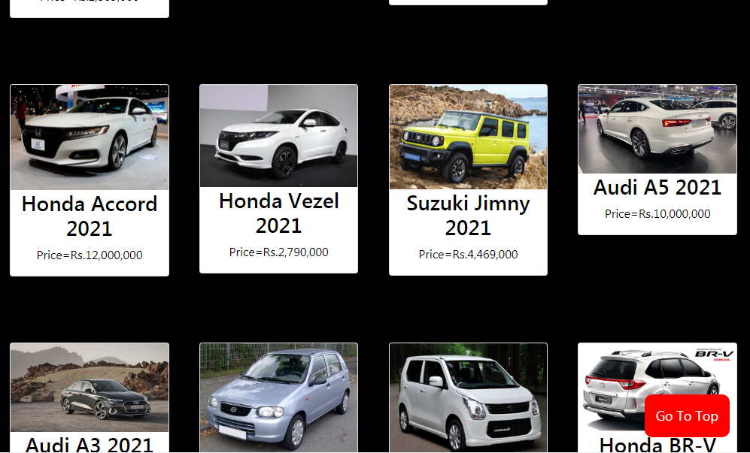

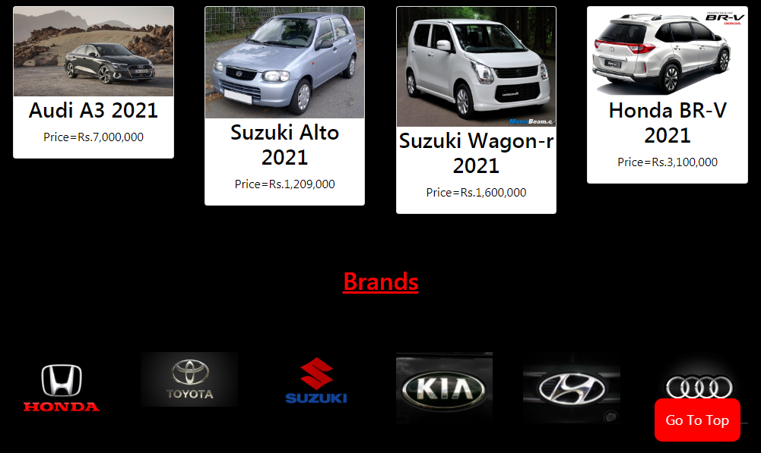

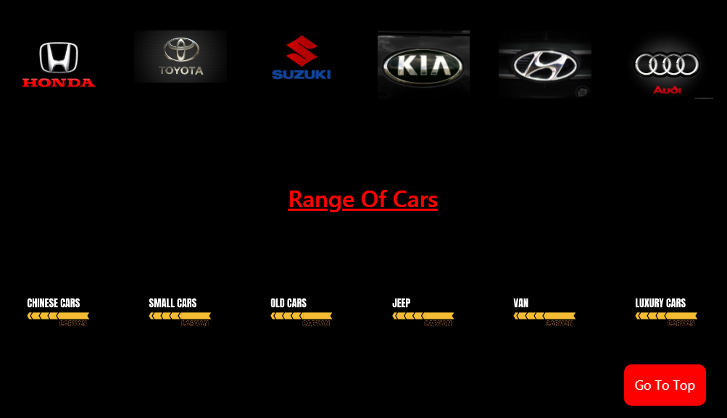

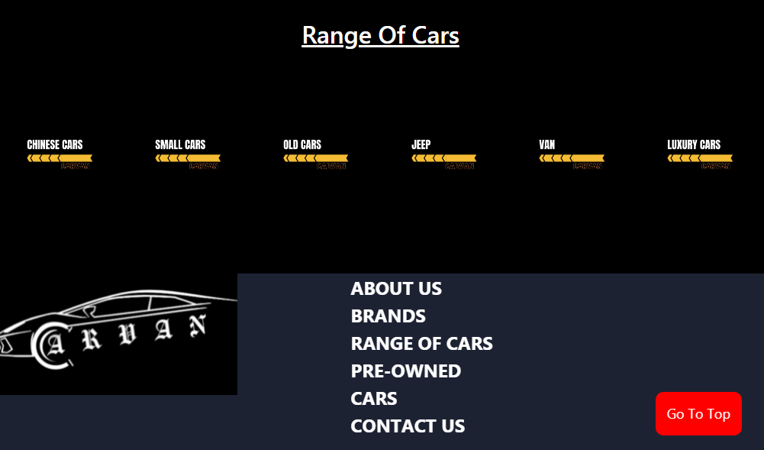

Contact Us

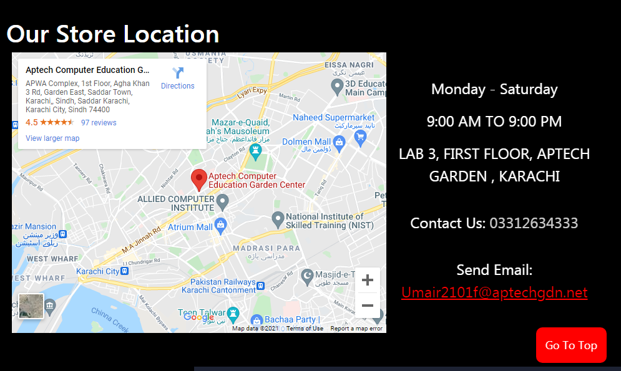

Conclusion

It was a wonderful and learning experience for me while working on this project. This project took us through the various phase of project development and gave me real insight into the world of E.COMMERCE. The joy of working and thrill involved while tackling the various problem and challenge gave us a feel of developers industry.

We enjoy each and every bit of work. We had put into this project. Thank you for each and every person who support us.

THANK YOU