IceSmack

|  |  |  |  |
| --- | --- | --- | --- |
| **Supervisor.** | Sir.Zaman | |  |
| **Batch.** | 2103F | |  |
| **Group.** | 1 | |  |
| **Serial No.** | **Enrollment Number** |  | **Student Name** |
| 1. | Student1307408 |  | Muhammad Fawad |
| 2. | Student1308866 |  | Raheem Ramzan |
| 3. | Student1298516 |  | Harish Kumar |
| 4. | Student1299967 |  | Umair Ali Bhutto |

Acknowledgement

The first, we would like to express my special thanks of gratitude to my teacher Sir Zaman, who helped us a lot in finalizing this project within the limited time frame, valuable counselling and assistance for the accomplishment of this project.

Secondly we would also like to thank the eProject team at Aptech Head Office, who gave us the golden opportunity to do this wonderful project about icesmack.

Thirdly, we also thank the eProject team, some of the benefits are as under:

* Re-enforcement of skills happens in the experiential learning process.
* A mentor, ensuring that we do not get drifted, constantly guides us.
* It gives us a lot of confidence to face an interview as we have worked on a project. We can explain virtually everything on the subject we have learnt.

Introduction

Mr. “A” is the owner of the big Ice-cream parlor shop. He is famous for the taste and quality of the product they provide. As the number of customer is increasing day by day, the branches of the shop keeps on increasing. To popularize it more the owner of the company has decided to go for making the website of his shop. For this he has approached you to make the website. He also wants to distribute his recipe to the registered customer by charging the appropriate fees. Those customers who had registered in the web site are able to see the entire recipe. For unregistered user the page will have following link access but the recipe of the desert will not be activated. He has also written various recipe books for the deserts and ice-cream and now he wishes to sell this book online through his website.

He also want the user to provide their own new recipe if it is selected then the user will get the prize money decided by the admin as well as the participation certificate from the shop. The name of the candidate will be enlisted in the Home Page of the Website in one section under the top recipe column

Problem Definition

Mr. A does not want his/her name to be shown so he will be called Mr. A he kept the name of his ice cream parlor icesmack the meaning be that he thought a name that could relate to the business he was doing so icesmack came to his mind by researching on the internet for available names with complete social media platforms as I know Mr.A was was not experienced in this type of stuff so he hired and took the help of Umair he researched and found many name like icewallop, icemasher, but icesmack was great in the opinion of Mr.A. ice smack is like a ice smacked like old times with flavor.

Ice smack is into business of creating and selling their ice cream around the world. They have been advertising about their recipes through newspapers, pamphlets, television. Now with changing times, they have decided to go online as customers today use Internet extensively. They have planned for a website with complete details about their recipes and books that user customers can easily access So, we solved many particular queries as followed:

* How the sitemap possibly looks like?
* What information should be displayed on each page?
* How to put every comment is friendly?
* How to give users the best experience when using the website?
* How to let the website properly function along with the system requirement?
* Will the user be able to contact with Icesmack company for advice?

Customer Requirements

To popularize his Ice-cream shop, Mr. “A” has listed out the few points which he wants to be their in website.

Here are list to be design in the project.

1. Home page: should contain Menus like home, login, free recipe available, contact us, feedback, adding recipe FAQ’s, Order the books of the recipe.
   * For Register page 🡪 the customer can register with the site provided he/she makes the payment . The payment for the members are

Monthly – 15 $

Yearly - 150$

Once the users get registered he/she must be allowed to login with their user name and password.

* Books can be ordered by both Registered and Un-Registered Users. They are suppose to provide the authenticate details and must pay the charge of the book online through credit card.

1. Feed back form (to take the feed back from both registered users and Unregistered Users.)
2. Online Order: Here the list of the books must be added with its image and little description. There should be link mentioned for buying the books, once the links gets clicked then the users is supposed to provide the authenticate details like
   * Name
   * Email ID
   * Contact Details
   * Address (where the book will get delivered)
   * Cost ( should come directly as per the book is selected)
   * Paying Option ( Whether Credit, Debit Card and Proper validation must be provided)
   * Submit

Once the transaction is complete the message must be prompted to the user whether the transaction is completed or not.

1. About Us: Describe about the Ice-cream parlor and the owner.
2. Contact Us: Should display the Contact details

Scope of the work (in brief)

The website is to be developed for the Windows Platform using

* + HTML5
  + CSS
  + JavaScript
  + C#
  + Asp.Net MVC
  + SQL.

The site should work well in all leading browsers including Chrome, IE, Firefox etc..

# Registered Users

For the registered the user this link will be enabled with all the previous function mentioned.

Links like most famous flavor available for the registered user.

For the entire list mentioned below the steps of making must be added by the admin through ADMIN Login. An image must be added for each flavor. It must include the details like ingredients, procedure to be followed.

* Vanilla
* Chocolate
* Chocolate chip
* Strawberry
* Mango
* Coffee
* Black currant
* Cherry
* Butterscotch
* Walnut
* Vanilla and strawberry (two in one)
* Pistachio
* Banana
* Banana Chocolate chip
* Chocolate almond
* Chocolate truffle
* Kiwi fruit
* Pineapple
* Fruit and nut
* Cashew Caramel crunch

Admin

Admin will have its own Login Page where the following functions will be taken care of:

* Details of the recipe will be added and updated.
* Checking the List of the registered users and their payment details
* Checking the list of the books being ordered and the updating the status like if the book is send then the order processes, once reached the status will be completed
* Checking the feedbacks entered by the user
* Checking the details of the new recipe

Sitemap

Add recipes

About us

Contact us

Feedback

User

Login

Sign up

Recipes

Buy recipes

Users

Contact us

Feedback

Login

Admin

Add recipes

Update Recipes

Delete recipes

See bought recipes

SQL ERD Diagram

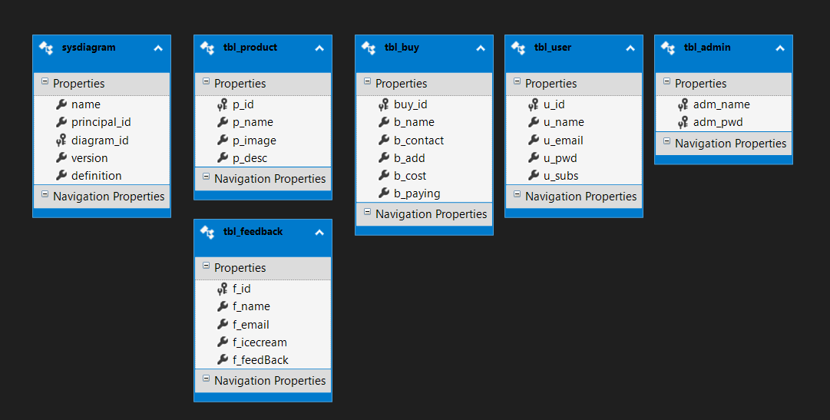

Tasks Completed By

|  |  |
| --- | --- |
| Muhammad Fawad  Student1307408 | Recipes page, Feedback page, Login page, Sign up page, Project name, Admin login, Add recipes page, Edit recipes page, Recipes details page, Delete recipe, Theme integration. |
| Raheem Ramzan  Student1308866 | Home page, Contact us page, Recipes page, Download recipes page, Feedback page, Login page, Sign up page, Project name, Admin login, Add recipes page, Edit recipes page, Recipes details page, Delete recipe, Cards Design, Theme integration. |
| Harish Kumar  Student1298516 | Data Collection, Recipes data, Word Files, Images of recipes. |
| Umair Ali Bhutto  Student1299967 | Logo, Project name, Documentation, About us page, Download recipe, Home page data, Show-users page, Show-feedback page, Show-bought-books pages, Navigation between pages, mistakes correction, Animations, Final reviews. |