**Group Students:**

* Umair Ali Bhutto

**Batch:** 2103F

**Faculty:** Sir Sadam Hussain

## *Introduction : –*

Across the world, people are facing unforeseen challenges due to Coronavirus pandemic. Design and develop a web application for online test and vaccination booking system for patient. The Covid 19 web app connects the people with the hospital and the administration to come together and fight the pandemic. With this web app, one can track the vaccination appointment, history and covid solution guidelines for symptoms.

***Proposed Solution :*** –

App will provide Online Registration System (ORS) is a framework to link various hospitals across the country for mobile number based online registration and appointment system. Portal facilitates online appointments for vaccination. Detail reports showing information about test and vaccination patients taking appointment through this portal can be seen. Hospitals can come on board this platform and provide their appointment slots for online booking by patients. The system facilitates Hospitals to easily manage their registration and appointment process and monitor the flow of patient.

# System Modules:

## Admin

* All Patient details
* Report of Covid test/vaccination
  + Test report, Vaccination (Date/week/monthly report)
* List of vaccine
  + available or unavailable
* Approval Hospital Login
* List of hospitals
* Booking Details

## Hospital

* Register
* Login
* List of patient details
* Request from patient (Covid test/Vaccination)
  + Approve or Reject
* Update Covid test result
* Update Vaccination status

## Patient

* Register
* Login
* Search Covid Test/Vaccination hospital
* Request for Covid Test/Vaccination for hospital
* Report of covid test/Vaccination taken
* Book Hospital appointment
* My Appointment
* View Results
* My profile

# Modules Description

## Admin

* All patient details
  + View all patient profile details
* Report of COVID – 19
  + patient, COVID – 19 test report(Date wise report)
  + Admin can export the details in xls format by date , week and month wise report
* List of vaccine
  + available or unavailable
  + Admin can view the availability of the vaccination
* Approve Hospital Login
  + Approve or Reject
  + Once the request for appointment from patient side, it will be approved from the admin
* List of hospitals
  + Admin can view the hospital details
* Booking Details
  + Admin can view the booking details from patient side for booking COVID – 19 test results

## Hospital

* Register & Login
  + Can register and login into the app with hospital name, address and location details.
* List of patient details
  + Hospitals can be view the patient details who are all approve for COVID – 19 tests.
* Request from patient
  + Hospitals can be request to the patient from the hospital side who are all approved / rejected for covid – 19 test / vaccination.
* Update covid – 19 result
  + Hospitals will be updated the patient’s covid – 19 results.
* Update vaccination status
  + Hospitals will be updated the patient’s vaccination status.

## Patient

* Register & Login
  + Patient can register and login into the app with patient name, address and location details.
* Search covid-19 / vaccination hospital
  + Patient Can search the covid-19 hospitals and get from the vaccination hospitals
* Request for covid-19 test / vaccination hospital
  + A Patient Can request to the hospital for the covid-19 test. It will approve patient can take vaccination from the hospitals
* Report of covid test/Vaccination taken
  + A Patient can take the covid-19 test result report and their suggestion vaccination.
* Book Hospital appointment
  + A Patient will booking the appointment from the hospitals and tested the covid-19 tests.
* My Appointment
  + A Patient will check the appointment timing and hospital details from the My Appointment module.
* View Results
  + A Patient can view their covid-19 test results and vaccination suggestions also.
* My profile
  + A patient will check the profile details and also edit or delete the other information also.

SNAP SHOTS OF WEBSITE

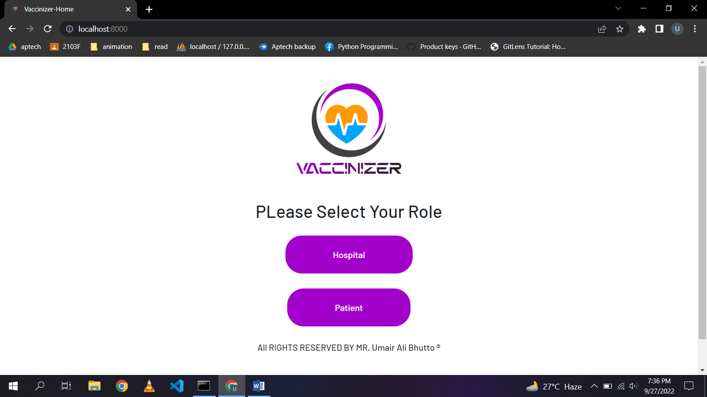

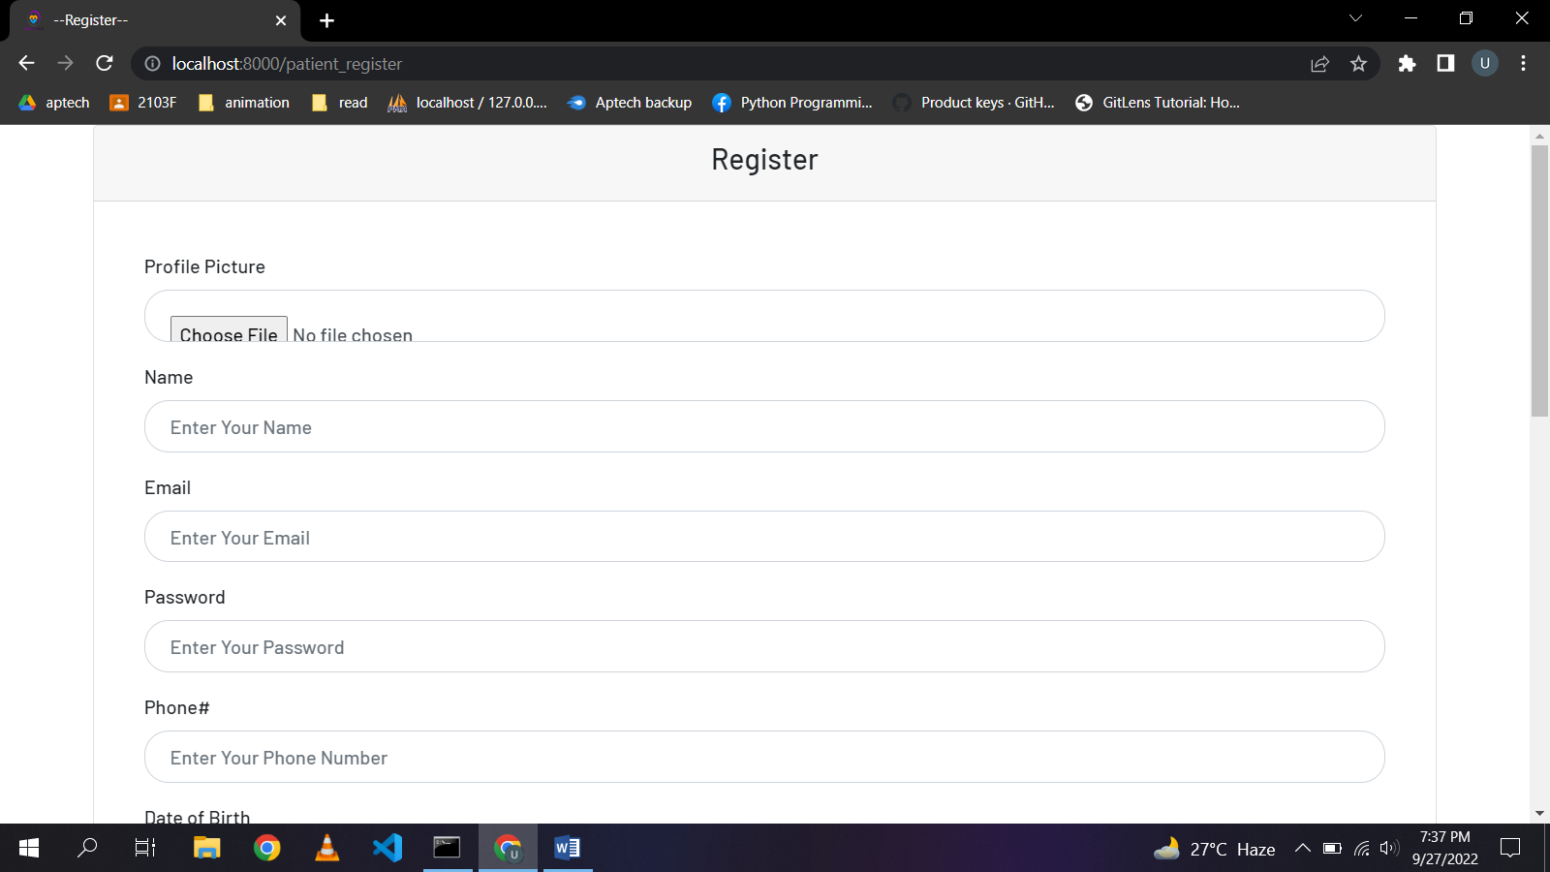 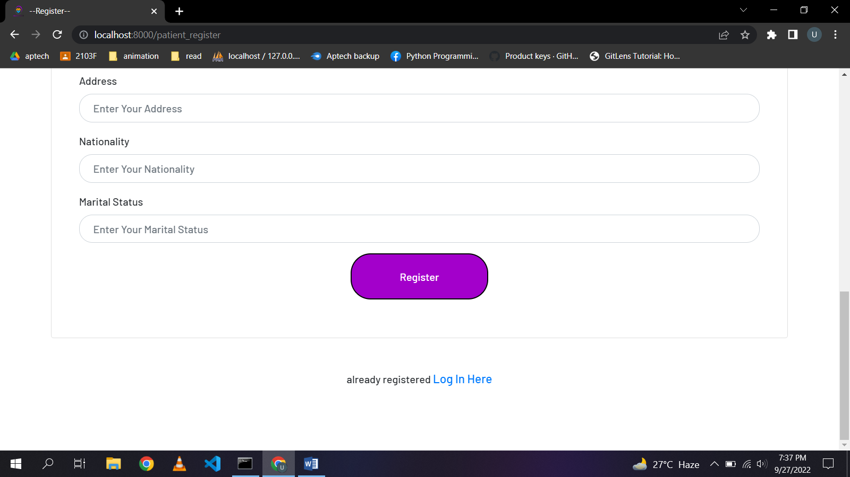 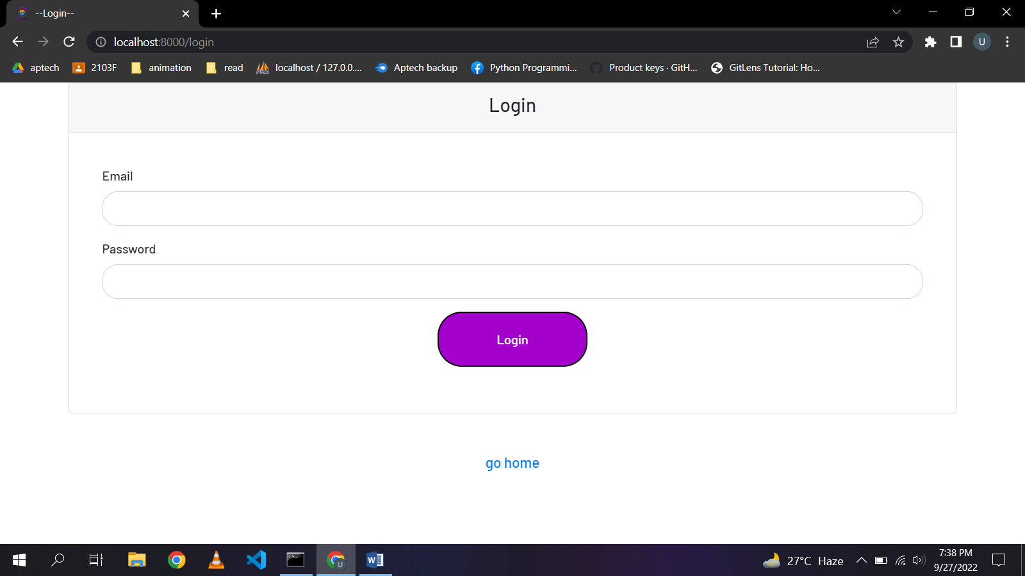 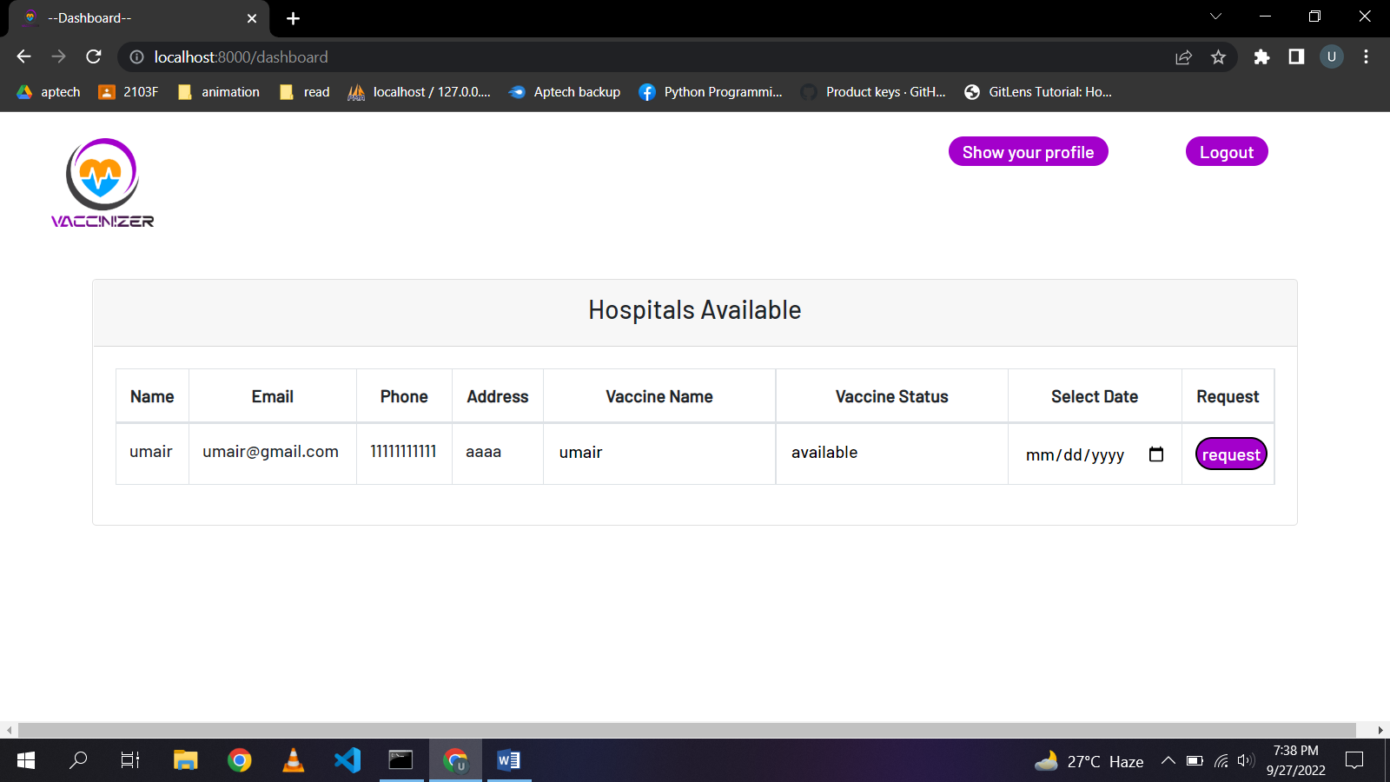 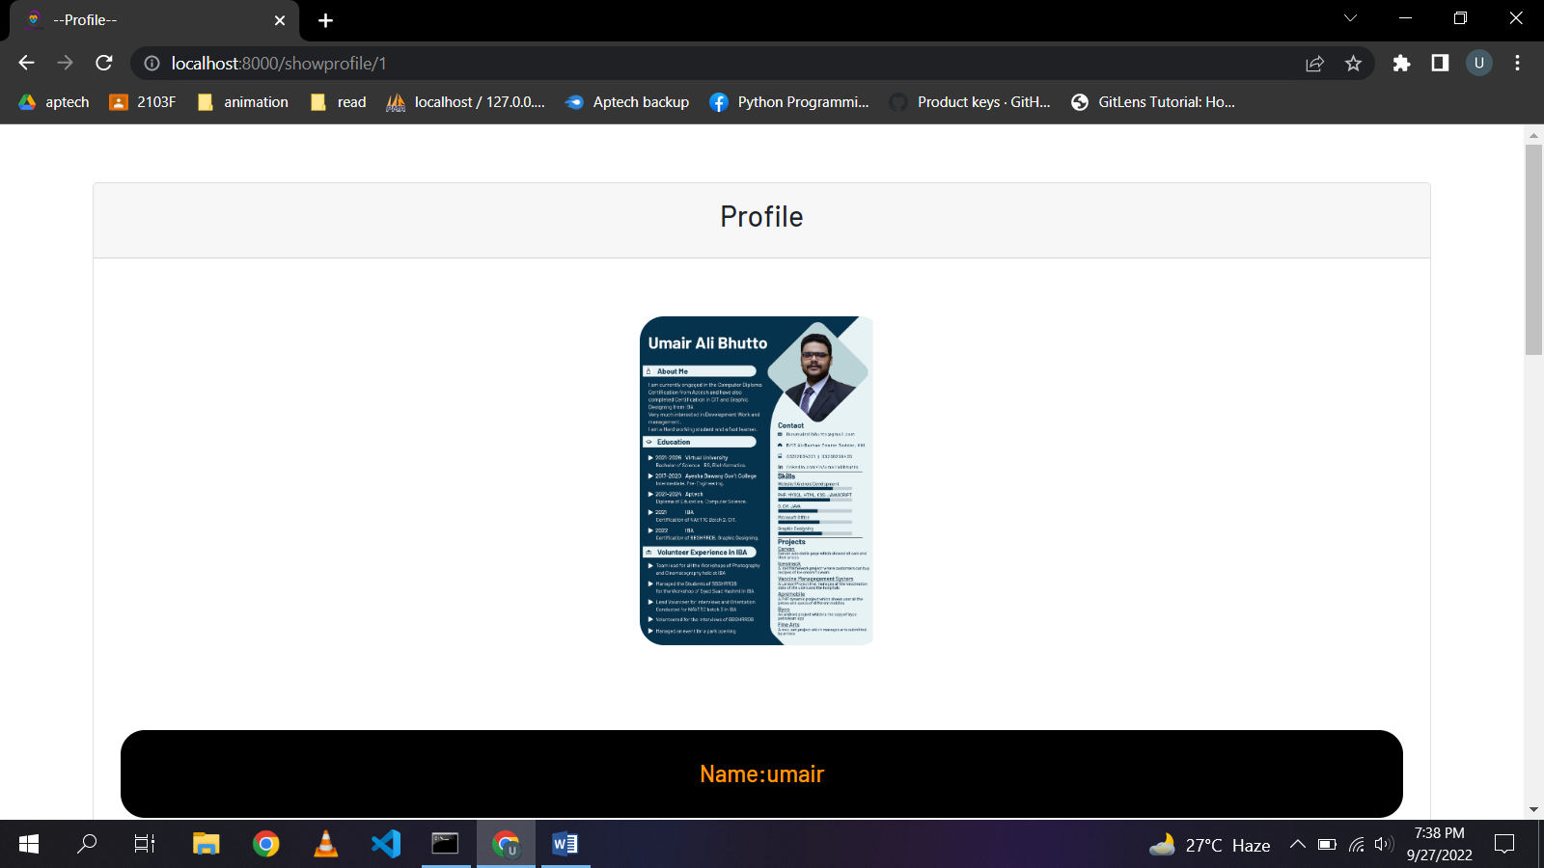 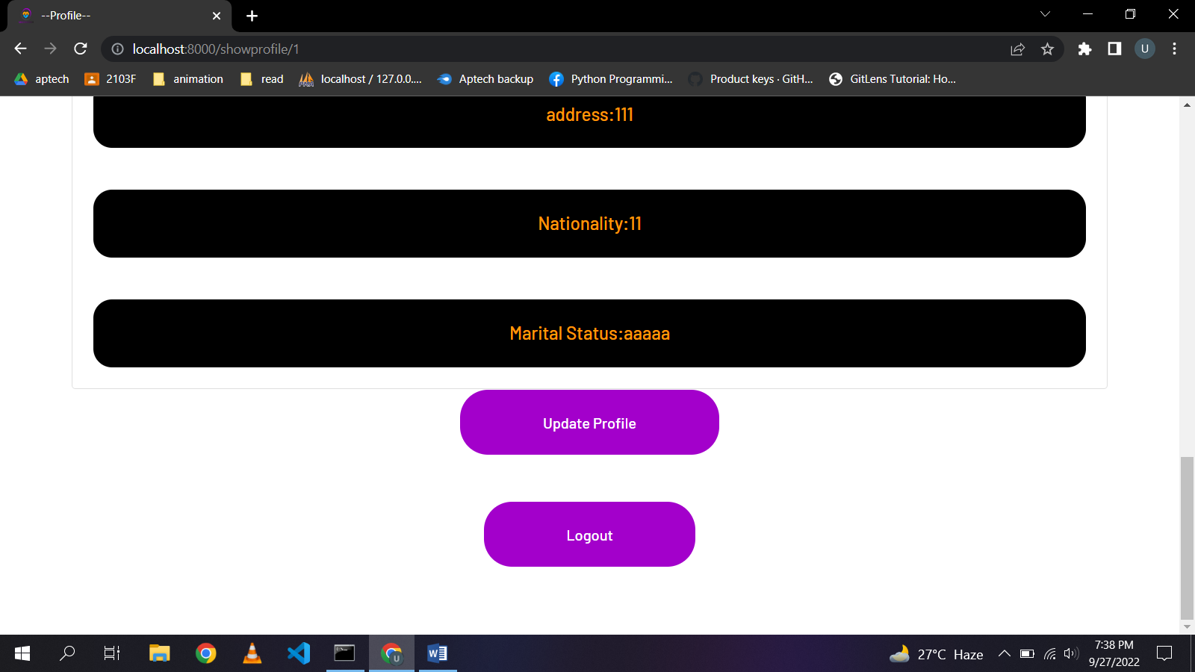 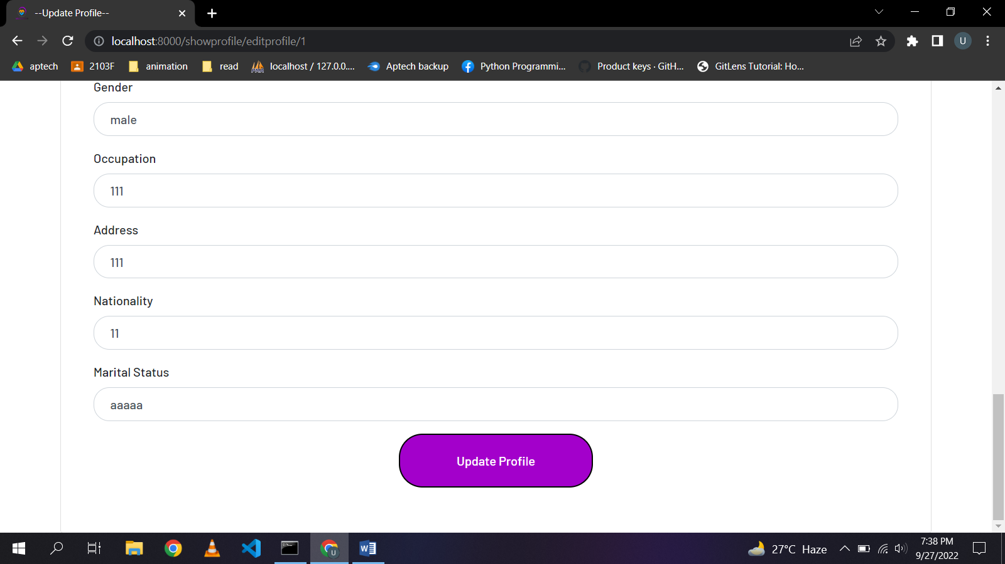 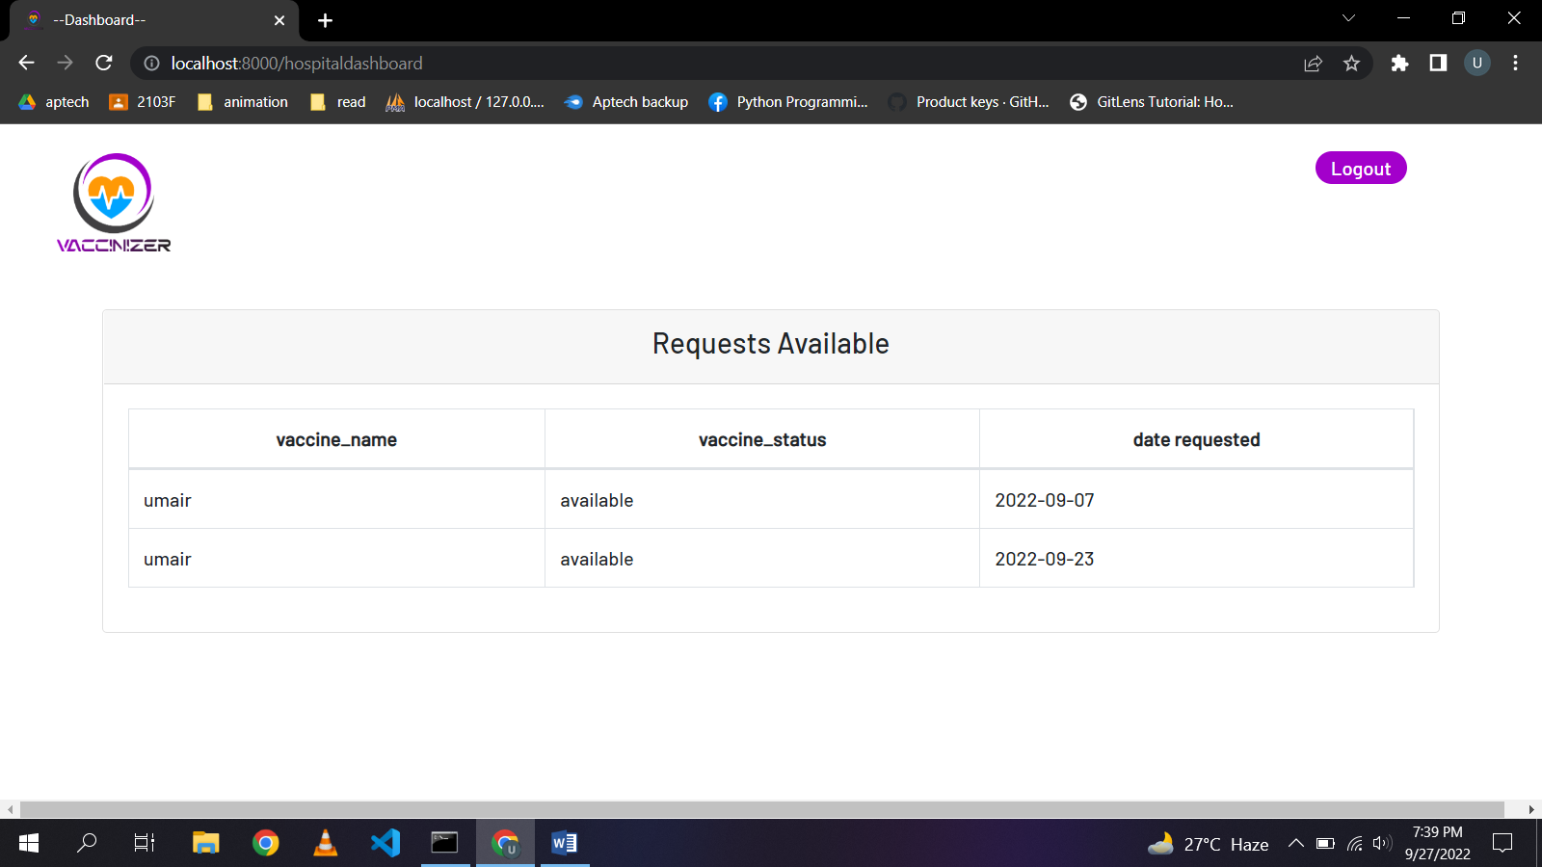 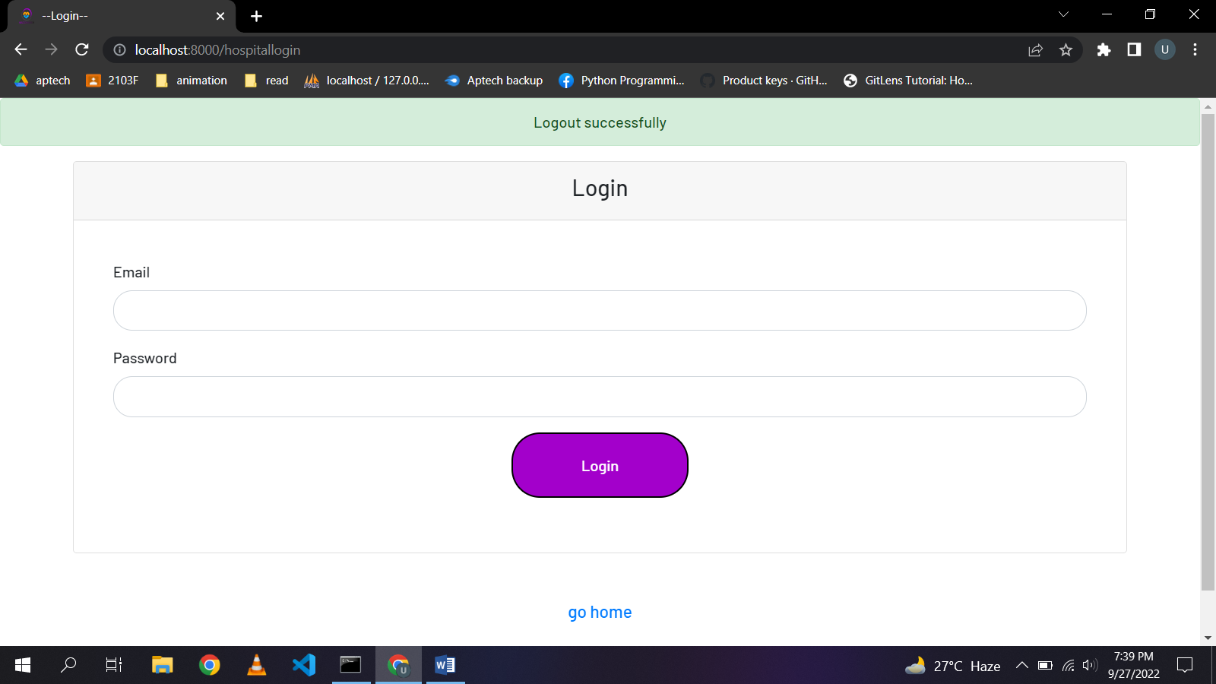 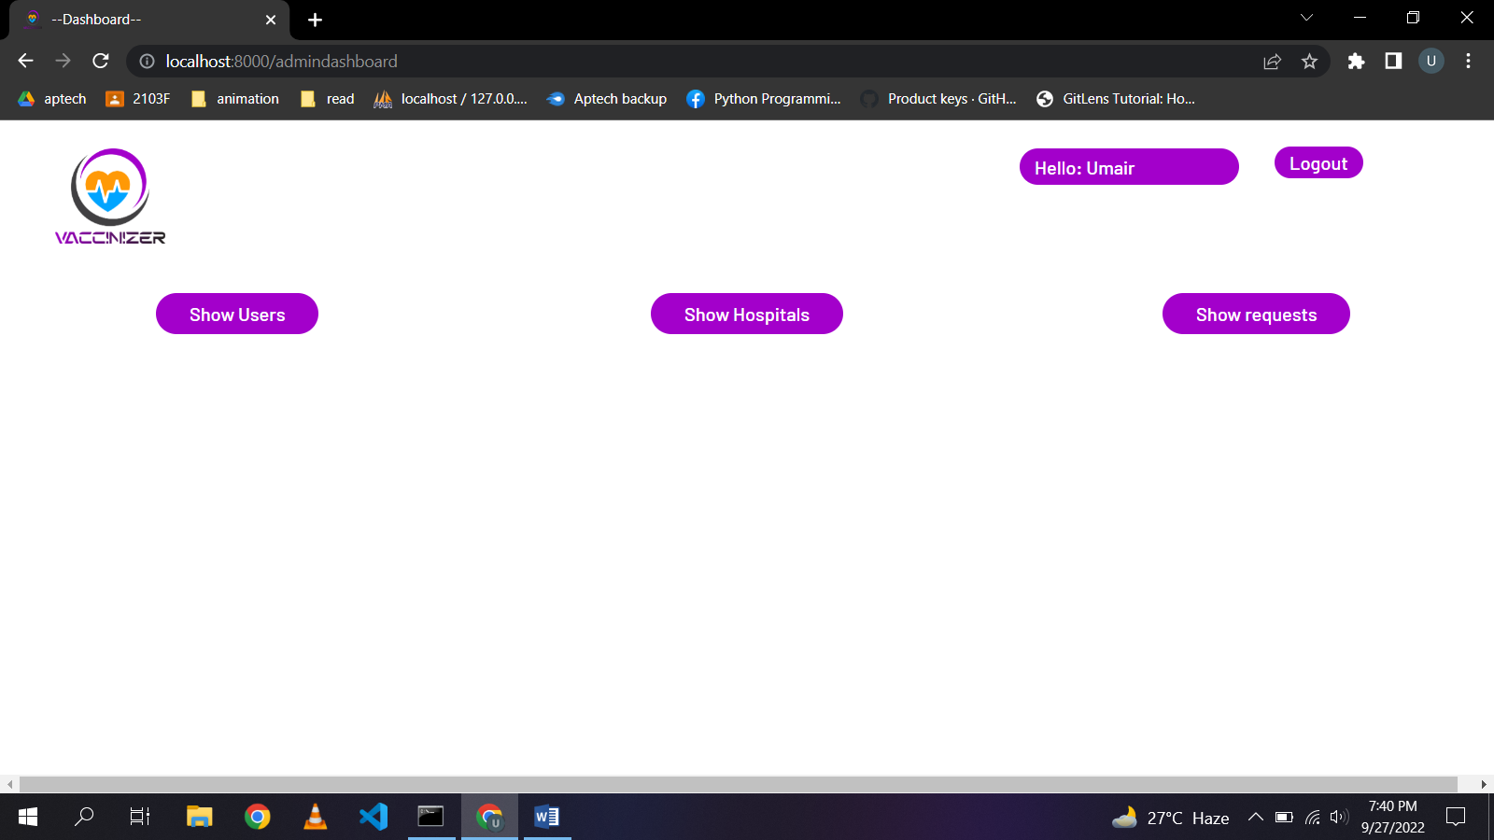 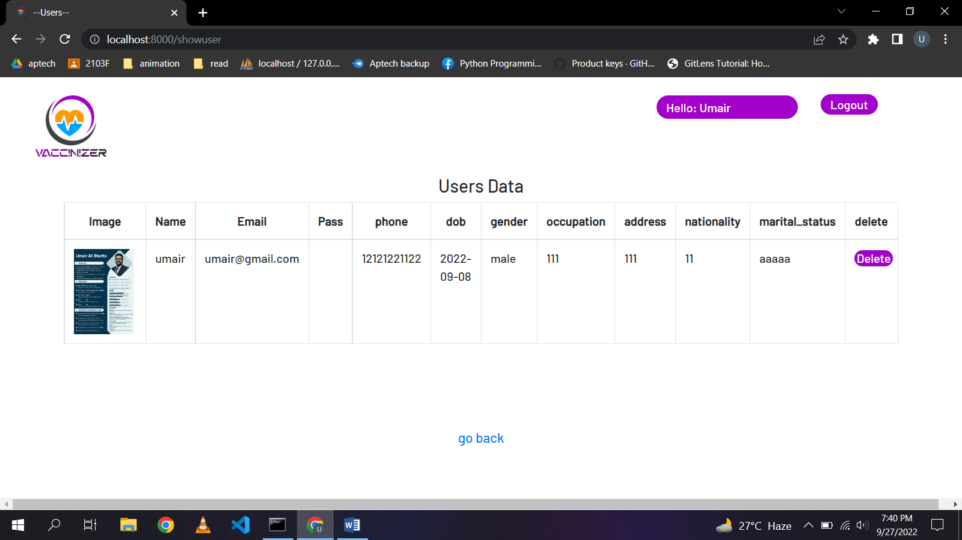 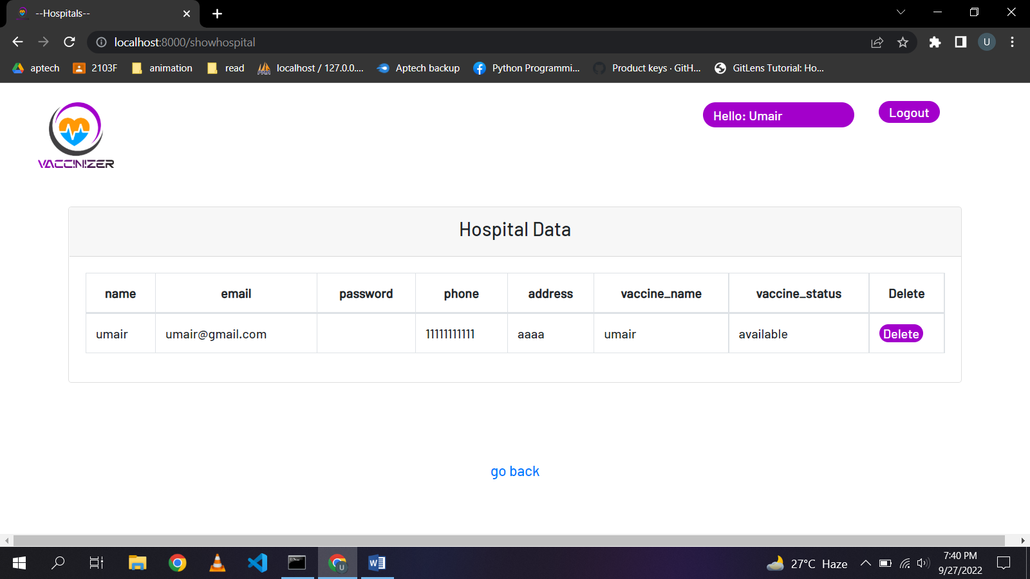 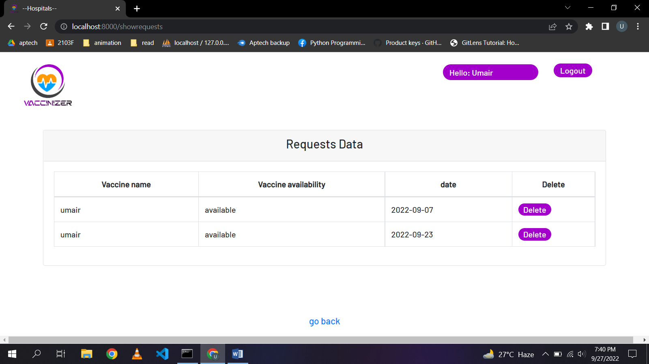

FINAL Checklist

All Work in this Project Vaccinization is done by

Mr. Umair Ali Bhutto

Conclusion

In simple words, I don’t trust my teammates, Strategic planning is a systematic process of deciding key decisions for an organization to thrive successfully in the next few years.

The planning process is a disciplined and time taking process produces fundamental decisions and actions that shape the organization.

Thank You!!