Theory Assignment 1
FYP Test Cases — Jira Test Management

Student: Ghulam Mujtaba
Student ID: FA21-BSE-084
Course: CSE-455 Software Testing
Instructor: Dr. Instructor
Date: February 2026

1. Test Cases Overview
21 test cases were created in Jira for the MegiLance FYP project, covering authentication, project management, proposals, contracts, payments, profiles, and AI matching modules.
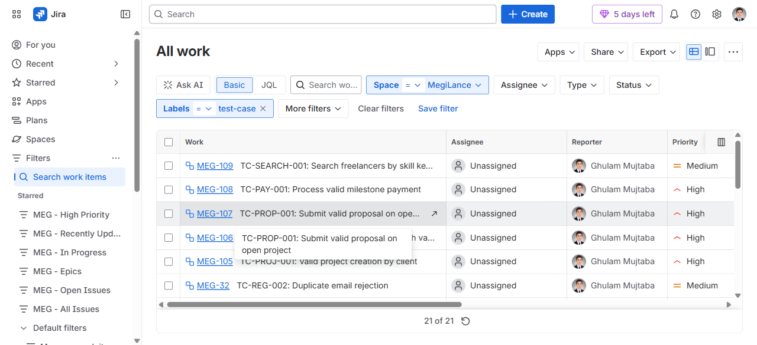
Figure 1: Jira Test Cases List — 21 of 21 test cases (label: test-case)

2. Test Case — Project Management
Each test case includes: Test Case ID, description, preconditions, test steps, expected results, priority, and labels (black-box, functional, test-case).
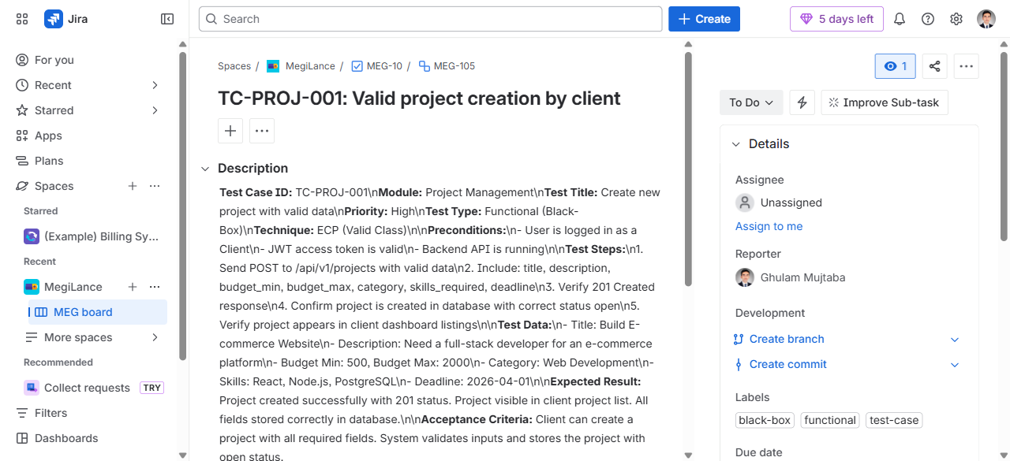
Figure 2: MEG-105 — TC-PROJ-001: Create New Project with Valid Data

3. Test Case — Profile Management
Profile management test case covering freelancer profile update with valid data.
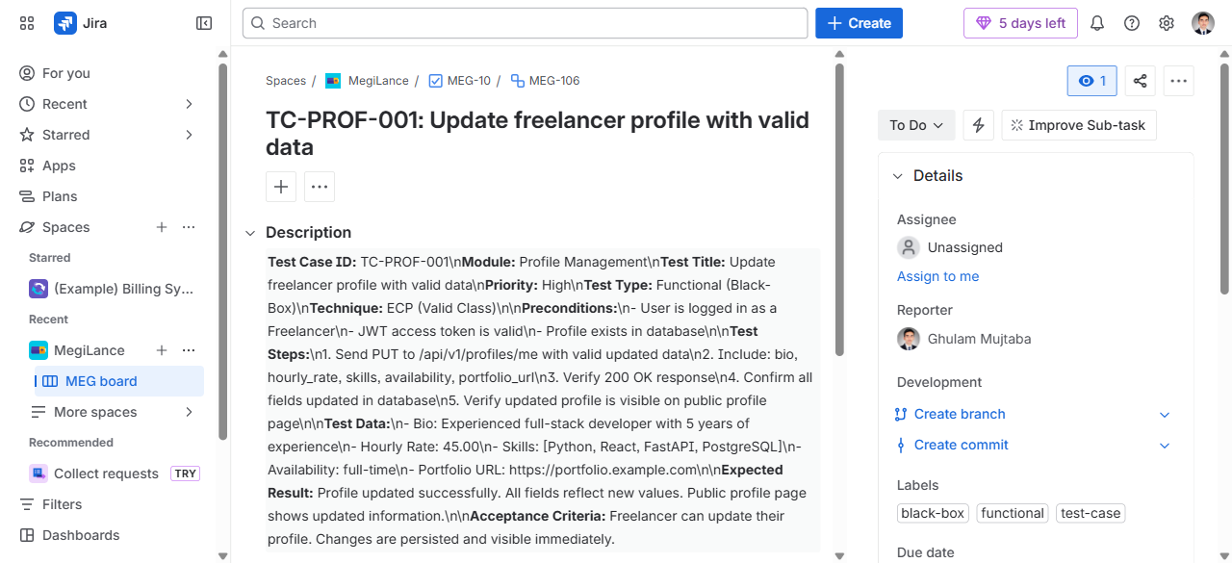
Figure 3: MEG-106 — TC-PROF-001: Update Freelancer Profile with Valid Data

4. Test Case — Proposal Management
Proposal management test case covering submission of valid proposals on open projects.
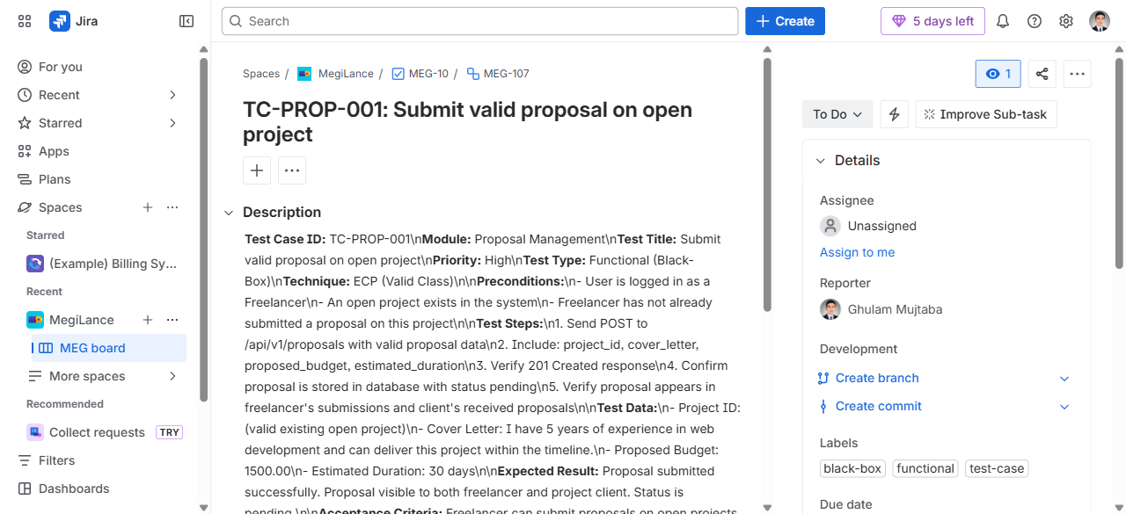
Figure 4: MEG-107 — TC-PROP-001: Submit Valid Proposal on Open Project

5. Test Case — Payment System
Payment system test case covering milestone payment processing.
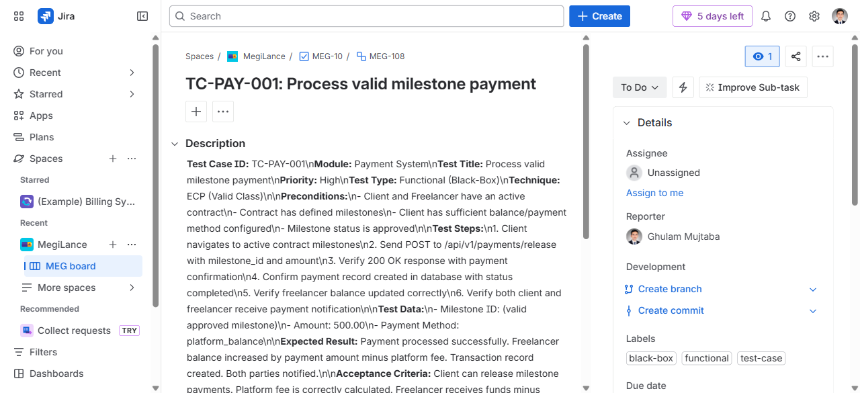
Figure 5: MEG-108 — TC-PAY-001: Process Valid Milestone Payment

6. Test Case — Search & AI Matching
Search and AI matching test case covering freelancer skill-based search.
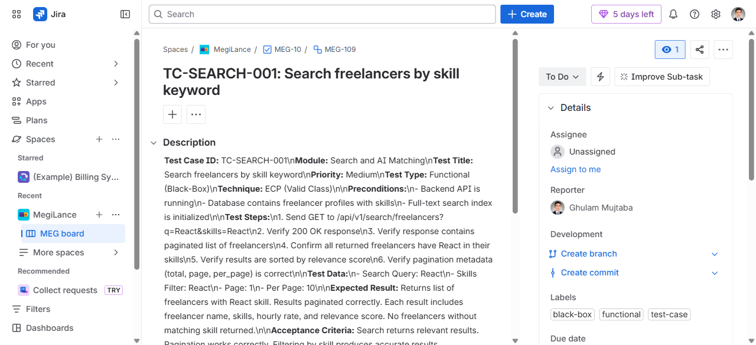
Figure 6: MEG-109 — TC-SEARCH-001: Search Freelancers by Skill Keyword

7. Test Case Categories
Test cases span multiple modules:
- Authentication & Security (login, registration, JWT, password reset)
- Project Management (create, browse, search, filter)
- Proposals & Contracts (submit, accept, milestone tracking)
- Payments & Invoices (escrow, withdrawals, refunds)
- User Profiles (freelancer/client profiles, portfolio, reviews)
- AI Matching Engine (skill matching, recommendations)

8. Zephyr Scale — Test Case Management
In addition to Jira issues, 10 test cases were created using Zephyr Scale (SmartBear Zephyr Advanced), a dedicated test management tool integrated with Jira. Zephyr Scale provides structured test case management with test steps, test cycles, test plans, and execution tracking.
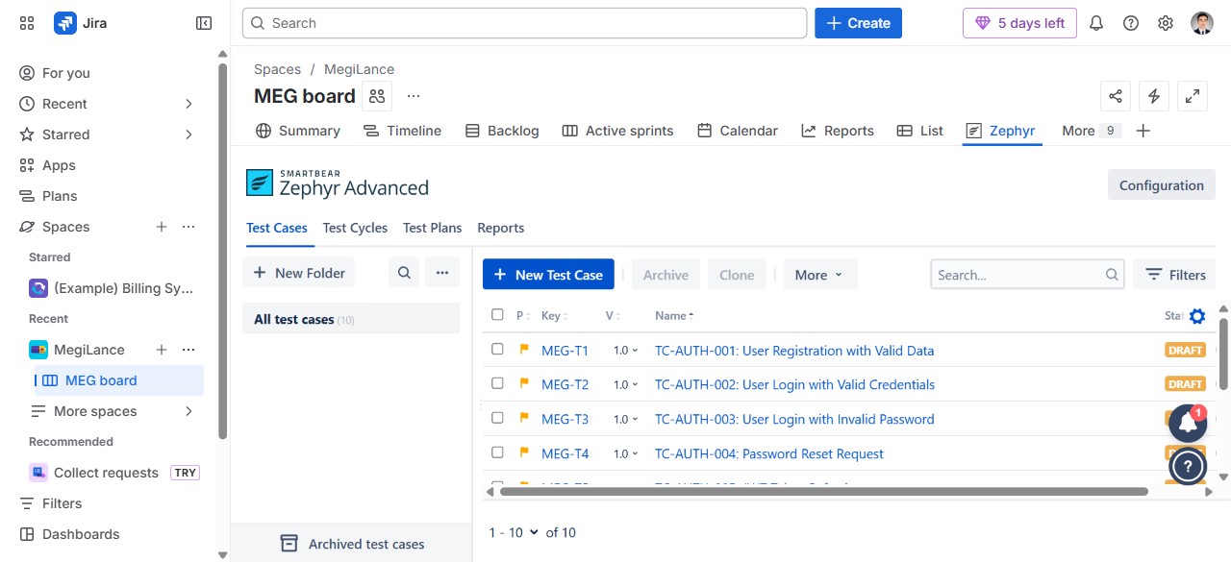
Figure 7: Zephyr Scale — All 10 Test Cases (MEG-T1 to MEG-T10)

8.1 Zephyr Scale Test Cases List
Key | Test Case Name | Status
MEG-T1 | TC-AUTH-001: User Registration with Valid Data | Draft
MEG-T2 | TC-AUTH-002: User Login with Valid Credentials | Draft
MEG-T3 | TC-AUTH-003: User Login with Invalid Password | Draft
MEG-T4 | TC-AUTH-004: Password Reset Request | Draft
MEG-T5 | TC-AUTH-005: JWT Token Refresh | Draft
MEG-T6 | TC-PROJ-001: Create New Project | Draft
MEG-T7 | TC-PROF-001: Update User Profile | Draft
MEG-T8 | TC-PROP-001: Submit Proposal for Project | Draft
MEG-T9 | TC-PAY-001: Process Payment Transaction | Draft
MEG-T10 | TC-SEARCH-001: Search Projects with Filters | Draft

8.2 Individual Test Case — Details View
Each Zephyr Scale test case includes: Name, Objective, Precondition, Status, Priority, Owner, and a Test Script tab for step-by-step test steps.
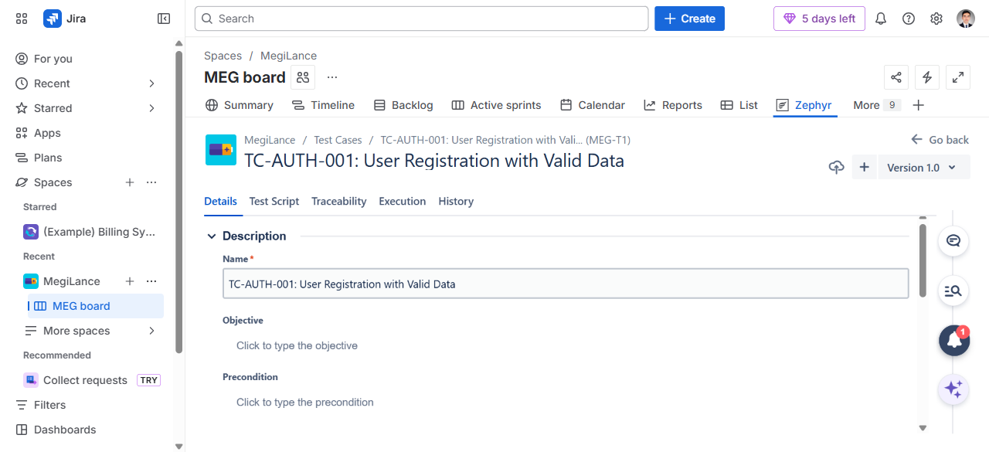
Figure 8: MEG-T1 — TC-AUTH-001: User Registration with Valid Data (Details View)

9. Jira & Zephyr URLs Reference
- All 21 Test Cases — Jira Issues: https://ghulam-mujtaba.atlassian.net/issues/?jql=project%20%3D%20MEG%20AND%20labels%20%3D%20test-case
- TC-PROJ-001 — Create New Project (MEG-105): https://ghulam-mujtaba.atlassian.net/browse/MEG-105
- TC-PROF-001 — Update Freelancer Profile (MEG-106): https://ghulam-mujtaba.atlassian.net/browse/MEG-106
- TC-PROP-001 — Submit Valid Proposal (MEG-107): https://ghulam-mujtaba.atlassian.net/browse/MEG-107
- TC-PAY-001 — Process Milestone Payment (MEG-108): https://ghulam-mujtaba.atlassian.net/browse/MEG-108
- TC-SEARCH-001 — Search by Skill Keyword (MEG-109): https://ghulam-mujtaba.atlassian.net/browse/MEG-109
- Zephyr Scale — All Test Cases: https://ghulam-mujtaba.atlassian.net/projects/MEG?selectedItem=com.atlassian.plugins.atlassian-connect-plugin:com.kanoah.test-manager__main-project-page

