Lab Assignment 2
Kanban/Scrum Board & Jira Automation Rules

Student: Ghulam Mujtaba
Student ID: FA21-BSE-084
Course: CSE-455 Software Testing
Instructor: Dr. Instructor
Date: February 2026

1. Scrum Board
The MegiLance project uses a Scrum board with TO DO, IN PROGRESS, and DONE columns.
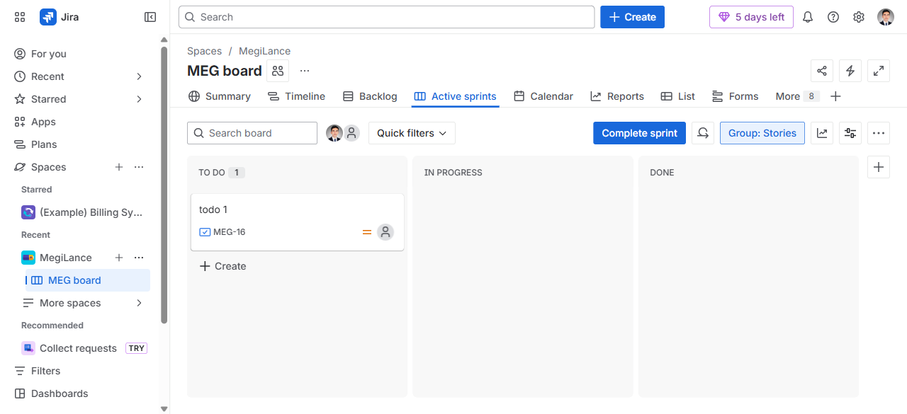
Figure 1: MEG Scrum Board — TO DO / IN PROGRESS / DONE columns

2. Backlog & Sprints
Sprints are organized in the backlog with defined start/end dates and assigned work items.
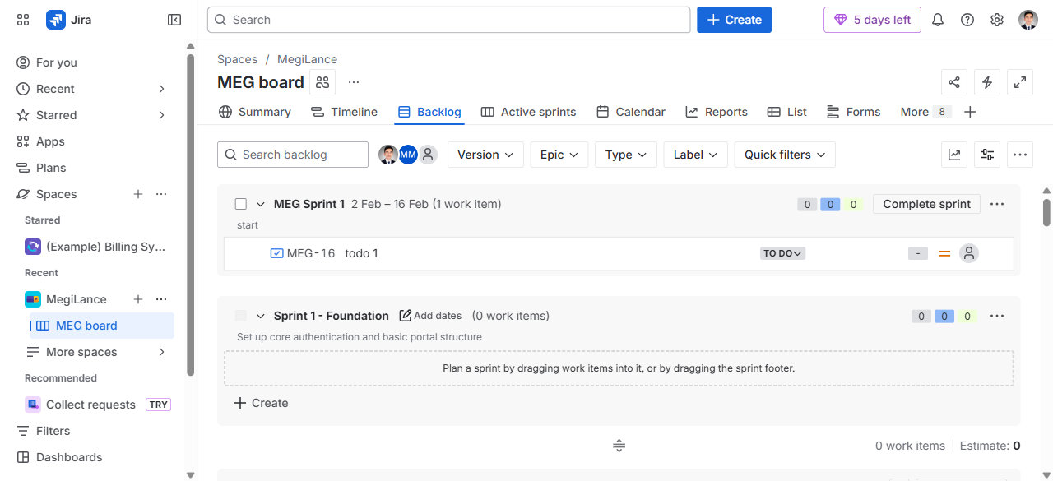
Figure 2: Backlog — Sprint planning with MEG Sprint 1 and Foundation Sprint

3. Timeline & Epics
Epics provide high-level feature grouping across the project timeline.
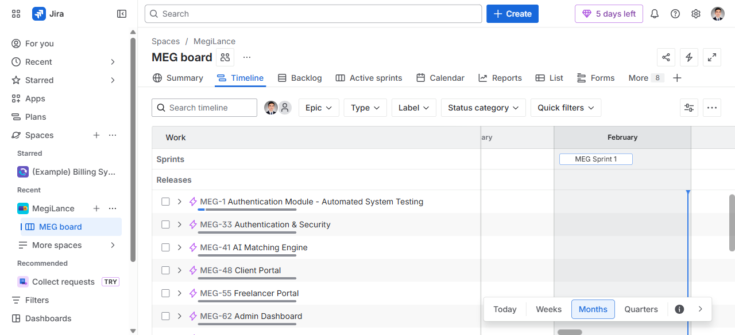
Figure 3: Timeline view — Epics (Auth, AI Matching, Client/Freelancer/Admin Portals)

4. Issue Types (Epics, Stories, Bugs, Tasks)
The project tracks 88 issues across multiple types: Epics, Stories, Bugs, and Tasks.
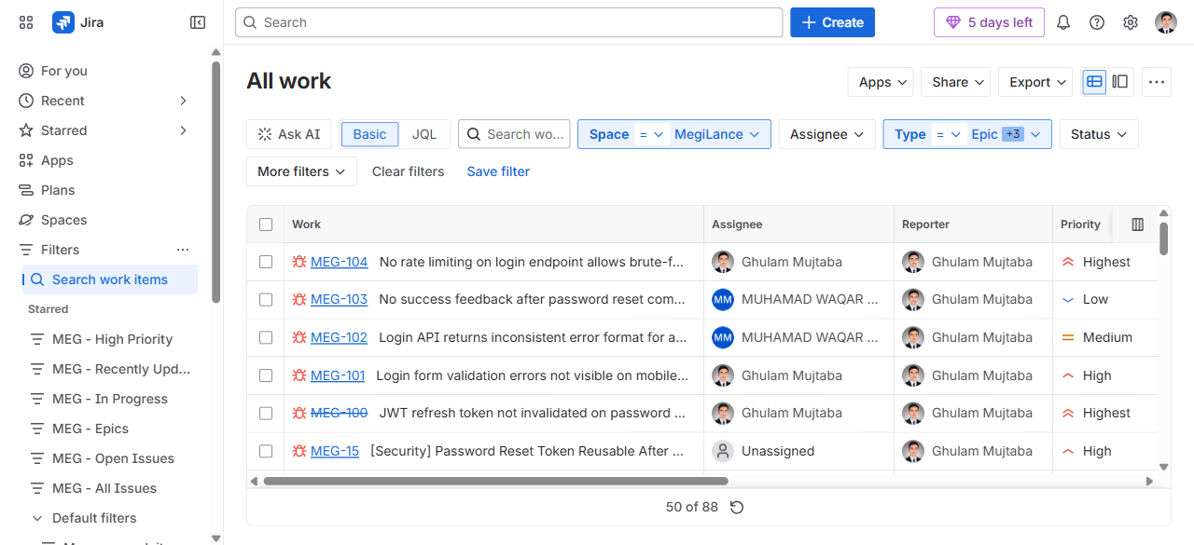
Figure 4: All work items — 88 issues filtered by type (Epic, Story, Bug, Task)

5. Automation Rules
4 Jira automation rules are active to streamline workflow:
- When a bug is created → set due date based on priority
- When all sub-tasks are done → move parent to done
- When a task is near due → send email reminder
- When a work item is transitioned → automatically assign
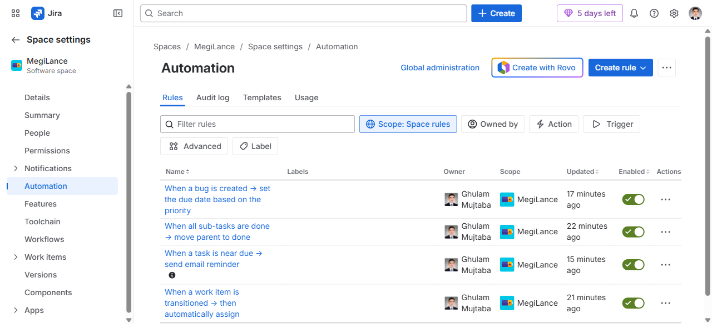
Figure 5: All 4 automation rules — enabled and active

6. Jira URLs Reference
- Scrum Board (TO DO / IN PROGRESS / DONE): https://ghulam-mujtaba.atlassian.net/jira/software/c/projects/MEG/boards/3
- Backlog & Sprints: https://ghulam-mujtaba.atlassian.net/jira/software/c/projects/MEG/boards/3/backlog
- Timeline / Epics: https://ghulam-mujtaba.atlassian.net/jira/software/c/projects/MEG/boards/3/timeline
- All Issues (Epic, Story, Bug, Task): https://ghulam-mujtaba.atlassian.net/issues/?jql=project%20%3D%20MEG%20AND%20type%20in%20(Epic%2C%20Story%2C%20Bug%2C%20Task)%20ORDER%20BY%20type%20ASC
- Automation Rules: https://ghulam-mujtaba.atlassian.net/jira/software/c/projects/MEG/settings/automate

