Theory Assignment 1 — Zephyr Scale
Test Case Management Using Zephyr Scale (Jira Plugin)

Student: Ghulam Mujtaba
Student ID: FA21-BSE-084
Course: CSE-455 Software Testing
Instructor: Dr. Instructor
Date: February 2026

1. Introduction
This assignment demonstrates the use of Zephyr Scale (SmartBear Zephyr Advanced), a professional test management tool integrated with Jira Cloud, for creating and managing structured test cases for the MegiLance FYP project — an AI-powered freelancing platform built with Next.js and FastAPI.
Zephyr Scale provides dedicated test case management capabilities including structured test steps, test cycles, test plans, execution tracking, and reporting — going beyond basic Jira issues to offer a complete test management solution.

2. Zephyr Scale Installation & Setup
Zephyr Scale (Zephyr Advanced by SmartBear) was installed from the Atlassian Marketplace as a 30-day free trial and enabled for the MegiLance (MEG) project.
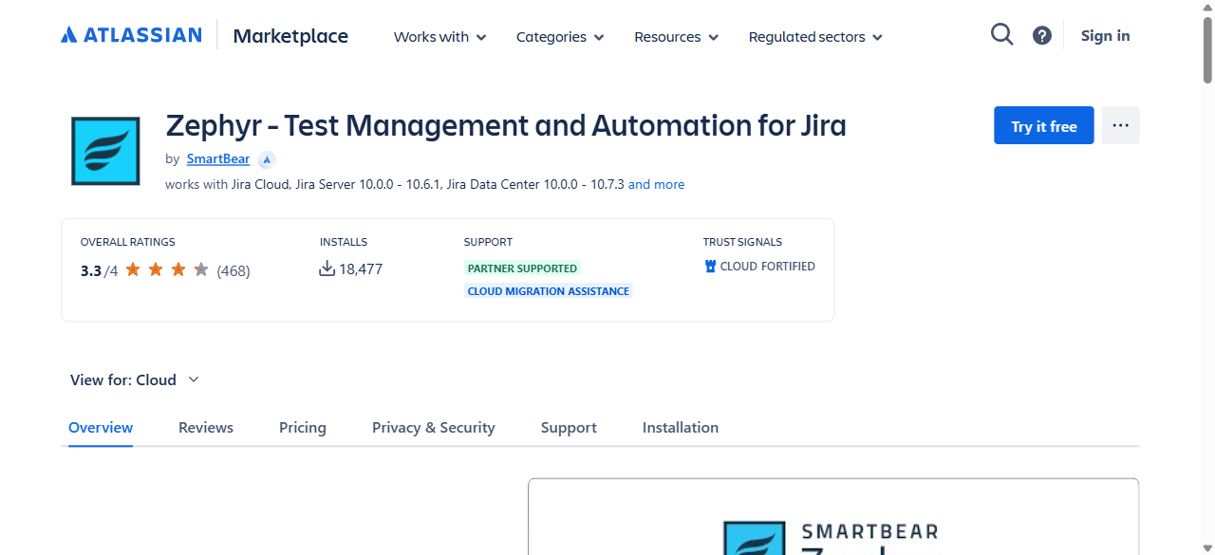
Figure 1: Zephyr Scale — Atlassian Marketplace Overview Page

2.1 Verifying Installation
After installation, Zephyr Scale appears in the Atlassian Administration under Connected Apps as 'Zephyr - Test Management and Automation for Jira' by SmartBear with the Advanced edition.
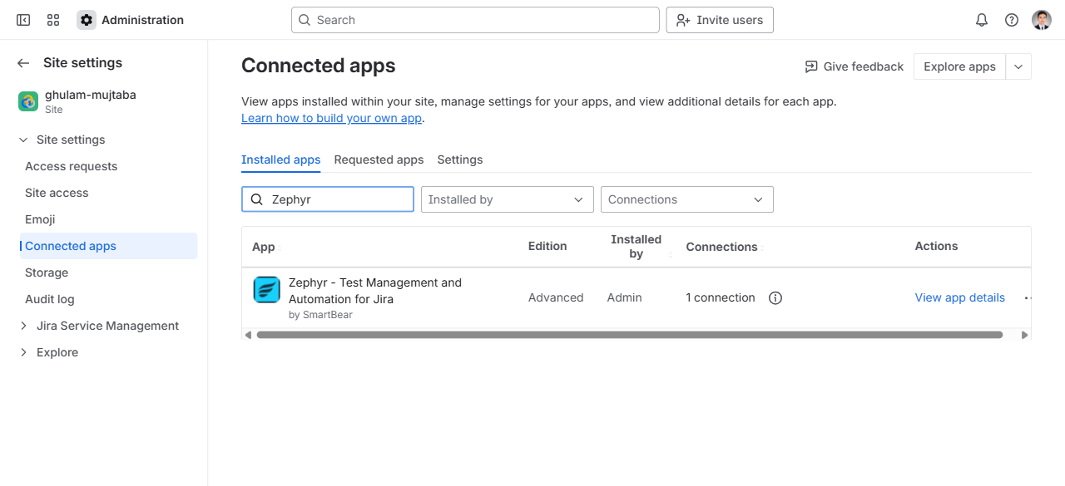
Figure 2: Connected Apps — Zephyr Scale Installed (Advanced Edition)

3. Test Cases Summary
10 test cases were created in Zephyr Scale covering the core modules of the MegiLance platform: Authentication & Security, Project Management, User Profiles, Proposals, Payments, and Search functionality.
Key | Test Case Name | Module | Status
MEG-T1 | TC-AUTH-001: User Registration with Valid Data | Authentication | Draft
MEG-T2 | TC-AUTH-002: User Login with Valid Credentials | Authentication | Draft
MEG-T3 | TC-AUTH-003: User Login with Invalid Password | Authentication | Draft
MEG-T4 | TC-AUTH-004: Password Reset Request | Authentication | Draft
MEG-T5 | TC-AUTH-005: JWT Token Refresh | Authentication | Draft
MEG-T6 | TC-PROJ-001: Create New Project | Project Management | Draft
MEG-T7 | TC-PROF-001: Update User Profile | User Profiles | Draft
MEG-T8 | TC-PROP-001: Submit Proposal for Project | Proposals | Draft
MEG-T9 | TC-PAY-001: Process Payment Transaction | Payments | Draft
MEG-T10 | TC-SEARCH-001: Search Projects with Filters | Search | Draft

4. Detailed Test Cases
Each test case below includes: Objective, Preconditions, Priority, and a step-by-step Test Script with Test Data and Expected Results.

MEG-T1: TC-AUTH-001: User Registration with Valid Data
Test Case ID | MEG-T1
Name | TC-AUTH-001: User Registration with Valid Data
Objective | Verify that a new user can register with valid credentials and receive a confirmation.
Preconditions | Application is running; /signup page is accessible; no existing account with the test email.
Priority | Normal
Status | Draft
Version | 1.0

Step # | Action | Test Data | Expected Result
1 | Navigate to the registration page at /signup |  | Registration form is displayed with email, password, full name, and role fields
2 | Enter a valid full name | John Doe | Name field accepts the input
3 | Enter a valid email address | testuser@example.com | Email field accepts the input
4 | Enter a strong password | SecureP@ss123! | Password field accepts input; strength indicator shows 'Strong'
5 | Select user role | Freelancer | Role dropdown shows selected value
6 | Click the 'Sign Up' button |  | Loading spinner appears; form is submitted
7 | Verify success response |  | HTTP 201; user object returned with id, email, role; JWT access and refresh tokens set

MEG-T2: TC-AUTH-002: User Login with Valid Credentials
Test Case ID | MEG-T2
Name | TC-AUTH-002: User Login with Valid Credentials
Objective | Verify that a registered user can log in with correct email and password.
Preconditions | A user account exists with known credentials; /login page is accessible.
Priority | Normal
Status | Draft
Version | 1.0

Step # | Action | Test Data | Expected Result
1 | Navigate to /login page |  | Login form displayed with email and password fields
2 | Enter registered email | testuser@example.com | Email field accepts input
3 | Enter correct password | SecureP@ss123! | Password field accepts input (masked)
4 | Click 'Log In' button |  | Loading spinner appears; credentials submitted to POST /api/auth/login
5 | Verify login success |  | HTTP 200; JWT access token (30 min) and refresh token (7 days) returned
6 | Verify redirect to dashboard |  | User is redirected to /portal/dashboard with correct role

MEG-T3: TC-AUTH-003: User Login with Invalid Password
Test Case ID | MEG-T3
Name | TC-AUTH-003: User Login with Invalid Password
Objective | Verify that login is rejected when an incorrect password is provided.
Preconditions | A user account exists with known email; /login page is accessible.
Priority | Normal
Status | Draft
Version | 1.0

Step # | Action | Test Data | Expected Result
1 | Navigate to /login page |  | Login form displayed
2 | Enter registered email | testuser@example.com | Email field accepts input
3 | Enter incorrect password | WrongPassword123 | Password field accepts input
4 | Click 'Log In' button |  | Credentials submitted
5 | Verify error response |  | HTTP 401; error message: 'Invalid credentials'
6 | Verify user stays on login page |  | No redirect; login form remains visible with error message

MEG-T4: TC-AUTH-004: Password Reset Request
Test Case ID | MEG-T4
Name | TC-AUTH-004: Password Reset Request
Objective | Verify that a user can request a password reset link via their registered email.
Preconditions | A user account exists; /forgot-password page is accessible; SMTP service is configured.
Priority | Normal
Status | Draft
Version | 1.0

Step # | Action | Test Data | Expected Result
1 | Navigate to /forgot-password page |  | Password reset form displayed with email field
2 | Enter the registered email | testuser@example.com | Email field accepts input
3 | Click 'Send Reset Link' button |  | Request sent to POST /api/auth/forgot-password
4 | Verify success message |  | Success message displayed: 'If the email exists, a reset link has been sent'
5 | Check email inbox |  | Password reset email received with a valid reset link containing a token

MEG-T5: TC-AUTH-005: JWT Token Refresh
Test Case ID | MEG-T5
Name | TC-AUTH-005: JWT Token Refresh
Objective | Verify that an expired access token can be refreshed using a valid refresh token.
Preconditions | User is logged in with valid access and refresh tokens; access token is about to expire or expired.
Priority | Normal
Status | Draft
Version | 1.0

Step # | Action | Test Data | Expected Result
1 | Make an API request with an expired access token | GET /api/auth/me with expired JWT | HTTP 401 Unauthorized response
2 | Send refresh token to /api/auth/refresh | POST with refresh_token cookie | HTTP 200; new access token returned
3 | Retry original request with new access token | GET /api/auth/me with new JWT | HTTP 200; user profile data returned successfully
4 | Verify new token expiry |  | New access token has 30-minute expiry; refresh token unchanged

MEG-T6: TC-PROJ-001: Create New Project
Test Case ID | MEG-T6
Name | TC-PROJ-001: Create New Project
Objective | Verify that a client user can create a new project with all required fields.
Preconditions | User is logged in as a Client; /portal/projects/create page is accessible.
Priority | Normal
Status | Draft
Version | 1.0

Step # | Action | Test Data | Expected Result
1 | Navigate to /portal/projects/create |  | Project creation form is displayed
2 | Enter project title | E-Commerce Website Redesign | Title field accepts input (max 200 chars)
3 | Enter project description | Full redesign of online store with React and Node.js backend | Description field accepts input
4 | Set budget range | Min: $500, Max: $2000 | Budget fields accept numeric input
5 | Select required skills | React, Node.js, PostgreSQL | Skills tags are added
6 | Set project deadline | 2026-06-30 | Date picker accepts future date
7 | Click 'Post Project' button |  | HTTP 201; project created with status 'Open'; redirect to project detail page

MEG-T7: TC-PROF-001: Update User Profile
Test Case ID | MEG-T7
Name | TC-PROF-001: Update User Profile
Objective | Verify that a user can update their profile information successfully.
Preconditions | User is logged in; /portal/profile/edit page is accessible.
Priority | Normal
Status | Draft
Version | 1.0

Step # | Action | Test Data | Expected Result
1 | Navigate to /portal/profile/edit |  | Profile edit form is displayed with current data pre-filled
2 | Update full name | John M. Doe | Name field accepts the updated value
3 | Update bio/description | Senior Full-Stack Developer with 5+ years experience | Bio field accepts input (max 1000 chars)
4 | Upload new avatar image | avatar.jpg (under 2 MB) | Image preview shown; file accepted
5 | Add/update skills | Python, FastAPI, Next.js, Docker | Skills tags updated
6 | Click 'Save Profile' button |  | HTTP 200; profile updated; success toast notification displayed
7 | Verify changes persisted |  | Reload profile page; all updated fields show new values

MEG-T8: TC-PROP-001: Submit Proposal for Project
Test Case ID | MEG-T8
Name | TC-PROP-001: Submit Proposal for Project
Objective | Verify that a freelancer can submit a proposal for an open project.
Preconditions | User is logged in as Freelancer; an open project exists; user hasn't already submitted a proposal for this project.
Priority | Normal
Status | Draft
Version | 1.0

Step # | Action | Test Data | Expected Result
1 | Navigate to an open project detail page |  | Project details displayed with 'Submit Proposal' button visible
2 | Click 'Submit Proposal' button |  | Proposal form/modal is displayed
3 | Enter proposed amount | $1200 | Amount field accepts numeric input within project budget
4 | Enter cover letter | I have 5 years of experience in React and Node.js... | Cover letter field accepts text input
5 | Set estimated delivery time | 30 days | Duration field accepts input
6 | Click 'Submit' button |  | HTTP 201; proposal created with status 'Pending'; confirmation message shown
7 | Verify proposal appears in user's proposals list |  | Proposal visible in /portal/proposals with correct status

MEG-T9: TC-PAY-001: Process Payment Transaction
Test Case ID | MEG-T9
Name | TC-PAY-001: Process Payment Transaction
Objective | Verify that a payment can be processed for an accepted contract milestone.
Preconditions | A contract exists with an accepted milestone; client has sufficient balance; payment gateway is configured.
Priority | Normal
Status | Draft
Version | 1.0

Step # | Action | Test Data | Expected Result
1 | Navigate to the contract detail page |  | Contract details displayed with milestones list
2 | Click 'Release Payment' on a completed milestone |  | Payment confirmation dialog appears
3 | Confirm the payment amount | $400 (milestone amount) | Amount displayed correctly
4 | Click 'Confirm Payment' button |  | Payment processed; HTTP 200 response
5 | Verify payment status updated |  | Milestone status changes to 'Paid'; transaction record created
6 | Verify freelancer balance updated |  | Freelancer's account balance increased by milestone amount minus platform fee

MEG-T10: TC-SEARCH-001: Search Projects with Filters
Test Case ID | MEG-T10
Name | TC-SEARCH-001: Search Projects with Filters
Objective | Verify that users can search and filter projects using multiple criteria.
Preconditions | Multiple projects exist in the system with varying skills, budgets, and categories.
Priority | Normal
Status | Draft
Version | 1.0

Step # | Action | Test Data | Expected Result
1 | Navigate to /projects (project listing page) |  | Project listing page displayed with search bar and filter panel
2 | Enter search keyword | React | Search field accepts input
3 | Apply skill filter | Select: React, Node.js | Filter tags applied; results update dynamically
4 | Apply budget range filter | Min: $500, Max: $2000 | Budget filter applied
5 | Apply sort option | Sort by: Newest First | Results re-ordered by creation date descending
6 | Verify filtered results |  | Only projects matching all criteria are displayed; result count updated
7 | Click on a project from results |  | Redirected to project detail page with correct data

5. Zephyr Scale Features Used
The following Zephyr Scale features were utilized in this assignment:
- Test Cases Tab — Centralized test case repository with search and filtering
- Test Case Versioning — Each test case has version tracking (Version 1.0)
- Step-by-Step Test Scripts — Structured test steps with Test Data and Expected Results
- Folder Organization — Test cases organized into folders by module
- Status Workflow — Draft → Approved → Deprecated lifecycle management
- Priority Levels — Normal, High, Low, Critical for test prioritization
- Owner Assignment — Test cases assigned to specific team members
- Traceability — Link test cases to Jira issues for requirement coverage
- Test Cycles — Group test cases together for sprint-based execution

6. Jira Issues vs Zephyr Scale — Comparison
The table below compares using plain Jira issues versus Zephyr Scale for test case management:
Feature | Jira Issues | Zephyr Scale
Test Steps | Manual (in description) | Structured step editor
Expected Results | Text in description | Per-step expected results
Test Execution | Manual status change | Dedicated execution engine
Test Cycles | Not available | Built-in test cycles
Test Plans | Epics/Stories | Dedicated test plans
Reporting | Jira dashboards | Test-specific reports
Versioning | Not available | Test case versioning
Traceability | Links only | Requirement coverage matrix

7. Conclusion
Zephyr Scale provides a significantly more structured and professional approach to test case management compared to plain Jira issues. The dedicated test case editor, step-by-step test scripts, execution tracking, and reporting capabilities make it the preferred tool for managing test cases in real-world software testing projects.
For the MegiLance FYP project, 10 test cases were successfully created in Zephyr Scale covering authentication, project management, user profiles, proposals, payments, and search modules — demonstrating the tool's capabilities for structured test management.

8. URLs Reference
- Zephyr Scale — All Test Cases: https://ghulam-mujtaba.atlassian.net/projects/MEG?selectedItem=com.atlassian.plugins.atlassian-connect-plugin:com.kanoah.test-manager__main-project-page
- Zephyr Scale — Atlassian Marketplace: https://marketplace.atlassian.com/apps/1213259/zephyr-test-management-and-automation-for-jira
- Jira Project — MegiLance (MEG): https://ghulam-mujtaba.atlassian.net/jira/software/c/projects/MEG/boards/3
- All 21 Jira Test Case Issues: https://ghulam-mujtaba.atlassian.net/issues/?jql=project%20%3D%20MEG%20AND%20labels%20%3D%20test-case

