Theory Assignment 1 — Zephyr Scale
Test Case Management Using Zephyr Scale (Jira Plugin)

Student: Ghulam Mujtaba
Student ID: FA21-BSE-084
Course: CSE-455 Software Testing
Instructor: Dr. Instructor
Date: February 2026

1. Introduction
This assignment demonstrates the use of Zephyr Scale (SmartBear Zephyr Advanced), a professional test management tool integrated with Jira Cloud, for creating and managing structured test cases for the MegiLance FYP project — an AI-powered freelancing platform built with Next.js and FastAPI.
Zephyr Scale provides dedicated test case management capabilities including structured test steps, test cycles, test plans, execution tracking, and reporting — going beyond basic Jira issues to offer a complete test management solution.

2. Zephyr Scale Installation & Setup
Zephyr Scale (Zephyr Advanced by SmartBear) was installed from the Atlassian Marketplace as a 30-day free trial and enabled for the MegiLance (MEG) project.
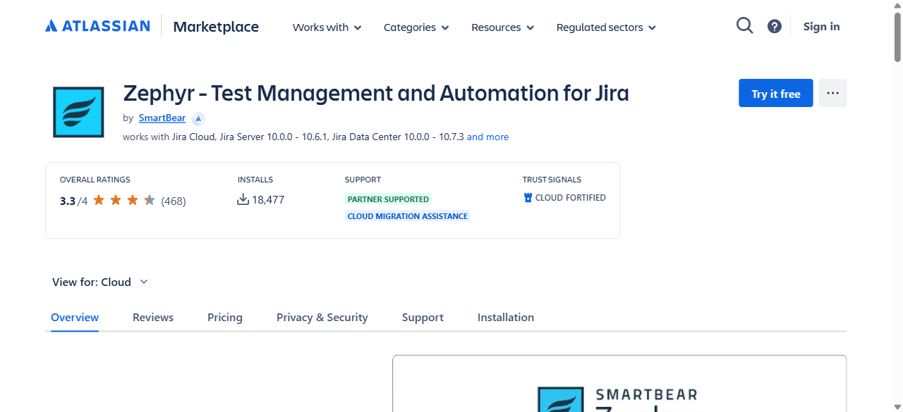
Figure 1: Zephyr Scale — Atlassian Marketplace Overview Page

3. Verifying Zephyr Scale Installation
After installation, Zephyr Scale appears in the Atlassian Administration under Connected Apps. The app is listed as 'Zephyr - Test Management and Automation for Jira' by SmartBear with the Advanced edition.
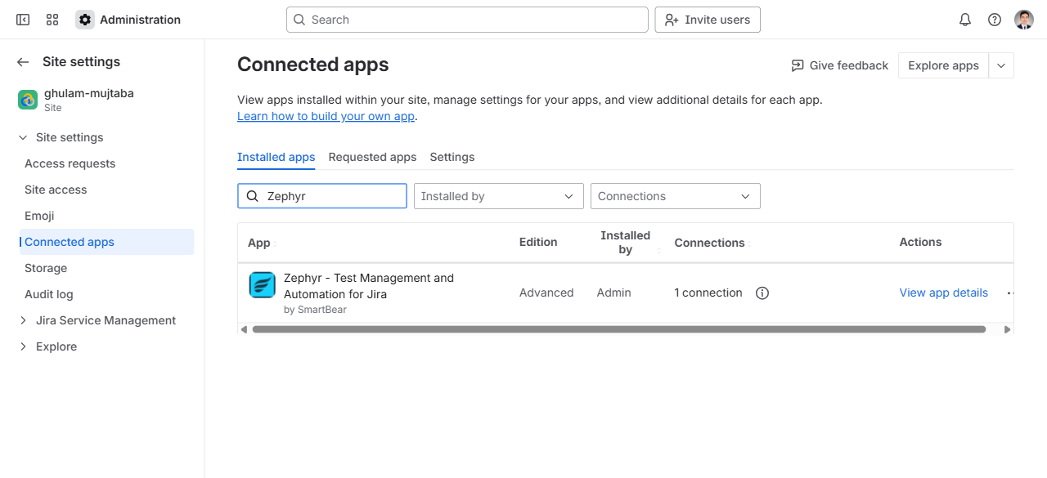
Figure 2: Connected Apps — Zephyr Scale Installed (Advanced Edition by SmartBear)

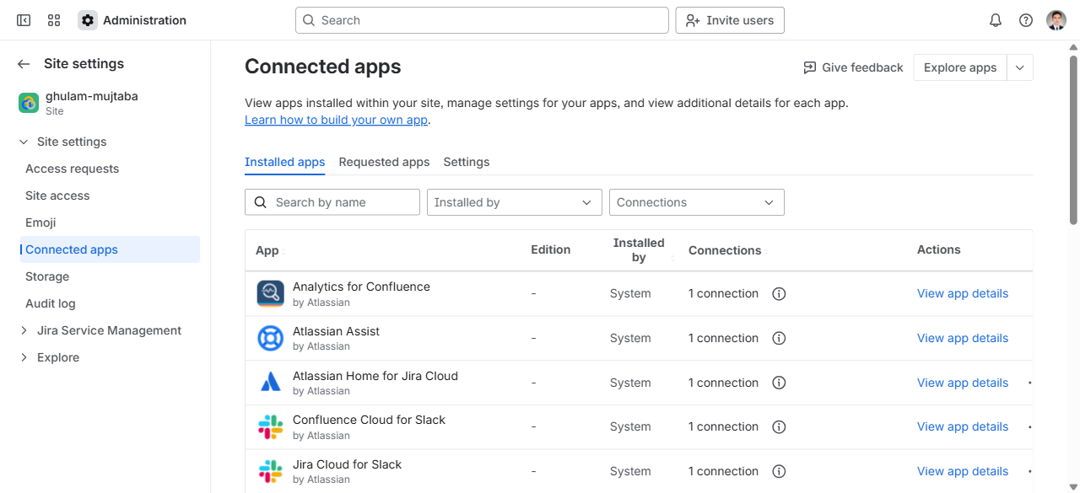
Figure 3: All Connected Apps in Atlassian Administration

4. Test Cases Created in Zephyr Scale
10 test cases were created in Zephyr Scale covering the core modules of the MegiLance platform: Authentication & Security, Project Management, User Profiles, Proposals, Payments, and Search functionality.
Key | Test Case Name | Module | Status
MEG-T1 | TC-AUTH-001: User Registration with Valid Data | Authentication | Draft
MEG-T2 | TC-AUTH-002: User Login with Valid Credentials | Authentication | Draft
MEG-T3 | TC-AUTH-003: User Login with Invalid Password | Authentication | Draft
MEG-T4 | TC-AUTH-004: Password Reset Request | Authentication | Draft
MEG-T5 | TC-AUTH-005: JWT Token Refresh | Authentication | Draft
MEG-T6 | TC-PROJ-001: Create New Project | Project Management | Draft
MEG-T7 | TC-PROF-001: Update User Profile | User Profiles | Draft
MEG-T8 | TC-PROP-001: Submit Proposal for Project | Proposals | Draft
MEG-T9 | TC-PAY-001: Process Payment Transaction | Payments | Draft
MEG-T10 | TC-SEARCH-001: Search Projects with Filters | Search | Draft

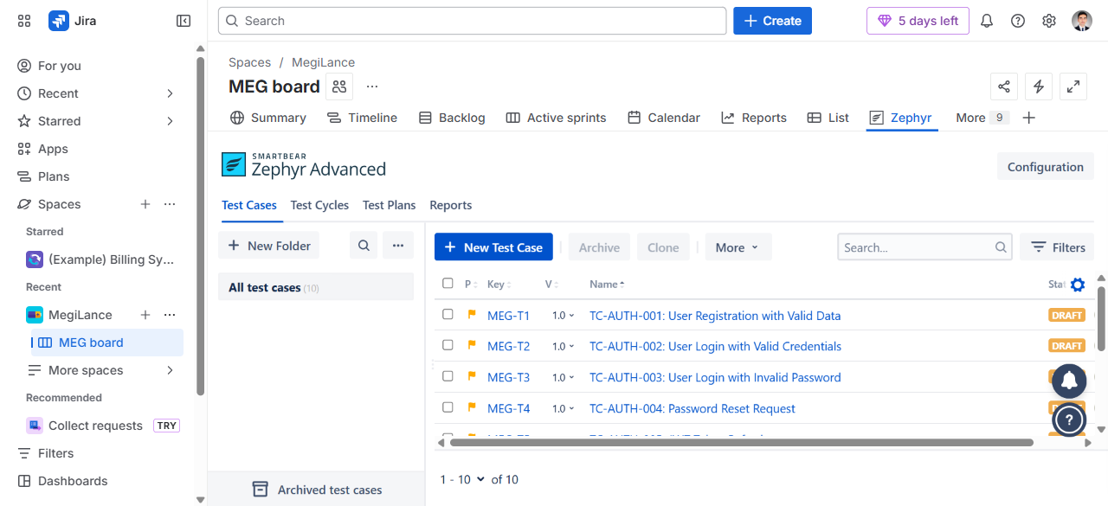
Figure 7: Zephyr Scale — All 10 Test Cases (MEG-T1 to MEG-T10)

5. Test Case Detail View
Each Zephyr Scale test case includes the following fields:
- Name — Descriptive test case name with category prefix (e.g., TC-AUTH-001)
- Objective — Purpose and goal of the test case
- Precondition — Required setup before test execution
- Status — Current state (Draft, Approved, Deprecated)
- Priority — Normal, High, Low, Critical
- Owner — Assigned team member responsible for the test case
- Test Script — Step-by-step test steps with Expected Results
- Traceability — Links to related Jira issues and requirements
- Execution — Test execution history and results

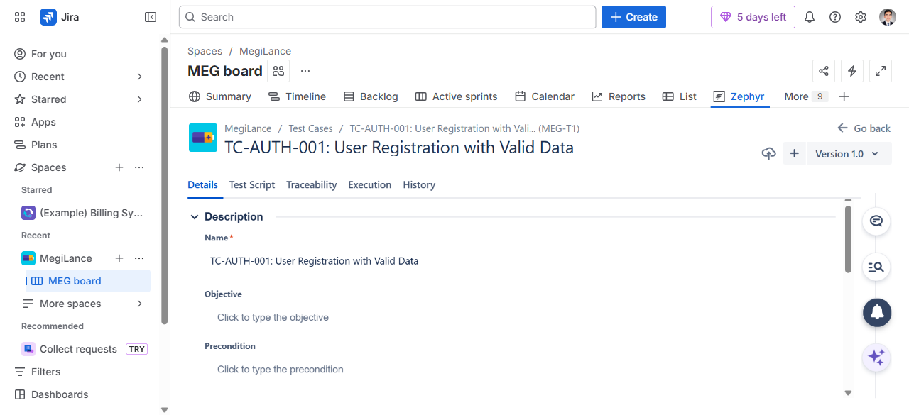
Figure 5: MEG-T1 — TC-AUTH-001: User Registration with Valid Data (Details View)

5.1 Test Script View
Each test case has a Test Script tab where step-by-step test steps are defined with Test Data and Expected Results. The following shows the Test Script view for MEG-T1:
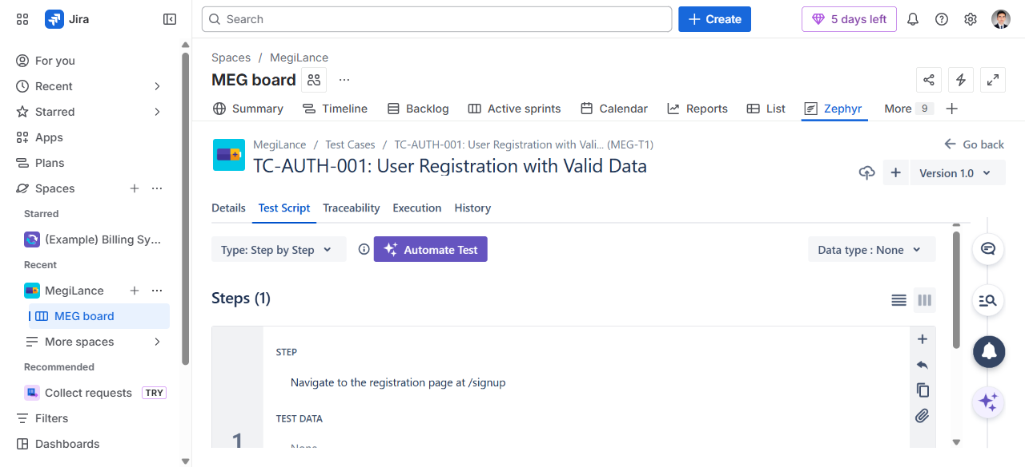
Figure 6: MEG-T1 — Test Script Tab (Step-by-Step Test Steps)

6. Test Cycles
Zephyr Scale provides a dedicated Test Cycles feature for organizing test execution. Test cycles group test cases together for a specific testing session or sprint.
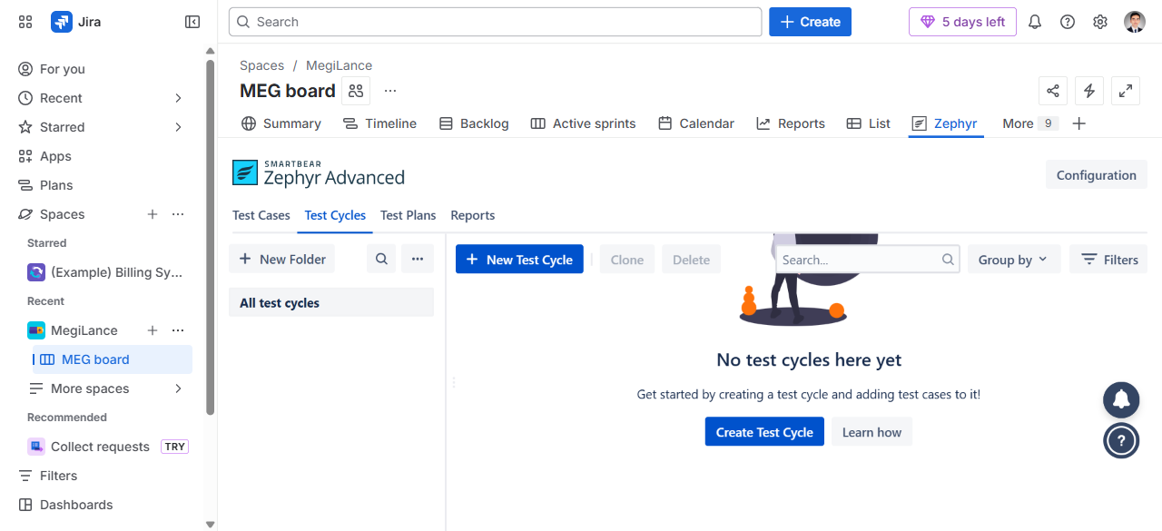
Figure 7: Zephyr Scale — Test Cycles Tab (Empty, Ready for Creation)

7. Zephyr Scale Features Used
The following Zephyr Scale features were utilized in this assignment:
- Test Cases Tab — Centralized test case repository with search and filtering
- Test Case Versioning — Each test case has version tracking (Version 1.0)
- Step-by-Step Test Scripts — Structured test steps with Test Data and Expected Results
- Folder Organization — Test cases can be organized into folders by module
- Status Workflow — Draft → Approved → Deprecated lifecycle management
- Priority Levels — Normal, High, Low, Critical for test prioritization
- Owner Assignment — Test cases assigned to specific team members
- Traceability — Link test cases to Jira issues for requirement coverage

8. Zephyr Scale Main Page
The Zephyr Scale main page shows the Zephyr Advanced header with tabs for Test Cases, Test Cycles, Test Plans, and Reports. The Zephyr tab is accessible from the project navigation in Jira.
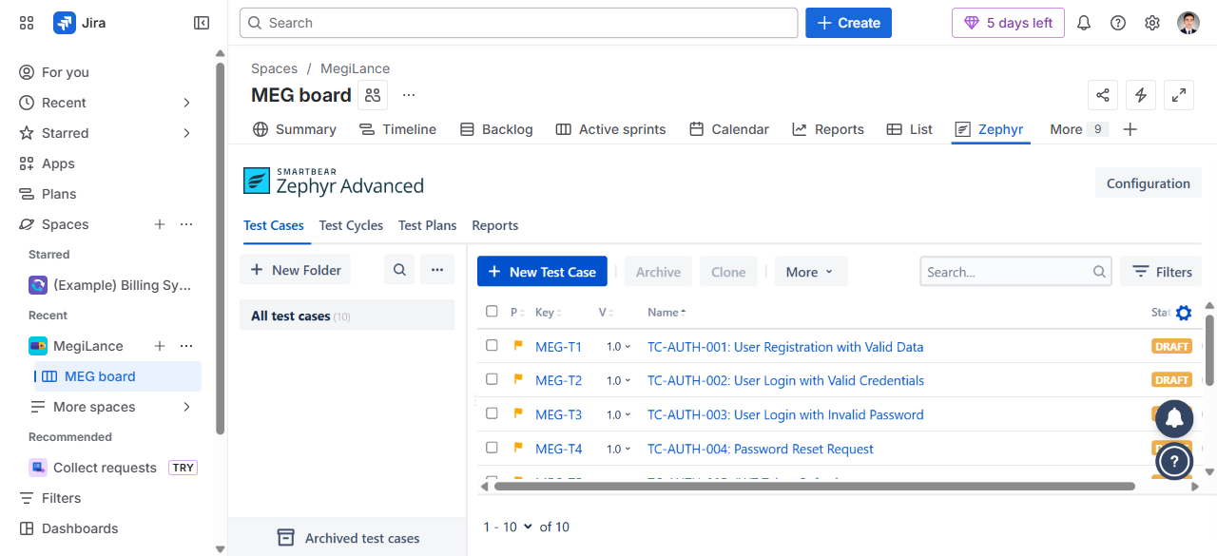
Figure 8: Zephyr Scale — Main Page with All Test Cases Loaded

9. Jira Issues vs Zephyr Scale — Comparison
The table below compares using plain Jira issues versus Zephyr Scale for test case management:
Feature | Jira Issues | Zephyr Scale
Test Steps | Manual (in description) | Structured step editor
Expected Results | Text in description | Per-step expected results
Test Execution | Manual status change | Dedicated execution engine
Test Cycles | Not available | Built-in test cycles
Test Plans | Epics/Stories | Dedicated test plans
Reporting | Jira dashboards | Test-specific reports
Versioning | Not available | Test case versioning
Traceability | Links only | Requirement coverage matrix

10. Conclusion
Zephyr Scale provides a significantly more structured and professional approach to test case management compared to plain Jira issues. The dedicated test case editor, step-by-step test scripts, execution tracking, and reporting capabilities make it the preferred tool for managing test cases in real-world software testing projects.
For the MegiLance FYP project, 10 test cases were successfully created in Zephyr Scale covering authentication, project management, user profiles, proposals, payments, and search modules — demonstrating the tool's capabilities for structured test management.

11. URLs Reference
- Zephyr Scale — All Test Cases: https://ghulam-mujtaba.atlassian.net/projects/MEG?selectedItem=com.atlassian.plugins.atlassian-connect-plugin:com.kanoah.test-manager__main-project-page
- Zephyr Scale — Atlassian Marketplace: https://marketplace.atlassian.com/apps/1213259/zephyr-test-management-and-automation-for-jira
- Jira Project — MegiLance (MEG): https://ghulam-mujtaba.atlassian.net/jira/software/c/projects/MEG/boards/3
- All 21 Jira Test Case Issues: https://ghulam-mujtaba.atlassian.net/issues/?jql=project%20%3D%20MEG%20AND%20labels%20%3D%20test-case

