|  |
| --- |
| **Hands-on Exercise No. 1**  **DigiSkills 2.0 Batch-03**  **Data Analytics & Business Intelligence** |

**Name:** MUHAMMAD UMAIR SHAFIQ

**Problem Statement:**

In this exercise, you are required to perform the given tasks and provide screenshots of each task in The MS word solution file:

**Tasks:**

**1) Go to Google scholar and search recent research papers about the topic: "Impact of global warming on regions". (2 Marks)**

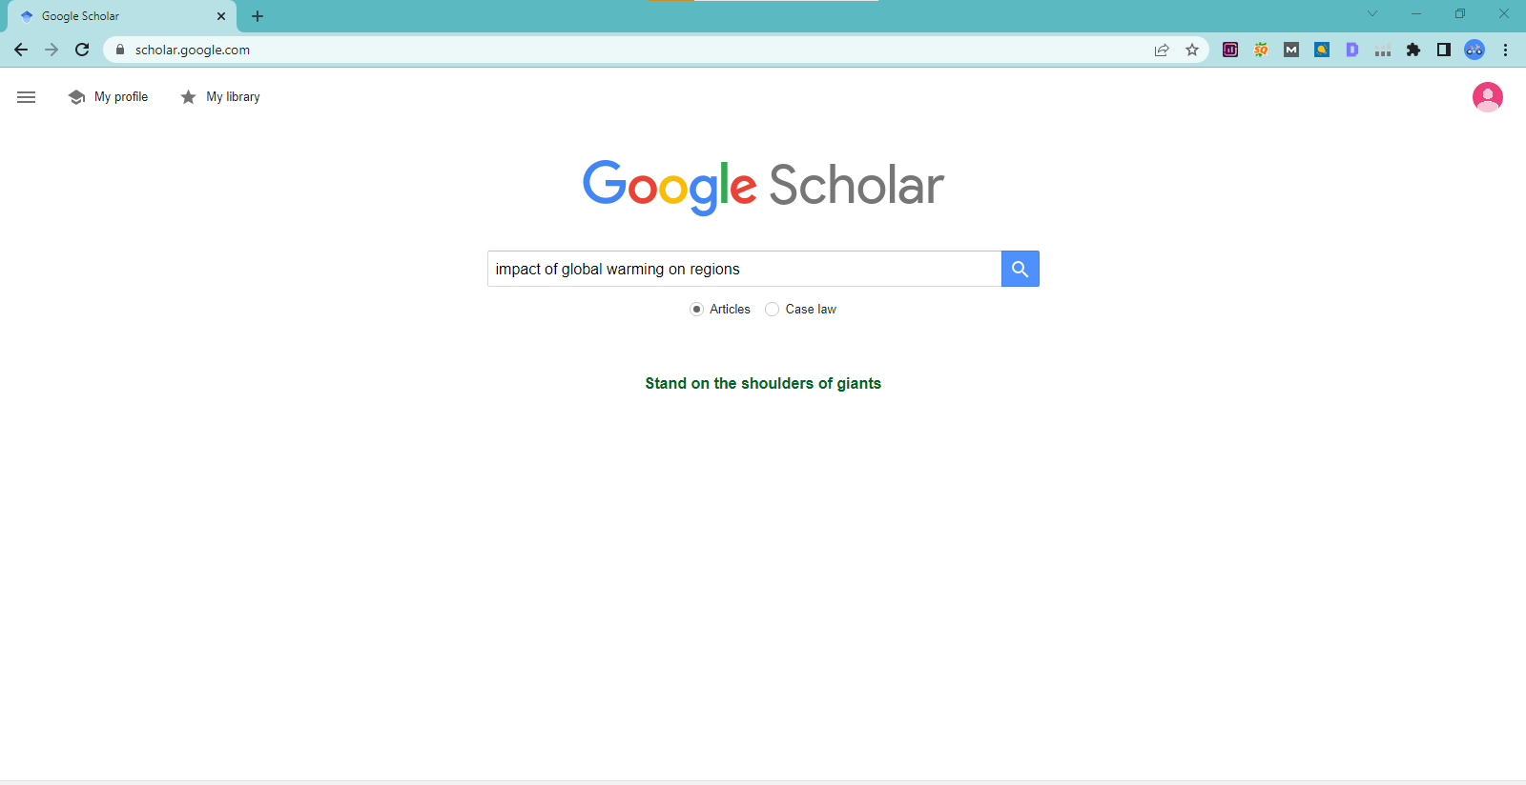

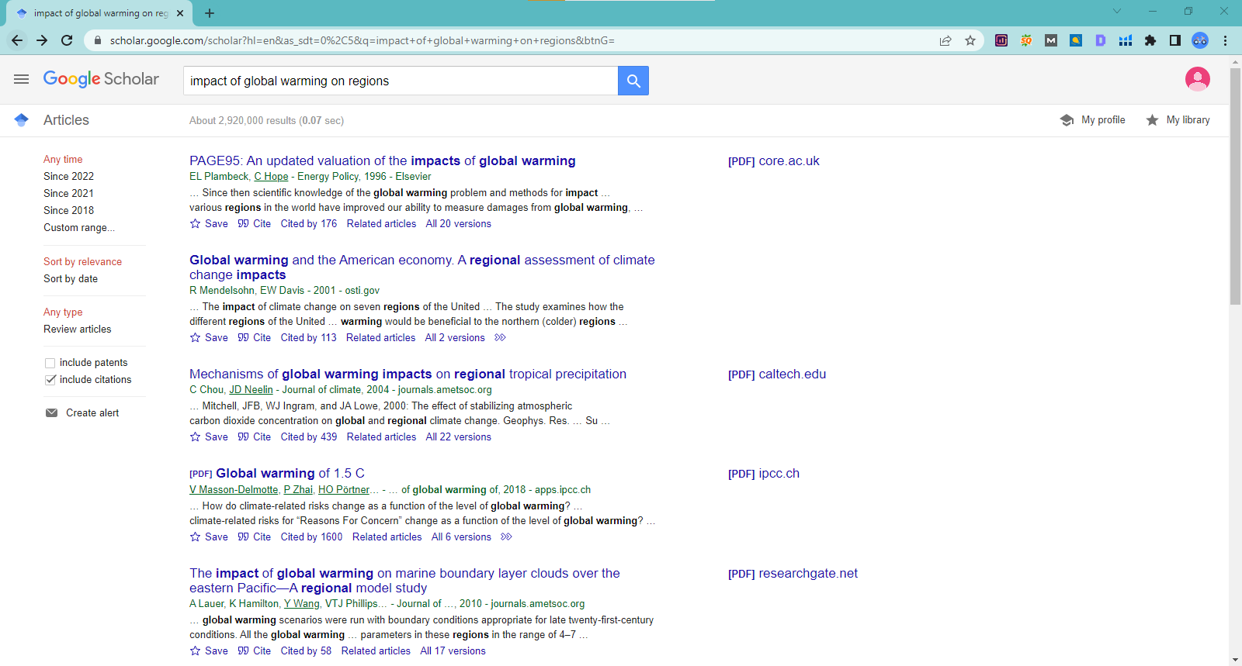

**2) Login to Google Drive, open the google docs file and then add adds-on extension "Word Cloud Generator". (2 Marks)**

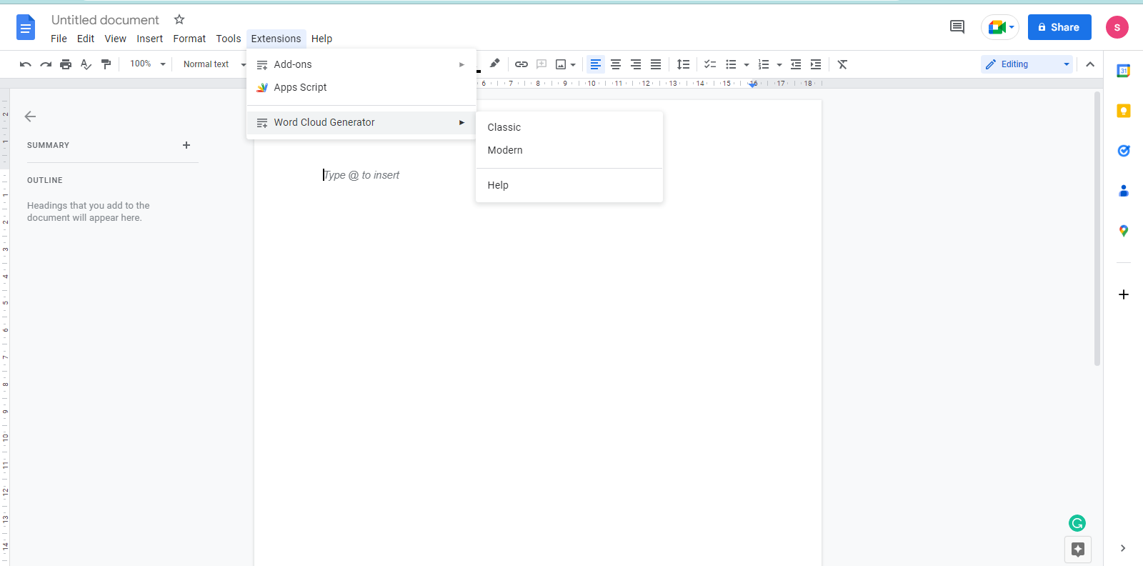

**3) Copy the research paper’s content and paste it into the google docs file, generate the Word Cloud by using the installed extension and then attach the generated image. (3 Marks)**

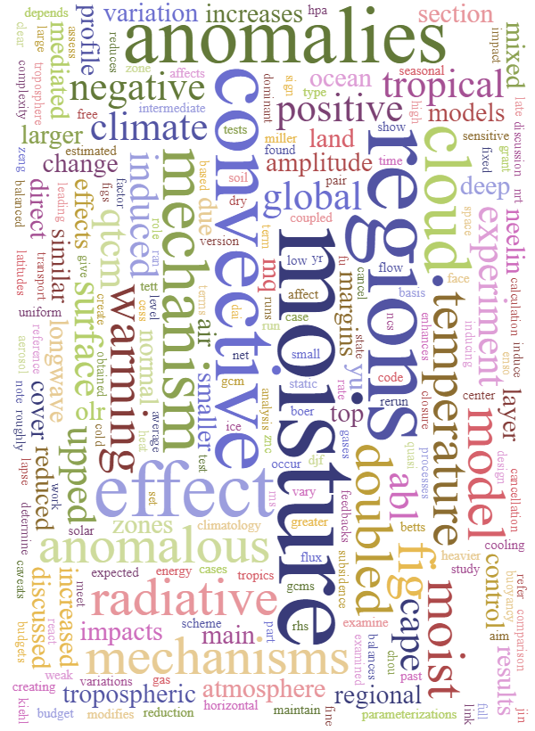

**4) Write down the 10 most prominent words from the word cloud image. (3 Marks)**

1. Anomalies
2. Convective
3. Moisture
4. Regions
5. Mechanism
6. Warming
7. Effect
8. Climate
9. Temperature
10. Cloud