Smart Ride-Sharing System

# Documentation

This document explains the design decisions, class structures, and how to run the Smart Ride-Sharing System application.

## Design Decisions

The application uses object-oriented principles to create an efficient ride-sharing system. Key classes include Rider, Driver, and Ride, representing real-world entities. The Rider class has methods for requesting rides, and the Ride class manages the details of each ride, such as calculating distance and estimated time. Drivers can be assigned to rides based on their availability. Randomized traffic factors are used to simulate real-world variations in estimated time of arrival.

## Class Structures

### Ride Class

The Ride class holds the rider and assigned driver, calculating the distance between the rider's current location and destination using the Haversine formula. The class also estimates the time based on distance and random traffic factors.

### Rider Class

The Rider class contains details about the rider such as their name and current/destination locations. It has a requestRide() method to search for available drivers and create a Ride instance when a driver is assigned.

## How to Run the Application

1. Open the Android Studio project.  
2. Build and run the project on an emulator or physical device.  
3. Use the buttons in the UI (activity_main.xml) to add drivers, request rides, and display information.  
The output will be shown in the output text view.

## Example Input/Output

1. Input: Rider requests a ride

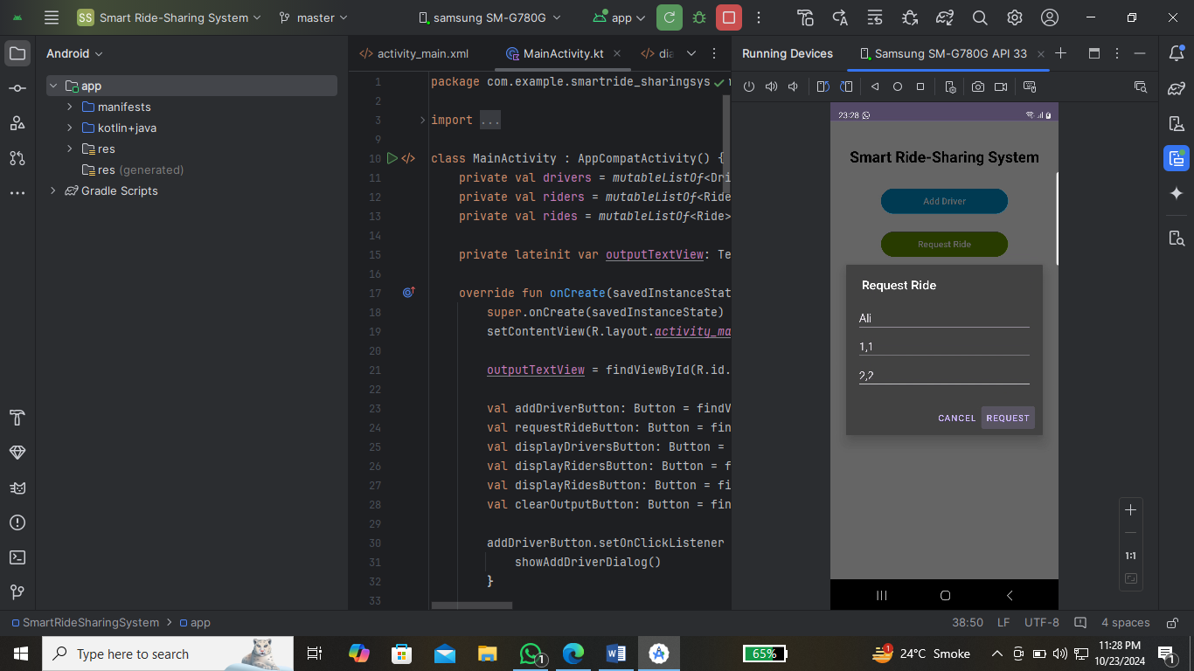

1. Output: No ride available, all drivers are busy.

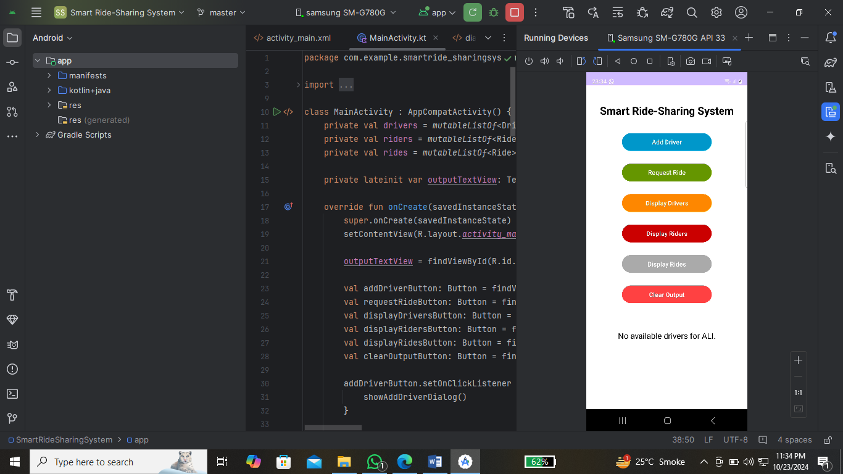

1. Output: Ride created, driver assigned to the rider.

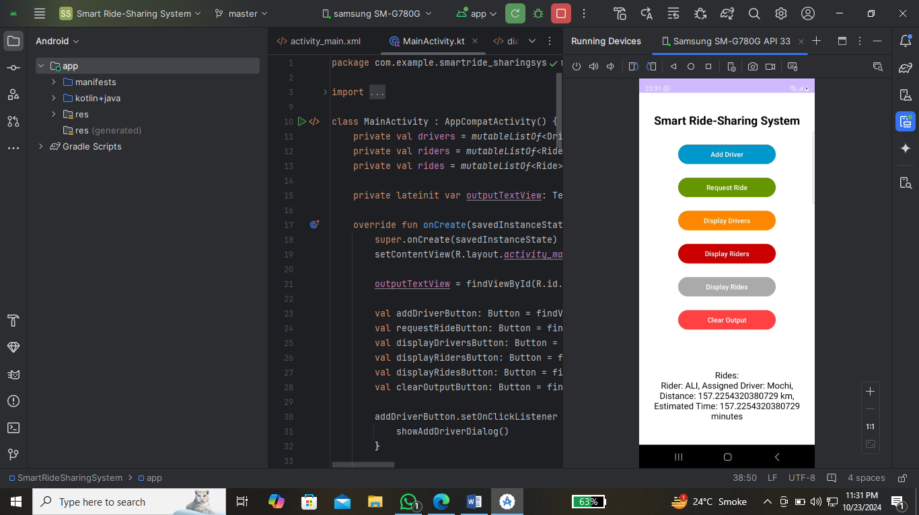

# Unit Tests

## Distance Calculation Test

Test whether the calculateDistance() method in the Ride class accurately calculates the distance between two coordinates using the Haversine formula.

## Ride Assignment Test

Test whether the requestRide() method in the Rider class correctly assigns an available driver to the rider or returns null when no drivers are available.