FANOFAN 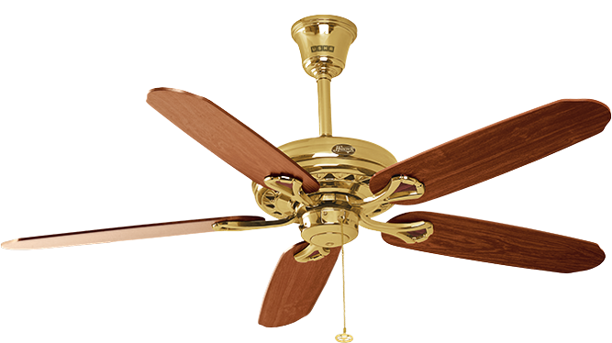

DOCUMENTATION

Student Details

|  |  |
| --- | --- |
| Student Name | Student ID |
| Shazmina | Student1365583 |
| Arooba | Student1362791 |

Faculty Details

*Sir Omair Mushtaq*

Coordinator

Miss Wajeeha

Curriculum

7062

ACKNOWLEDGEMENT

The first, we would like to express my special

thanks of gratitude to my teacher Omair Mushtaq

who helped us a lot in finalizing this project within

the limited time frame, valuable counselling and

assistance for the accomplishment of this project.

Secondly, we would also like to thank the eProject

team at Aptech Head Office, who gave us the

golden opportunity to do this wonderful project

about Fanofan.

Thirdly, we also thank the eProject team, some of

the benefits are as under:

• Re-enforcement of skills happens in the

experiential learning process.

• A mentor, ensuring that we do not get drifted,

constantly guides us.

• It gives us a lot of confidence to face an

interview as we have

worked on a project. We can explain virtually

everything on the subject we have learnt.

.

SYNOPSIS

Follow the strong development of the internet,

technology watches and the growing watch

market, every business needs a website design to

display products on the internet.

Online beauty shop is a web portal developed to

display and sell cosmetic products online. It is full-

fledged ecommerce site where customer can select

product, add product to shopping cart and checkout.

System administrator can add product,upload product

image from web interface. So, Fanofan shares the best

product images through the website for everyone to know

our products. However, purchases are not made directly on

the website, we are working on it.

PROBLEM DEFINITION

FANoFAN Company is into manufacturing and selling on Fans. They

manufacture fans for various needs of customers. From Ceiling Fans

to Table Fans to Exhaust Fans, they are into all types of Fan Manufacturing.

They are looking to come up with their own website and display all the

Products available with them. They want to provide a detailed information

about all their products.

CUSTOMER REQUIREMENT

SPECIFICATION

(CRS)

The Web site is to be created based on the following

requirements.

1) The Home Page should be created making use of Sections with a suitables

logo, the header section can be added which will show images Fans.

2) The site must contain the links to navigate through any category for the

information.

3) Links of bottles can be categorized like (Ceiling Fans, Table Fans, Exhaust

etc.)

4) Specification and Pricing of Fans can be added along with the images.

5) Gallery section can be added for viewing different images.

6) Feedback must be allowed to enter by the viewer

7) Site map, Gallery, about us, Queries link, Contact us link must be added.

8) The complete description must be allowed to get download as pdf or doc file.

9) The advertise section with various facilities provided should be mentioned.

SCOPE OF THE WORK (IN BRIEF)

The website is to be developed for the Windows

Platform using HTML5, CSS, Bootstrap, jQuery and

JavaScript and. The site should work well in all

leading browsers including Chrome, IE, Firefox,

Opera and Microsoft Edge etc.

**Homepage show:**

1.Logo

2.Navbar

3.Image Slider

4.Product Images

5.Footer

**About Us page show:**

1.Logo

2.Navbar

3.Mission

4.Vision

5.Info

6.Footer

**Contact Us page show**

1.Logo

2.Navbar

3.Map

4.Contact us

5.Footer

**Feedback page show**

1.Logo

2.Navbar

4.Product review image

5.Feedback us

6.Footer

**Product Page Contains:**

1.Logo

2.Navbar

4. Product details

5.Product card

6.Footer

**Our Gallery Page Contains**

1.Logo

2.Navbar

4.Images

5.Footer

SITEMAP ENGLISH

Home

About

Checkout

Gallery

Feedback

Contact

Product

gallery.html

Feedback.html

Contact.html

home.html

About us.html

Checkout.html

Charging Fans

Stand Fans

Exhaust Fans

Table fans

Ceiling fans

Charging fans.html

Exhaust fan.html

Ceiling fan.html

Stand .html

Table .html

• Home page (home.html)

• About Page (about us.html)

• Contact-Us page (contact.html)

• Feedback (feedback.html)

• Product (product.html)

1.Ceiling Fans(ceilingfan.html)

2.Table Fans(table.html)

3.Exhaust Fans(Exhaust fan.html)

4.Stand Fans(stand.html)

5.Charging Fans(charging fans.html)

**Task Sheet Review:**

|  |  |  |  |  |
| --- | --- | --- | --- | --- |
| S.no | Tasks | Date | Group  members | Status |
| 1. | Analysis | 17/6/22 | Shazmina,Arooba | Complete |
| 2. | Wireframes | 19/6/22 | Shazmina,Arooba | Complete |
| 3. | Data  Collections | 24/6/22 | Shazmina,Arooba | Complete |
| 4. | Home Page | 28/6/22 | Shazmina,Arooba | Complete |
| 5. | ProductPages | 1/7/22 | Shazmina | Complete |
| 6. | Gallery Page | 5/7/22 | Arooba | Complete |
| 7. | Compile all  Pages | 7/7/22 | Shazmina,Arooba | Complete |

|  |  |  |  |  |
| --- | --- | --- | --- | --- |
| 8. | Responsiveness | 8/7/22 | Shazmina,Arooba | Complete |
| 9. | JavaScript | 9/7/22 | Shazmina,Arooba | Complete |
| 10. | Validations | 11/7/22 | Shazmina,Arooba | Complete |
| 11. | Finalization | 12/7/22 | Shazmina,Arooba | Complete |
| 12. | Documentation | 15/7/22 | Shazmina | Complete |

*Task Sheet Review*:

|  |  |  |  |  |  |  |
| --- | --- | --- | --- | --- | --- | --- |
| **Project ref. No.:**  **eP/Advertisement portal management system/01** | | **Project title** | **Date of preparation of activity plan** | | | |
| **S.NO** | **Task** | **SIMPLON’S Beauty care** | **Actual Date** | **Actual days** | **Team-mate Names** | **Status** |
| 1 | Check Color, Format, Size JavaScript,  responsive in the Home page | SIMPLON’S Beauty care | 19/3/22 | 5 | Shazmina, Arooba | Complete |
| 2 | Check Color, Format, Size JavaScript, responsive in  Product page and product line-up | 2/4/22 | 6 | Shazmina | Complete |
| 3 | Check Color, Format, Size JavaScript,  Responsive in Technology,  Support, Store Locator,  Register page | 3/4/22 | 8 | Shazmina, Arooba | Complete |
| 4 | Write a developer guide | 10/4/22 | 2 | Shazmina, Arooba | Complete |
| 5 | Write user manuals | 10/4/22 | 2 | Shazmina, Arooba | Complete |
| 6 | Overall Inspection of the Project | 12/4/22 | 2 | Shazmina, Arooba | Complete |