Predictive Analysis of Housing Prices in German Metropolitan Areas Using AI-Driven Insights web App
Github Link: https://github.com/umair1994-project/german_house_price.git

Contents
1. Introduction 4
2. System Architecture 5
3. Implementation 7
3.1. Data Preprocessing: 7
3.2. Model Training: 8
3.3. Deployment via Web Application: 8
3.3. Flow Diagram of Implementation: 9
4. Challenges and Solutions 9
Feature Complexity and High Cardinality: 9
Data Quality and Missing Values: 9
Real-Time Predictions in Web Application: 10
Model Generalization and Overfitting: 10
4. Results 10
4.1 Model Performance: 11
4.2 Application in Web Interface: 11
4.3 Interpretability: 14
4.4 Practical Implications: 14
4.5 Limitations: 15
5. Conclusion and Future Work 15
5.1 Challenges and Lessons Learned: 15
5.2 Future Work: 15
5.3 Conclusion: 16
Reference: 16

Figures
Figure 1 Dashboard of German housing price predictor 12
Figure 2 Input Panel of German housing price predictor Web App 12
Figure 3 Predicted Price Card of German housing price predictor Web App 13
Figure 4 Price per Square meter graph 13
Figure 5 Top 10 Feature Importances Graph 14

1. Introduction
The main goal of this project is to create a system that is powered by AI and implemented to reliably predict the prices of houses in the residential sector of Germany. The predictive model evaluates important property attributes like location, size, condition, type, and heating system and gives accurate value estimates. The system not only predicts prices but also helps understand the complications and movements of the German housing market, thus, enabling a variety of stakeholders such as buyers, sellers, and real agents to take advantage of the insight; city planners too.
The German real estate market is very diverse and dynamic. Prices of properties are highly influenced by many different factors such as the geographic location, accessibility, and the quality of the building along with the services and amenities available. In cities like Berlin, Munich, and Frankfurt where the demand is very high, these fluctuations in demand may differ significantly even within the same city. So, understanding these twists and turns is not only difficult for people but also organizations leading to wrong predictions being made about the future property prices.
Conventional assessment tactics that are grounded on past data or expert judgment often do not work out well because of the different and complex factors that determine the market value of houses. Therefore, it becomes essential to use data-driven predicting tools that are capable of revealing the intricate links between the characteristics of the real estate and the prices in the market. The use of sophisticated machine learning methods allows the predictions to be more precise and, as a result, gives the stakeholders the insights to take actions corresponding to their decisions (Bachmann, 2025; Tekouabou et al., 2024).
The project's output is extremely beneficial for real-world application. It can be utilized by the potential buyers to find out the just price of the property so that they won't be paying extra, thus the risk of overpayment is lessened. The sellers and real estate companies will be able to post property listings that are attractive, set prices that compete, and find the significant characteristics that add to the value of the property. Furthermore, the urban planners and financial analysts can apply the model to track the market trends, evaluate the investment possibilities, and direct the policy changes. In the predicted scenarios, which are clear and easy to comprehend, the system brings the stakeholders up to date with the decisions that are so important in the very competitive and swiftly changing market (Cina et al., 2025; Krämer et al., 2023).
The method utilizes a combination of contemporary machine learning methods and a deployment framework that is not only efficient but also very intuitive. Gradient Boosting Regression has been the main predictive engine, which is chosen because of its extraordinary capability to discover intricate, non-linear links between property characteristics and prices. The dataset is first subjected to rigorous preprocessing before it is fed into the model in order to deal with missing values, encode categorical features, and standardize numerical attributes, thereby providing inputs that are not only uniform but also trustworthy. Hyperparameter tuning is done in order to improve the performance of the model and to also ensure that overfitting does not occur.
The trained model is finally made available through a Streamlit web application, which provides users with the facility to input property details interactively and receive price predictions instantly.

2. System Architecture
The system architecture of this project is designed to provide a seamless and efficient framework for predicting German residential housing prices.
Data Layer:
The data layer is the system's core component. It is made up of property datasets that are very well organized around the main attributes such as area, property type, size, age, heating, condition, and accessibility. The data comes from public real estate records and old market data (Tekouabou et al., 2024).
Data cleaning is performed before the data is taken into the model, and it includes handling of missing data, encoding of categorical features, and scaling of numerical variables. The intention is to make the input data to be machine learning algorithms clean, consistent, and suitable. One-hot encoding was one of the techniques that was used for this; it was applied for categorical variables and normalization for continuous variables (Cina et al., 2025).
Model Layer:
At the heart of the predictive system is a Gradient Boosting Regression model. Gradient Boosting was the chosen method for its capability of minimizing overfitting while still being able to capture complex, non-linear relationships between property features and market prices (Bachmann, 2025). Hyperparameter tuning plays a crucial role in optimizing model performance by adjusting the parameters like the number of estimators, learning rate, maximum depth, and subsampling rate.
The model trained not just make predictions on purchase prices but also reveals the most important features of the property, giving the stakeholders an idea of the factors that are the strongest influencers on the property value (DP et al., 2025). This layer carries out all the computations related to predictions and creates outputs that are both comprehensible and actionable.
Application Layer:
The application layer acts as the bridge connecting the users and the predictive engine. This layer, which is based on Streamlit, allows users to make property detail submissions and get prices predicted at once through an interactive web application. Different kinds of inputs like dropdowns for categorical variables and numeric input fields for features such as living space and number of bedrooms are all part of the app's functionality.
Moreover, the users are supported by the interface with EDA visualizations showing, for instance, price distributions and the most important features, which serve to give users the right background for the predictions. The deployment guarantees that the application is accessible on all devices which makes it a handy tool for buyers, sellers, and real estate agents (Tekouabou et al., 2024).
Integration and Flow:
The architecture as a whole guarantees a seamless transition from the input of data to the output of predictions. The user inputs coming from the web interface go through the same preprocessing pipeline that was used during model training, with the data being processed and transformed.
The Gradient Boosting model then takes the pre-processed data and produces a prediction of the price. Lastly, the interface shows the results together with the visual insights. This setup provides the benefits of real-time predictions, interpretability and transparency in the decision-making process (Bachmann, 2025; Cina et al., 2025).
To put it all together, the system architecture integrates strong data processing, a high-performance prediction model, and a user-friendly interface. It is a good example of AI deployment in real estate that is not only accurate but also user-friendly, thus complying with the current trends in applying machine learning solutions to business problems.

3. Implementation
The implementation phase of this project focuses on transforming the conceptual design into a functional predictive system for German residential housing prices.

3.1. Data Preprocessing:
Data Preprocessing: Data preprocessing is described as a methodical process that cleans, rationalizes and prepares the data for use by the model. The dataset applied in this project has several noteworthy attributes; those are:
- obj_regio1: The property’s region or location.
- obj_heatingType: The heating system type in the property.
- obj_condition: The property's overall condition.
- obj_immotype: The property style (e.g., apartment, house).
- obj_barrierFree: A property with no physical restrictions or accessible has been indicated.
- obj_livingSpace: The property’s area in square meters is the size.
- obj_noRooms: The number of rooms total in the property is presented.
- obj_yearConstructed: The year when the property was constructed is stated.
The model will benefit from the careful preprocessing of these features—missing value treatment, encoding of categorical variables, and scaling of numerical data—and will thus be capable of more efficient learning and more accurate outcomes.
- Handling Missing Values: Incomplete categorical values receive the no_information or (blank) label to ensure that incomplete inputs would not cause a failure in the model processing (Tekouabou et al., 2024). For the numerical attributes of living space or number of rooms, median imputation is used in order not to distort the predictions.
- Feature Engineering: A new feature, building_age, is calculated by subtracting the year of construction from the current year. This demonstrates the effect of property age on the market value.
- Encoding and Scaling: Categorical variables are converted to numerical variables using one-hot encoding, making them suitable for the Gradient Boosting model. Numerical features are subjected to robust scaling to reduce the effect of outliers, which is a frequent occurrence in real estate data (Cina et al., 2025).
3.2. Model Training:
The main prediction engine is a Gradient Boosting Regressor. Gradient Boosting is selected due to its ability to efficiently capture non-linear relationships as well as feature interactions (Bachmann, 2025). The model training process consists of major steps:
In order to get the best performance out of the Gradient Boosting model, a grid search was conducted along with the training process to discover the best hyperparameter settings. The hyperparameters that were put to consideration included number of estimators, learning rate, maximum depth, minimum samples per split, and subsample ratio.
Training and Evaluation: In order to determine how well the model performs, the data was first split into two sets: training and testing. The R² score of the model for the training data was 0.93, hence, the model was a very good fit for the training data. For the test data, the R² move was 0.54, thus, the model was able to predict with a moderate performance on the unseen data, most probably because of the natural fluctuations in the housing market.
The model’s prediction accuracy was expressed in terms of the Root Mean Square Error (RMSE), which is a measure of the average difference between the predicted and actual property prices, therefore, providing clear indication of the prediction errors (DP et al., 2025).

3.3. Deployment via Web Application:
The model is set up with the help of Streamlit, which is a web framework in Python that is ideal for creating data applications in a quick way. Users of the application can add the property details step by step, which consist of region, type, condition, living space, and, among other things, features. After the user submits the form, the system processes the input through the same pipeline as in training and produces the predicted purchase price right away.
In addition to an interactive metric component that displays the predicted price, the app also has dropdown menus for categorical features, numeric input fields for continuous variables, and the predicted price displayed with an interactive metric component. In addition, exploratory data analysis (EDA) visualizations such as price distributions, price per square meter, and feature importance charts are included to provide context and transparency (Tekouabou et al., 2024).

3.3. Flow Diagram of Implementation:
The implementation flow follows a clear pipeline:
- User inputs data via the web interface
- Data preprocessing (imputation, encoding, scaling)
- Gradient Boosting model predicts property price
- Predicted price and EDA visualizations displayed to the user.
This structured approach provides stakeholders with a user-friendly solution that guarantees reproducibility, interpretability, and ease of maintenance (Bachmann, 2025; Cina et al., 2025).

4. Challenges and Solutions
During the development of the German Housing Price Predictor, several technical and design challenges were encountered.

Feature Complexity and High Cardinality:
A number of categorical features such as obj_regio1 (region) and obj_heatingType (heating type) with high cardinality are available which can raise model dimensionality and cause overfitting thus, the one-hot encoding technique was applied. To be in line with the Gradient Boosting model feature space was gradually handled at the same time. Also, rare categories were merged to create Other in order to decrease sparsity and boost model generalization (Bachmann, 2025).

Data Quality and Missing Values:
In real estate datasets it is common to encounter missing or inconsistent data for certain features like heating type, property condition, or property type etc. Having missing values may cause model errors or predictions being biased (Tekouabou et al., 2024). As a remedy, missing categorical features have been labeled as no_information or (blank) thereby permitting the model to recognize patterns even if some data points are incomplete.
For numerical features, median imputation was performed in order to diminish the effect of outliers and ensure that the predictions are still robust. This strategy made sure that the model remained operative and correct even with imperfect data.

Real-Time Predictions in Web Application:
The trained model's integration into a Streamlit web application brought along the difficulty of offering real-time predictions based on user inputs. On-the-fly standardization of input data was achieved through the implementation of efficient preprocessing pipelines, consequently allowing the web application to generate predictions at once. In addition, to reduce user input errors, convenient input controls like dropdowns and numeric fields were provided.

Model Generalization and Overfitting:
Models based on Gradient Boosting are widely associated with the occurrence of overfitting, particularly if the dataset used for training is intricate and contains numerous features. The training data recorded an impressive R² of 0.93, but the R² for the test set was merely 0.54, suggesting that the generalization was only moderate. In an effort to counter this, a series of hyperparameter adjustments were made, which included setting a limit on the maximum tree depth, changing the learning rate, and managing the number of estimators.
Additionally, randomization was incorporated through subsampling as a means to reduce the likelihood of overfitting. Consequently, the model's capacity to generalize to new data was enhanced without sacrificing too much in terms of predictive accuracy (DP et al., 2025).

4. Results
The model employed Gradient Boosting Regression and included as features both numerical and categorical variables like region (obj_regio1), property type (obj_immotype), heating type (obj_heatingType), number of rooms, living space, and condition of the property (obj_condition).

4.1 Model Performance:
The model that underwent optimization displayed excellent performance over the training dataset, recording an R² score of 0.93 and a Root Mean Squared Error (RMSE) of €312,163. For the testing dataset, the R² score was 0.54 with an RMSE of €358,392.
The positive side of the model is that it can explain a huge part of the variance in housing prices, but at the same time, the economic predictions have a considerable uncertainty because of the complexity and variability of the German housing market (Bachmann, 2025; DP et al., 2025).

4.2 Application in Web Interface:
The model trained has been integrated into a Streamlit web-based application which lets end-users obtain predictions in real-time. Users of the app can provide information about the property in terms of region, type, heating system, condition, barrier-free access, number of rooms, living space, and year of construction. The app shows an estimated purchase price along with other insights immediately after submission.
Dashboard
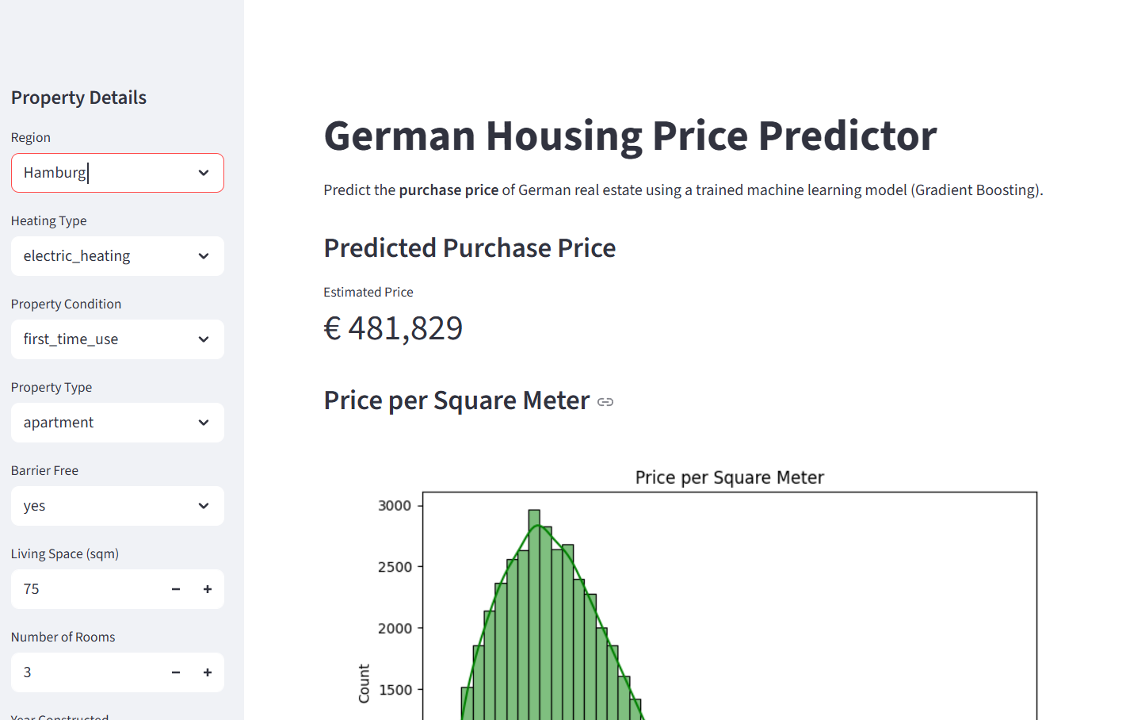
Figure 1 Dashboard of German housing price predictor
The screenshots of the application show the easy-to-use interface:
Input Panel: Users choose property characteristics from dropdown lists and numeric input fields.
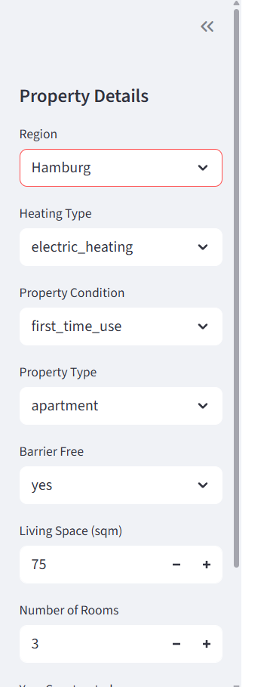
Figure 2 Input Panel of German housing price predictor Web App
Price Predicted Card: The prediction price is shown on a metric component that gives a clear and concise estimate.

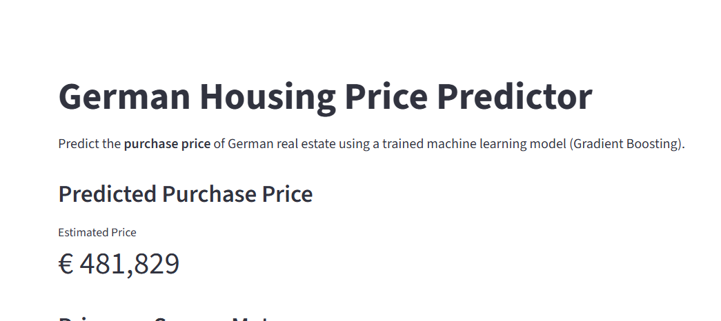
Figure 3 Predicted Price Card of German housing price predictor Web App
EDA Visualizations Pannel: Among the included visualizations are feature importance graphs and price per square distributions and top 10 performance which are meant to aid the users in understanding the predictions
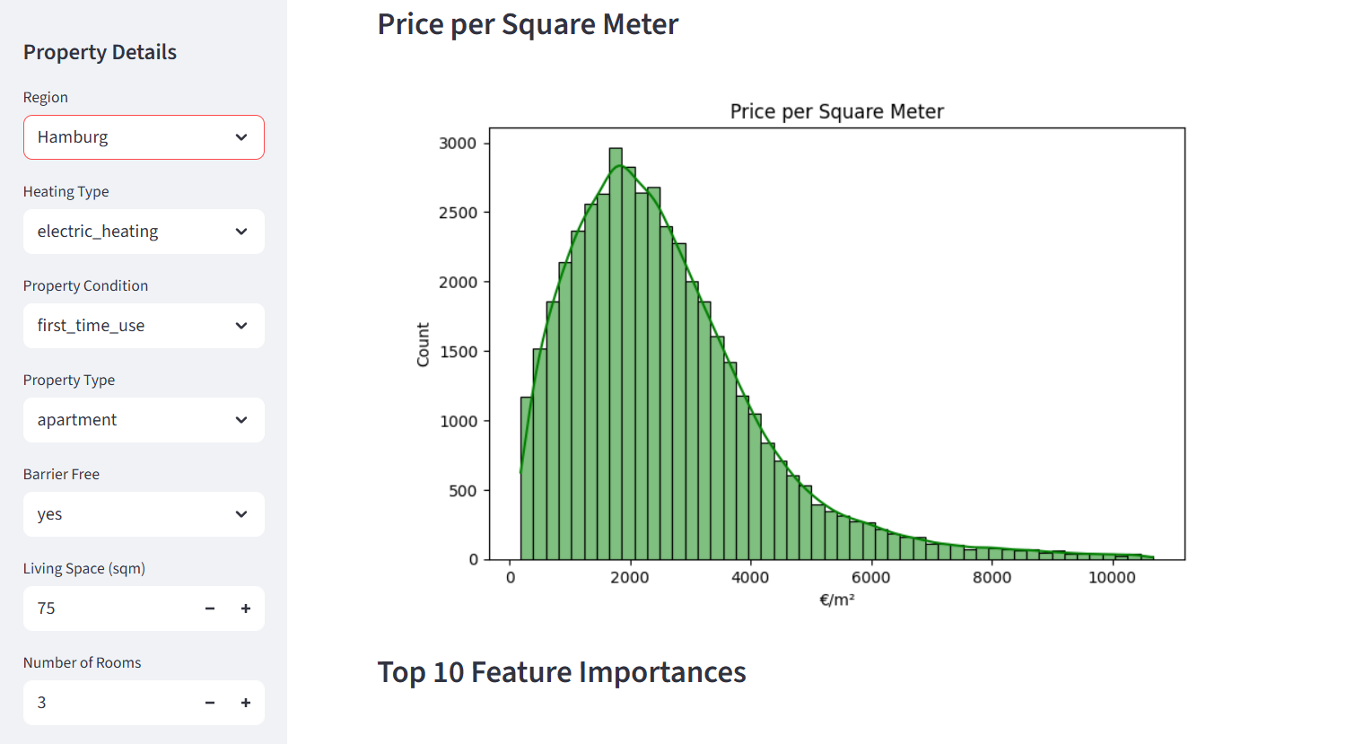
Figure 4 Price per Square meter graph
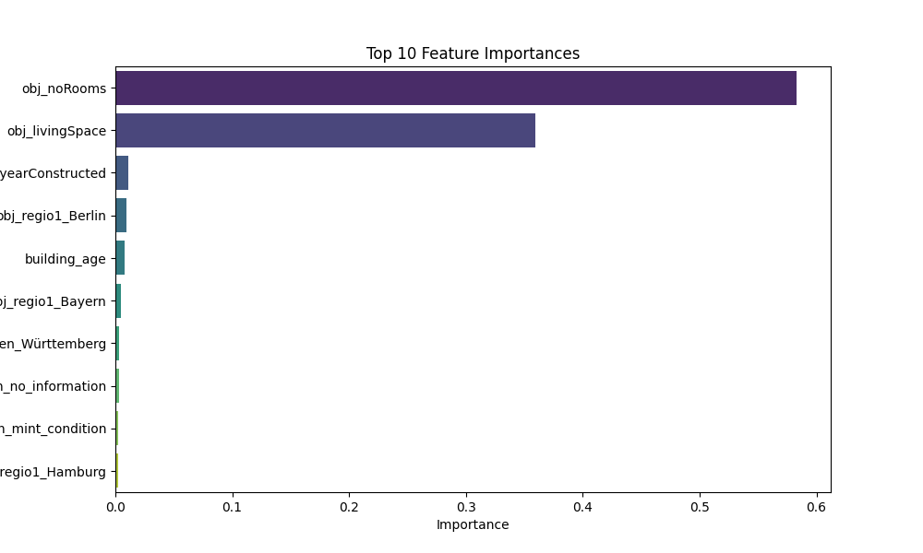
Figure 5 Top 10 Feature Importances Graph

4.3 Interpretability:
Explainable AI principles were utilized to provide transparency. The application offers visualizations of feature importance, which indicate how much each variable contributed to the final prediction relatively. It is very clear to the user that a property in a certain area or with a specific number of rooms might have a higher or lower estimated price based on the prediction.
This is consistent with the principles of interpretable machine learning applied to housing markets, which highlight the necessity of accountability and trustworthiness in AI-supported decisions (Krämer et al., 2023).

4.4 Practical Implications:
The predictive tool has several advantages:
- Buyers: Can determine if a property is fairly priced compared to the predicted estimates.
- Sellers and Real Estate Agencies: Can set the prices for their listings in a way that they will not only get buyers but also make a profit.
- Urban Planners and Analysts: Can spot and track property value changes in different areas which will be a great help for making decisions and planning investments (Tekouabou et al., 2024).

4.5 Limitations:
The robustness of the model is not enough to ensure perfect predictions, since there are still some influential factors outside the dataset such as economic fluctuations, urban developments, and transient market changes. Therefore, the recommendation is to continuously feed the model with the latest data in order to maintain the accuracy of the predictions.

5. Conclusion and Future Work

5.1 Challenges and Lessons Learned:
The project was effective but still had to tackle a number of hurdles that included the management of missing or inconsistent data, the encoding of categorical variables having multiple levels, and the dealing with market volatility. Data preprocessing techniques, tuning of hyperparameters, and appropriate validation were needed to pass through the hardships.
The whole process revealed how important it is to update the model and retrain it continuously to get the right prediction in a constantly changing housing market (Cina et al., 2025).

5.2 Future Work:
System improvements for the future could be aimed at a few main areas to both increase accuracy and usability. It is suggested to combine new features like economic indicators, distances to different facilities, and quality of public transport that can help in increasing predictive performance considerably. If the future development of modeling techniques by applying ensemble methods or deep learning were to capture more of the complex, non-linear relationships this could lead to a significant increase in accuracy. The use of geospatial data through GIS could make predictions at a very fine scale, say even neighborhoods or districts, thus aligning with the smart city planning trend (Tekouabou et al., 2024).
Data collection and model retraining systems would automatically be able to ensure that predictions are still relevant by being updated as market conditions alter. Moreover, the introduction of these very powerful AI explanation tools like counterfactuals and interactive visualization would not only contribute to user trust but also make the entire system quite transparent and comprehendible.

5.3 Conclusion:
In general, the project proves the efficient application of AI in the house price prediction and providing insightful information for the stakeholders of the German real estate market. It shows how high-end machine learning methods can be applied through a user-friendly web interface, hence supporting decision-making based on data and increasing transparency in property valuation. The proposed enhancements, if incorporated, would lead to the elevating of the already existing system to a more powerful and effective real estate tool for both individual investors and corporate players.
The German Housing Price Predictor is an excellent example of how artificial intelligence and machine learning can be effectively utilized in the residential real estate market. By using Gradient Boosting Regression and combining both categorical and numerical property features, the model generates precise and understandable housing price estimates for Germany. The model has been made available through a Streamlit web application that is easy to use, thereby making it accessible to a wide range of people, such as buyers, sellers, real estate agents, and urban planners, among others.

Reference:
Bachmann, S., 2025. Interpretable machine learning for the german residential rental market–shedding light into model mechanics. Aestimum, 86, pp.25-46.
Cina, E., Elbasi, E., Elmazi, G. and AlArnaout, Z., 2025. The Role of AI in Predictive Modelling for Sustainable Urban Development: Challenges and Opportunities. Sustainability (2071-1050), 17(11).
DP, S.P., Sameer, S., Ranga, R.C., Chowdary, R.P. and Venkatesh, K., 2025, March. Smart Housing Forecast: Leveraging AI Models for Predictive Pricing and Recommendations. In 2025 International Conference on Data Science, Agents & Artificial Intelligence (ICDSAAI) (pp. 1-7). IEEE.
Krämer, B., Nagl, C., Stang, M. and Schäfers, W., 2023. Explainable AI in a real estate context–exploring the determinants of residential real estate values. Journal of Housing Research, 32(2), pp.204-245.
Karger, E., Rothweiler, A., Brée, T. and Ahlemann, F., 2025. Building the Smart City of Tomorrow: A Bibliometric Analysis of Artificial Intelligence in Urbanization. Urban Science, 9(4), p.132.
Stang, M., Krämer, B., Cajias, M. and Schäfers, W., 2024. Changing the location game–improving location analytics with the help of explainable AI. Journal of Real Estate Research, 46(4), pp.421-443.
Rahacheuski, P., 2025. Developing a Business Plan for a Data Analytical Company in the Real Estate Domain (Doctoral dissertation, Technische Universität Wien).
Tekouabou, S.C., Gherghina, Ş.C., Kameni, E.D., Filali, Y. and Gartoumi, K.I., 2024. AI-Based on Machine Learning Methods for Urban Real Estate Prediction: A Systematic Survey. Archives of Computational Methods in Engineering, 31(2).
Weller, S.W. and Batra, R., 2024. Population distribution-weighting: Exploring a human-centered approach to house price statistics in German housing markets. Journal of Urban Affairs, 46(7), pp.1450-1470.
Yuan, Y., 2025. Research on Real Estate Market Prediction Models Based on Big Data and Artificial Intelligence. International Journal of High Speed Electronics and Systems, p.2540439.

